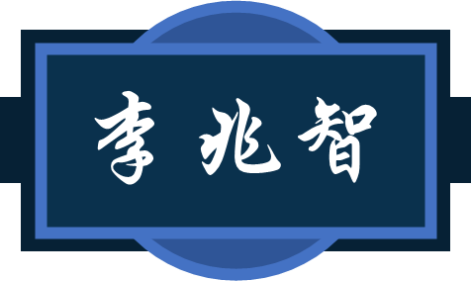

Synfig Studio for cutout animation midterm

30 October 2022

Having now completed half of the course, you should have grasped the basics of animation, including the 12 principles of animation. You should also know how to use Synfig to produce cutout animation.

In this midterm, you will be tasked to make a set of cutout animated gifs. These gifs will be used on social media including WeChat, Facebook, and others as “memes”. This portfolio should comprise of 20 gifs featuring a character making different motions. There should be both facial and body movements in each gif. Memes should be fun and deliver clear messages that can be used in lieu of words in social media interactions. The portfolio will be uploaded to GIPHY, allowing users to download and use. The design work will be shared on Instagram, Tumblr and the press release will be made on the official website of the Office of Li Zhaozhi three days ahead of the official launch.

In addition to the gifs, you should submit all the working files. Your complete portfolio should include these items:

1. Proposal: This proposal should explain in detail what the gif collection is about, what resources are required for production, and how you wish to make these animated memes. This document should also review budget and timeline.
2. Charter: The charter should be a condensed version of the proposal. It should be delivered in the form of a slide deck and include all essential information from the proposal.
3. Video: Record a video of a walk-through of the charter deck. Explain the reasons behind each component. In the video, you should also walk through the production process. Remember to save screenshots or make video recordings to record the key points in the process. These should be presented in the video and submitted as part of this portfolio.
4. Gifs: You should submit the finished product. This product should include gif outputs from Synfig as well as the source Synfig file and other production files such as concept art, storyboards, and software test files.

This midterm should take no more than 14 days to deliver. Late and incomplete submissions won’t be accepted. In addition to these items, please complete the following reflection sheet. This reflection will be graded and archived with all the production files.