# Full-Stack Design System

# Developer Documentation

This full-stack web framework supports the development of functional, consistent, accessible and engaged online experiences. All these start with a responsive, mobile-first 12-column layout system that’s ready to use out of the box.

## Layout System

The system uses CSS Flex for layout and CSS Grid for alignment. Flex is well supported in modern and legacy browsers, and Grid supports flexible alignment of elements on user interfaces. Developers can use the code provided by this design system to easily build Web projects.

Illustration

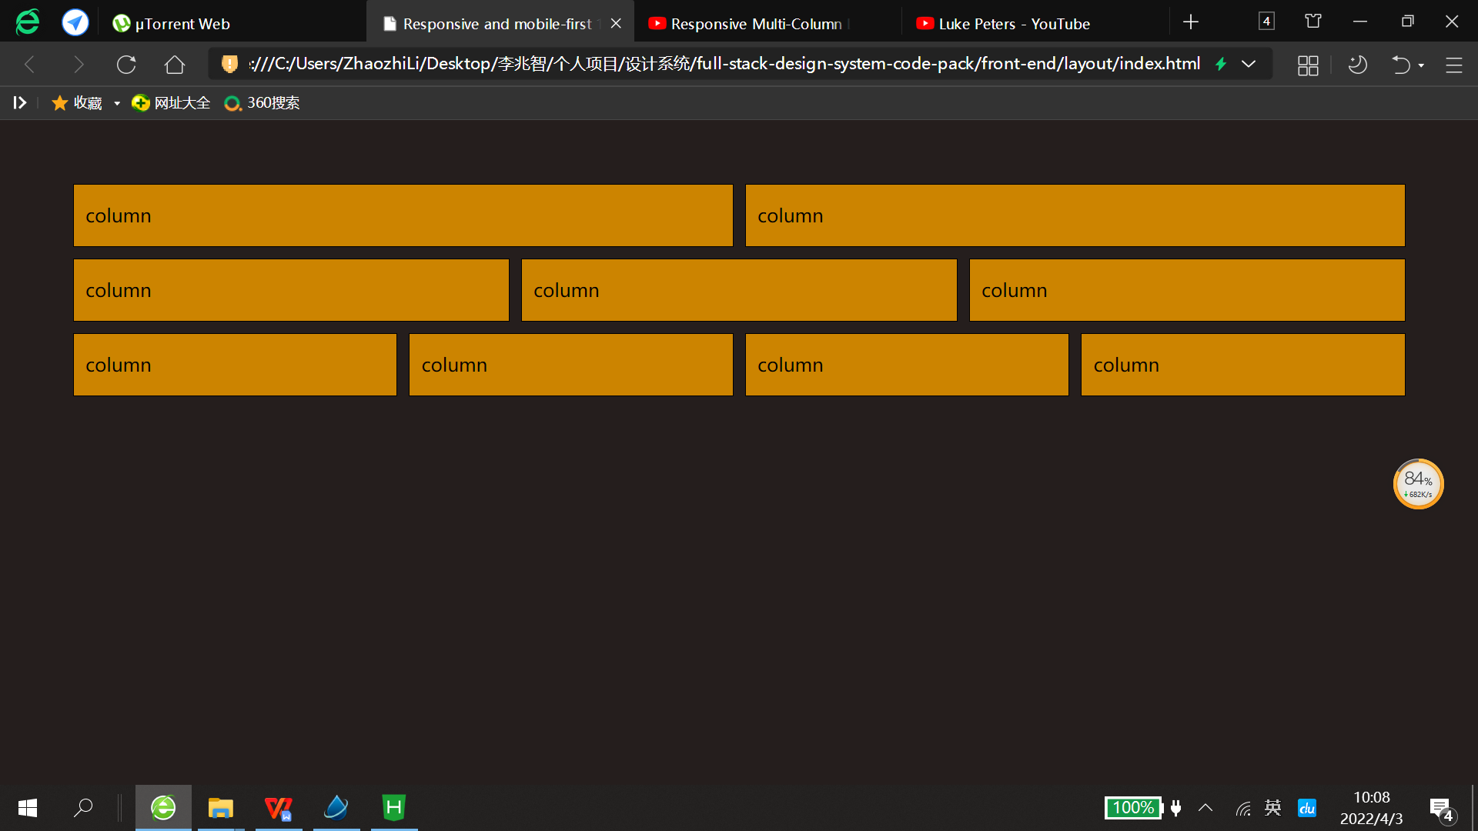

|  |
| --- |
| index.html |
| <!DOCTYPE html>  <html>  <head>  <meta charset="utf-8">  <title>Responsive and mobile-first 12-column layout system built with CSS Flex</title>  <link rel="stylesheet" type="text/css" href="css/layout.css" />  <style type="text/css">  body{  background: #2E2624  }  section > div{  background: orange;  border: 1px solid #000000;  margin: 5px;  }  </style>  </head>  <body>    <div style="margin: 50px;">  <section class="col-container">  <div class="col-sm-5 gutter"><p>column</p></div>  <div class="col-sm-5 gutter"><p>column</p></div>  </section>    <section class="col-container">  <div class="col-sm-4 gutter"><p>column</p></div>  <div class="col-sm-4 gutter"><p>column</p></div>  <div class="col-sm-4 gutter"><p>column</p></div>  </section>    <section class="col-container">  <div class="col-sm-3 gutter"><p>column</p></div>  <div class="col-sm-3 gutter"><p>column</p></div>  <div class="col-sm-3 gutter"><p>column</p></div>  <div class="col-sm-3 gutter"><p>column</p></div>  </section>  </div>    </body>  </html> |

|  |
| --- |
| layout.css |
| /*The responsive, mobile-first 12-column layout system built with CSS Flexbox*/  .row-container{  display: flex;  flex-direction: column;    /* internet explorer */  display: -ms-flexbox;  -ms-flex-direction: column;  }  .col-container{  display: flex;  flex-direction: row;    /* internet explorer */  display: -ms-flexbox;  -ms-flex-direction: row;  }  .col-container > .col{  flex: 1 1 0px; /*grow shrink and basis*/  }  $numbers: (1 2 3 4 5 6 7 8 9 10 11 12);  @for $index from 1 through length($numbers) {  $number: nth($numbers, $index);    /* Extra small devices (phones, 600px and down) */  @media only screen and (max-width: 600px) {  .row-container > .row-es-#{$number}, .col-container > .col-es-#{$number} {  flex: $index $index 0px;  }  }    /* Small devices (portrait tablets and large phones, 600px and up) */  @media only screen and (min-width: 600px) {  .row-container > .row-sm-#{$number}, .col-container > .col-sm-#{$number} {  flex: $index $index 0px;  }  }    /* Medium devices (landscape tablets, 768px and up) */  @media only screen and (min-width: 768px) {  .row-container > .row-me-#{$number}, .column-container > .col-me-#{$number} {  flex: $index $index 0px;  }  }    /* Large devices (laptops/desktops, 992px and up) */  @media only screen and (min-width: 992px) {  .row-container > .row-lg-#{$number}, .column-container > .col-lg-#{$number} {  flex: $index $index 0px;  }  }    /* Extra large devices (large laptops and desktops, 1200px and up) */  @media only screen and (min-width: 1200px) {  .row-container > .row-el-#{$number}, .column-container > .col-el-#{$number} {  flex: $index $index 0px;  }  }  }  .row-container > .auto-row, .column-container > .auto-col{  flex: 0 0 auto; /*grow shrink and basis*/  }  $gutter-size: 20px !default;  .gutter > * {  margin-left: calc($gutter-size / 2);  margin-right: calc($gutter-size / 2);  } |