INDEX

|  |  |  |
| --- | --- | --- |
| **TITLE** | | |
| **SL.NO** | **PART A** | **PAGE. NO** |
| **1.** | **Write a program to create a 3 X 3 matrices A and B and perform the following operations**  **a. AT.B**  **b. BT.(A.AT)**  **c. (A.AT).BT**  **d. [(B.BT)+(A.AT)-100I3]-1** |  |
| **2.** | **Write R program to find roots of quadratic equation using user defined function. Test the**  **program user supplied values for all possible cases.** |  |
| **3.** | **Write R script to generate prime numbers between two numbers using loops** |  |
| **4.** | **Write an R program to create a list containing strings, numbers, vectors and logical**  **values and do the following manipulations over the list**  **a. Access the first element in the list**  **b. Give the names to the elements in the list**  **c. Add element at some positions in the list**  **d. Remove the element**  **e. print the first and third element**  **f. Update the third element** |  |
| **5.** | **The following table shows the time taken (in minutes) by 100 students to travel to school on a particular day.**    **a. Draw the histogram**  **b. Draw frequency polygon** |  |
| **6.** | **Write an R program to create a Data Frame with following details and do the following**  **operations.**    **a. Subset the Data frame and display the details of only those items whose price is**  **greater than or equal to 350.**  **b. Subset the Data frame and display only the items where the category is either “Office**  **Supplies” or “Desktop Supplies”**  **c. Subset the Data frame and display the items where the Itemprice between 300 and**  **700**  **d. Compute the sum of all ItemPrice**  **e. Create another Data Frame called “item-details” with three different fields itemCode,**  **ItemQtyonHand and ItemReorderLvl and merge the two frames.** |  |
| **7.** | **Create a factor marital_status with levels Married, single, divorced. Perform the**  **following operations on this factor**  **a. Check the variable is a factor**  **b. Access the 2nd and 4th element in the factor**  **c. Remove third element from the factor**  **d. Modify the second element of the factor**  **e. Add new level widowed to the factor and add the same level to the factor marital_status** |  |
| **8.** | **Write a R language Script for following operation on Iris Data Set**  **1. Load the Iris Dataset**  **2. View first six rows of iris dataset**  **3. Summarize iris dataset**  **4. Display number of rows and columns**  **5. Display column names of dataset.**  **6. Create histogram of values for sepal length**  **7. Create scatterplot of sepal width vs. sepal length**  **8. Create boxplot of sepal width vs. sepal length**  **9. Find Pearson correlation between Sepal.Length and Petal.Length**  **10. Create correlation matrix for dataset** |  |

|  |  |  |
| --- | --- | --- |
| **TITLE** | | |
| **SL.NO** | **PART B** | **PAGE. NO** |
| **1.** | **Write a R program to create a Vector containing following 8 values and perform the**  **following operations.**  **4 3 0 5 2 9 4 5**  **a. Find mean, median, mode.**  **b. Find the range.**  **c. Find the 35th and 78th percentile.**  **d. Find the variance and standard deviation**  **e. Find the interquartile range.**  **f. Find the z-score for each value.** |  |
| **2.** | **Write R script to find the correlation coefficient and type of correlation between advertisement expenses and sales volume using Karl Pearson’s coefficient of correlation method (Direct Method).** |  |
| **3.** | **Write R script to compute the regression equation of y on x from the following data. Predict the value of y when x=7** |  |
| **4.** | **The times taken by a large group of students to complete a piece of homework, T minutes, are Normally distributed with a mean of 57 minutes and standard deviation of6.5. Find the probability that the time taken by a random student from the group tocomplete this homework will be less than 60 minutes.**  **Write R script to Find the probability that the time taken by a random student from the group to complete this homework**  **a) Will be less than 60 minutes**  **b) Between 50 and 80 minutes** |  |
| **5.** | **Write R script to perform the following using binomial distribution**  **i. If n=4 and p=0.10, find P(x=3)**  **ii. If n=12 and p=0.45, find P(5<=x<=7)** |  |
| **6.** | **Perform the following using uniform distribution between 200 and 240**  **i. P(x>230)**  **ii. P(205≤x≤220)** |  |
| **7.** | **Following are the scores of max vertical jumps before and after the training program.**  **Test whether the training program is helpful to the students (Use Paired t-test).** |  |
| **8.** | **A company has three manufacturing plants, and company officials want to determine**  **whether there is difference in the average age of workers at the three locations. The**  **following data are the ages of five randomly selected workers at each plant. Perform a**  **one-way ANOVA to determine whether there is a significant difference in the mean ages**  **of the workers at three plants. Use α=0.01. Write R script for the above problem.**  **Plant(Employee Ages)** |  |

**PART-A**

**/*****************************************************************/Aim1)** **Write a program to create a 3 X 3 matrices A and B and perform the following operations**

**a. AT.B**

**b. BT.(A.AT)**

**c. (A.AT).BT**

**d. [(B.BT)+(A.AT)-100I3]-1**

**Name:**

**Reg. No:U05DP21S0**

**Date:**

**/*****************************************************************/**

A<-matrix(c(1,2,3,4,5,6,7,8,9),nrow=3,ncol=3)

B<-matrix(c(9,8,7,6,5,4,3,2,1),nrow=3,ncol=3)

#a)AT.B

result_a<-t(A)%*%B

#b)BT.(A.AT)

result_b<-t(B)%*%(A%*%t(A))

#c)(A.AT).BT

result_c<-(A%*%t(A))%*%t(B)

#d)[(B.BT)+(A.AT)-100*diag(3)^(-1)]

result_d<-solve((B%*%t(B))+(A%*%t(A))-100*diag(3))

cat("matrix A:\n")

print(A)

cat("matrix B:\n")

print(B)

cat("\na)AT.B:\n")

print(result_a)

cat("\nb)BT.(A.AT):\n")

print(result_b)

cat("\nc)(A.AT).BT:\n")

print(result_c)

cat("\nd)[(B.BT)+(A.AT)-100*diag(3)]^(-1):\n")

print(result_d)

**Output:**

matrix A:

[,1] [,2] [,3]

[1,] 1 4 7

[2,] 2 5 8

[3,] 3 6 9

matrix B:

[,1] [,2] [,3]

[1,] 9 6 3

[2,] 8 5 2

[3,] 7 4 1

a)AT.B:

[,1] [,2] [,3]

[1,] 46 28 10

[2,] 118 73 28

[3,] 190 118 46

b)BT.(A.AT):

[,1] [,2] [,3]

[1,] 1848 2202 2556

[2,] 1146 1365 1584

[3,] 444 528 612

c)(A.AT).BT:

[,1] [,2] [,3]

[1,] 1332 1098 864

[2,] 1584 1305 1026

[3,] 1836 1512 1188

d)[(B.BT)+(A.AT)-100*diag(3)]^(-1):

[,1] [,2] [,3]

[1,] -0.006620683 0.004061135 0.004742954

[2,] 0.004061135 -0.005938865 0.004061135

[3,] 0.004742954 0.004061135 -0.006620683

**/*****************************************************************/Aim2:** **Write R program to find roots of quadratic equation using user defined function. Test the program user supplied values for all possible cases.**

**Name:**

**Reg.No: U05DP21S0**

**Date:**

**/*****************************************************************/**

quadratic_equation<-function(a,b,c){

d<-b^2-4*a*c

if(d>0){

x1<-(-b+sqrt(d))/(2*a)

x2<-(-b-sqrt(d))/(2*a)

print(paste("the roots of the equation are:",x1,"and",x2))

}

else if(d==0){

x<- -b/(2^a)

print(paste("root of the equation is:",x))

}else{

print("the equation has no real roots")

}

}

a<-as.numeric(readline("enter the value of a:"))

b<-as.numeric(readline("enter the value of b:"))

c<-as.numeric(readline("enter the value of c:"))

quadratic_equation(a,b,c)

**Output1:**

enter the value of a:1

enter the value of b:2

enter the value of c:3

[1] "the equation has no real roots"

**Output2:**

enter the value of a:2

enter the value of b:9

enter the value of c:4

[1] "the roots of the equation are: -0.5 and -4"

**Output3:**

enter the value of a:1

enter the value of b:2

enter the value of c:1

[1] "root of the equation is: -1"

**/****************************************************************************/Aim3:** **Write R script to generate prime numbers between two numbers using loops.**

**Name:**

**Reg.No: U05DP21S0**

**Date:**

**/*****************************************************************/**

generate_primes<-function(a,b)

{

primes<-c()

for(n in a:b)

{

if(all(n%%2:(n-1)!=0))

{

primes<-append(primes,n)

}

}

return(primes)

}

**Output:**

source("C:/kavana/PartA3new.r")

> generate_primes(2,50)

[1] 3 5 7 11 13 17 19 23 29 31 37 41 43 47

> generate_primes(1,10)

[1] 3 5 7

**/*****************************************************************/Aim4: Write an R program to create a list containing strings, numbers, vectors and logical values and do the following manipulations over the list**

**a. Access the first element in the list**

**b. Give the names to the elements in the list**

**c. Add element at some positions in the list**

**d. Remove the element**

**e. print the first and third element**

**f. Update the third element**

**Name:**

**Reg.No: U05DP21S0**

**Date:**

**/*****************************************************************/**

list_data<-list("Red",c(21,32,11),TRUE,51.23)

print(list_data)

list_data[1]

names(list_data)<-c("color","marks","flag","average")

list_data

p1=as.numeric(readline("Enter Position to insert"))

append(list_data,"canada",after=p1-1)

list_data

p2=as.numeric(readline("Enter Position to Remove"))

list_data[-p2]

list_data

list_data[1]

list_data[3]

list_data[3]<-88.97

list_data

list_data["average"]<-67.5

list_data

**Output:**

list_data<-list("Red",c(21,32,11),TRUE,51.23)

> print(list_data)

[[1]]

[1] "Red"

[[2]]

[1] 21 32 11

[[3]]

[1] TRUE

[[4]]

[1] 51.23

> list_data[1]

[[1]]

[1] "Red"

> names(list_data)<-c("color","marks","flag","average")

> list_data

$color

[1] "Red"

$marks

[1] 21 32 11

$flag

[1] TRUE

$average

[1] 51.23

> p1=as.numeric(readline("Enter Position to insert"))

Enter Position to insert1

> append(list_data,"canada",after=p1-1)

[[1]]

[1] "canada"

$color

[1] "Red"

$marks

[1] 21 32 11

$flag

[1] TRUE

$average

[1] 51.23

> list_data

$color

[1] "Red"

$marks

[1] 21 32 11

$flag

[1] TRUE

$average

[1] 51.23

> p2=as.numeric(readline("Enter Position to Remove"))

Enter Position to Remove2

> list_data[-p2]

$color

[1] "Red"

$flag

[1] TRUE

$average

[1] 51.23

> list_data

$color

[1] "Red"

$marks

[1] 21 32 11

$flag

[1] TRUE

$average

[1] 51.23

> list_data[1]

$color

[1] "Red"

> list_data[3]

$flag

[1] TRUE

> list_data[3]<-88.97

> list_data

$color

[1] "Red"

$marks

[1] 21 32 11

$flag

[1] 88.97

$average

[1] 51.23

> list_data["average"]<-67.5

> list_data

$color

[1] "Red"

$marks

[1] 21 32 11

$flag

[1] 88.97

$average

[1] 67.5

**/*****************************************************************/Aim5: The following table shows the time taken (in minutes) by 100 students to travel to school on a particular day.**



**a. Draw the histogram**

**b. Draw frequency polygon**

**Name:**

**Reg.No: U05DP21S0**

**Date:**

**/*****************************************************************/**

time_intervals<-c("0-5","5-10","10-15","15-20","20-25")

no_of_students<-c(5,25,40,17,13)

midpoints<-c(2.5,7.5,12.5,17.5,22.5)

time_taken<-c(rep(2.5,5),rep(7.5,25),rep(12.5,40),rep(17.5,17),rep(22.5,13))

hist(time_taken,

breaks=c(0,5,10,15,20,25),

col="blue",

xlab="Time(minutes)",

ylab="Number of students",

main="Histogram of the Time taken by Students to travel to school")

plot(midpoints,no_of_students,type="n",xlab="Time(miniutes)",ylab="Number of students",main="Frequency polygon")

polygon(midpoints,no_of_students,col="yellow",border="green")

points(midpoints,no_of_students,pch=16,col="red")

legend("topright",legend="Frequency polygon",fill="yellow",border="green")

**Output:**

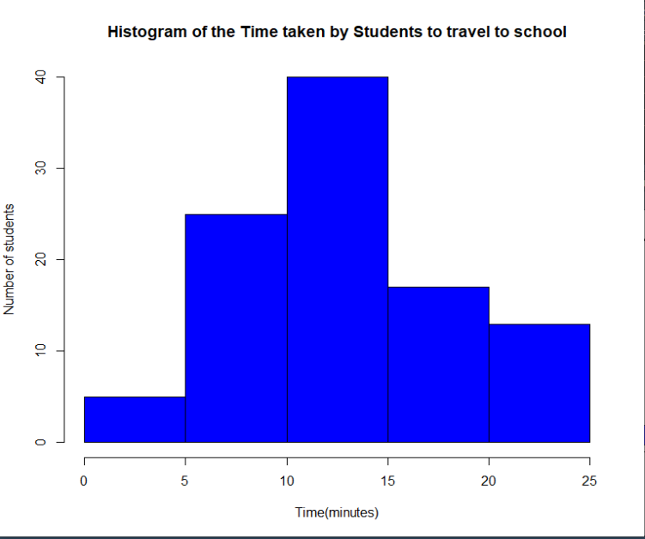

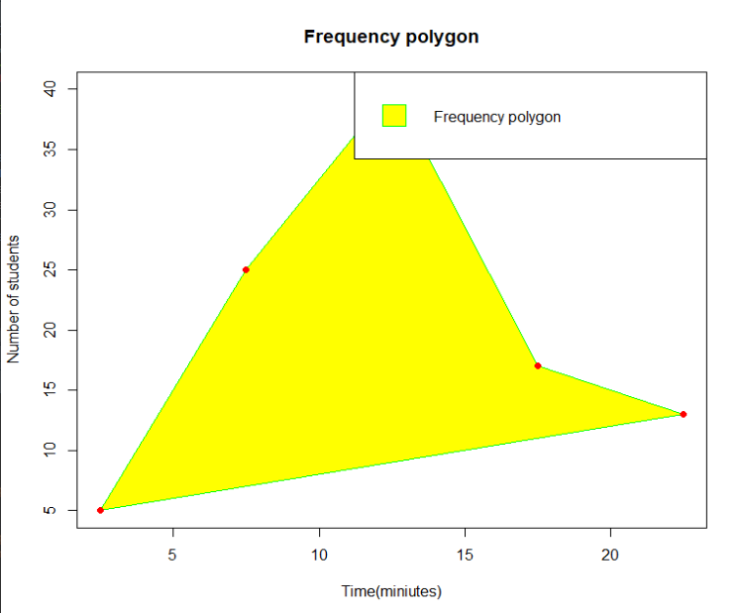

**/*****************************************************************/Aim6: Write an R program to create a Data Frame with following details and do the following operations.**

|  |  |  |
| --- | --- | --- |
| **ItemCode** | **itemCategory** | **ItemPrice** |
| **1001** | **Electronics** | **700** |
| **1002** | **Desktop Supplies** | **300** |
| **1003** | **Office Supplies** | **350** |
| **1004** | **USB** | **400** |
| **1005** | **CD Drive** | **800** |

* 1. **Subset the Data frame and display the details of only those items whose price is greater than or equal to 350.**
  2. **Subset the Data frame and display only the items where the category is either “Office Supplies” or “Desktop Supplies”**
  3. **Subset the Data frame and display the items where the Itemprice between 300 and**

**700**

* 1. **Compute the sum of all ItemPrice**
  2. **Create another Data Frame called “item-details” with three different fields itemCode, ItemQtyonHand and ItemReorderLvl and merge the two frames.**

**Name:**

**Reg.No: U05DP21S0**

**Date:**

**/*************************************************************/**

Data<-data.frame(itemCode=c(1001,1002,1003,1004,1005),

itemCategory=c("Electronics","DesktopSuppliers","OfficeSuppliers","USB","CD Drives"),

itemPrice=c(700,300,350,400,800))

subset_a<-data[data$itemPrice>=350,]

subset_b<-data[data$itemCategory%in%c("OfficeSuppliers","DesktopSuppliers"),]

subset_c<-data[data$itemPrice>=300&data$itemPrice<=700,]

total_Price<-sum(data$itemPrice)

item_details<-data.frame(

itemCode=c(1001,1002,1003,1004,1005),

itemQtyonhand=c(10,15,20,5,12),

itemReorderLvl=c(2,5,3,4,6)

)

merge_data<- merge(data,item_details,by="itemCode")

print("a.subset greater than=350")

print(subset_a)

print("b.subset item is office or desktop")

print(subset_b)

print("c.between 300 and 700")

print(subset_c)

print("d.sum of the item")

print(total_Price)

print("e.Merge data")

print(merge_data)

**Output:**

[1] "a.subset greater than=350"

itemCode itemCategory itemPrice

1 1001 Electronics 700

3 1003 OfficeSuppliers 350

4 1004 USB 400

5 1005 CD Drives 800

[1] "b.subset item is office or desktop"

itemCode itemCategory itemPrice

2 1002 DesktopSuppliers 300

3 1003 OfficeSuppliers 350

[1] "c.between 300 and 700"

itemCode itemCategory itemPrice

1 1001 Electronics 700

2 1002 DesktopSuppliers 300

3 1003 OfficeSuppliers 350

4 1004 USB 400

[1] "d.sum of the item"

[1] 2550

[1] "e.Merge data"

itemCode itemCategory itemPrice itemQtyonhand itemReorderLvl

1 1001 Electronics 700 10 2

2 1002 DesktopSuppliers 300 15 5

3 1003 OfficeSuppliers 350 20 3

4 1004 USB 400 5 4

5 1005 CD Drives 800 12 6

**/****************************************************************/**

**Aim7: Create a factor marital_status with levels Married, single, divorced. Perform the following operations on this factor a. Check the variable is a factor**

* 1. **Access the 2nd and 4th element in the factor**
  2. **Remove third element from the factor**
  3. **Modify the second element of the factor**
  4. **Add new level widowed to the factor and add the same level to the factor marital_status**

**Name:**

**Reg.No: U05DP21S0**

**Date:**

**/*************************************************************/**

marital_status<-factor(c("Married","Single","Divorced","Widow","Married","Single","Widow","Divorced"))

is.factor(marital_status)

marital_status[c(2,4)]

marital_status<-marital_status[-3]

marital_status

marital_status[2]<-"Widow"

print(marital_status)

marital_status

levels(marital_status)<-c(levels(marital_status),"Widowed")

marital_status

**Output:**

> is.factor(marital_status)

[1] TRUE

> marital_status[c(2,4)]

[1] Single Widow

Levels: Divorced Married Single Widow

> marital_status<-marital_status[-3]

> marital_status

[1] Married Single Widow Married Single Widow Divorced

Levels: Divorced Married Single Widow

> marital_status[2]<-"Widow"

> print(marital_status)

[1] Married Widow Widow Married Single Widow Divorced

Levels: Divorced Married Single Widow

> marital_status

[1] Married Widow Widow Married Single Widow Divorced

Levels: Divorced Married Single Widow

> levels(marital_status)<-c(levels(marital_status),"Widowed")

> marital_status

[1] Married Widow Widow Married Single Widow Divorced

Levels: Divorced Married Single Widow Widowed

**/****************************************************************************/Aim 8: Write a R language Script for following operation on Iris Data Set**

**1. Load the Iris Dataset**

**2. View first six rows of iris dataset**

**3. Summarize iris dataset**

**4. Display number of rows and columns**

**5. Display column names of dataset.**

**6. Create histogram of values for sepal length**

**7. Create scatterplot of sepal width vs. sepal length**

**8. Create boxplot of sepal width vs. sepal length**

**9. Find Pearson correlation between Sepal.Length and Petal.Length**

**10. Create correlation matrix for dataset**

**Name:**

**Reg.No: U05DP21S0**

**Date:**

**/*************************************************************/**

data("iris")

head(iris)

summary(iris)

dim(iris)

names(iris)

hist(iris$Sepal.Length,col="blue",main="histogram",xlab="Length",ylab="Frequency")

plot(iris$Sepal.Width,iris$Sepal.Length,col="blue",main="scatter plot",xlab="Sepal Width",ylab="Sepal Length")

plot(iris$Sepal.Length~Species,data=iris,col="blue",border="green",main="Sepal Length by species",xlab="Species",ylab="Sepal Length")

cor(iris$Sepal.Length,iris$Sepal.Width,method=c("pearson"))

str(iris)

**Output:**

data("iris")

> head(iris)

Sepal.Length Sepal.Width Petal.Length Petal.Width Species

1 5.1 3.5 1.4 0.2 setosa

2 4.9 3.0 1.4 0.2 setosa

3 4.7 3.2 1.3 0.2 setosa

4 4.6 3.1 1.5 0.2 setosa

5 5.0 3.6 1.4 0.2 setosa

6 5.4 3.9 1.7 0.4 setosa

> summary(iris)

Sepal.Length Sepal.Width Petal.Length Petal.Width

Min. :4.300 Min. :2.000 Min. :1.000 Min. :0.100

1st Qu.:5.100 1st Qu.:2.800 1st Qu.:1.600 1st Qu.:0.300

Median :5.800 Median :3.000 Median :4.350 Median :1.300

Mean :5.843 Mean :3.057 Mean :3.758 Mean :1.199

3rd Qu.:6.400 3rd Qu.:3.300 3rd Qu.:5.100 3rd Qu.:1.800

Max. :7.900 Max. :4.400 Max. :6.900 Max. :2.500

Species

setosa :50

versicolor:50

virginica :50

> dim(iris)

[1] 150 5

> names(iris)

[1] "Sepal.Length" "Sepal.Width" "Petal.Length" "Petal.Width"

[5] "Species"

> hist(iris$Sepal.Length,col="blue",main="histogram",xlab= ="Length",ylab="Frequency")

> plot(iris$Sepal.Width,iris$Sepal.Length,col="blue",main="scatter plot",xlab="Sepal Width",ylab="Sepal Length")

> plot(iris$Sepal.Length~Species,data=iris,col="blue",border="green",main="Sepal Length by species",xlab="Species",ylab="Sepal Length")

> cor(iris$Sepal.Length,iris$Sepal.Width,method=c("pearson"))

[1] -0.1175698

> str(iris)

'data.frame': 150 obs. of 5 variables:

$ Sepal.Length: num 5.1 4.9 4.7 4.6 5 5.4 4.6 5 4.4 4.9 ...

$ Sepal.Width : num 3.5 3 3.2 3.1 3.6 3.9 3.4 3.4 2.9 3.1 ...

$ Petal.Length: num 1.4 1.4 1.3 1.5 1.4 1.7 1.4 1.5 1.4 1.5 ...

$ Petal.Width : num 0.2 0.2 0.2 0.2 0.2 0.4 0.3 0.2 0.2 0.1 ...

$ Species : Factor w/ 3 levels "setosa","versicolor",..: 1 1 1 1 1 1 1 1 1 1 1

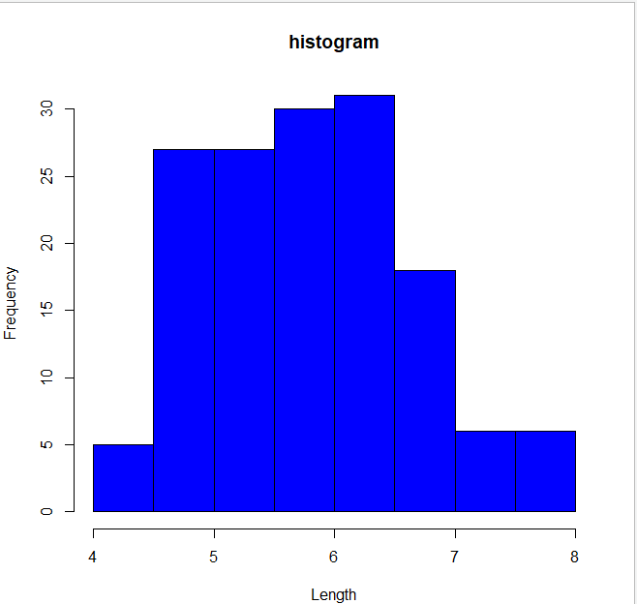

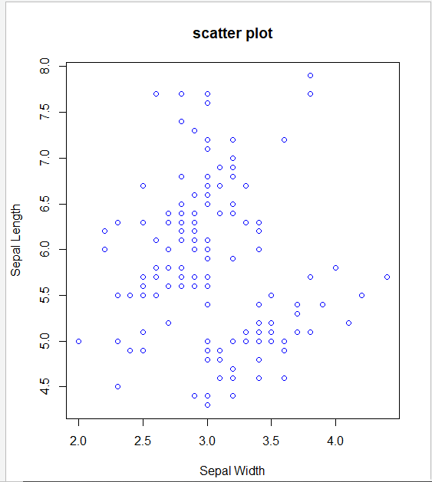

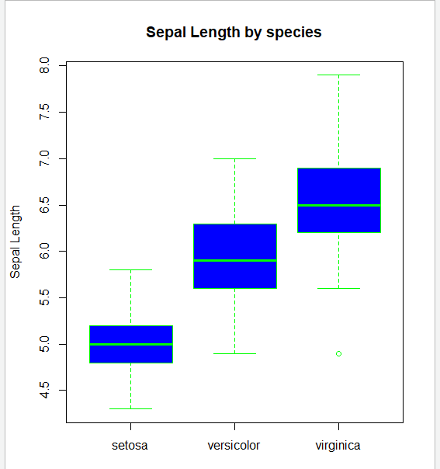

**PART-B**

**/****************************************************************************/**

**Aim 1: Write a R program to create a Vector containing following 8 values and perform the**

**following operations.**

**4 3 0 5 2 9 4 5**

**a. Find mean, median, mode.**

**b. Find the range.**

**c. Find the 35th and 78th percentile.**

**d. Find the variance and standard deviation**

**e. Find the interquartile range.**

**f. Find the z-score for each value.**

**Name:**

**Reg.No: U05DP21S0**

**Date:**

**/*************************************************************/**

vec<-c(4,3,0,5,2,9,4,5)

paste("Mean=",mean(vec))

paste("Median=",median(vec))

getmode<-function(v){

uniqv<-unique(v)

uniqv[which.max(tabulate(match(v,uniqv)))]}

mode<-getmode(vec)

paste("Mode=",mode)

paste("Range=",diff(range(vec)))

quantile(vec,prob=c(0.35,0.78))

paste("variance=",var(vec))

paste("Standard deviation=",sd(vec))

paste("Interquantile range=",IQR(vec))

vec_zscore<-((vec-mean(vec))/sd(vec))

vec_zscore

**Output:**

vec<-c(4,3,0,5,2,9,4,5)

> paste("Mean=",mean(vec))

[1] "Mean= 4"

> paste("Median=",median(vec))

[1] "Median= 4"

> getmode<-function(v){

+ uniqv<-unique(v)

+ uniqv[which.max(tabulate(match(v,uniqv)))]}

> mode<-getmode(vec)

> paste("Mode=",mode)

[1] "Mode= 4"

> paste("Range=",diff(range(vec)))

[1] "Range= 9"

> quantile(vec,prob=c(0.35,0.78))

35% 78%

3.45 5.00

> paste("variance=",var(vec))

[1] "variance= 6.85714285714286"

> paste("Standard deviation=",sd(vec))

[1] "Standard deviation= 2.61861468283191"

> paste("Interquantile range=",IQR(vec))

[1] "Interquantile range= 2.25"

> vec_zscore<-((vec-mean(vec))/sd(vec))

> vec_zscore

[1] 0.0000000 -0.3818813 -1.5275252 0.3818813 -0.7637626 1.9094065 0.0000000 0.3818813

**/*****************************************************************/Aim 2: Write R script to find the correlation coefficient and type of correlation between advertisement expenses and sales volume using Karl Pearson’s coefficient of correlation method (Direct Method).**

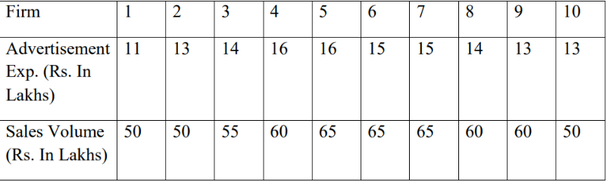

**Name:**

**Reg.No: U05DP21S0**

**Date:**

**/*************************************************************/**

advertisement_exp<-c(11,13,14,16,16,15,15,14,13,13)

sales_volume<-c(50,50,55,60,65,65,65,60,60,50)

mean_ad_exp<-mean(advertisement_exp)

mean_sales_volume<-mean(sales_volume)

sum_deviation_product<-sum((advertisement_exp-mean_ad_exp)*(sales_volume-mean_sales_volume))

sum_squared_dev_ad_exp<-sum((advertisement_exp-mean_add_exp)^2)

sum_squared_dev_sales_volume<-sum((sales_volume-mean_sales_volume)^2)

correlation_coefficient<-sum_deviation_product/sqrt(sum_squared_dev_ad_exp*sum_squared_dev_sales_volume)

if(correlation_coefficient>0){

correlation_type<-"positive correlation"

} else if

(correlation_coefficient<0){

correlation_type<-"Negative correlation"

} else{

correlation_type<-"No correlation"

}

cat("Correlation Coeffiecient:",correlation_coefficient,"\n")

cat("Type of correlation:",correlation_type,"\n")> cat("Correlation Coeffiecient:",correlation_coefficient,"\n")

**Output:**

Correlation Coeffiecient: 0.7865665

Type of correlation: positive correlation

**/*****************************************************************/Aim3: Write R script to compute the regression equation of y on x from the following data. Predict the value of y when x=7**

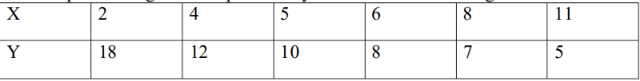

**Name:**

**Reg.No: U05DP21S0**

**Date:**

**/*************************************************************/**

x<-c(2,4,5,6,8,11)

y<-c(18,12,10,8,7,5)

model<-lm(y~x)

summary(model)

new_data<-data.frame(x=7)

predicted_y<-predict(model,newdata=new_data)

cat("Regression equation:y=",round(coefficients(model)[1],2),"+",round(coefficients(model)[2],2),"x\n")

cat("Predicted y when x=7:",round(predicted_y,2),"\n")

**Output:**

cat("Regression equation:y=",round(coefficients(model)[1],2),"+",round(coefficients

(model)[2],2),"x\n")

Regression equation:y= 18.04 + -1.34 x

> cat("Predicted y when x=7:",round(predicted_y,2),"\n")

Predicted y when x=7: 8.66

**/****************************************************************/**

**Aim4: The times taken by a large group of students to complete a piece of homework, T minutes, are Normally distributed with a mean of 57 minutes and standard deviation of 6.5. Find the probability that the time taken by a random student from the group to complete this homework will be less than 60 minutes. Write R script to Find the probability that the time taken by a random student from the group to complete this homework**

**a) Will be less than 60 minutes**

**b) Between 50 and 80 minutes**

**Name:**

**Reg.No: U05DP21S0**

**Date:**

**/*************************************************************/**

mean_time<-57

std_deviation<-6.5

prob_less_than_60<-pnorm(60,mean=mean_time,sd=std_deviation)

cat("probability that time is less than 60 minutes:",prob_less_than_60,"\n")

prob_between_50_and_80<-pnorm(80,mean=mean_time,sd=std_deviation)-pnorm(50,mean=mean_time,sd=std_deviation)

cat("Probability that time isbetween 50 and 80 minutes:",prob_between_50_and_80,"\n")

**Output:**

probability that time is less than 60 minutes: 0.6777938

Probability that time is between 50 and 80 minutes: 0.8590415

**/****************************************************************************/Aim5: Write R script to perform the following using binomial distribution**

**i. If n=4 and p=0.10, find P(x=3)**

**ii. If n=12 and p=0.45, find P(5<=x<=7)**

**Name:**

**Reg.No: U05DP21S0**

**Date:**

**/*************************************************************/**

n1<-4

p1<-0.10

prob_x_3<-dbinom(3,size=n1,prob=p1)

n2<-12

p2<-0.45

prob_x_between_5_7<-sum(dbinom(5:7,size=n2,prob=p2))

cat("i.p(x=3)=",prob_x_3,"\n")

cat("ii.p(5<=x<=7)=",prob_x_between_5_7,"\n")

cat("i.p(x=3)=",prob_x_3,"\n")

**Output:**

i.p(x=3)= 0.0036

> cat("ii.p(5<=x<=7)=",prob_x_between_5_7,"\n")

ii.p(5<=x<=7)= 0.583828

/****************************************************************************/

**Aim6: Perform the following using uniform distribution between 200 and 240**

**i. P(x>230)**

**ii. P(205≤x≤220)**

**Name:**

**Reg.No: U05DP21S0**

**Date:**

**/*************************************************************/**

n<-10000

random_numbers<-runif(n,min=200,max=240)

probability_x_gt_230<-mean(random_numbers>230)

cat("i.P(x>230):",probability_x_gt_230,"\n")

probability_x_between_205_and_220<-mean(random_numbers>=205& random_numbers<=220)

cat("ii.P(205<=x<=220):",probability_x_between_205_and_220,"\n")

**Output:**

> probability_x_between_205_and_220<-mean(random_numbers>=250 & random_numbers<=220)

i.p(x>230): 0.2479

> cat("ii.p(205<=x<=220):",probability_x_between_205_and_220,"\n")

ii.P(205<=x<=220): 0.3765

/***************************************************************************/

**Aim7: Following are the scores of max vertical jumps before and after the training program. Test whether the training program is helpful to the students (Use Paired t-test).**

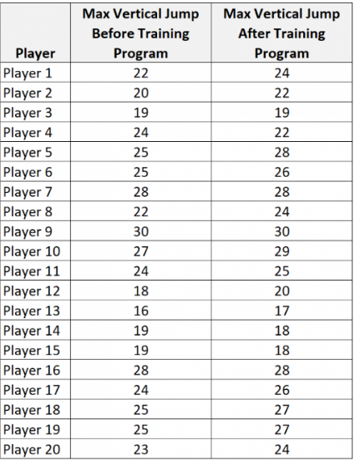

**Name:**

**Reg.No: U05DP21S0**

**Date:**

**/*************************************************************/**

data<-data.frame(

player=1:20,

before=c(22,20,19,24,25,25,28,22,30,27,24,18,16,19,19,28,24,25,25,23),

after=c(24,22,19,22,28,26,28,24,30,29,25,20,17,18,18,28,26,27,27,24))

result<-t.test(data$before,data$after,paired=TRUE)

cat("paired t_test result:\n")

cat("t-value:",result$statistic,"\n")

cat("p-value:",result$p.value,"\n")

cat("degrees of freedom:",result$parameter,"\n")

cat("confidence interval of the difference:",result$conf.int,"\n")

cat("effect size(cohen'sd):",(mean(data$before)-mean(data$after))/sd(data$before-data$after),"\n")

alpha<-0.05

if(result$p.value<alpha){

cat("the training program is statstically significant in improving max vertical jumps.\n")

}else{

cat("there is no significant improvemnet in max vertical jumps after the training program.\n")

}

**Output:**

> source("~/rp/partb7.r")

paired t_test result:

t-value: -3.226173

p-value: 0.004445371

degrees of freedom: 19

confidence interval of the difference: -1.566325 -0.3336745

effect size(cohen'sd): -0.7213943

the training program is statstically significant in improving max vertical jumps.

**/*****************************************************************/**

**Aim8: A company has three manufacturing plants, and company officials want to determine**

**whether there is difference in the average age of workers at the three locations. The following data are the ages of five randomly selected workers at each plant. Perform a one-way ANOVA to determine whether there is a significant difference in the mean ages of the workers at three plants. Use α=0.01. Write R script for the above problem.**

**Plant (Employee Ages)**

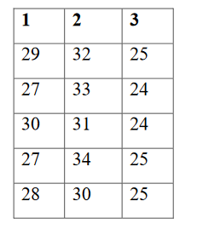

**Name:**

**Reg.No: U05DP21S0**

**Date:**

**/*************************************************************/**

plant1 <- c(29,27,30,27,28)

plant2 <- c(32,33,31,34,30)

plant3 <- c(25,24,24,25,25)

data1 <- data.frame(

Plant = factor(rep(1:3,each = 5)),

Age = c(plant1,plant2,plant3)

)

data1

result <- aov(Age~Plant,data = data1)

summary(result)

pvalue <- summary(result)[[1]][["Pr(>F)"]][1]

alpha <- 0.01

pvalue

if(pvalue<alpha){

cat("There is a sgnificant in the mean ages of workers at three plants (p-value = ",pvalue,")")

}else{

cat("There is no sgnificant in the mean ages of workers at three plants (p-value = ",pvalue,")")

}

**Output:**

data1

plant age

1 1 29

2 1 27

3 1 30

4 1 27

5 1 28

6 2 32

7 2 33

8 2 31

9 2 34

10 2 30

11 3 25

12 3 24

13 3 24

14 3 25

15 3 25

> result<-aov(age~plant,data=data1)

> summary(result)

Df Sum Sq Mean Sq F value Pr(>F)

plant 2 136.9 68.47 45.64 2.46e-06

Residuals 12 18.0 1.50

---

Signif. codes: 0 ‘***’ 0.001 ‘**’ 0.01 ‘*’ 0.05 ‘.’ 0.1 ‘ ’ 1

> pvalue<-summary(result)[[1]][["Pr(>F)"]][1]

> alpha<-0.01

> pvalue

[1] 2.459041e-06

> if(pvalue < alpha){

+ cat("There is a significant difference in the mean ages of workers atthree plants(p_value=",pvalue,")")

+ }else{

+ cat("There is no significant difference in the mean ages of workers atthree plants(p_value=",pvalue,")")

+ }

There is a significant difference in the mean ages of workers atthree plants(p_value= 2.459041e-06 )