University Management System

Analysis and Design Document

Student: Marius Pop

**Group: 30431**

Revision History

|  |  |  |  |
| --- | --- | --- | --- |
| **Date** | **Version** | **Description** | **Author** |
| 04/18/2018 | 1 | A web application designed to work like sinu.utcluj, where students are able to see their scholar situation and details | Marius Pop |
|  |  |  |  |
|  |  |  |  |
|  |  |  |  |

Table of Contents

I. Project Specification 4

II. Elaboration – Iteration 1.1 4

1. Domain Model 4

2. Architectural Design 4

2.1 Conceptual Architecture 4

2.2 Package Design 4

2.3 Component and Deployment Diagrams 4

III. Elaboration – Iteration 1.2 4

1. Design Model 4

1.1 Dynamic Behavior 4

1.2 Class Design 4

2. Data Model 4

3. Unit Testing 4

IV. Elaboration – Iteration 2 4

1. Architectural Design Refinement 4

2. Design Model Refinement 4

V. Construction and Transition 5

1. System Testing 5

2. Future improvements 5

VI. Bibliography 5

# Project Specification

*This web application is designed to work like the very well known website sinu.utcluj.ro belonging to the Technical University of Cluj-Napoca, where all the students that hold a record in the database, fact that suppose to be signed up for one of the faculties belonging to the Technical University of Cluj-Napoca, are able to see the detail and grades or announcements during the examination session and not only. In such a way a more optimal solution and a quicker access to the University platform is done. This results in an optimal interaction between the both sides representing an step in the future for being an alternative to the old papers with grades or announcements (papers) that are posted in front of the University panel.*

# Elaboration – Iteration 1.1

# Domain Model

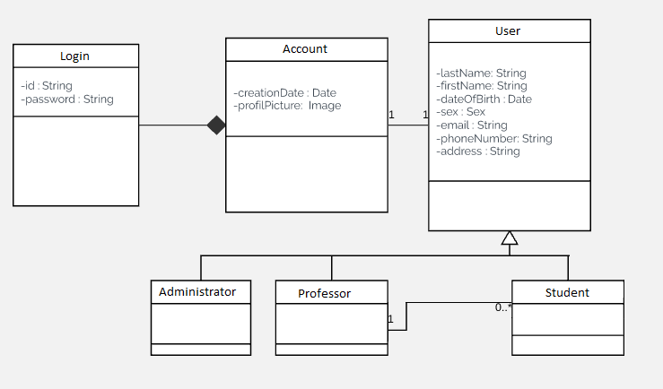

# Architectural Design

## Conceptual Architecture

*The architectural design pattern used was Layers Design Pattern. There are present 3 layers :*

*🡪Presentation Layer where the classes belonging to the Graphical User Interface are stored*

*🡪Business Layer where the date related to the services can be found.*

*🡪Data Access layer where the methods related to the database are located.*

## Package Design

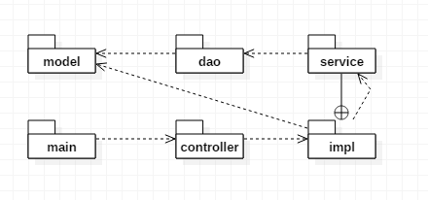

## Component and Deployment Diagrams

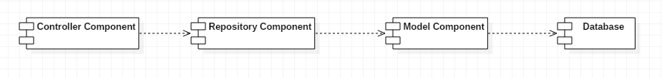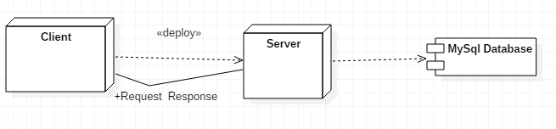

# Elaboration – Iteration 1.2

# Design Model

## Dynamic Behavior

*[Create the interaction diagrams (1 sequence, 1 communication diagrams) for 2 relevant scenarios]*

## Class Design

*[Create the UML class diagram; apply GoF patterns and motivate your choice]*

# Data Model

*[Create the data model for the system.]*

# Unit Testing

*[Present the used testing methods and the associated test case scenarios.]*

# Elaboration – Iteration 2

# Architectural Design Refinement

*[Refine the architectural design: conceptual architecture, package design (consider package design principles), component and deployment diagrams. Motivate the changes that have been made.]*

# Design Model Refinement

## *[Refine the UML class diagram by applying class design principles and GRASP; motivate your choices. Deliver the updated class diagrams.]*

# Construction and Transition

# System Testing

*[Describe how you applied integration testing and present the associated test case scenarios.]*

# Future improvements

*[Present future improvements for the system]*

# Bibliography