**Learning Unix: Day 2 Quiz**

1. What is the command you would use to get this display:

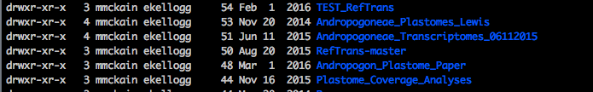

1. I am currently editing a file in the vi editor. What four keystrokes do I use to save and exit the file?
2. How can I use the “cat” command to number the lines of a file I am creating?
3. What is the name of the Apollo node from where you submit condor jobs?
4. Name a pro and con of using a command-line interface (CLI) over a graphical-user interface (GUI).