Name:______________________

**Exam III**

Identify the numbered specimens to family. (20 pts.)

|  |  |
| --- | --- |
| 1.) | 11.) |
| 2.) | 12.) |
| 3.) | 13.) |
| 4.) | 14.) |
| 5.) | 15.) |
| 6.) | 16.) |
| 7.) | 17.) |
| 8.) | 18.) |
| 9.) | 19.) |
| 10.) | 20.) |

21.) (2 pts.)

The cyathium is also called a *pseudanthium*, meaning “false flower”. **Using the specimen provided**, equate the parts of the cyathium to analogous parts of a true flower.

22.) (1.5 pts.)

Label the marked structures on this Poaceae species.

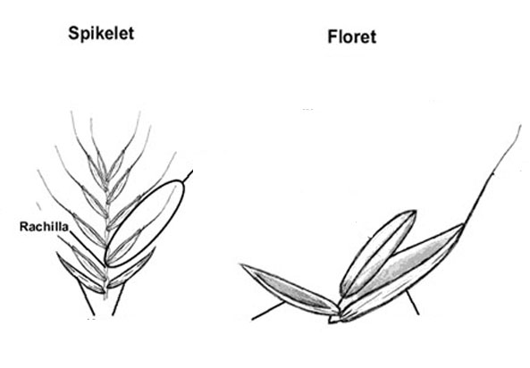

23.) (4 pts.)

We covered 4 families with opposite phyllotaxy. Name them and give at least one morphological character you could use to distinguish between them.

Family:

Character:

Family:

Character:

Family:

Character:

Family:

Character:

24.) (1.5 pts.)

The Fabaceae (subfamily Faboideae) commonly have monodelphous or diadelphous stamens. The Brassicaceae commonly have tetradynamous stamens. Define monadelphous, diadelphous and tetradynamous.

25.) (1 pt.)

Both *Ranunculus abortivus* (Ranunculaceae) and *Potentilla indica* (Rosaceae: subfamily Rosoideae, *Deuchesnia indica*) are apocarpous with 5 sepals, 5 petals and numerous whorled stamens. What other floral character could you use to separate these two species into their respective families?

26.) (1 pt.)

Why are *Nepenthes* and *Sarracenia* an example of convergent evolution (homoplasy)?

27.) (1 pt.)

What is your favorite angiosperm family and why?