Angiosperm Morphology Exam (35 pts)
PBIO4650/6650 Plant Taxonomy, Spring 2011

Part I. Stations (2min each)
1. (2 pts)
a. What is the shape of this leaf?

b. Describe the leaf base.

2. (2 pts)
a. What is the ovary position of this flower model?

b. Describe the completeness of this flower (i.e. is it perfect or imperfect; complete or incomplete?).

3. Name the inflorescence type of this plant. (1 pt)

4. Describe the apex, shape, margin, leaf base and texture. (1 pt)

5. Label the 2 parts of this reproductive structure (1pt).

a.________________________

b.________________________

6. Describe the placentation. (1 pt)

7. What is the leaf arrangement of this plant? (1 pt)

8. Define the term epipetalous stamen. (1 pt)

9. Label the following pinned structures (2 pts).

a._____________________

b._____________________

10. Draw a floral formula for a flower with the following features (4 pts):
a. 5 connate sepals
b. 5 free petals adnate to calyx
c. 10 stamens
d. 2 fused carpels
e. superior ovary
g. actinomorphic

11. (2 pts)
a. Name the fruit type.

b. What is the edible portion of this fruit?

12. Name the inflorescence type of this plant. (1 pt)

13. (2 pts)
a. Describe the leaf margin.

b. Describe the leaf apex.

14. Write a couplet that could be used to differentiate these 2 species in a key. (1 pt)

15. Describe the floral symmetry. (1 pt)

16. Describe the gynoecium. (Hint: Be specific.) (1 pt)

17. Name the inflorescence type of this plant. (1 pt)

18. (2 pts)
a. Name the fruit type.

b. From what part of the plant does the pinned structure develop?

19. Draw a simple, petiolate leaf with palmate venation, acuminate apex, an oblique base and dentate margins. (1 pt)

Part II. (15 mins)

1. Draw the floral formula for the following flower. (1pt)

2. Define: fruit. (1 pt)

3. What is wrong with this key? (1 pt)
1. Leaves simple
2. Inflorescence a panicle……….species D
2. Inflorescence a spike
3. Apex acuminate………species C
3. Margin serrate………...species E
1. Leaves compound
4. Leaves pinnately compound….species B
4. Leaves palmately compound…species A

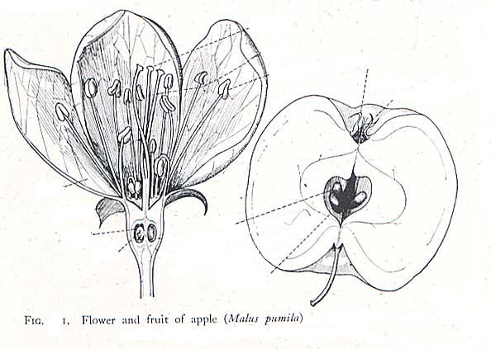
4. Label the following structures onto proper parts of the flower and the fruit on the right. (4 pts)

A. Stamen
B. Sepal
C. Ovary
D. Endocarp
E. Ovule
F. Seed

Extra Credit. Give the flora formula. (5 pts.)

