**External CSS**

# **Ethical Dairy**

### Task 1

Add the link to the external CSS document to each of the three html files.

The head of your document should look something like the image below.

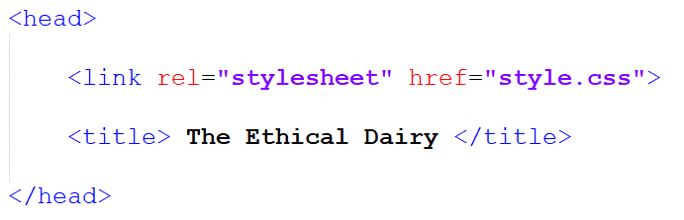

### Task 2

Using the completed designs on the following pages add the required DIV tags and Classes to **our_story.html** and **news.html**

### Task 3

Implement CSS in the external stylesheet, and the per the style guidance contained in the purple boxes on the following pages.

## Index.html

**All Pages**

Font

Verdana

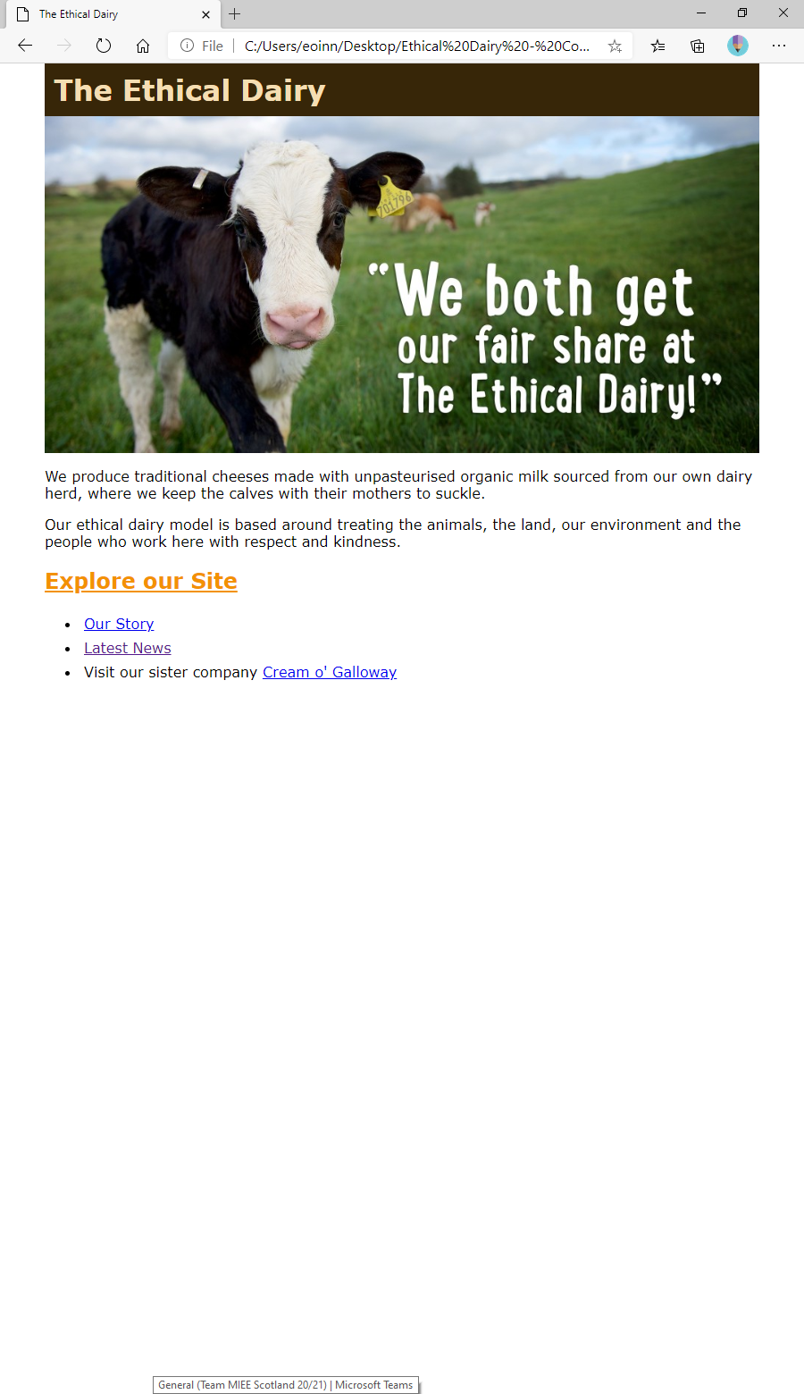

**Header Images**

*All Pages*

Width  
800px

## our_story.html

**H1**

Background  
rgb(55,38,8)

Colour

Wheat

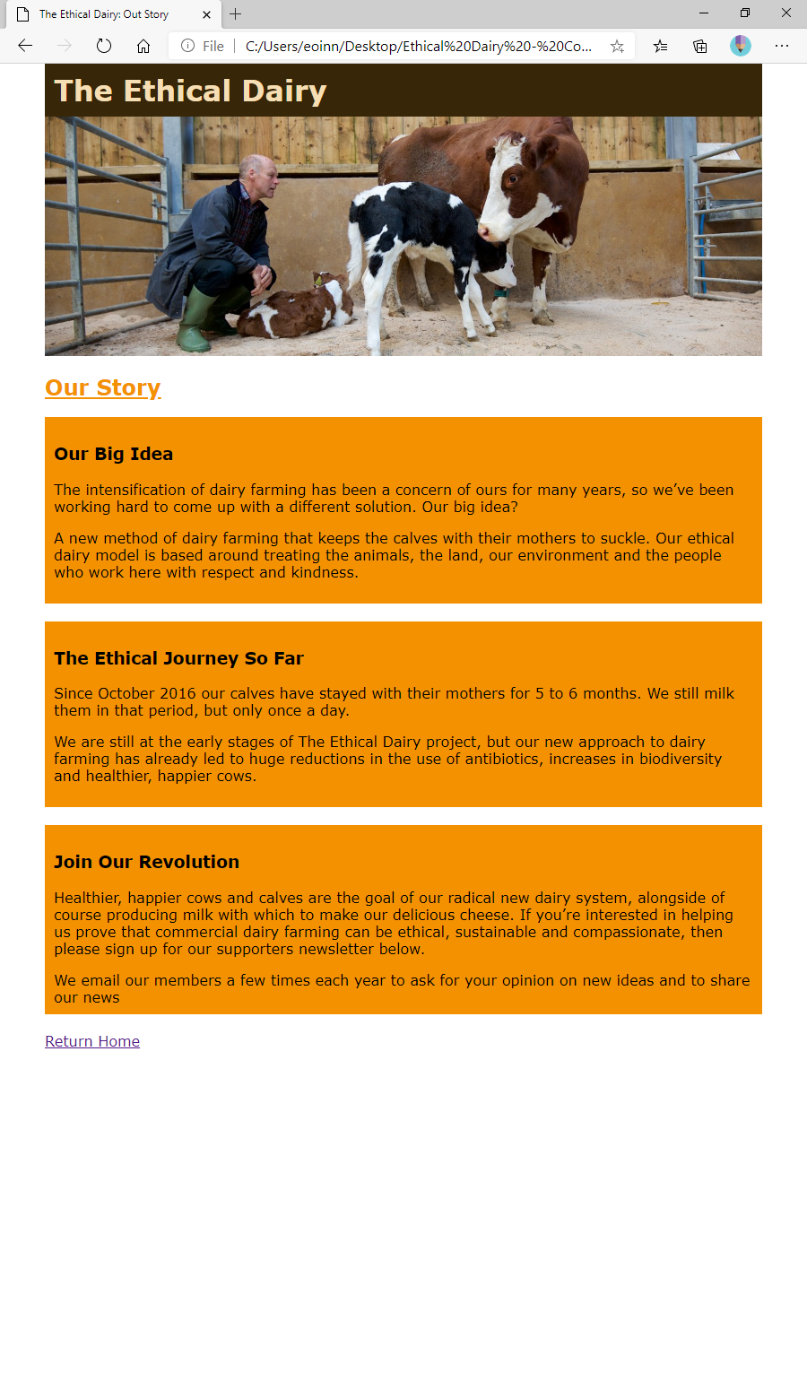

**H2**

Colour  
rgb (243,145,1)

Decoration

Underlined

## news.html

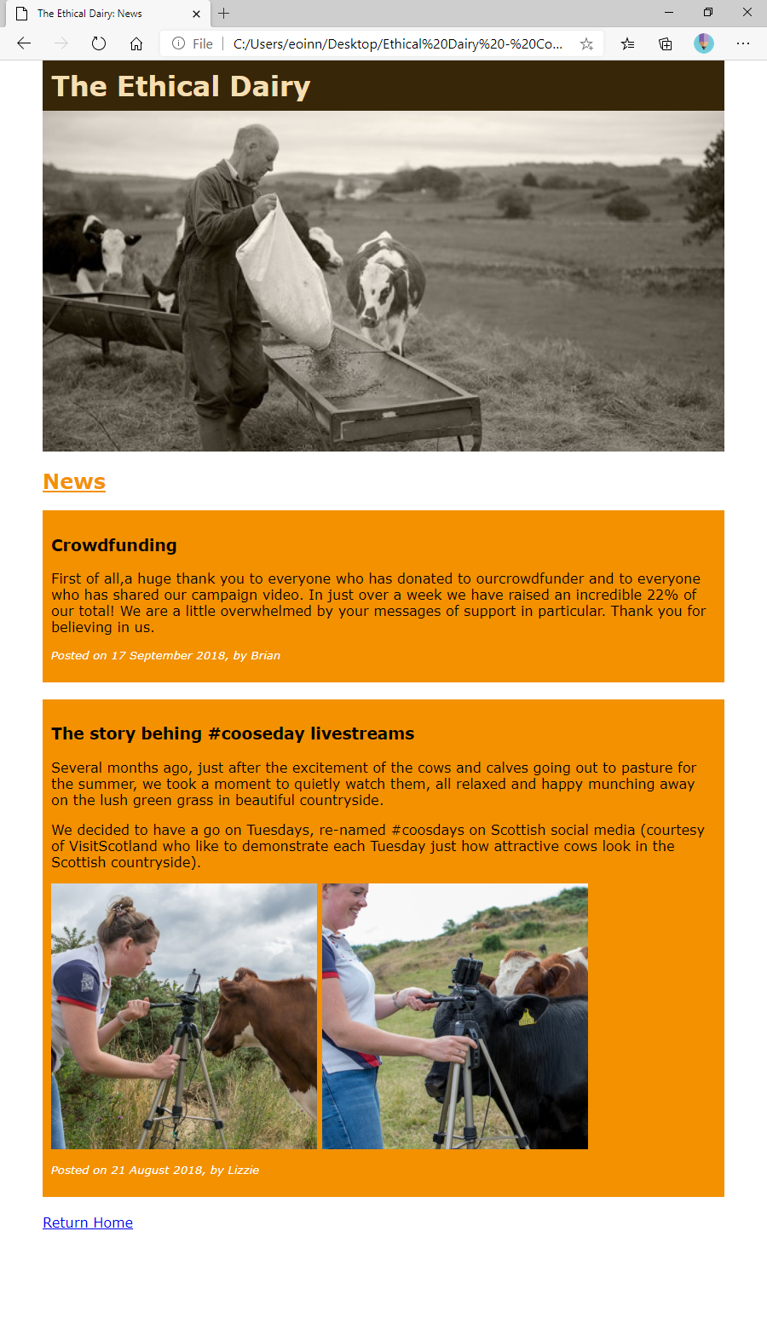

**News Images**

Width  
40%

**DIV**

Background  
rgb(243,145,1)

**Date**

Colour  
White

Style

Italic

Size

10pt