2 TASK
Exploratory Data Analysis and Visualization
Dataset: Titanic – Machine Learning from Disaster
Submitted by: MD FAIZAN KURAISHI
Internship/Organization: YuvaIntern
Course/Department: Virtual Data Science with Python Trainee
Submission Date: 18/10/2026

1. Abstract
This report presents an Exploratory Data Analysis (EDA) and visualization workflow performed on the publicly available Titanic dataset. Python, Pandas, Matplotlib, and Seaborn were used to inspect the dataset, calculate descriptive statistics, identify missing values, study passenger survival patterns, examine distributions and relationships, and create visualizations. The analysis uses 891 passenger records and 12 original columns. The results provide useful insights into survival by gender and passenger class, fare and age distributions, and relationships among numerical variables.

2. Introduction
Exploratory Data Analysis is an important stage of data analysis because it helps understand the structure, quality, distribution, relationships, and important patterns present in a dataset. Visualizations make these patterns easier to interpret and communicate.
For this task, the Titanic dataset was analyzed using Python. The analysis includes dataset inspection, descriptive statistics, missing-value checks, categorical comparisons, distribution plots, scatter analysis, correlation analysis, and grouped calculations.

3. Dataset Description and Acquisition
Dataset: Titanic – Machine Learning from Disaster
Source: Kaggle – Titanic: Machine Learning from Disaster
File analyzed: titanic_cleaned.csv
The Titanic dataset was used for the analysis because it contains passenger information and the Survived target variable, making it suitable for studying relationships between passenger characteristics and survival.

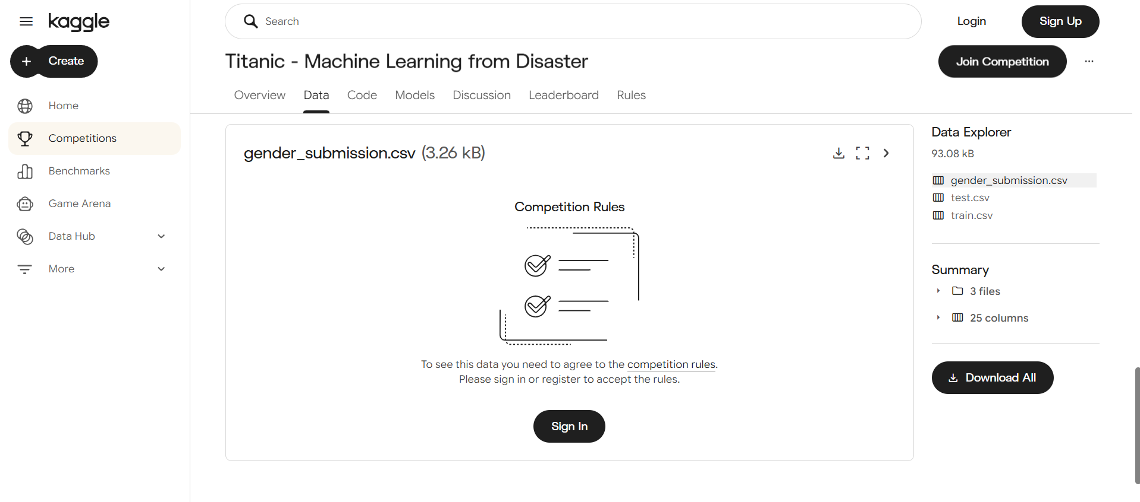
Optional screenshot: Kaggle Titanic dataset/download page

4. Tools and Libraries
Tool / Library | Purpose
Python | Programming language used for the analysis
Pandas | Loading, inspecting, grouping, and analyzing tabular data
Matplotlib | Creating and saving charts
Seaborn | Creating statistical visualizations
VS Code | Development environment used to run the Python script

5. Project Structure
The project contains the dataset, Python analysis script, generated visualizations, requirements file, and this report.
EDA_Visualization/
├── data/
│ └── titanic_cleaned.csv
├── visualizations/
├── eda_analysis.py
├── requirements.txt
└── Week2_EDA_Report.docx

6. Dataset Loading
The dataset was loaded using Pandas read_csv():
df = pd.read_csv("data/titanic_cleaned.csv")
The first five records were displayed using df.head() to confirm that the dataset was loaded successfully.

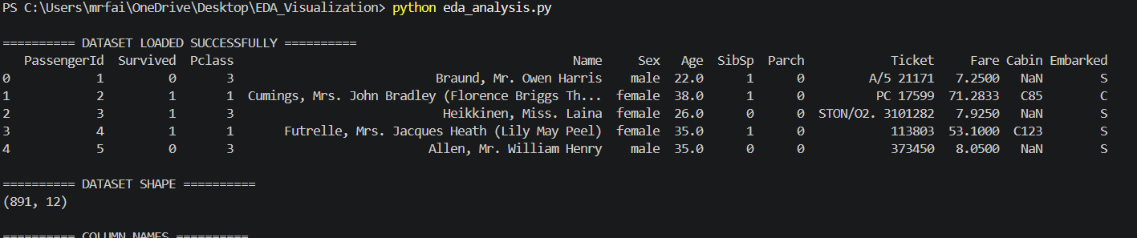
Screenshot 1: Terminal showing 'DATASET LOADED SUCCESSFULLY' and df.head() output

7. Initial Dataset Exploration
The dataset contained 891 rows and 12 columns. The analysis displayed the column names, data types, non-null counts, and descriptive statistics.
Metric | Result
Rows | 891
Columns | 12
Age missing values | 177
Cabin missing values | 687
Embarked missing values | 2
Duplicate rows | 0

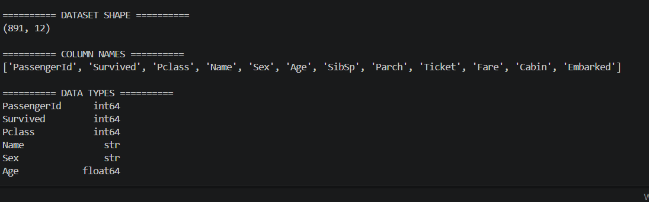
Screenshot 2: Terminal showing df.shape, column names, df.info(), and/or df.describe()

8. Statistical Summary
The descriptive statistics showed that the average passenger age was approximately 29.70 years, the average fare was approximately 32.20, and the average Survived value was 0.384. The maximum recorded age was 80 years and the maximum fare was 512.3292.
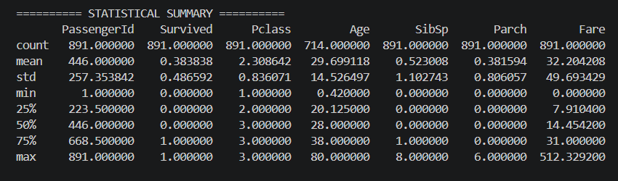
Screenshot 3: Terminal showing the STATISTICAL SUMMARY output

9. Missing Value Analysis
The missing-value check found 177 missing Age values, 687 missing Cabin values, and 2 missing Embarked values. These values are important to identify because missing data can affect statistical analysis and interpretation.
Column | Missing Values | Percentage
Age | 177 | 19.87%
Cabin | 687 | 77.10%
Embarked | 2 | 0.22%
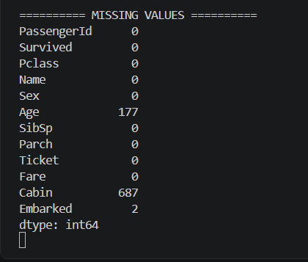
Screenshot 4: Terminal showing the MISSING VALUES output

10. Survival Count Analysis
The survival count chart compares passengers who did not survive with passengers who survived. The chart provides an overall view of the target variable before studying survival by other features.
[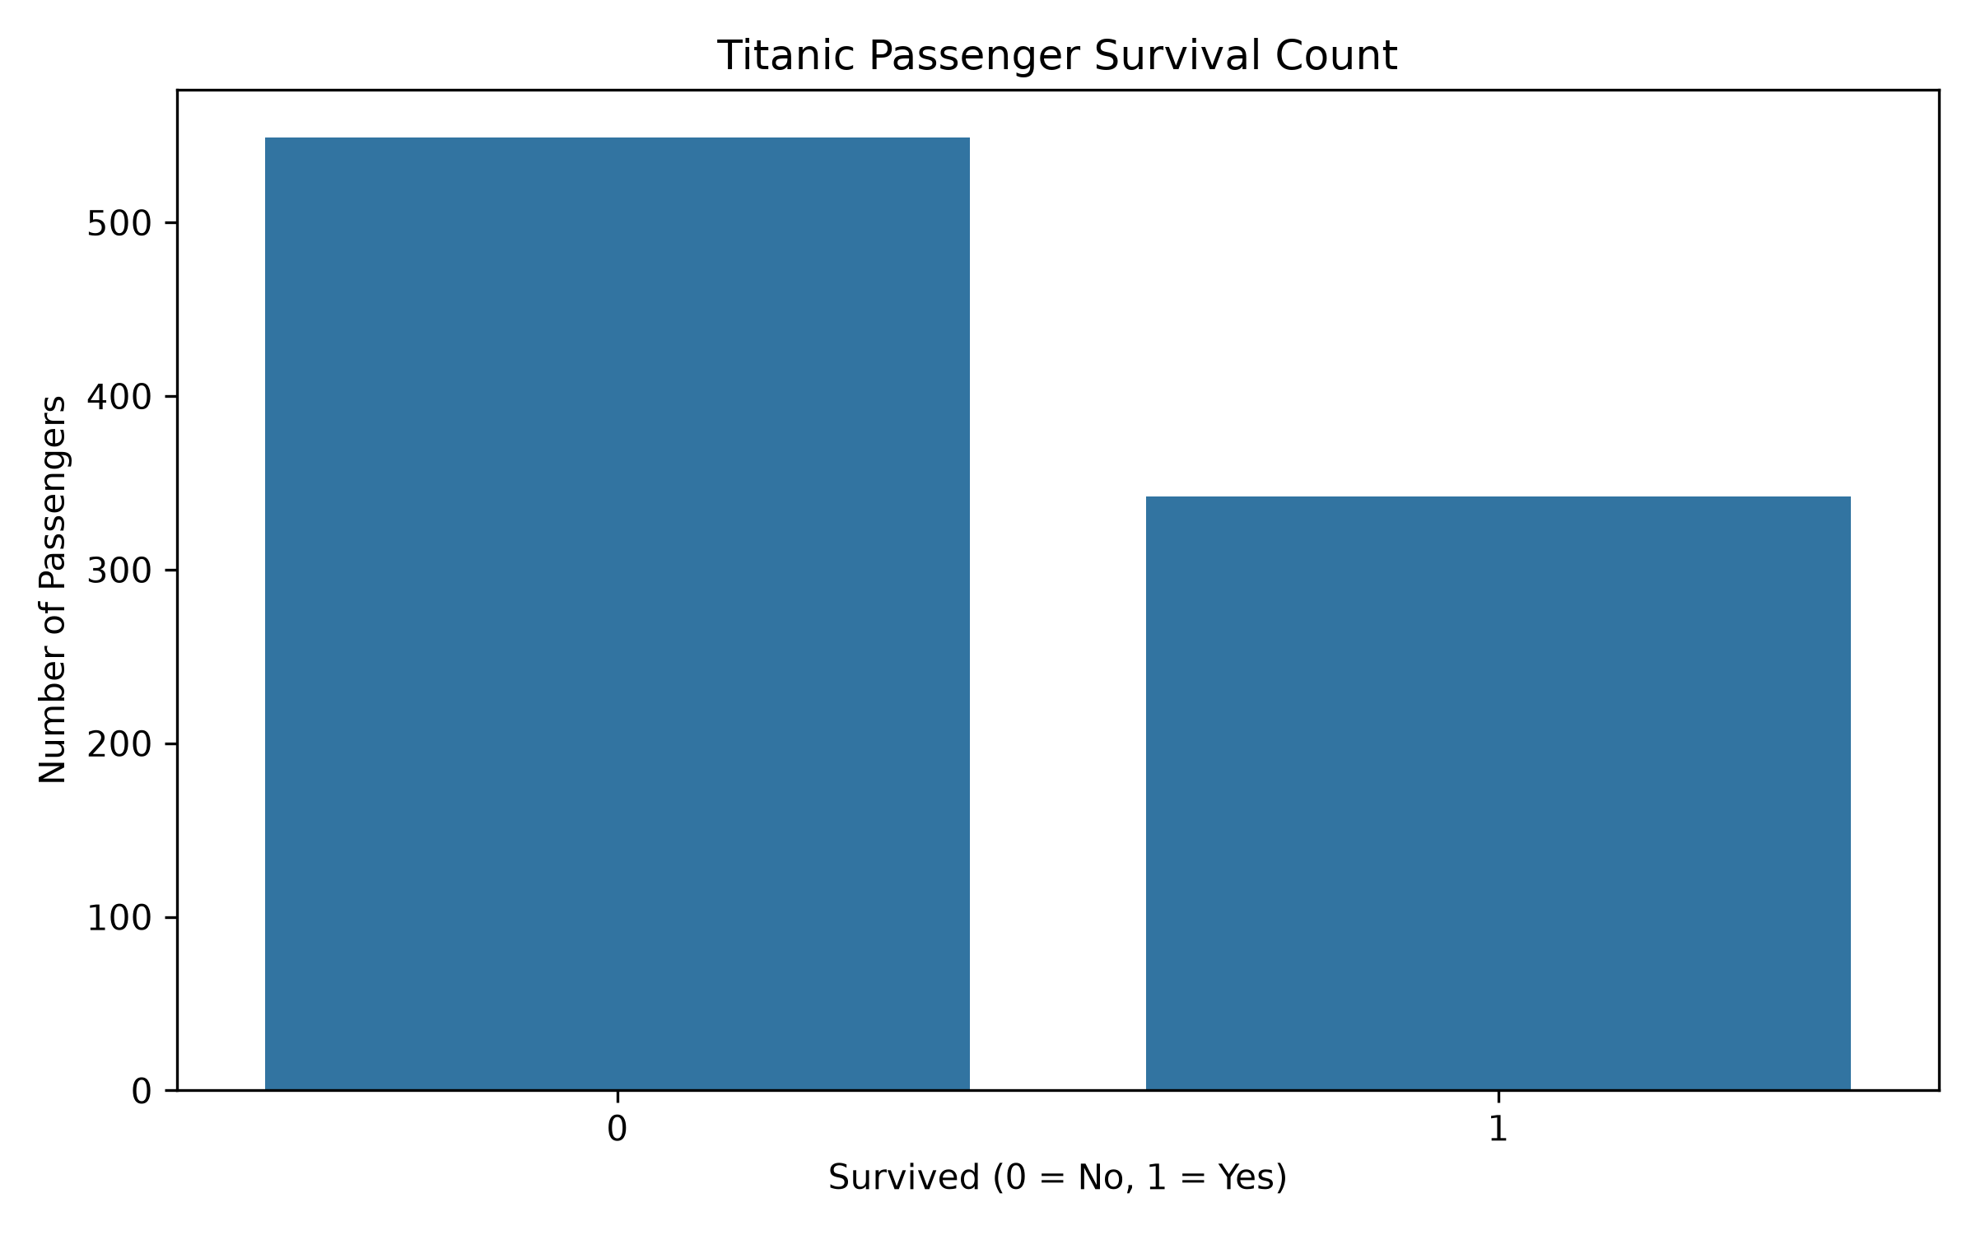]
Screenshot 5: survival_count.png
Interpretation: The chart shows that the number of passengers who did not survive was higher than the number who survived.

11. Survival by Gender
Gender was compared with survival using a count plot. The analysis also calculated survival rates for each gender.
Gender | Survival Rate
Female | 74.20%
Male | 18.89%
[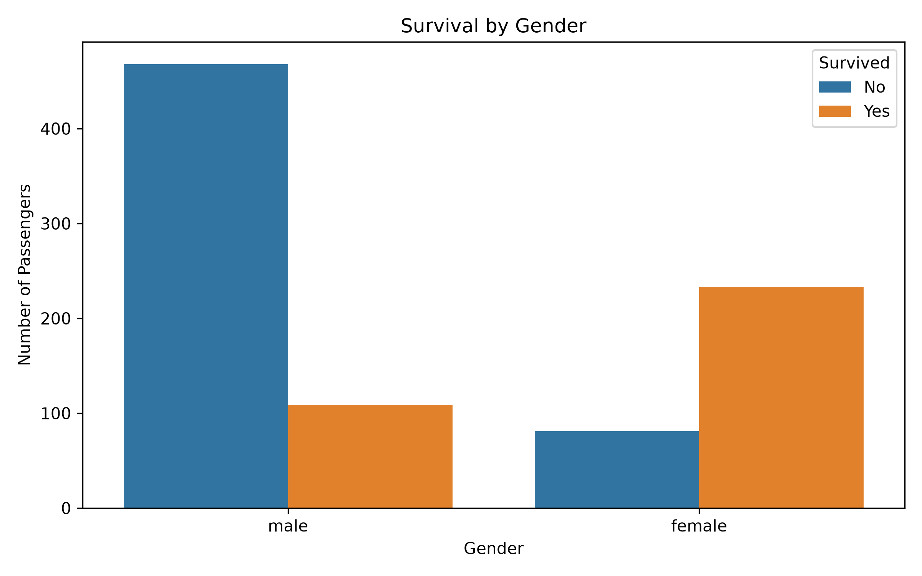]
Screenshot 6: survival_gender.png
Interpretation: Female passengers had a substantially higher survival rate than male passengers in this dataset. This indicates a strong association between gender and survival.

12. Survival by Passenger Class
Passenger class was analyzed to understand whether survival differed among first-, second-, and third-class passengers.
Passenger Class | Survival Rate
1st Class | 62.96%
2nd Class | 47.28%
3rd Class | 24.24%
[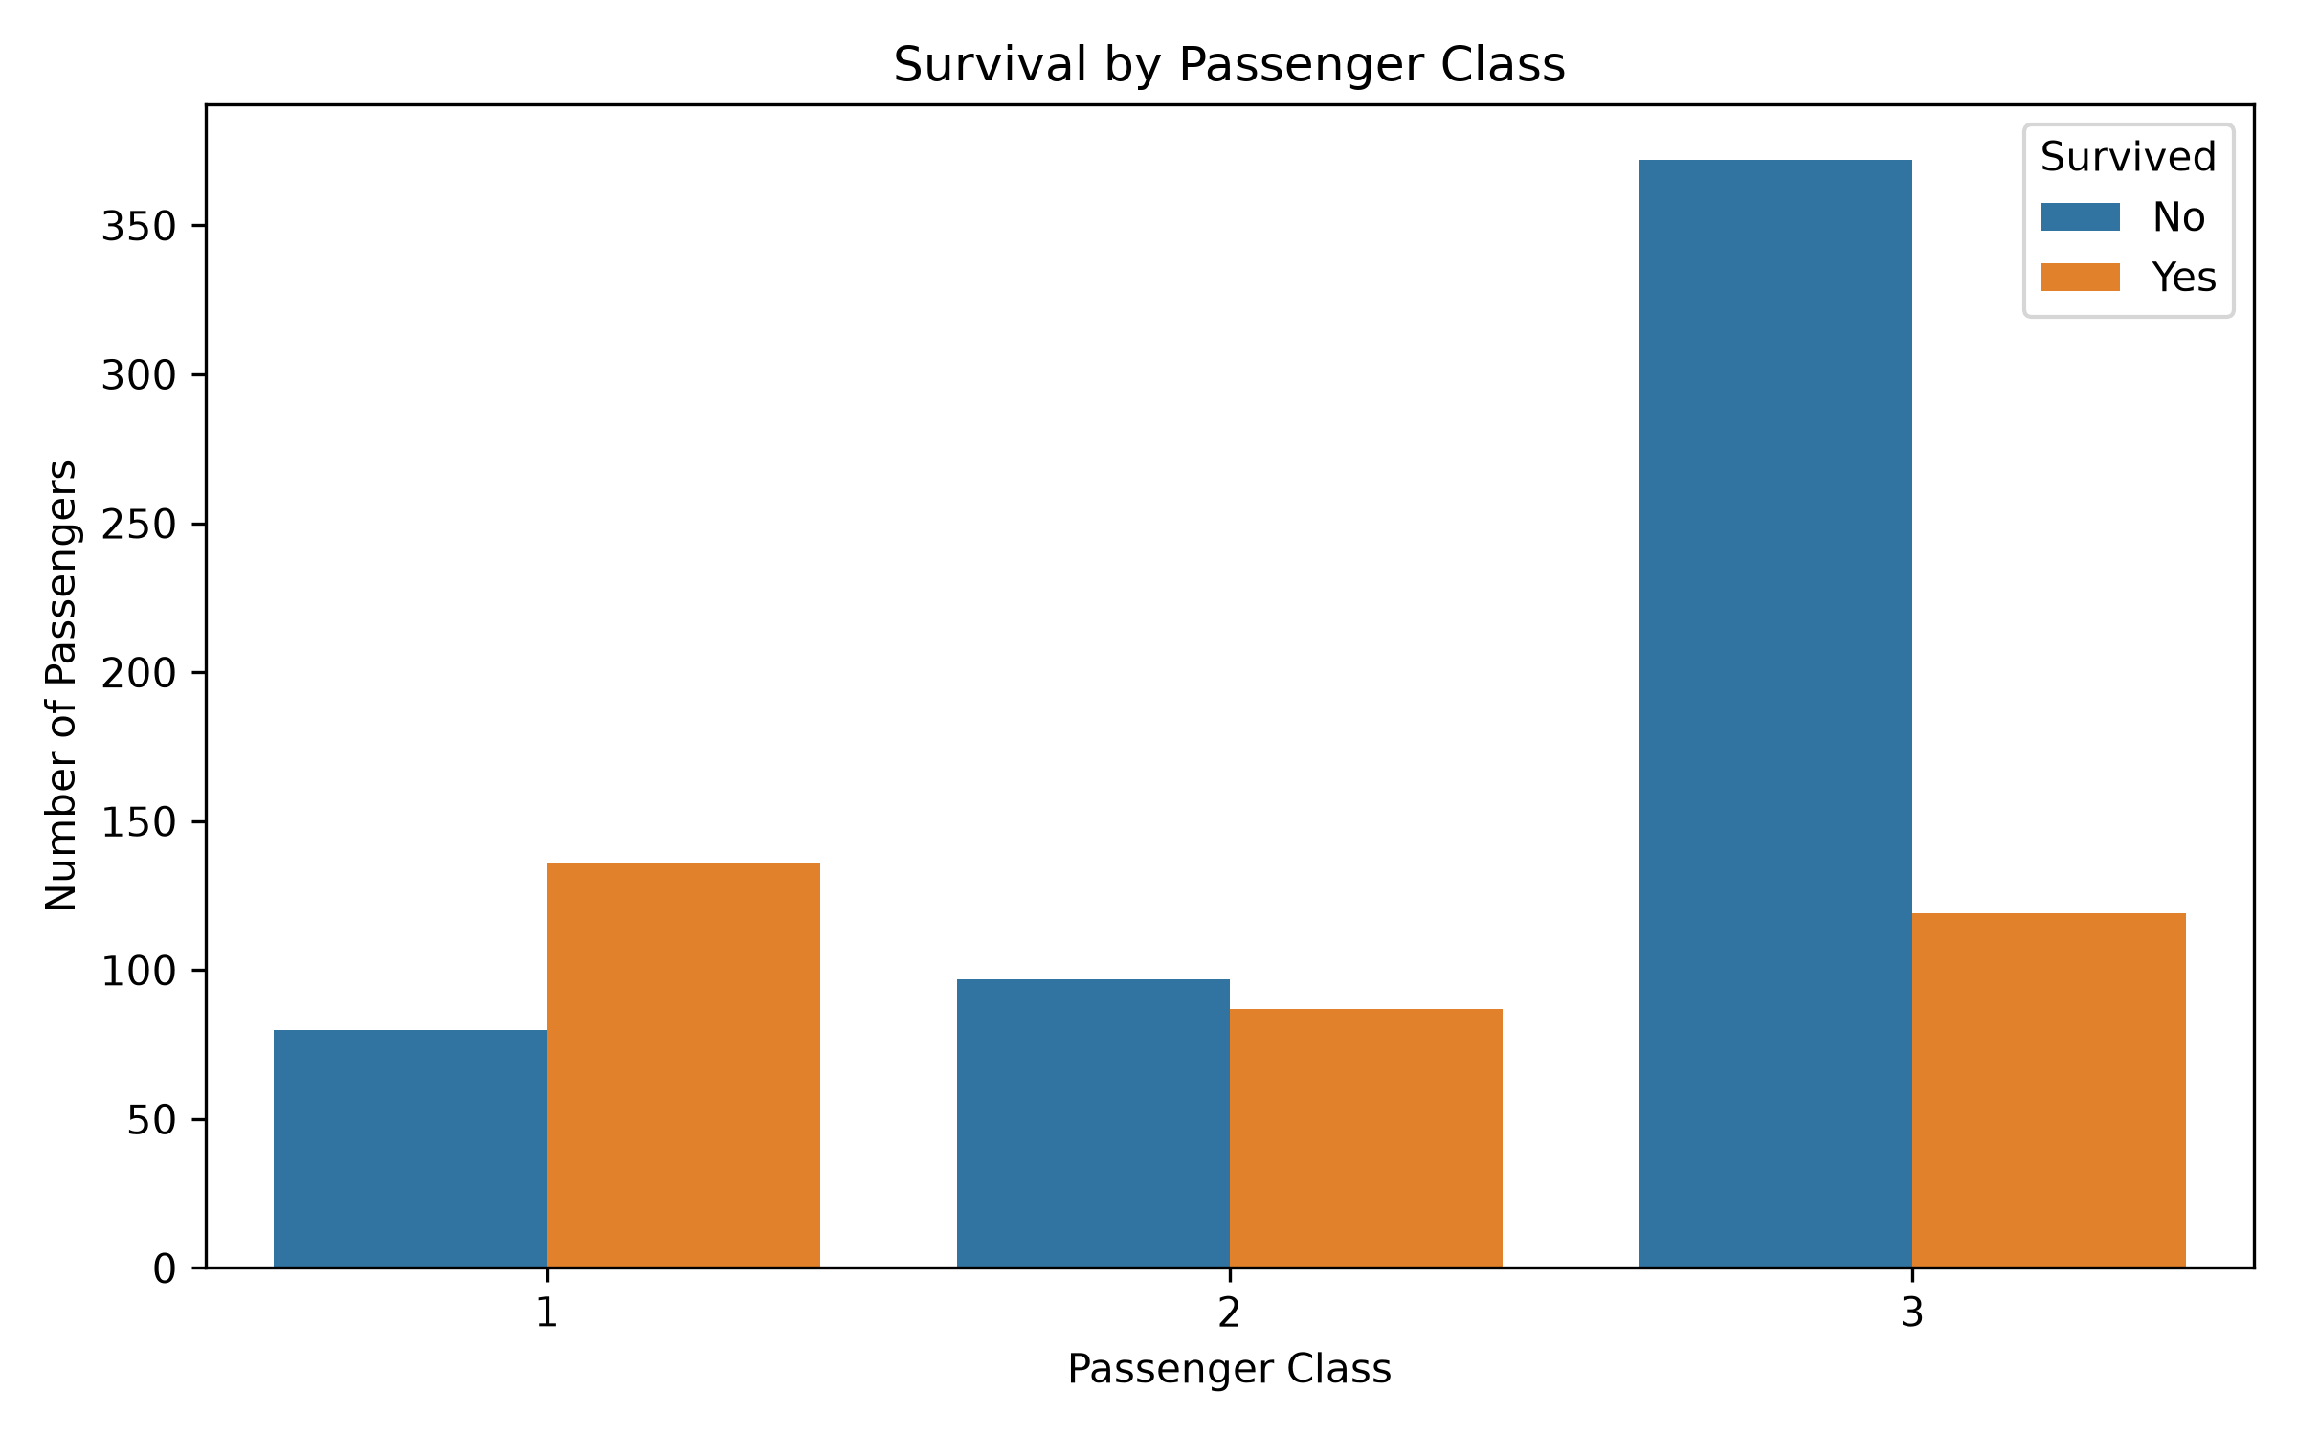]
Screenshot 7: survival_class.png
Interpretation: Survival rate decreased from first class to third class. First-class passengers had the highest survival rate, while third-class passengers had the lowest.

13. Age Distribution
A histogram with a KDE curve was used to examine the distribution of passenger ages. The analysis showed an average age of approximately 29.70 years among the available Age values.
[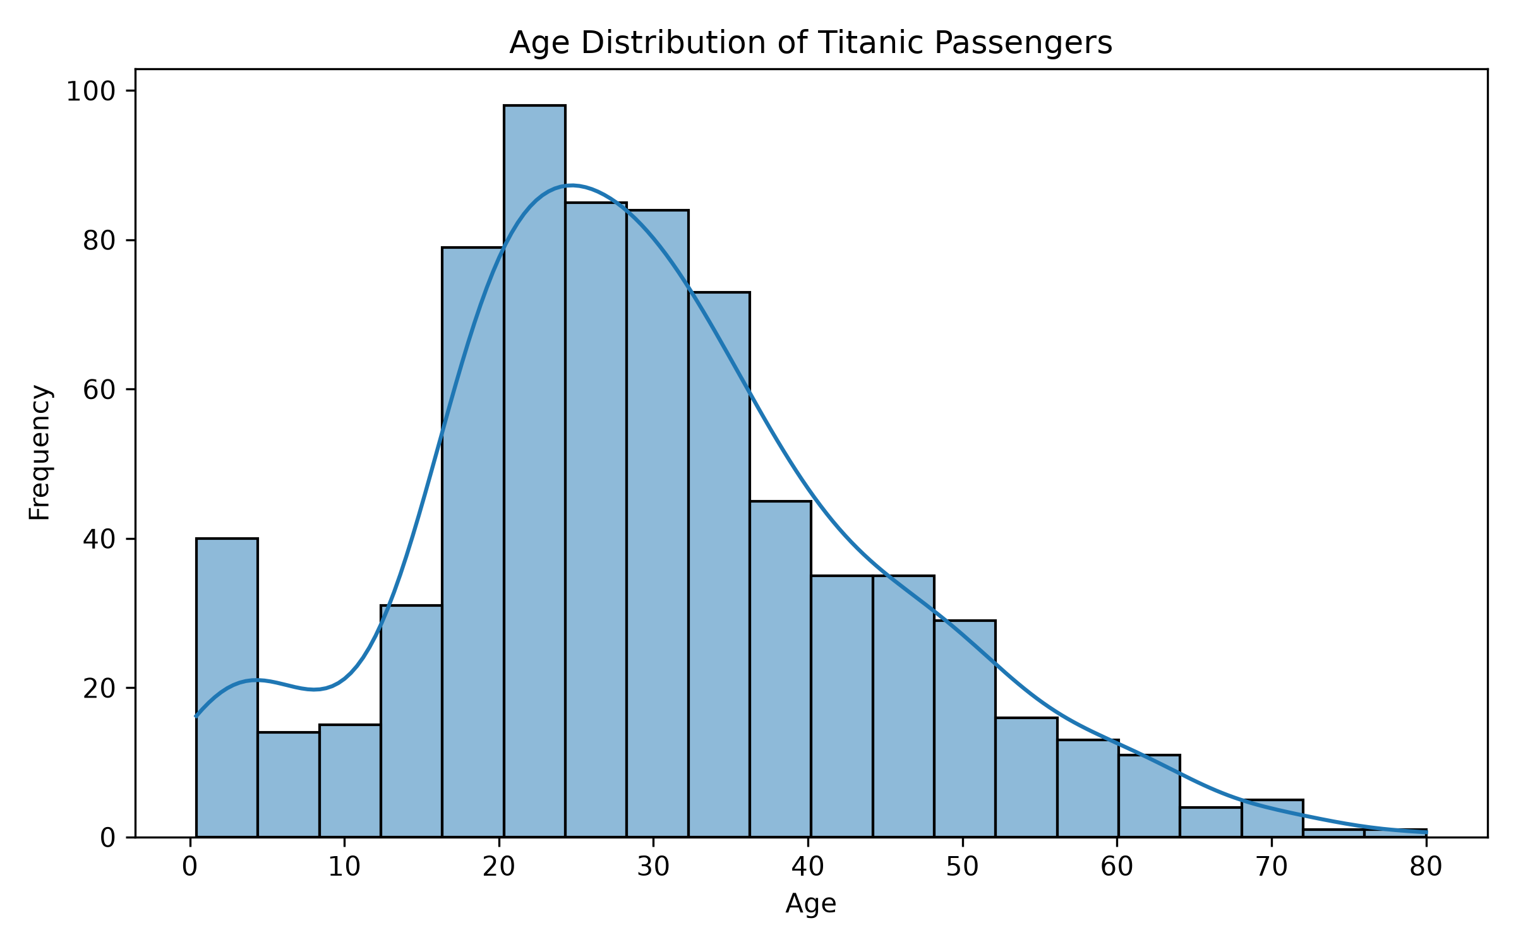]
Screenshot 8: age_distribution.png
Interpretation: Most passengers were concentrated in the young-adult and middle-age ranges, while fewer passengers were present at very young and very old ages.

14. Fare Distribution
The fare distribution was visualized using a histogram with KDE. The average fare was approximately 32.20 and the maximum recorded fare was 512.3292.
[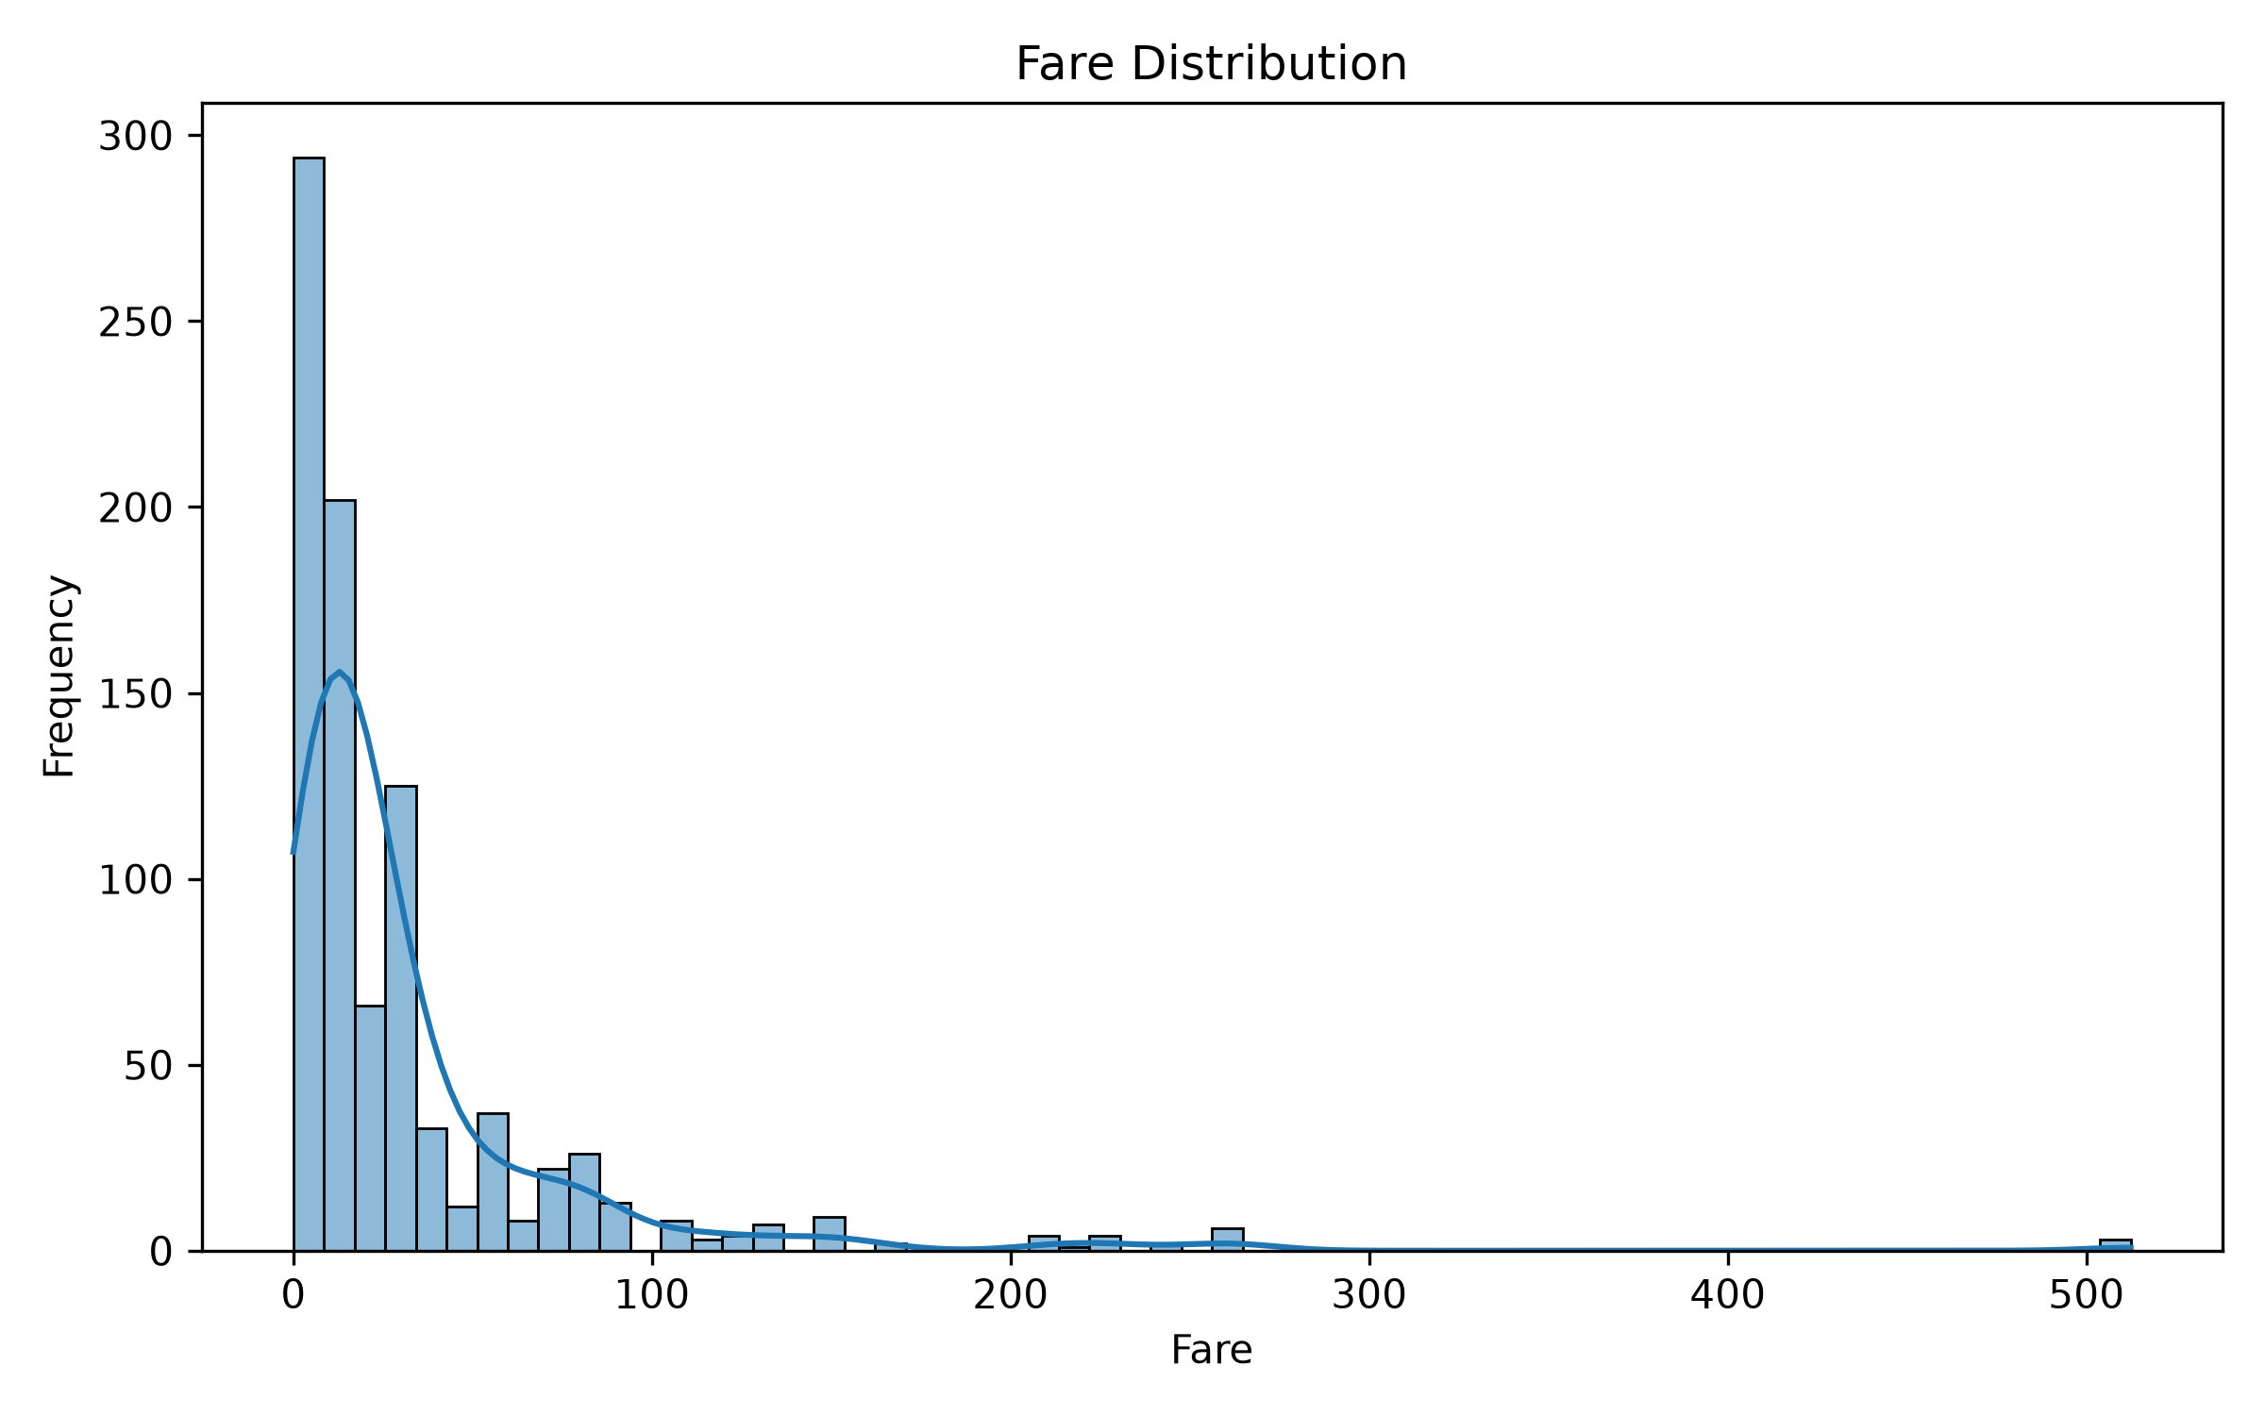]
Screenshot 9: fare_distribution.png
Interpretation: Fare values are strongly concentrated at lower amounts, with a smaller number of passengers paying substantially higher fares.

15. Relationship Between Age and Fare
A scatter plot was created to examine the relationship between Age and Fare, with survival used as a grouping variable.
[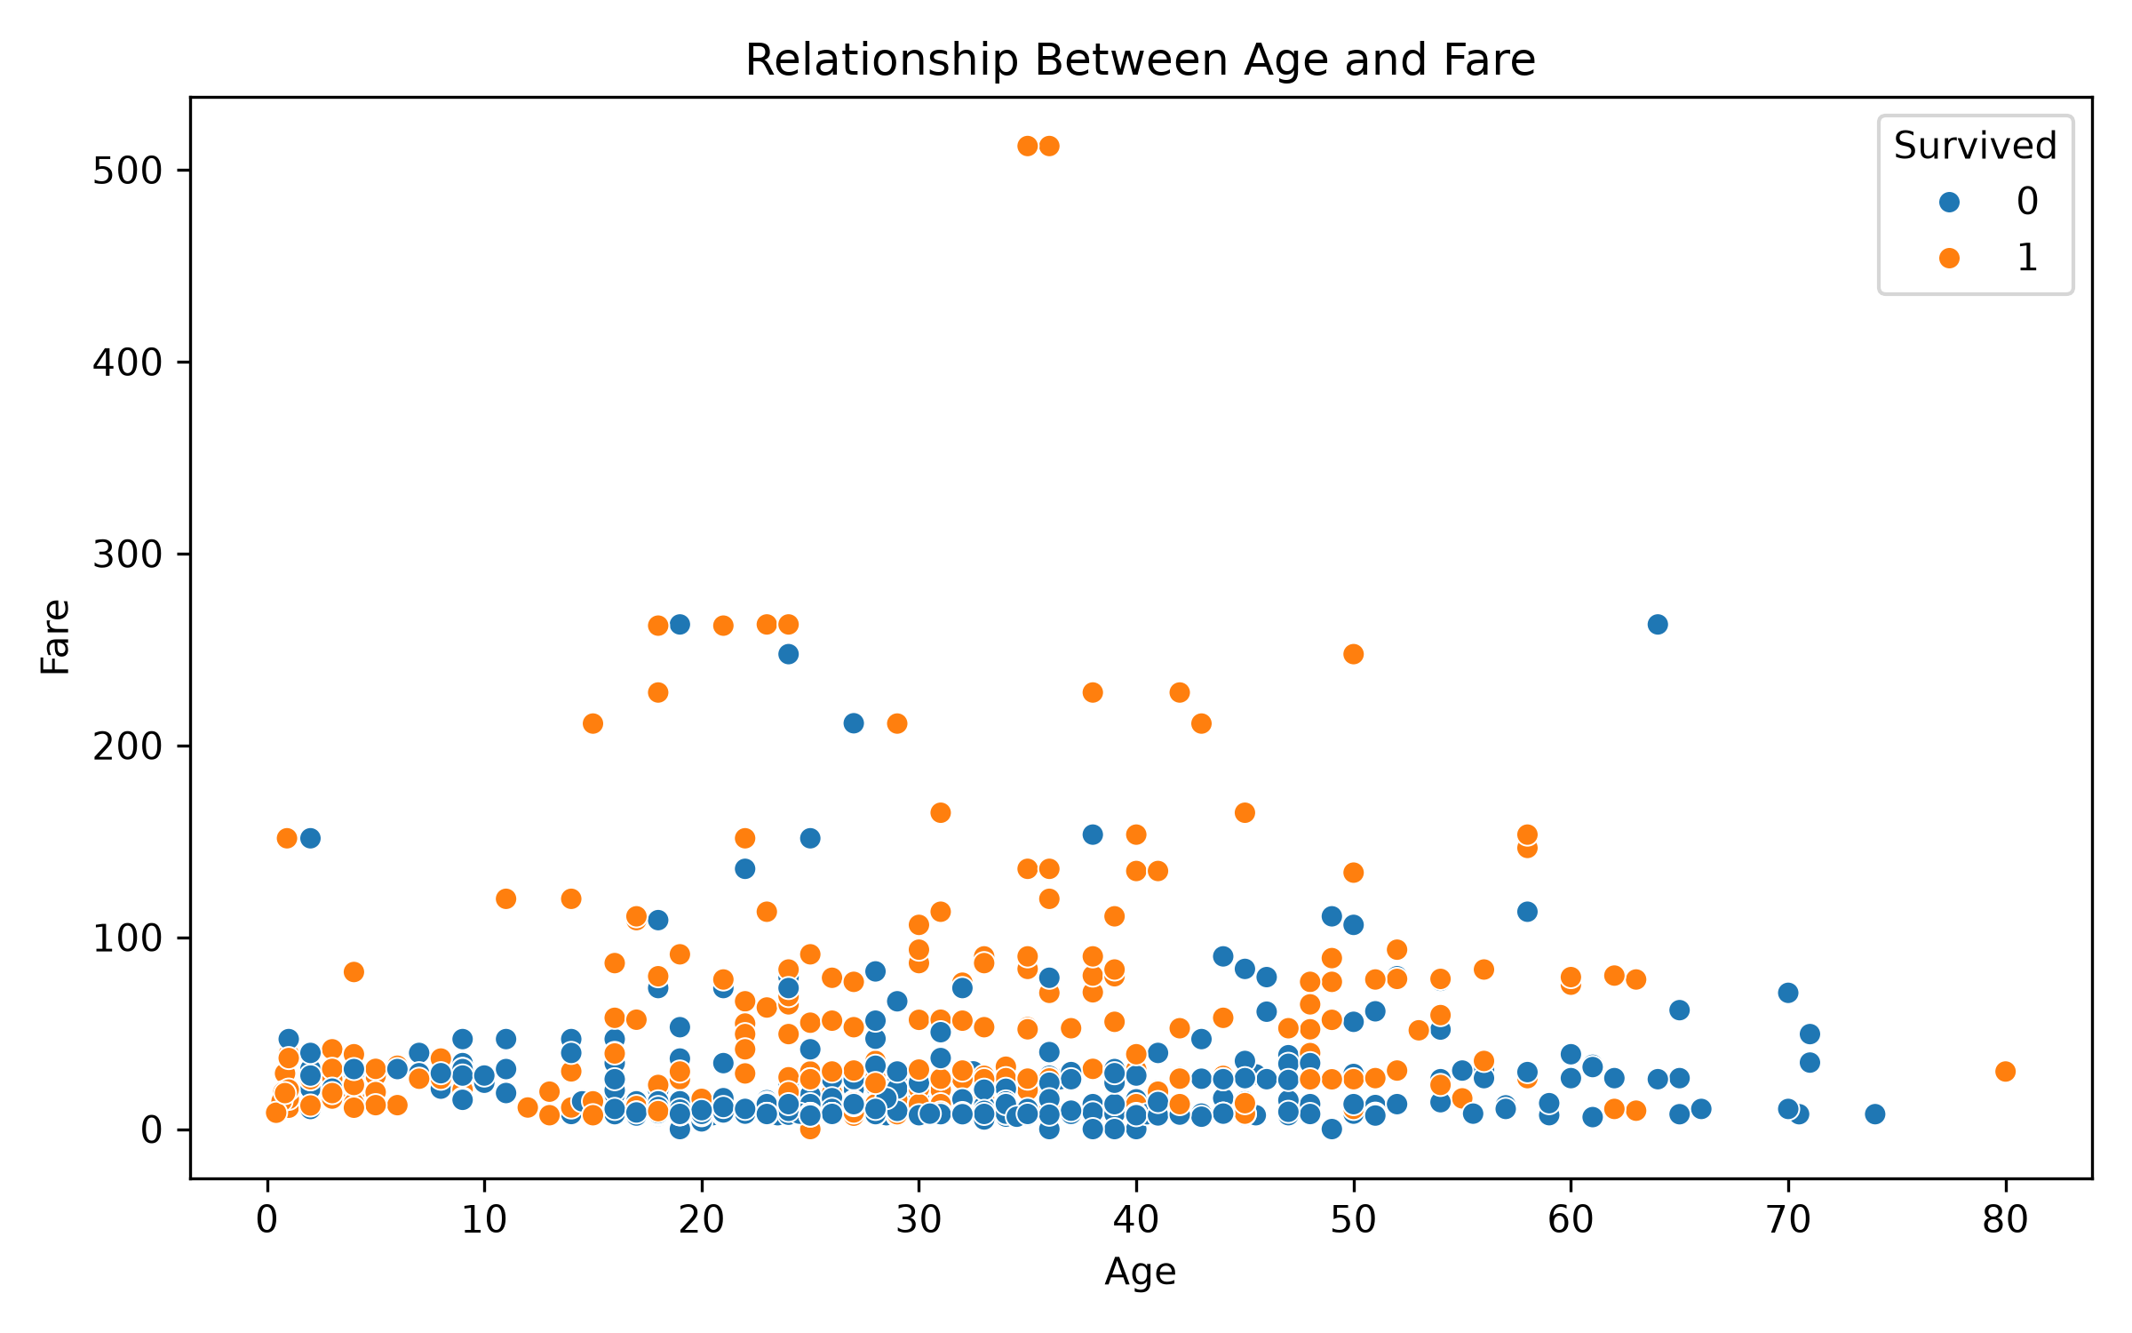]
Screenshot 10: age_fare_scatter.png
Interpretation: The scatter plot shows how fare values vary across passenger ages and also allows survival groups to be visually compared.

16. Correlation Analysis
A correlation matrix was calculated for numerical variables. Correlation describes the direction and strength of linear association between two numerical variables; it does not by itself prove causation.
Variable Pair | Correlation
Survived – Pclass | -0.338
Survived – Fare | 0.257
Survived – Age | -0.077
SibSp – Parch | 0.415
Pclass – Fare | -0.550
[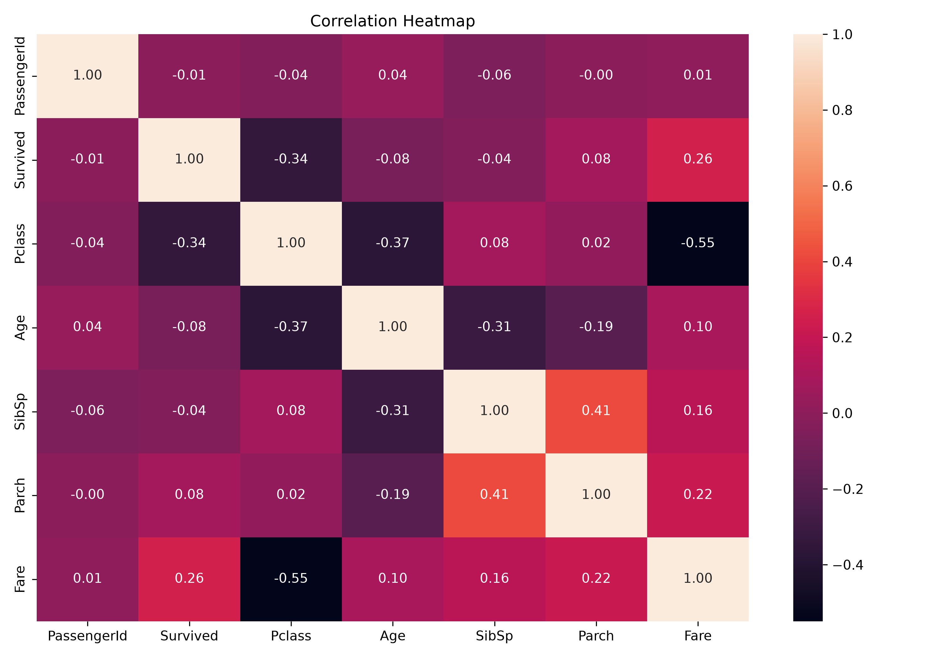]
Screenshot 11: correlation_heatmap.png
Interpretation: Survived has a negative correlation with Pclass because lower numerical class values represent higher passenger classes. Fare has a positive correlation with Survived. Pclass and Fare show a relatively strong negative correlation in this dataset.

17. Age Distribution by Passenger Class
A box plot was used to compare the age distribution across passenger classes. This visualization helps compare medians, spread, and potential extreme observations.
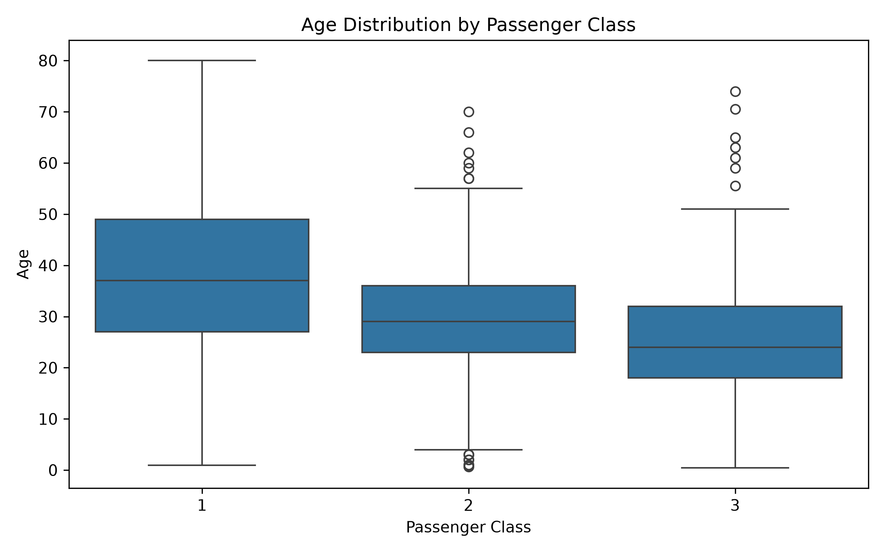
Screenshot 12: age_class_boxplot.png
Interpretation: The box plot allows the age distributions of the three passenger classes to be compared and highlights differences in spread and extreme values.

18. Average Fare by Passenger Class
Average fare was calculated using groupby() and plotted as a bar chart.
Passenger Class | Average Fare
1st Class | 84.154687
2nd Class | 20.662183
3rd Class | 13.675550
[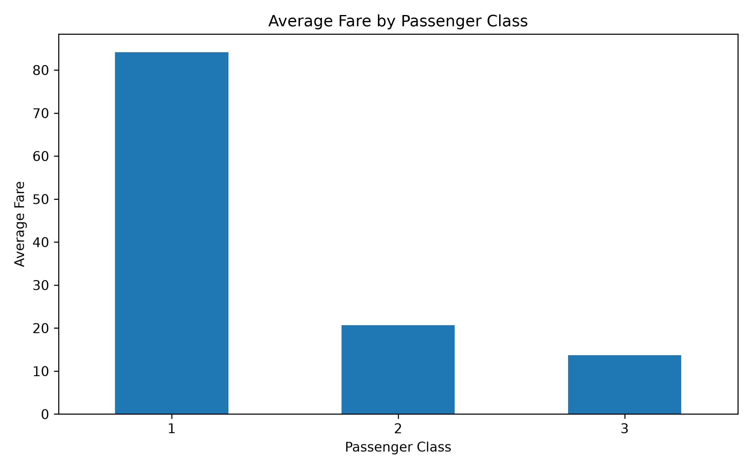
Screenshot 13: average_fare_class.png
Interpretation: First-class passengers paid a much higher average fare than second- and third-class passengers.

19. Survival Rate by Gender
Survival rate was calculated by grouping the data by Sex and taking the mean of the binary Survived variable, then multiplying by 100.
[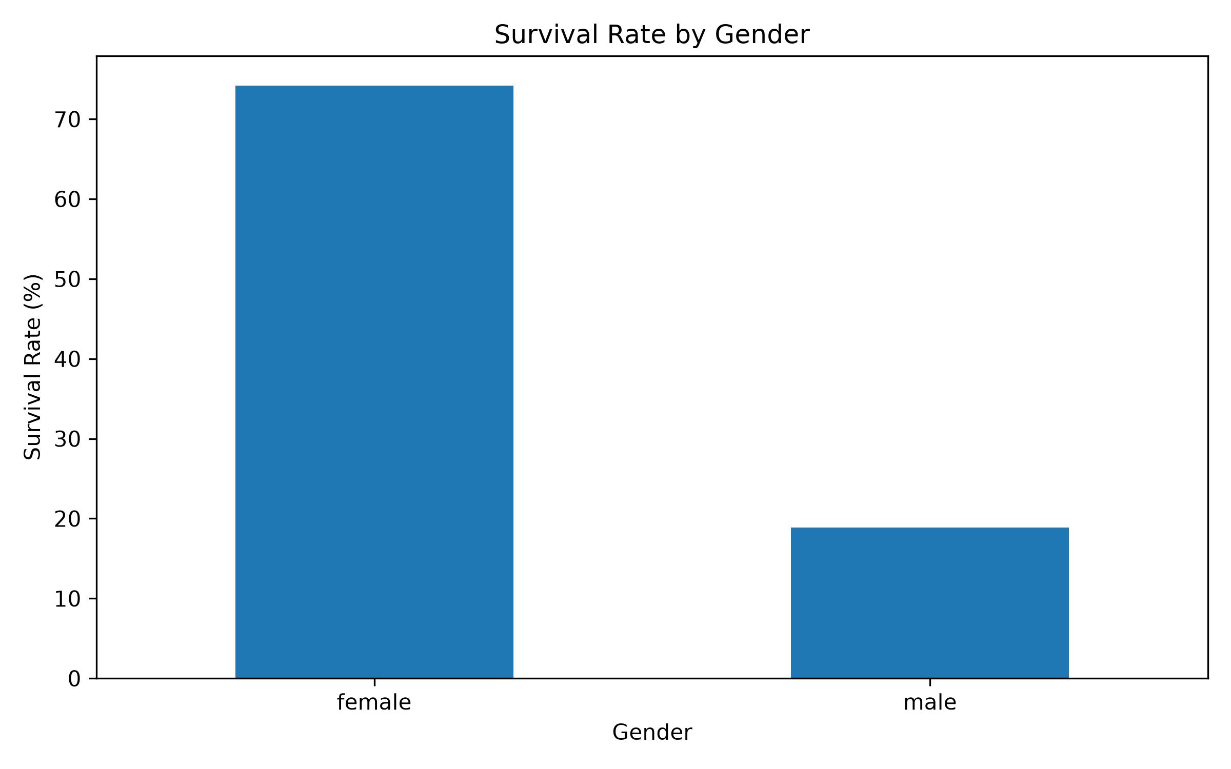
Screenshot 14: survival_rate_gender.png
Interpretation: The chart confirms the large difference in survival rate between female and male passengers.

20. Survival Rate by Passenger Class
Survival rate was also calculated for each passenger class.
[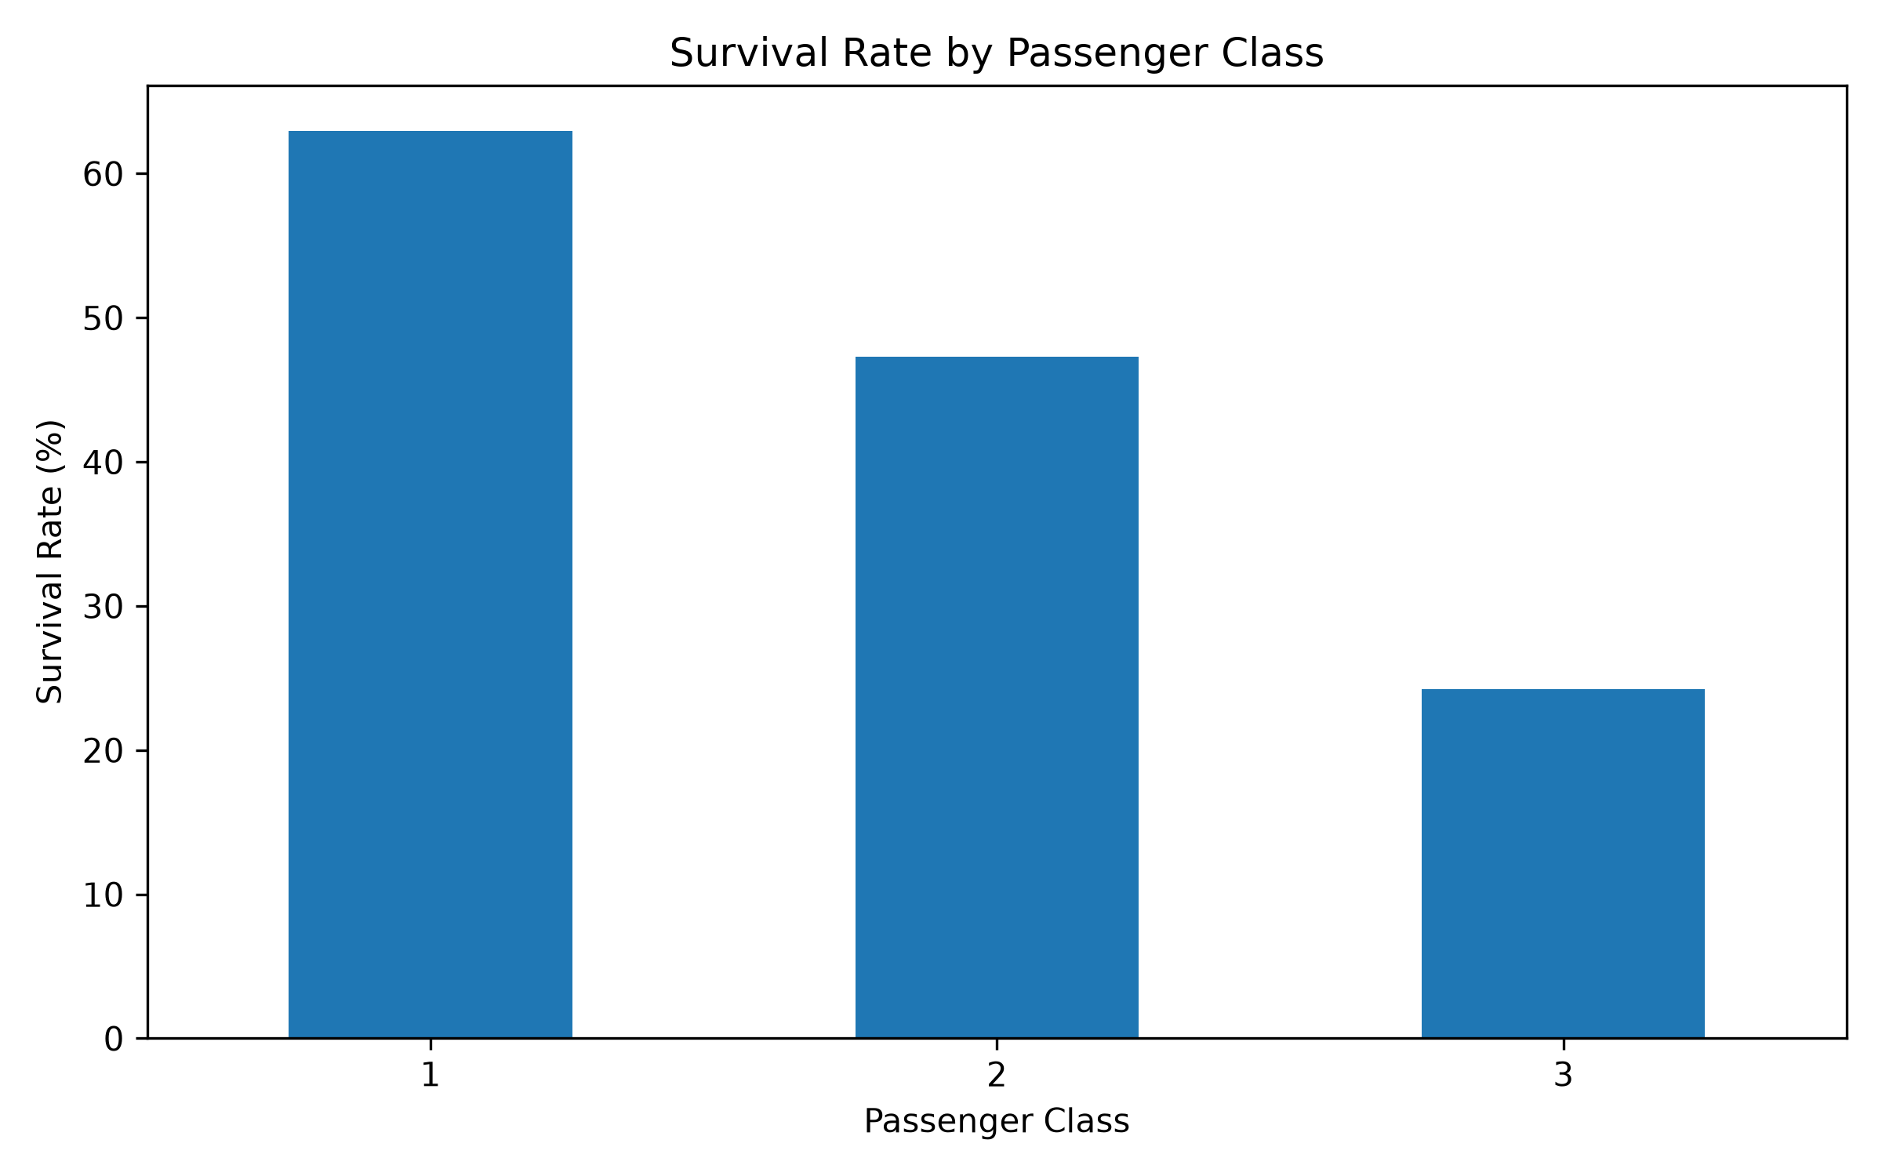]
Screenshot 15: survival_rate_class.png
Interpretation: Survival rate was highest in first class and lowest in third class.

21. Key Findings
- The dataset contains 891 rows and 12 columns.
- There are missing values in Age, Cabin, and Embarked.
- Female passengers had a much higher survival rate than male passengers.
- First-class passengers had the highest survival rate, while third-class passengers had the lowest.
- First-class passengers also had the highest average fare.
- Fare values are strongly concentrated at lower amounts, with a small number of high-fare observations.
- The correlation analysis shows a negative relationship between Pclass and Fare and a moderate negative relationship between Pclass and Survived.
- Grouped calculations and visualizations helped identify important patterns that are not as clear from raw rows alone.

22. Transformations and Aggregations Used
The analysis used grouped aggregation with Pandas groupby() to calculate average fare by passenger class and survival rate by gender and passenger class. Numerical columns were selected for the correlation matrix. The visualizations were generated from these original or grouped values.

23. Challenges Faced
- Understanding the structure and data types of the Titanic dataset.
- Identifying missing values before interpreting distributions.
- Selecting suitable charts for categorical and numerical variables.
- Interpreting correlations without treating them as proof of causation.
- Generating and saving multiple visualizations in an organized folder.
- Ensuring the Python environment had the required Pandas, Matplotlib, and Seaborn libraries installed.

24. Conclusion
The Titanic dataset was successfully explored using Python, Pandas, Matplotlib, and Seaborn. The EDA process examined dataset structure, descriptive statistics, missing values, survival patterns, distributions, relationships, correlations, and grouped summaries. The analysis showed clear differences in survival by gender and passenger class and a strong difference in average fare across passenger classes. The generated visualizations make these findings easier to interpret and provide a useful foundation for further statistical analysis or machine-learning work.

25. References
1. Kaggle – Titanic: Machine Learning from Disaster
https://www.kaggle.com/competitions/titanic/data
2. Pandas Documentation
https://pandas.pydata.org/docs/
3. Matplotlib Documentation
https://matplotlib.org/stable/
4. Seaborn Documentation
https://seaborn.pydata.org/

26. Screenshot Checklist
- Kaggle dataset/download page – Section 3
- df.head() and successful dataset loading – Section 6
- df.shape / column names / df.info() / df.describe() – Section 7
- Missing values output – Section 9
- survival_count.png – Section 10
- survival_gender.png – Section 11
- survival_class.png – Section 12
- age_distribution.png – Section 13
- fare_distribution.png – Section 14
- age_fare_scatter.png – Section 15
- correlation_heatmap.png – Section 16
- age_class_boxplot.png – Section 17
- average_fare_class.png – Section 18
- survival_rate_gender.png – Section 19
- survival_rate_class.png – Section 20

