WEEK 6 INTEGRATIVE CAPSTONE PROJECT
Student Performance Prediction and Analysis using Data Science
Data Science with Python Internship
Submitted by: MD FAIZAN KURAISHI
Course / Department: Computer Science Engineering
Submission Date: 21 October 2026

1. Introduction
This integrative capstone project demonstrates the complete data science workflow using Python. The project focuses on analysing student academic performance and building machine learning models that can predict final student grades. The workflow combines data acquisition, data cleaning, preprocessing, exploratory data analysis, feature engineering, supervised learning, model evaluation, unsupervised learning, clustering, interpretation, and recommendations.
The project uses the publicly available UCI Student Performance dataset. The final grade, represented by G3, is treated as the primary target variable for supervised regression. In addition, K-Means clustering is applied to identify groups of students with similar numerical academic and behavioural characteristics.

2. Problem Statement
Student academic performance can be influenced by several academic, demographic, social, and behavioural factors. Educational institutions can benefit from identifying patterns in student data and detecting students who may require additional academic support.
The problem addressed in this project is to analyse student performance data, identify meaningful patterns, predict final grades using machine learning, and segment students into groups using unsupervised learning.

3. Objectives
- Acquire a reliable publicly available student performance dataset.
- Inspect the dataset structure and assess its data quality.
- Identify and handle missing values and duplicate records.
- Perform exploratory data analysis using statistical summaries and visualizations.
- Prepare categorical and numerical variables for machine learning.
- Build supervised regression models for predicting final grades.
- Compare Linear Regression and Random Forest Regression using MAE, RMSE, and R².
- Apply K-Means clustering to identify student groups.
- Use PCA to visualize the student clusters in two dimensions.
- Generate practical insights, recommendations, and future improvements.

4. Dataset Description
The project uses the UCI Student Performance dataset. The mathematics subject dataset (student-mat.csv) contains 395 student records and 33 original columns. The target variable G3 represents the final grade, while G1 and G2 represent earlier period grades.
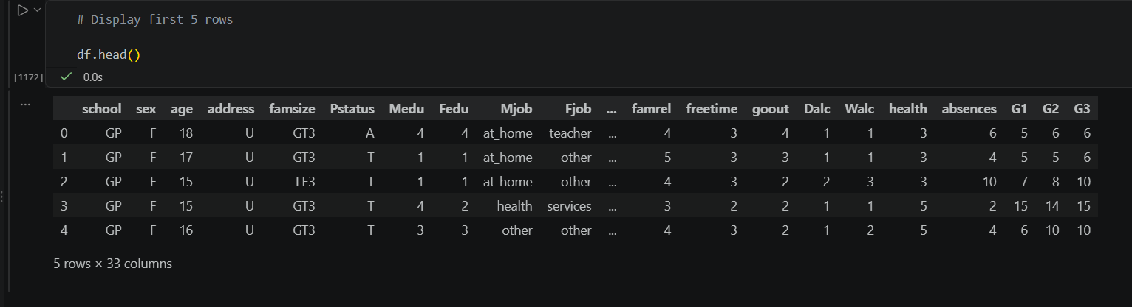
Figure 1: Preview of the Student Performance Dataset

Item | Value
Dataset | UCI Student Performance Dataset
File | student-mat.csv
Records | 395 students
Original columns | 33
Target variable | G3 (final grade)
Previous grade variables | G1 and G2
Primary task | Student final-grade prediction

4.1 Dataset Variables
The dataset contains variables related to school, gender, age, address, family information, parental education and jobs, study time, failures, school support, extracurricular activities, absences, previous grades, and other student-related characteristics.

5. Data Collection
The dataset was obtained from the UCI Machine Learning Repository, a reliable public source of machine learning datasets. The CSV file was downloaded and placed inside the project's data folder.
Project data path used in the notebook:
file_path = "../data/student-mat.csv"
df = pd.read_csv(file_path, sep=";")
print("Dataset shape:", df.shape)
The semicolon separator was specified because the source CSV file uses ';' as its delimiter.
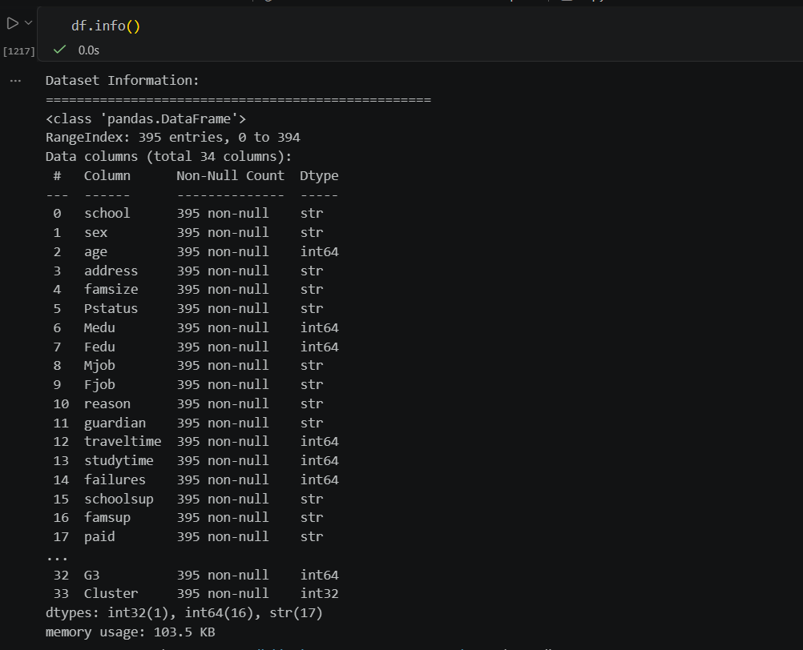
Figure 2: Dataset Structure and Information

6. Data Cleaning
Data quality checks were performed before modelling. The dataset was inspected for missing values, duplicate rows, invalid categorical values, and unrealistic grade ranges.
missing_values = df.isnull().sum()
print("Total missing values:", missing_values.sum())
duplicate_count = df.duplicated().sum()
print("Number of duplicate rows:", duplicate_count)
The dataset did not require imputation for missing values, and duplicate records were checked and removed where applicable. Grade ranges for G1, G2, and G3 were also inspected to confirm that the values were within the expected grading range.
df = df.drop_duplicates()
print("Rows:", df.shape[0])
print("Columns:", df.shape[1])
The cleaned dataset was saved for reuse in subsequent analysis:
cleaned_file = "../data/student_performance_cleaned.csv"
df.to_csv(cleaned_file, index=False, sep=";")
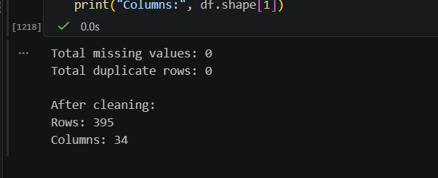
Figure 3: Missing Value Analysis

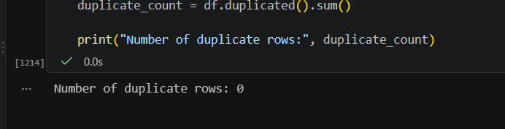
Figure 4: Duplicate Record Check

7. Data Preprocessing
Machine learning algorithms require numerical input. The categorical variables were therefore converted into numerical indicator variables using one-hot encoding. The target variable G3 was separated from the predictor variables.
X = df.drop("G3", axis=1)
y = df["G3"]
X_encoded = pd.get_dummies(X, drop_first=True)
The data was divided into training and testing sets using an 80:20 split with a fixed random state of 42 to make the experiment reproducible.
X_train, X_test, y_train, y_test = train_test_split(
X_encoded, y, test_size=0.20, random_state=42
)
StandardScaler was applied to the Linear Regression input data. Random Forest does not require feature scaling, so the unscaled encoded data was used for the Random Forest model.
scaler = StandardScaler()
X_train_scaled = scaler.fit_transform(X_train)
X_test_scaled = scaler.transform(X_test)

8. Exploratory Data Analysis
Exploratory Data Analysis (EDA) was conducted to understand grade distributions and relationships between student characteristics and final performance. Multiple visualizations were generated and saved in the outputs/charts folder.

Final Grade Distribution
A histogram was used to inspect the distribution of G3.
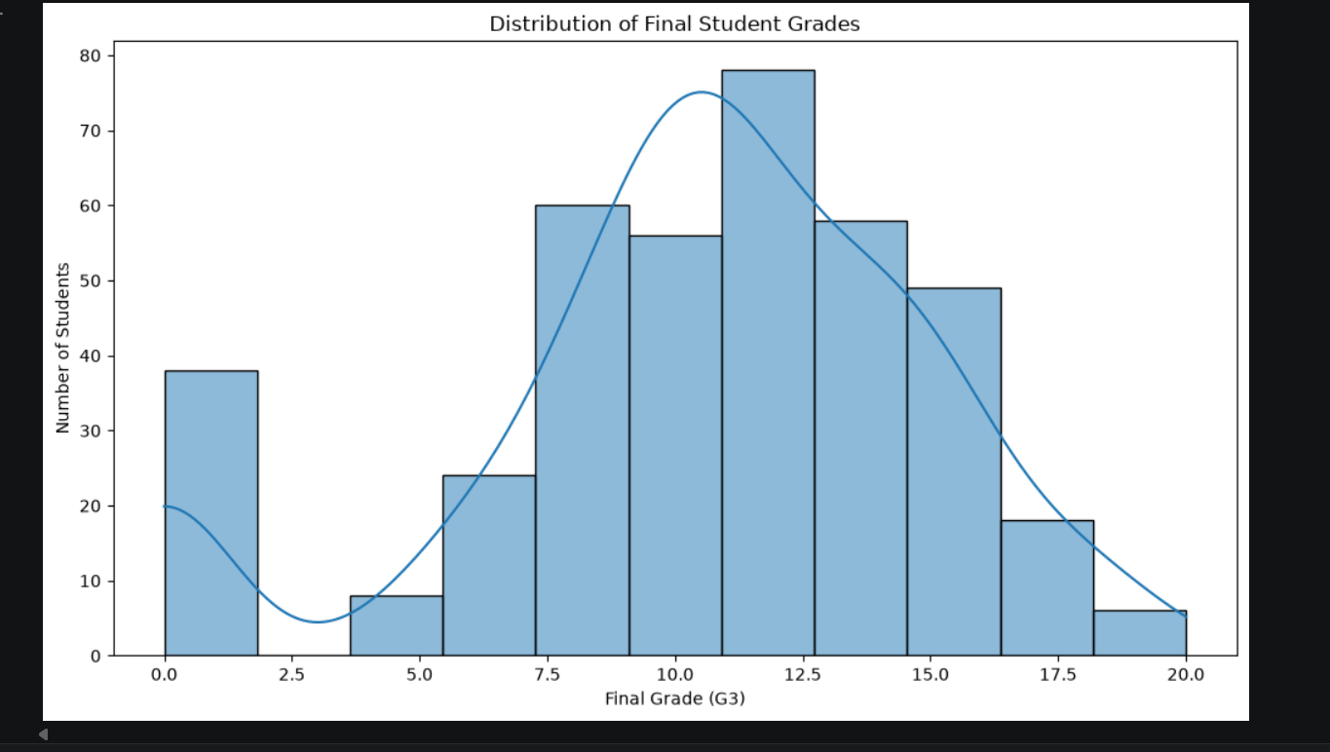
Figure 5: Distribution of Final Student Grades

Average Grade by Gender
Group-wise mean final grades were compared by gender.
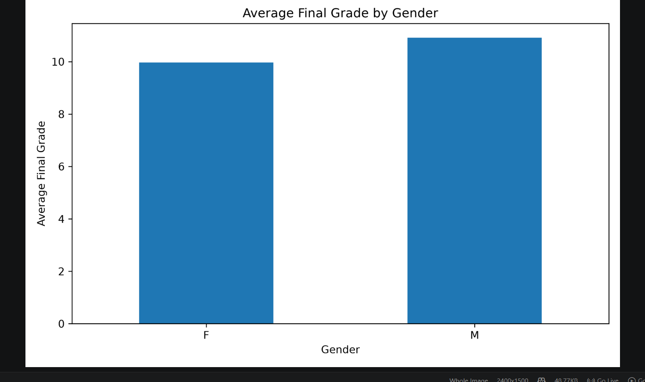
Figure 6: Average Final Grade by Gender

Study Time vs Grade
Average final grades were examined across study-time categories.
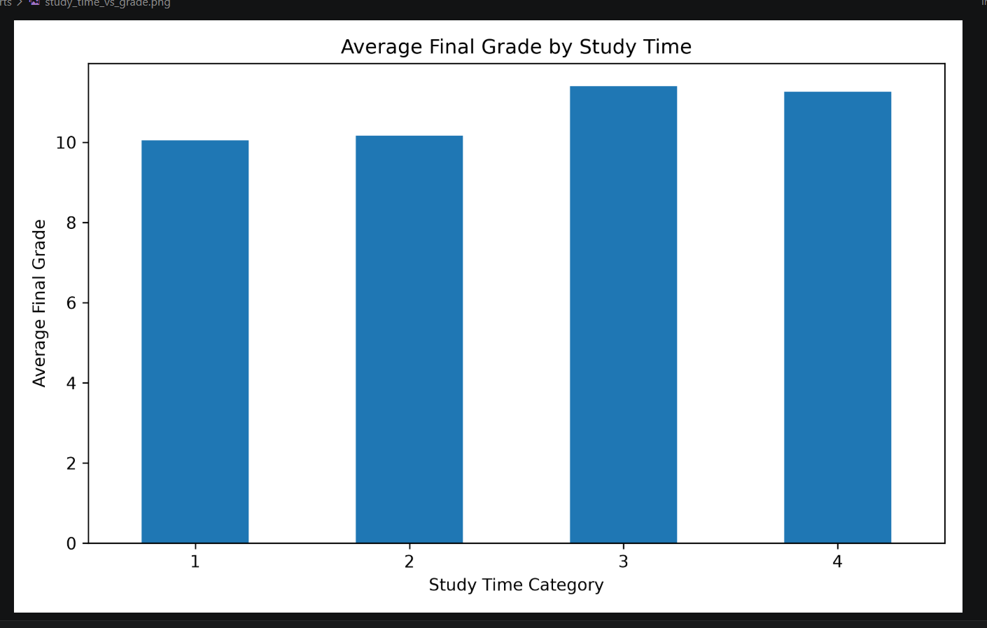
Figure 7: Average Final Grade by Study Time

Absences vs Grade
A scatter plot was used to examine the relationship between absences and final grade.
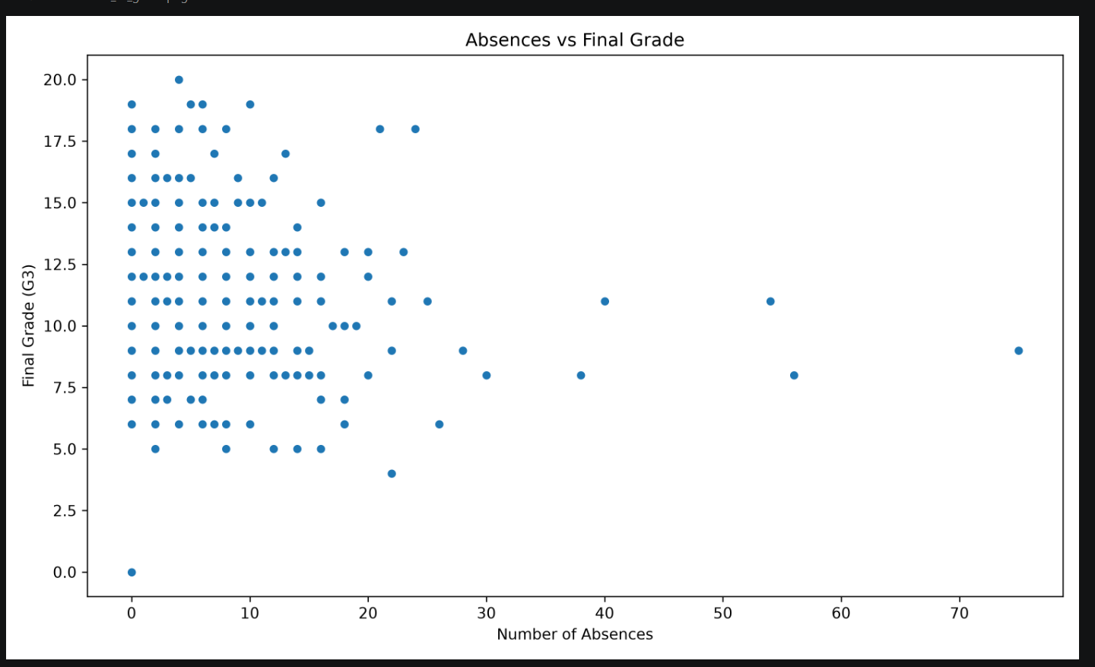
Figure 8: Relationship Between Absences and Final Grade

Correlation Heatmap
Numerical correlations were visualized to identify strongly related variables.
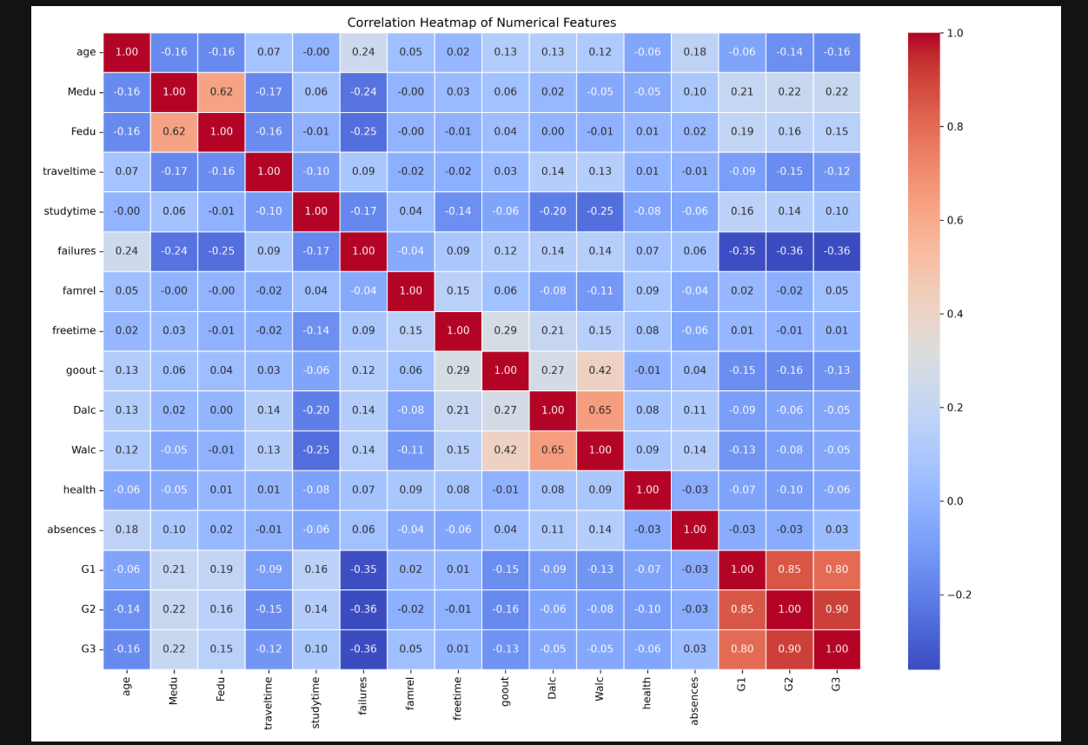
Figure 9: Correlation Heatmap of Numerical Features

Average Grade by School
Average final grades were compared between the two schools.
plt.figure(figsize=(10, 6))
sns.histplot(df["G3"], bins=11, kde=True)
plt.title("Distribution of Final Student Grades")
plt.tight_layout()
plt.savefig("../outputs/charts/final_grade_distribution.png", dpi=300)
plt.show()
The EDA stage showed that previous grades are highly relevant to final performance and that student behavioural variables such as study time and absences can also provide useful analytical signals. The correlation heatmap was particularly useful for identifying relationships among numerical variables.
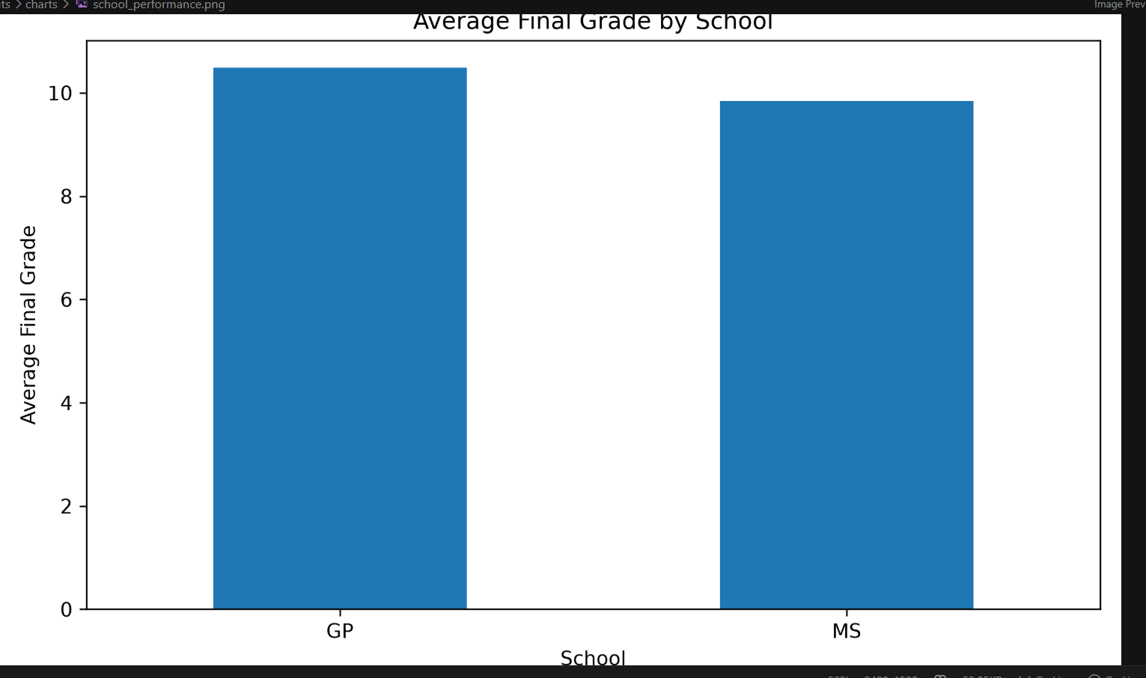
Figure 10: Average Final Grade by School

9. Feature Engineering and Encoding
Feature engineering in this project mainly involved preparing categorical variables for modelling through one-hot encoding. This transformed the original mixed-type dataset into a numerical feature matrix suitable for machine learning algorithms.
X_encoded = pd.get_dummies(X, drop_first=True)
print("Encoded feature count:", X_encoded.shape[1])
Using drop_first=True helps avoid redundant dummy variables for binary categorical categories. The resulting feature matrix was then used for model training and evaluation.

10. Supervised Learning
Because G3 is a numerical final grade, the supervised learning problem was formulated as a regression task. Two regression algorithms were trained: Linear Regression and Random Forest Regression.

10.1 Linear Regression
Linear Regression provides a simple baseline model that assumes the target can be estimated using a linear combination of the input variables.
from sklearn.linear_model import LinearRegression
linear_model = LinearRegression()
linear_model.fit(X_train_scaled, y_train)
y_pred_linear = linear_model.predict(X_test_scaled)

10.2 Random Forest Regression
Random Forest Regression combines multiple decision trees and can model non-linear relationships between student characteristics and final grades.
from sklearn.ensemble import RandomForestRegressor
rf_model = RandomForestRegressor(
n_estimators=200,
random_state=42
)
rf_model.fit(X_train, y_train)
y_pred_rf = rf_model.predict(X_test)

11. Model Evaluation
The supervised models were evaluated using Mean Absolute Error (MAE), Root Mean Squared Error (RMSE), and R² Score. Lower MAE and RMSE indicate smaller prediction errors, while a higher R² indicates that the model explains a larger proportion of the variation in the target.
mae_rf = mean_absolute_error(y_test, y_pred_rf)
rmse_rf = np.sqrt(mean_squared_error(y_test, y_pred_rf))
r2_rf = r2_score(y_test, y_pred_rf)
print("MAE :", round(mae_rf, 3))
print("RMSE:", round(rmse_rf, 3))
print("R² :", round(r2_rf, 3))
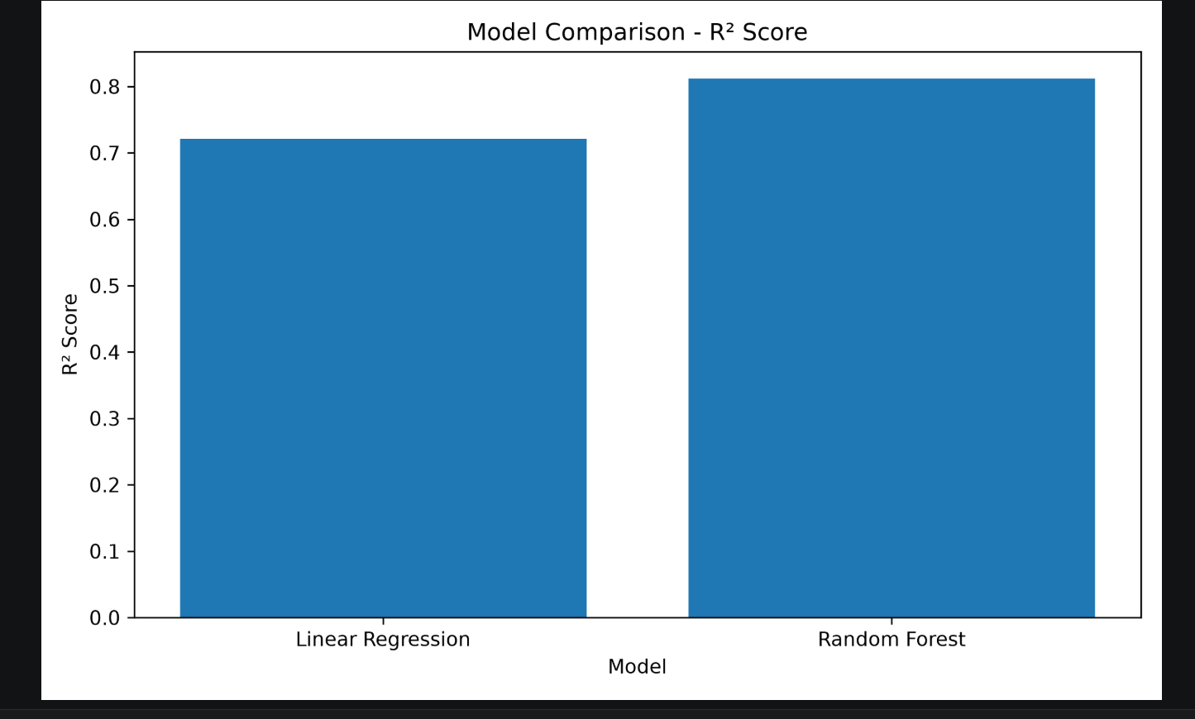
Figure 11: Comparison of Regression Models Based on R² Score
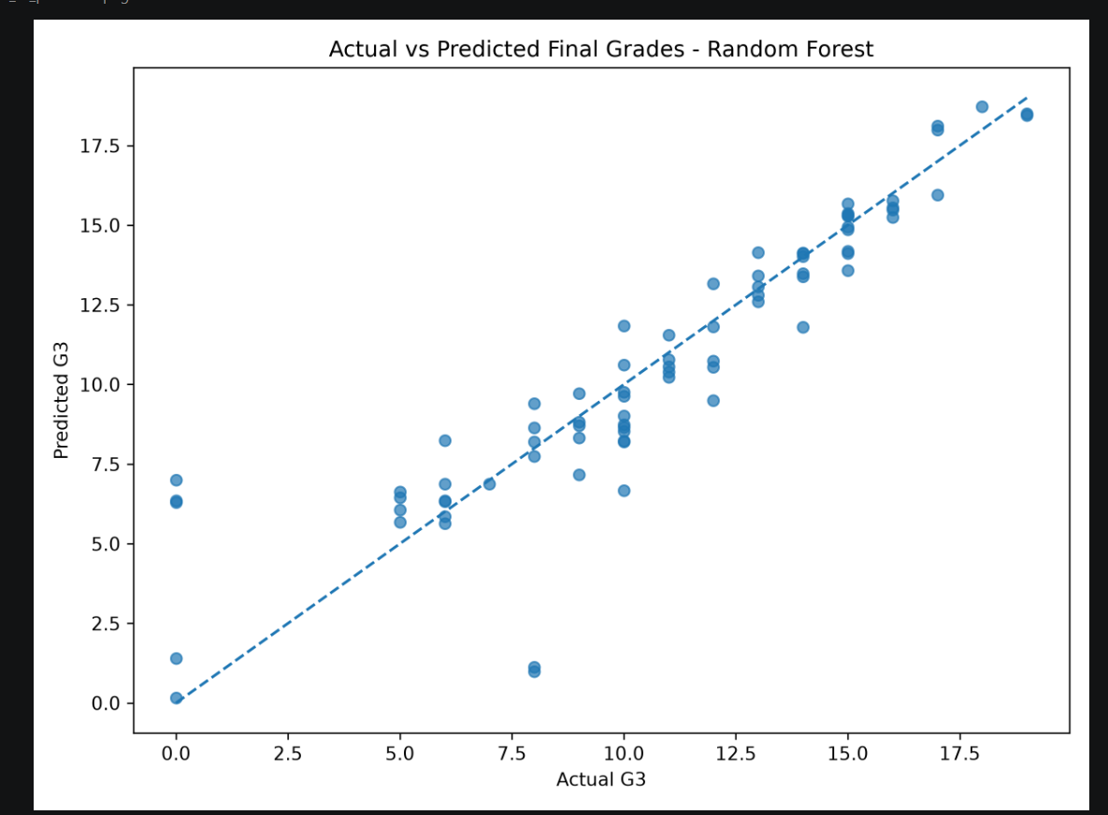
Figure 13: Actual Versus Predicted Final Grades

11.1 Final Model Results
Model | MAE | RMSE | R² Score
Random Forest | 1.174 | 1.964 | 0.812
Linear Regression | Calculated in notebook | Calculated in notebook | Calculated in notebook
Random Forest was selected as the best supervised model based on the recorded evaluation output. It achieved an MAE of 1.174, RMSE of 1.964, and R² of 0.812.
An R² score of 0.812 indicates that the Random Forest model explains approximately 81.2% of the variation in final grades on the test set. The MAE of 1.174 indicates that the predictions differ from actual grades by approximately 1.17 grade points on average.
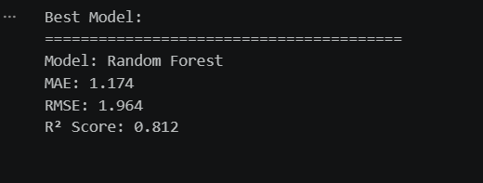
Figure 12: Final Evaluation Results of the Random Forest Model

12. Unsupervised Learning and Student Clustering
Unsupervised learning was included to identify groups of students with similar numerical characteristics. The target G3 was excluded from the clustering input to avoid directly grouping students according to their final grade.
cluster_features = df.select_dtypes(include=np.number).drop(
columns=["G3"], errors="ignore"
)
cluster_scaler = StandardScaler()
cluster_scaled = cluster_scaler.fit_transform(cluster_features)
The Elbow Method was used to inspect the within-cluster sum of squares (inertia) for different values of K. A three-cluster solution was then used for student segmentation.
kmeans_model = KMeans(n_clusters=3, random_state=42, n_init=10)
clusters = kmeans_model.fit_predict(cluster_scaled)
df["Cluster"] = clusters
PCA was used to reduce the standardized clustering features to two principal components for visualization.
pca = PCA(n_components=2)
cluster_pca = pca.fit_transform(cluster_scaled)
pca_df = pd.DataFrame(cluster_pca, columns=["PC1", "PC2"])
pca_df["Cluster"] = df["Cluster"].values
The resulting cluster summary can be used to compare average previous grades, final grades, study time, and absences across the student groups.
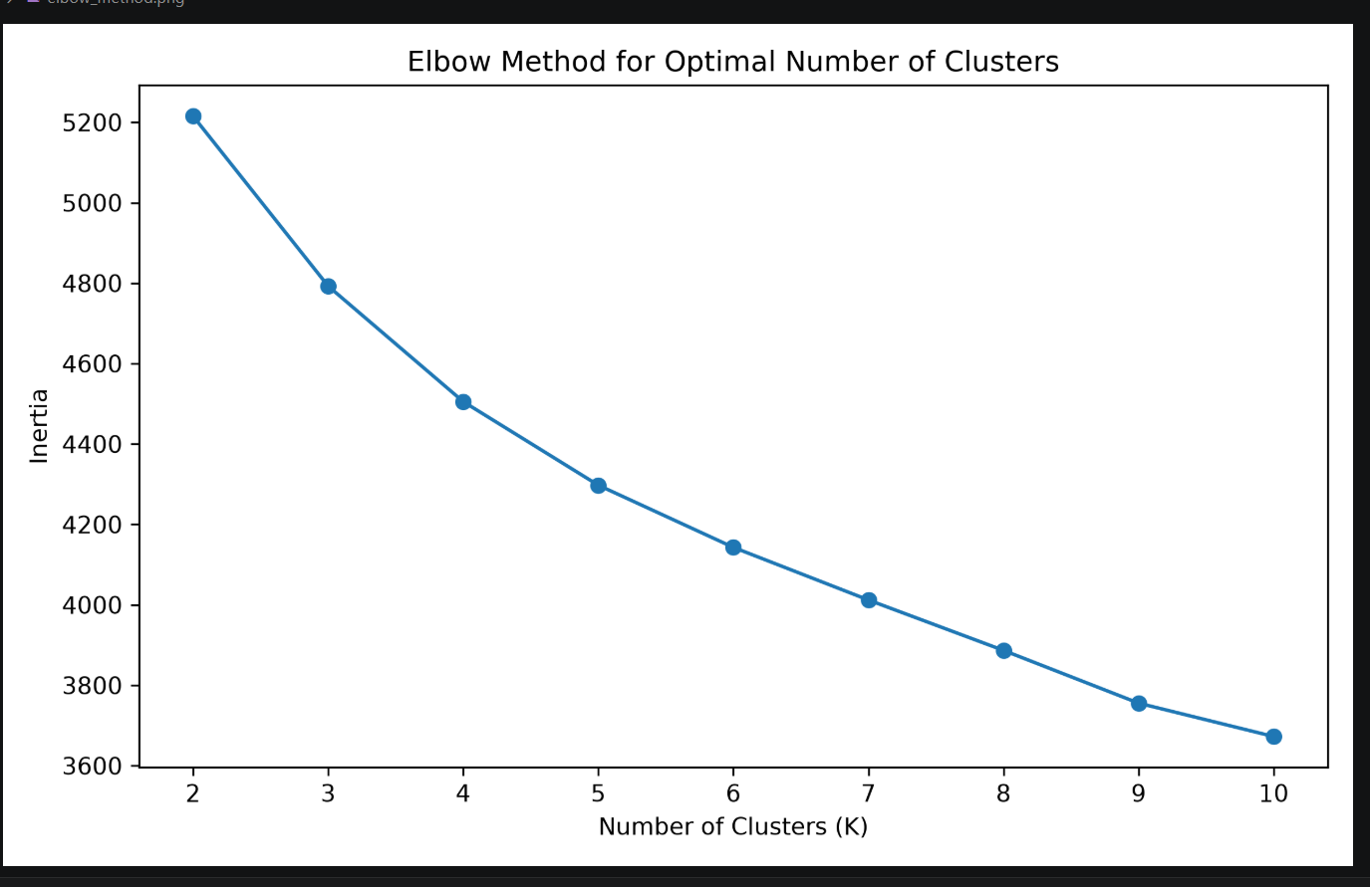
Figure 15: Student Clusters Visualized Using PCA

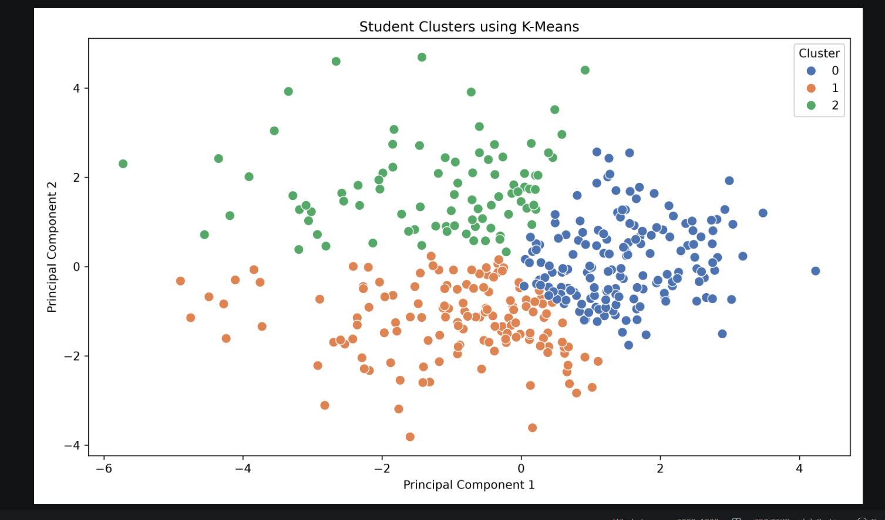
Figure 14: Elbow Method for K-Means Clustering

13. Feature Importance and Interpretation
Random Forest feature importance was calculated to identify which input variables contributed most strongly to the model's predictions.
feature_importance = pd.DataFrame({
"Feature": X_encoded.columns,
"Importance": rf_model.feature_importances_
}).sort_values(by="Importance", ascending=False)
feature_importance.head(15)
The feature-importance chart provides a practical way to understand which student characteristics are most useful to the prediction model. In particular, previous academic performance variables can be expected to carry substantial predictive information because G1 and G2 are earlier grades related to the same academic outcome.
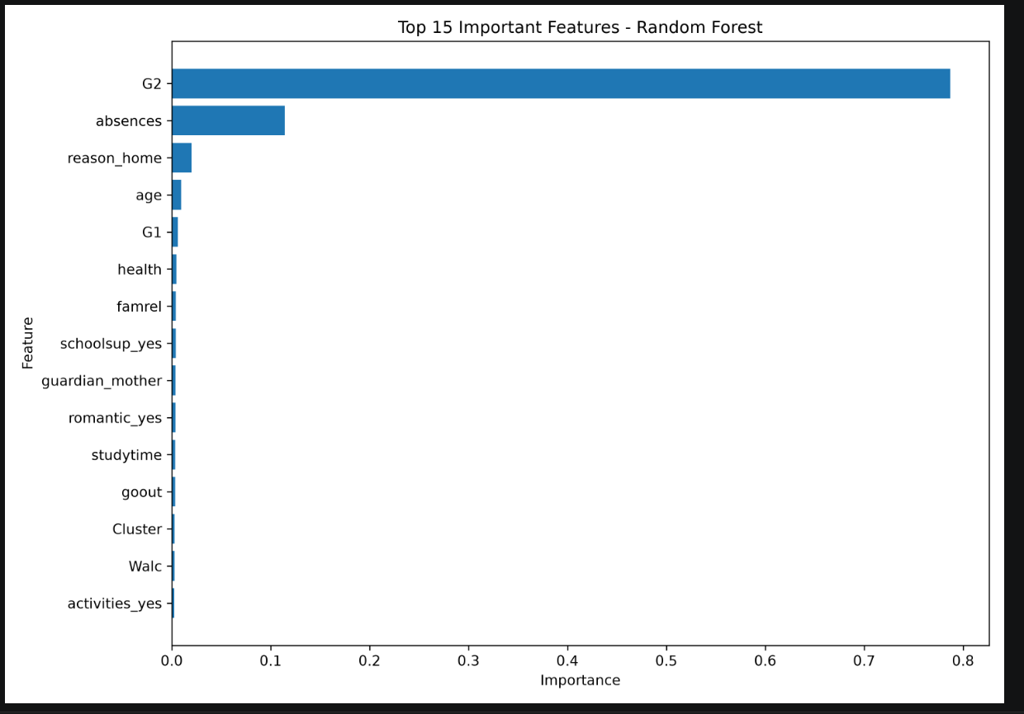
Figure 16: Top 15 Important Features in Random Forest

14. Key Findings
- The complete data science pipeline was successfully implemented from acquisition through evaluation.
- The dataset contained 395 student records and 33 original variables.
- Data quality checks found no major missing-value problem requiring imputation.
- Duplicate records and grade ranges were explicitly checked during cleaning.
- EDA demonstrated useful relationships among academic performance, study behaviour, absences, and other student characteristics.
- Both Linear Regression and Random Forest Regression were trained for final-grade prediction.
- Random Forest was the best recorded supervised model, with MAE = 1.174, RMSE = 1.964, and R² = 0.812.
- K-Means clustering identified three groups of students based on standardized numerical characteristics.
- PCA provided a two-dimensional visualization of the student clusters.
- Feature importance analysis was used to support interpretation of the predictive model.

15. Recommendations
- Encourage students to maintain consistent and effective study habits.
- Monitor students with high absence levels and provide early academic support where appropriate.
- Use previous academic performance as an early indicator for identifying students who may need additional assistance.
- Use student clusters to design different support strategies for different groups of learners.
- Provide personalized learning support to students showing lower academic performance.
- Use predictive modelling as a decision-support tool rather than as the sole basis for educational decisions.
- Collect richer longitudinal educational data in future work to improve the reliability and usefulness of predictions.

16. Challenges Faced and Solutions
Challenge | Solution
Mixed categorical and numerical data | Categorical variables were converted using one-hot encoding.
Data quality verification | Missing values, duplicates, unique categorical values, and grade ranges were inspected.
Model comparison | Multiple regression algorithms were evaluated using the same test set and consistent metrics.
Clustering mixed-scale numerical variables | Numerical clustering features were standardized before K-Means.
Cluster visualization | PCA was used to reduce the feature space to two dimensions.
Model interpretation | Random Forest feature importance was calculated to understand influential variables.

17. Limitations and Critical Discussion
Although the Random Forest model achieved a strong R² score of 0.812 on the test set, the result should not be interpreted as proof that the model will achieve the same performance on every new student population. The dataset is relatively small and represents a particular educational context.
Another important consideration is that G1 and G2 are previous grades from the same academic process and are strongly informative about G3. Their availability is reasonable for a late-stage prediction scenario, but they would not be available if the objective were to predict performance at the beginning of the academic year. A future experiment should therefore compare models with and without G1/G2 to measure how much early prediction performance changes.
The K-Means clustering solution with three clusters is an analytical segmentation rather than a ground-truth classification. Cluster labels should therefore be interpreted as groups found by the algorithm, not as fixed student categories.

18. Future Scope
- Evaluate additional regression algorithms such as Gradient Boosting, Random Forest tuning, and other ensemble methods.
- Perform cross-validation and hyperparameter optimization for more robust model evaluation.
- Build a separate early-warning model that excludes G1 and G2.
- Experiment with classification, such as predicting pass/fail status, if a suitable target definition is provided.
- Use additional educational, attendance, behavioural, and longitudinal information.
- Deploy the trained model through a simple web application or dashboard.
- Monitor model performance on new data and periodically retrain the model.

19. Conclusion
This Week 6 Integrative Capstone successfully combined the major skills developed throughout the Data Science with Python internship. The project started with acquisition of a public student performance dataset and continued through data quality assessment, cleaning, preprocessing, EDA, machine learning, clustering, evaluation, and interpretation.
Two supervised regression models were implemented and compared. Random Forest produced the strongest recorded performance, achieving an MAE of 1.174, RMSE of 1.964, and R² of 0.812. K-Means clustering was additionally used to identify three groups of students with similar numerical characteristics. Overall, the project demonstrates how Python-based data science can transform raw educational data into predictive insights and actionable recommendations.

20. Project File Structure
Week6_Integrative_Capstone/
├── data/
│ ├── student-mat.csv
│ ├── student_performance_cleaned.csv
│ └── student_performance_clustered.csv
│
├── notebooks/
│ └── Week6_Capstone.ipynb
│
├── outputs/
│ ├── charts/
│ │ ├── final_grade_distribution.png
│ │ ├── gender_performance.png
│ │ ├── study_time_vs_grade.png
│ │ ├── absences_vs_grade.png
│ │ ├── correlation_heatmap.png
│ │ ├── school_performance.png
│ │ ├── model_comparison.png
│ │ ├── elbow_method.png
│ │ ├── student_clusters.png
│ │ ├── actual_vs_predicted.png
│ │ └── feature_importance.png
│ │
│ └── model_results/
│ ├── supervised_model_results.csv
│ ├── clustering_summary.csv
│ └── feature_importance.csv
│
├── src/
├── requirements.txt
└── Week6_Integrative_Capstone_Report.docx

21. Requirements and Tools
- Python 3.14.7
- Pandas
- NumPy
- Matplotlib
- Seaborn
- Scikit-learn
- Jupyter Notebook
- VS Code
- Git and GitHub for project version control and submission

22. Final Project Status
PROJECT COMPLETE
The notebook, processed datasets, analysis outputs, machine learning results, clustering results, and this final report together form the complete Week 6 Integrative Capstone submission.

