Java Developer Fresher
Fundamentals and Setup
Task 1 Project Report

Submitted by: [MD FAIZAN KURAISHI]
Internship/Organization: [Yuva Intern]
Course/Department: Computer Science Engineering
Submission date: [21/10/2026]

REPORT STATUS: Completed – Java development environment setup, Hello World application, project documentation, Git version control, and GitHub repository upload have been successfully completed.

1. Introduction
This project is the Fundamentals and Setup task for the Java Developer Fresher internship. The purpose of this phase is to configure a Java development environment, understand a basic project structure, create and execute a Hello World application, and establish a Git and GitHub workflow.

2. Objective
- Install and verify the Java Development Kit (JDK).
- Configure a development environment for Java programming.
- Create and run a basic Java application.
- Understand the basic organization of a Java project.
- Use Visual Studio Code for Java development.
- Use Git for version control.
- Upload the project to GitHub.
- Document the setup and verification process.

3. Development Environment
Tool | Purpose
Java JDK 26.0.2 | Java development and compilation
javac | Java source-code compilation
Visual Studio Code | Writing and managing source code
PowerShell | Running development commands
Git | Version control
GitHub | Remote repository and project sharing

4. Java Installation Verification
The Java installation was verified using the following commands:
java -version
javac -version
The installed Java version was verified as Java/JDK 26.0.2, and the Java compiler (javac) was also available. Both commands executed successfully.

5. Project Structure
Java-Fundamentals-Setup/
├── .gitignore
├── README.md
├── docs/
│ └── Fundamentals_Setup_Report.md
├── screenshots/
│ ├── 01_Java_Version.png
│ ├── 02_Project_Structure.png
│ ├── 03_Main_Java_Code.png
│ ├── 04_Hello_World_Output.png
│ └── 05_GitHub_Repository.png
└── src/
└── Main.java

6. Hello World Application
The main Java source file contains the following program:
public class Main {
public static void main(String[] args) {
System.out.println("Hello World!");
System.out.println("Java Fundamentals Setup");
System.out.println("Java Developer Fresher Project");
System.out.println("Environment setup completed successfully.");
}
}

7. Compilation and Execution
The program was compiled using:
javac src\Main.java
The program was executed using:
java -cp src Main
Successful output:
Hello World!
Java Fundamentals Setup
Java Developer Fresher Project
Environment setup completed successfully.

8. Git and GitHub
Git was used to track project changes and GitHub was used as the remote repository. The project was committed and pushed to a public GitHub repository named Java-Fundamentals-Setup.
Typical version-control commands used in the project included:
git init
git add .
git commit -m "Complete Java fundamentals setup"
git branch -M main
git push -u origin main

9. Screenshots and Evidence
The following screenshots are intended to be included as evidence of the setup and implementation. The actual screenshots can be inserted in the indicated positions before final submission.
Screenshot 1 – Java Version
Paste the screenshot showing both java -version and javac -version here.
[ 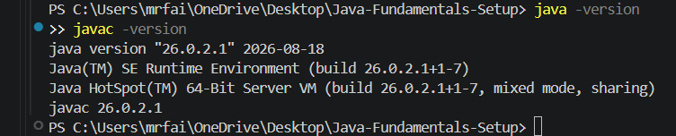 ]

Screenshot 2 – Project Structure
Paste the VS Code screenshot showing the project folders and files here.
[ 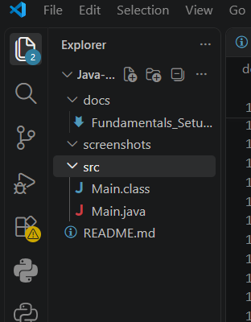 ]

Screenshot 3 – Main.java Code
Paste the VS Code screenshot showing the complete Main.java code here.
[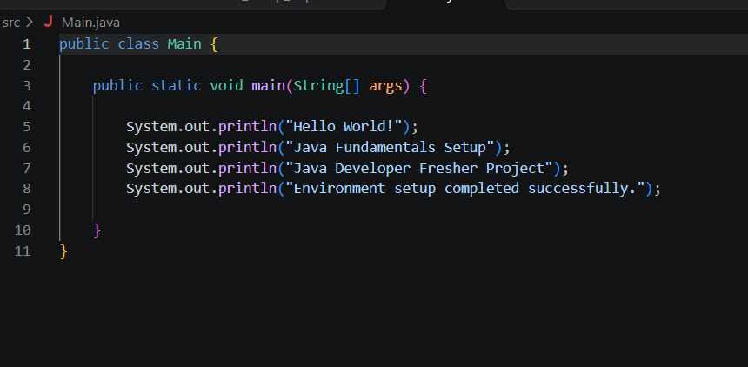]

Screenshot 4 – Hello World Output
Paste the terminal screenshot showing the successful Hello World output here.
[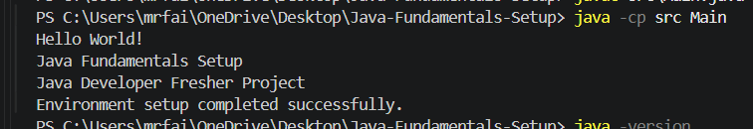]

Screenshot 5 – GitHub Repository
Paste the GitHub repository screenshot showing the uploaded project files here.
[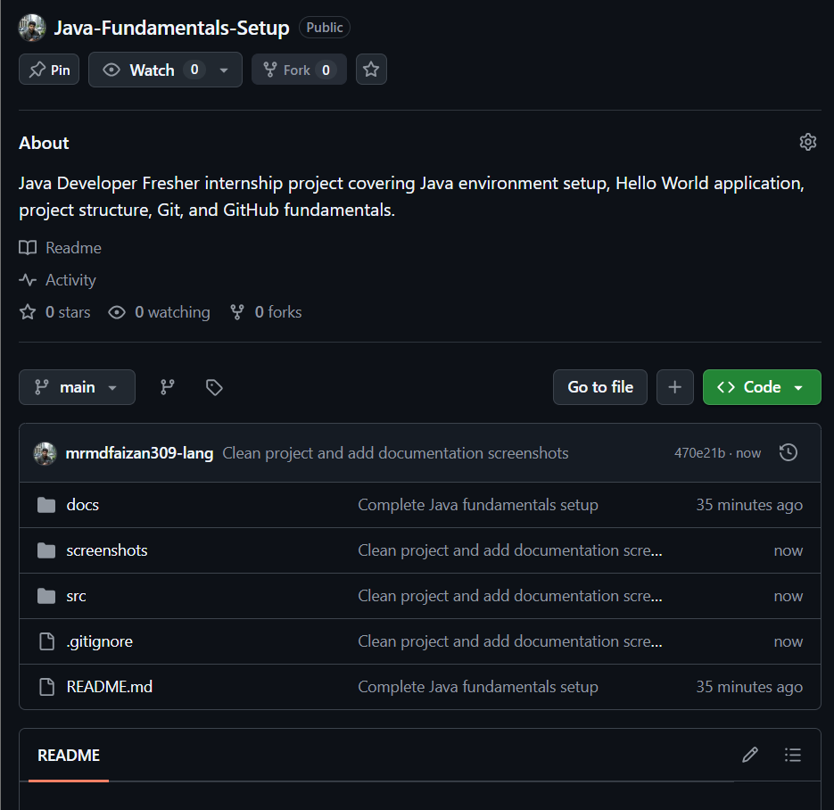]

10. Challenges Faced
The main setup challenge was verifying that both the Java runtime and Java compiler were properly available from PowerShell. This was resolved by checking java -version and javac -version and then creating the project structure and source file.

11. Learning Outcomes
- Verified a Java development environment.
- Created and executed a Java program.
- Understood a basic Java project structure.
- Used VS Code and PowerShell for development.
- Practiced Git version control.
- Uploaded and maintained the project on GitHub.
- Prepared project documentation and evidence.

12. Conclusion
The Fundamentals and Setup task was completed successfully. The Java environment was configured, the Hello World application was compiled and executed successfully, and the project was prepared for version control and GitHub submission. This setup provides a foundation for subsequent Java development tasks.

