WEEK 1 TASK
Data Acquisition, Cleaning, and Preprocessing

Submitted by: [MD FAIZAN KURAISHI]
Internship/Organization: [YuvaIntern]
Course/Department: Computer Science Engineering
Submission date: [22/10/2026]

REPORT STATUS: Final run completed using the publicly available Kaggle Titanic dataset. Data cleaning, missing value treatment, outlier analysis, and preprocessing were performed using Python.

1. Abstract
This report presents a reproducible workflow for data acquisition, inspection, cleaning, and preprocessing using Python and Pandas. For this project, the Titanic dataset was obtained from the Kaggle public dataset repository. The dataset was explored to understand its structure and identify data quality issues such as missing values, duplicate records, inconsistent entries, and potential outliers. Appropriate data cleaning and preprocessing techniques were applied to prepare the dataset for further analysis. The report documents the complete process, including Python code, results, explanations, and recommended screenshots.

2. Introduction
Data preprocessing is an important step in data analysis and machine learning. Real-world datasets often contain missing values, duplicate records, incorrect entries, inconsistent formats, and outliers. If these problems are not handled properly, they can affect the accuracy and reliability of further analysis.
In this task, the Titanic dataset was selected as a publicly available dataset from Kaggle. Python and the Pandas library were used to inspect, clean, and preprocess the dataset. The main objective was to identify data quality problems and apply suitable techniques to prepare the dataset for further analysis.

3. Dataset Acquisition
Dataset: Titanic – Machine Learning from Disaster
Source: Kaggle – Titanic: Machine Learning from Disaster
Source URL: https://www.kaggle.com/competitions/titanic/data?utm_source=chatgpt.com
File used: train.csv
The train.csv file was downloaded from Kaggle and placed in the project's data folder. It contains passenger information and the Survived target variable.
[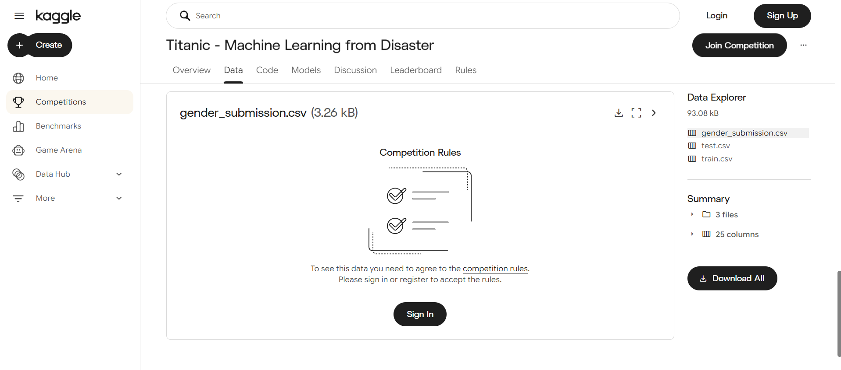
]
Figure 1: Titanic dataset downloaded from Kaggle.

4. Project Environment
Tool/Library | Purpose
Python | Programming language used for the analysis
Pandas | Data loading, inspection, cleaning, and transformation
NumPy | Numerical/data manipulation support
Matplotlib | Outlier visualization using box plots
VS Code | Development environment used to run the Python script

5. Project Folder Structure
Week1_Data_Cleaning/
├── data/
│ └── train.csv
├── data_cleaning.py
└── Week1_Report.docx

6. Loading the Dataset
import pandas as pd
# Load Titanic dataset
df = pd.read_csv("data/train.csv")
print(df.head())
The dataset was imported using Pandas read_csv(). The head() function was used to display the first five records and confirm that the file was loaded correctly.
[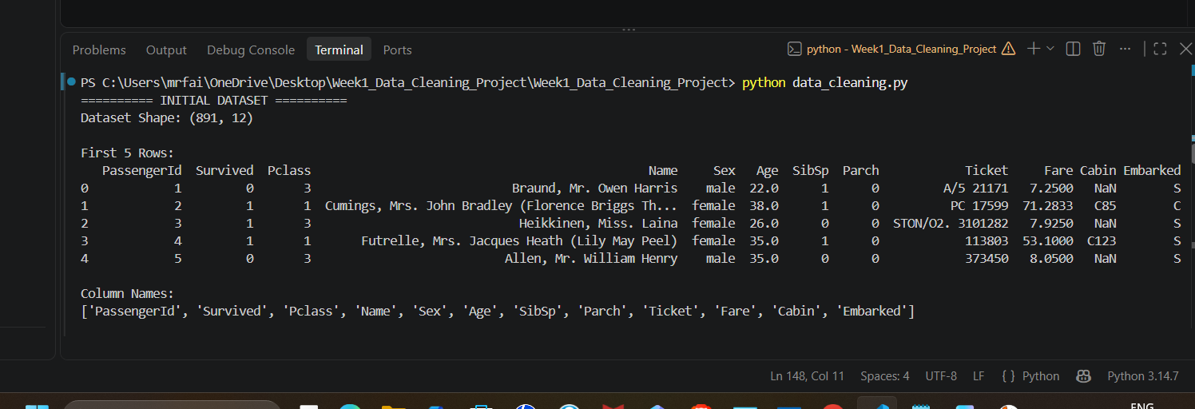
]
Figure 2: First five records of the Titanic dataset.

7. Initial Dataset Exploration
print("Dataset Shape:", df.shape)
print(df.columns)
df.info()
print(df.describe())
The dataset contains 891 rows and 12 columns. The shape, column names, data types, non-null counts, and statistical summary were inspected before cleaning.
Metric | Actual Result
Rows | 891
Columns | 12
Duplicate rows | 0
[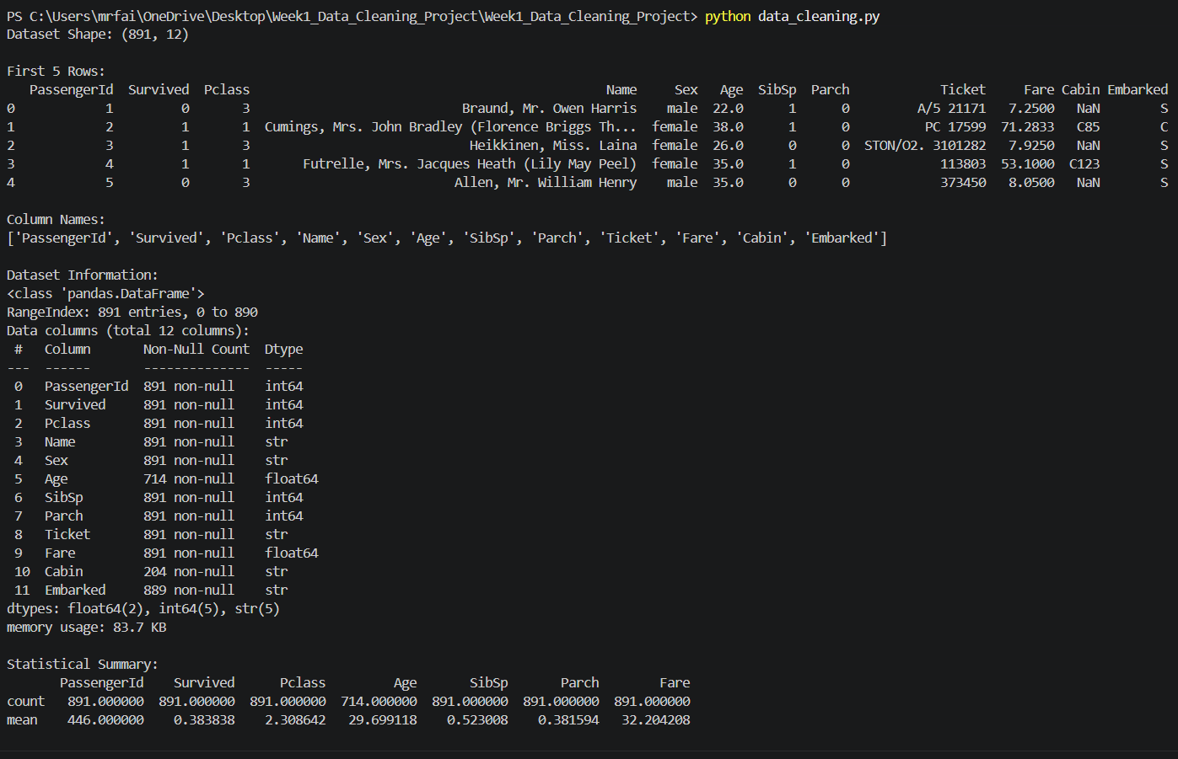]
Figure 3: Dataset structure and statistical summary.

8. Missing Value Analysis
print(df.isnull().sum())
missing_percentage = (df.isnull().sum() / len(df)) * 100
print(missing_percentage)
Column | Missing Values | Percentage
Age | 177 | 19.87%
Cabin | 687 | 77.10%
Embarked | 2 | 0.22%
Missing values were found in Age, Cabin, and Embarked. Age has 177 missing values (19.87%), Cabin has 687 missing values (77.10%), and Embarked has 2 missing values (0.22%).
[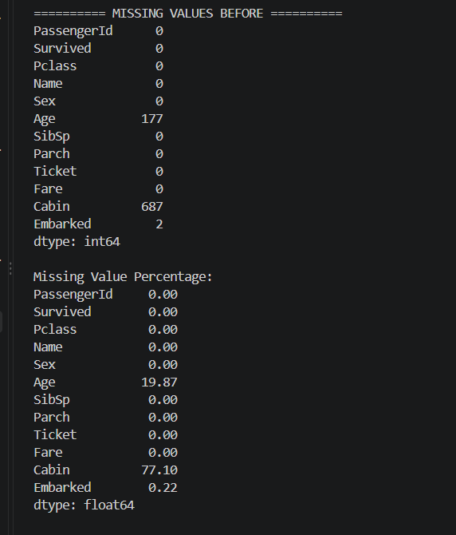]
Figure 4: Missing values identified in the Titanic dataset.

9. Missing Value Treatment
df["Age"] = df["Age"].fillna(df["Age"].median())
df["Embarked"] = df["Embarked"].fillna(df["Embarked"].mode()[0])
df = df.drop(columns=["Cabin"])
Missing Age values were replaced with the median because the median is less affected by extreme values. Missing Embarked values were replaced with the mode because Embarked is categorical. The Cabin column was removed because approximately 77.10% of its values were missing.

10. Duplicate Record Analysis
print("Duplicate rows:", df.duplicated().sum())
The dataset contained 0 duplicate rows. Therefore, no duplicate records needed to be removed from the original dataset.

11. Erroneous and Inconsistent Data Analysis
print(df["Sex"].unique())
print(df["Embarked"].unique())
print(df["Pclass"].unique())
print(df["Survived"].unique())
Categorical variables were examined using unique(). The Sex, Embarked, Pclass, and Survived columns were checked to ensure their values followed expected categories or ranges.

12. Outlier Analysis
Potential outliers were investigated using the Interquartile Range (IQR) method. The results below are potential outliers, not automatically erroneous records.
Column | Q1 | Q3 | IQR | Potential Outliers
Age | 20.125 | 38.000 | 17.875 | 11
Fare | 7.910 | 31.000 | 23.090 | 116
SibSp | 0.000 | 1.000 | 1.000 | 46
Parch | 0.000 | 0.000 | 0.000 | 213
The analysis identified potential outliers in Age, Fare, SibSp, and Parch. These values were not automatically deleted because extreme values may represent valid passengers or travel circumstances. For example, high fares can represent expensive tickets, while larger family-related counts can be legitimate.
plt.figure(figsize=(8, 5))
plt.boxplot(df["Age"].dropna())
plt.title("Age Outlier Detection")
plt.show()
plt.figure(figsize=(8, 5))
plt.boxplot(df["Fare"].dropna())
plt.title("Fare Outlier Detection")
plt.show()
[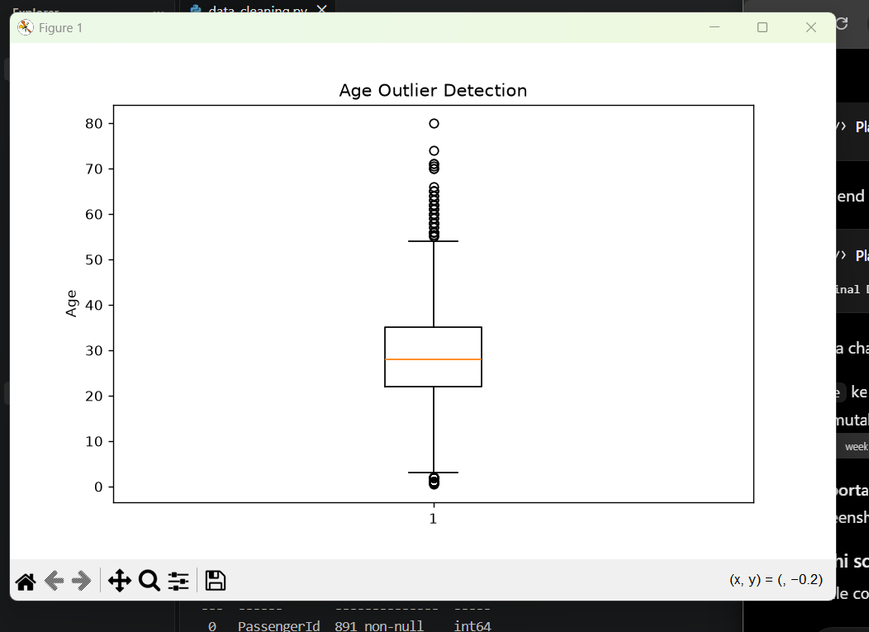]
Figure 5: Box plots used for potential outlier detection.

13. Data Preprocessing
df = pd.get_dummies(
df,
columns=["Sex", "Embarked"],
drop_first=True
)
Categorical variables were converted into numerical representations using one-hot encoding. This makes categorical information suitable for statistical analysis and machine learning algorithms.

14. Before vs After Cleaning
Measure | Before Cleaning | After Cleaning
Rows | 891 | 891
Columns | 12 | 11
Missing Age | 177 | 0
Missing Embarked | 2 | 0
Cabin | Present | Removed
Duplicate rows | 0 | 0
Total missing values | 866 | 0
After cleaning, the working dataset contains 891 rows and 891 columns, with 0 remaining missing values. The Cabin column was removed.
[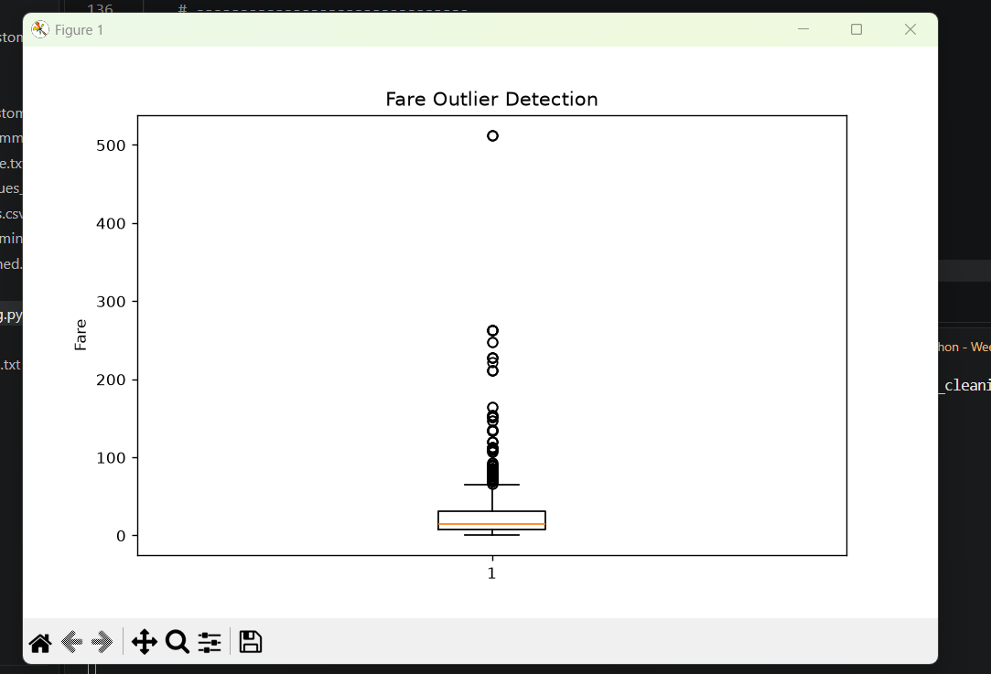]
Figure 6: Final cleaned and preprocessed dataset.

15. Saving the Cleaned Dataset
df.to_csv("data/titanic_cleaned.csv", index=False)
The cleaned dataset can be saved as titanic_cleaned.csv inside the data folder for later analysis.

16. Challenges Faced
The main challenges were handling missing values, deciding appropriate imputation methods, identifying potential outliers without deleting valid observations, and converting categorical variables into a machine-readable form. Median imputation was used for Age, mode imputation for Embarked, and the Cabin column was removed due to its very high missing-value proportion.

17. Impact of Preprocessing
Preprocessing improves the quality and usability of the dataset for subsequent analysis. Handling missing values prevents incomplete observations from causing problems. Removing duplicate records prevents repeated observations from affecting results, while encoding categorical variables makes the data suitable for machine learning. However, preprocessing decisions can affect future results, so they should be selected according to the purpose of the analysis.

18. Conclusion
The Titanic dataset was successfully acquired from Kaggle and processed using Python and Pandas. The original dataset contained 891 records and 12 columns. Missing values were identified and handled using median and mode imputation, while the Cabin column was removed because of extensive missing data. No duplicate records were found. Potential outliers were investigated using the IQR method and were not automatically removed because they may represent valid observations. Categorical variables were encoded to prepare the dataset for further analysis and machine learning.

19. References
1. Kaggle – Titanic: Machine Learning from Disaster
https://www.kaggle.com/competitions/titanic/data?utm_source=chatgpt.com
2. Pandas Documentation – https://pandas.pydata.org/docs/
3. Matplotlib Documentation – https://matplotlib.org/stable/

20. Screenshot Checklist
- Kaggle Titanic Data/Download page
- df.head() output
- df.info() / df.describe() output
- df.isnull().sum() output
- Age and Fare box plots
- Final cleaned dataset / final missing-value check

