INB374 – Assignment 2

Bjorn Lyngwa n5499879

# System Description

The system allows a member of the sales team to create new quotes, update status of current quotes in the system and check part availability and get an ETA for any parts not in stock that need ordering from the supplier.   
Although the prototype client does not allow quotes with multiple parts, the back-end services do handle having multiple parts listed in the quotes.

Please be aware, none of the services or client performs any kind of data validation, if you enter a letter in a number field or leave a field blank, crashes or unexpected behaviour can occur. Please use caution when entering new data.

# Links

## Service Repository

<http://fastapps04.qut.edu.au/n5499879/ServiceRepo>

## Web client

<http://fastapps04.qut.edu.au/n5499879/Client/WebClient>

# Diagrams

## Logically Layered Architecture

## Interaction Diagram

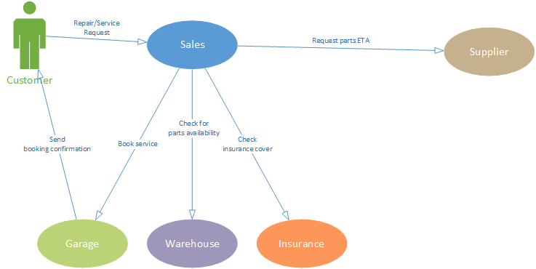

## Choreography Model

## Deployment Diagram

# SOA Analysis and Design

Top-down approach was employed when designing the architecture of the system.  
This method was chosen as it seemed the most appropriate for this type of scenario where there are no pre-existing software systems in use that may need consideration or will possibly continue to be in use at the same time as the new SOA system is installed. This is also why the bottom-up approach would not be suitable as the scenario provided is relatively simple and no current systems need consideration.  
Each department is modelled within the business as an independent service. Ensuring services are loosely coupled and can be expanded or swapped out depending on future business needs.

## Omissions and assumptions

The client does not display a total price or prices for parts, the database does store this, and the services do have fields with this information readily available. I simply forgot to include it in the form when designing the client interface initially and discovered the error too late to rectify it.

I also struggled with providing a status text and updating the client interface, in some cases while stepping through the process of creating and approving quotes it will appear as if nothing happened when clicking the submit button or action link. If this occurs go to the Home page and then return to the quote you were processing, the web page will now display the correct options and information.

Sending purchase orders and booking service times is not implemented, even though the client promises to do so at the final stages of the quoting process, no such action will be initiated.

# Aspects of Service Orientation

## Data Service

* Data-centric, provides data storage by storing its data in the underlying database.
* Provides classes describing quotes, items and parts which can be re-used by other services.

## Sales Service

* Logic & Process centric
* Performs service time calculations and ensures correct action is taken based on quote status

## Supplier Service

* Basic service that accepts a part description and returns a lead time on supplying this in the format of number of days.
* Implemented using REST a client only has to be able to communicate using HTTP and be able to parse XML or JSON to consume this service.

# Deployment Table

|  |  |  |  |  |  |
| --- | --- | --- | --- | --- | --- |
| Service Name | Platform | Language | API/Technology | Lines of Code | Team Member |
| Data | Windows | C# | WCF / SOAP | 573 | Bjorn Lyngwa |
| Sales | Windows | C# | WCF / SOAP | 161 | Bjorn Lyngwa |
| Web client | Windows | C# | WCF / SOAP | 318 | Bjorn Lyngwa |
| Supplier | Linux | Java | JAX-WS / REST | 90 | Bjorn Lyngwa |