FARMERSDELIGHT
Farmer to Consumer Marketplace App
Business Requirements Document (BRD) and Product Requirements Document (PRD)
Item | Detail
Product | FarmersDelight: mobile app (Android first) connecting farmers directly with nearby consumers
Version | 1.0 (Draft for review)
Date | 16 October 2026
Prepared for | Founder and product owner
Launch region and languages | Tamil Nadu, India. English and Tamil at launch; Telugu, Kannada, Malayalam and Hindi later
Business model | Completely free. No ads. No commission.
Technology | Flutter (Android first), Supabase (PostgreSQL + PostGIS, Auth, Realtime, Storage)

Contents
- Part A. Business Requirements Document (sections 1 to 11)
- Part B. Product Requirements Document (sections 12 to 25)
- Appendix. Screen designs, user stories and open items

PART A
Business Requirements Document

1. Executive summary
FarmersDelight is a free mobile app that lets farmers sell vegetables directly to consumers living nearby. A farmer pins the farm on a map and posts produce either at a fixed price, as a timed auction, or as an open negotiation. A consumer finds farmers within a chosen distance, buys or bids, and collects the produce from the farm. Delivery is offered only when the farmer chooses to provide it.
The app takes no commission, shows no ads and collects only the data needed to complete a trade. Payment is cash on pickup or delivery, so the app does not handle money.

2. Problem statement and opportunity
- Small farmers often sell through middlemen and lose a large share of the final price, and they have little control over price discovery.
- Consumers want fresher produce at fair prices but have no easy way to find nearby farmers and buy directly.
- Existing grocery and marketplace apps are built for large sellers, charge fees, show ads, and collect far more personal data than a simple trade needs.
- Most farmers and many buyers are more comfortable in Tamil than in English and need a simple, low-literacy-friendly interface.
Opportunity: a neighbourhood-level, free and privacy-respecting marketplace where the farmer decides how to price (fixed, auction or negotiation) and whether to deliver.

3. Business objectives and success measures
ID | Objective | Success measure (first 6 months)
BO-1 | Give farmers a direct sales channel with better price realisation | Farmers onboarded and posting at least one listing per week; sell-through rate of listings
BO-2 | Give consumers easy access to fresh produce nearby | Consumers who complete a first order; repeat order rate
BO-3 | Build trust between strangers without a payment platform | Share of orders completed without a dispute; average farmer rating; trust-level distribution
BO-4 | Stay free, ad-free and privacy-first | Zero ads; no sensitive data collected beyond the agreed list; no privacy incidents
BO-5 | Launch for Tamil-speaking users and expand to other South Indian languages | Share of users on Tamil UI; time to add a new language
Target values for each measure are to be set by the product owner before launch.

4. Scope

4.1 In scope (MVP)
- Mobile number and OTP sign-in; roles for Farmer and Consumer; separate admin web panel.
- Farmer location pin with privacy protection (approximate location shown to the public).
- Listings with three sale modes: fixed price, timed auction, open negotiation.
- Nearby discovery by map and list with radius, search and filters.
- Optional delivery chosen by the farmer for each listing; pickup is always available.
- Orders, cash payment, chat and call after confirmation, ratings and reviews.
- Farmer trust level based on clean sales; optional verified badge approved by admin.
- Push notifications for bids, offers and order updates.
- English and Tamil user interface.

4.2 Out of scope (later phases)
- Online payments such as UPI, wallets and refunds.
- Delivery partner or logistics integration.
- Subscriptions, recurring orders and bulk or wholesale buyers.
- Telugu, Kannada, Malayalam and Hindi (planned after launch), iOS app, voice input.
- Price trend analytics and recommendations.

5. Stakeholders
Stakeholder | Interest
Farmers (sellers) | Fair price, simple posting, control over pricing and delivery, protection of exact location and phone number
Consumers (buyers) | Fresh produce nearby, clear price and quantity, trust in the seller, privacy
Product owner / founder | Adoption, trust, low running cost, ability to stay free
Admin / support | Review farmer verification, handle reports and disputes
Development and QA team | Clear requirements, testable acceptance criteria

6. Business requirements
ID | Business requirement | Priority
BR-01 | The business shall let a farmer post vegetables with quantity, unit, price, harvest date and photos. | Must
BR-02 | The business shall let the farmer choose per listing between fixed price, timed auction, or open negotiation. | Must
BR-03 | The business shall let consumers discover listings within a chosen distance of their location. | Must
BR-04 | The business shall let the farmer choose whether to offer delivery for each listing. Pickup is always available. | Must
BR-05 | The business shall not charge users any fee or commission and shall not show advertisements. | Must
BR-06 | The app shall support English and Tamil at launch and be designed so further languages can be added without code changes. | Must
BR-07 | The app shall collect and store only the data needed to run a trade, and shall not read unrelated data from a farmer's or consumer's device. | Must
BR-08 | The app shall protect users with secure sign-in, encrypted communication and strict access control. | Must
BR-09 | A farmer's exact location and any user's phone number shall be revealed only to the other party of a confirmed order. | Must
BR-10 | The business shall provide buyer ratings for farmers and a reliability measure (trust level) based on clean sales. | Must
BR-11 | The business shall allow optional farmer verification approved by an admin, shown as a Verified badge. | Should
BR-12 | The business shall allow users to report listings or users, and admins to resolve disputes. | Must
BR-13 | The business shall support cash payment at pickup or delivery and shall not process money in the MVP. | Must
BR-14 | The app shall work acceptably on low-cost Android phones and slow rural networks. | Should

7. Business rules

7.1 Sale modes
- Fixed price: a buyer pays the listed price per unit and the order is created immediately, subject to the farmer's confirmation.
- Timed auction: buyers place bids until the end time the farmer sets. Each new bid must be at least the starting bid and higher than the current highest bid. The farmer may set an optional private reserve price and an optional buy-now price.
- Open negotiation: a buyer makes an offer, and the farmer accepts, rejects or counters. The conversation continues until one side accepts or either side stops.

7.2 Winner confirmation
When an auction ends, the highest bidder has 2 hours to confirm the order. If the winner does not confirm in time, the offer passes to the next highest bidder. If the reserve price is not met, the farmer may decline to sell.

7.3 Delivery and payment
- The farmer decides per listing whether delivery is offered, and sets the delivery charge and the maximum distance. Most orders are expected to be pickup.
- Payment is cash on pickup or delivery. The app records the agreed amount only.

7.4 Trust level and ratings
- Stars (1 to 5) show buyer opinion and come from reviews after a completed order.
- Trust level shows reliability. A farmer gains one level for every 10 completed sales without a dispute (level = clean sales divided by 10, rounded down).
- A disputed order does not count toward the 10. It does not reset progress or remove levels already earned. This follows the decision confirmed with the product owner; a rolling rating that can also fall is an open item (section 11).
- The Verified badge is separate from trust level and is given only after admin review. Verification is optional.

7.5 Privacy
- The map shows a farm's location shifted by about 300 to 500 metres. The exact location is visible only to the farmer, admin, and the buyer of a confirmed pickup order.
- Consumers do not store a location or address on their profile. The search location is used for the query and discarded. A delivery address is stored only on a delivery order.
- The phone number stays in the sign-in system and is shared with the other party only after an order is confirmed.

8. Assumptions, constraints and dependencies

Assumptions
- Most users have Android smartphones with GPS and mobile data.
- Farmers can photograph produce and are comfortable with a simple, icon-led interface.
- Trades are small and local, so cash payment and in-person handover are acceptable.

Constraints
- No revenue from ads or commission, so running costs must stay low.
- Android first; the iOS app comes later.
- The app must comply with India's data protection law (Digital Personal Data Protection Act, 2023), including clear consent for location.

Dependencies
- An SMS provider for OTP delivery. Indian telecom rules require sender and template registration (DLT), which takes lead time.
- A map and geocoding provider, a push notification service, and a Google Play developer account.
- Supabase for database, authentication, storage and realtime features.

9. Risks and mitigations
Risk | Level | Mitigation
Not enough farmers or buyers in the same area (cold start) | High | Launch in one district first; onboard farmers in person; show listings only within the chosen radius so the app does not feel empty
Fake or no-show buyers and sellers | High | Binding bids with a 2-hour confirmation window; ratings; reports; admin can block users; Verified badge
Location or phone number misuse | High | Fuzzed public location; contact revealed only after confirmation; row-level security; no contact data in public views
Running cost without revenue (SMS, maps, hosting) | Medium | Start on free or low tiers; limit OTP requests; compress images; monitor usage; plan sustainability funding
Low literacy and language barriers | Medium | Tamil UI, icon-heavy design, large touch targets, short text; field testing with farmers
Poor connectivity in rural areas | Medium | Image compression; farmers can draft listings offline and sync later
Disputes without online payment | Medium | Clear order records and chat history; admin review; disputed orders do not count toward trust level

10. Commercial model
The app is completely free for farmers and consumers, with no ads and no commission. Costs are limited to cloud hosting, SMS for OTP, maps and push notifications. The product owner should decide how these costs will be funded (own funds, grants, sponsorship or a future optional feature) before launch. Any future funding method must respect the no-ads and privacy principles.

11. Open items for the business
- Rating behaviour: the current design uses a lifetime average of buyer reviews for stars and a trust level that only goes up. If a rolling score (for example the last 50 orders) that can also fall is preferred, the rating calculation changes. This document assumes the current design.
- How running costs will be funded while the app is free.
- Whether farmer verification should become mandatory after launch.
- Target numbers for the success measures in section 3.

PART B
Product Requirements Document

12. Product overview
Vision: the simplest and most trustworthy way to buy vegetables straight from a farmer nearby.
Product principles:
- Farmer in control: the farmer chooses the price method and whether to deliver.
- Privacy by default: collect the minimum; reveal contact details only when needed.
- Simple for everyone: Tamil first, big buttons, few steps, icons over text.
- Secure: deny-by-default access rules and server-side checks for every important action.
- Free: no ads and no commission, ever.

13. Personas
Persona | Description and needs
Murugan, farmer | 45, grows tomato, brinjal and okra on 3 acres, Tamil speaker, uses WhatsApp and a basic Android phone. Wants a fair price for fresh harvest, quick posting with photos, and no complicated forms.
Priya, urban consumer | 32, works in the city, prefers fresh and local produce, comfortable with apps, wants to see distance, price and farmer reputation, and prefers to pick up on the weekend.
Karthik, small shop owner | 38, buys 20 to 30 kg at a time, likes bidding and negotiating, wants delivery when possible.
Admin | Reviews verification documents, handles reports and disputes, monitors misuse.

14. Roles and permissions
Capability | Farmer | Consumer | Admin (web)
Sign in with mobile OTP | Yes | Yes | Separate secure login
Pin farm location, create and manage listings | Yes | No | Can remove listings
Browse nearby listings | Yes | Yes | Yes
Buy, bid or make offers | No (not on own listing) | Yes | No
Accept or reject bids and offers | Own listings | No | No
See other party's phone and exact location | After confirmed order | After confirmed order | Yes
Review and report | After completed order | After completed order | Resolve reports
Approve Verified badge, block users | No | No | Yes
The admin panel is a separate web application using a server-side key. It is never part of the mobile app.

15. Functional requirements
Priority uses MoSCoW: Must, Should, Could. All items below are in the MVP unless marked Phase 2.

15.1 Onboarding and account (AUTH)
ID | Requirement | Priority
AUTH-1 | User selects language (English or Tamil) on first launch and can change it later in settings. | Must
AUTH-2 | User signs in with a mobile number and a 6-digit OTP. OTP requests are rate limited and the code expires after a short time. | Must
AUTH-3 | New user chooses a role (Farmer or Consumer), enters name and optional photo. | Must
AUTH-4 | Farmer enters farm name. Verification document upload is optional. | Must
AUTH-5 | User can sign out and delete the account. Deletion removes personal data and anonymises past orders. | Must
AUTH-6 | Location permission is requested only while the app is in use, with a clear explanation. The app works with manual location if permission is denied. | Must

15.2 Farmer location (LOC)
ID | Requirement | Priority
LOC-1 | Farmer pins the farm using GPS auto-detect and can drag the pin to adjust. | Must
LOC-2 | System stores the exact point privately and generates a public point shifted by about 300 to 500 metres for maps and search. | Must
LOC-3 | Screen explains that buyers see only an approximate area until an order is confirmed. | Must
LOC-4 | Exact location is shown to the buyer only for a confirmed pickup order, with a directions shortcut. | Must

15.3 Listings (LST)
ID | Requirement | Priority
LST-1 | Farmer creates a listing with vegetable name, category, 1 to 5 photos, quantity, unit (kg, gram, bunch, piece, dozen), harvest date and available-until time. | Must
LST-2 | Farmer selects the sale mode: Fixed, Auction or Negotiation. | Must
LST-3 | Fixed: price per unit. Auction: starting bid, end time, optional buy-now price and optional private reserve. Negotiation: asking price. | Must
LST-4 | Farmer toggles 'I can deliver' per listing and sets a delivery charge and maximum distance. Pickup is always available. | Must
LST-5 | Farmer can edit, pause, resume, delete or mark a listing sold out. Listings with active bids cannot lower the quantity below accepted orders. | Must
LST-6 | Photos are compressed on the device before upload, and location (EXIF) data is removed. | Must
LST-7 | Farmer can save a draft offline and it syncs when the network returns. | Should
LST-8 | Listings expire automatically at the available-until time or the auction end time. | Must
LST-9 | The private reserve price is never sent to buyers. | Must

15.4 Discovery (DIS)
ID | Requirement | Priority
DIS-1 | Consumer sees nearby listings on a map and in a list, switchable with one tap. | Must
DIS-2 | Consumer chooses a radius (for example 5, 10 or 25 km). Results show distance, price, unit, sale mode and delivery badge. | Must
DIS-3 | Search by vegetable name in English or Tamil; filter by category, price, sale mode, delivery and freshness. | Must
DIS-4 | Listing detail shows photos, quantity, price or current highest bid with countdown, farmer name, rating, trust level and verified badge. | Must
DIS-5 | The consumer's search location is used only for the query and is not stored. | Must
DIS-6 | Nearby results load within about 2 seconds on a typical 4G connection. | Should

15.5 Buying, bidding and negotiation (BID)
ID | Requirement | Priority
BID-1 | Fixed price: consumer chooses quantity and pickup or delivery and places the order. | Must
BID-2 | Auction: consumer places a bid at or above the starting bid and above the current highest bid. Bids are processed on the server one at a time to avoid conflicts. | Must
BID-3 | Previous top bidder is notified when outbid. Bidders cannot bid on their own listing (farmers) and cannot withdraw a winning bid. | Must
BID-4 | At auction end the top bidder is the winner and has 2 hours to confirm. After that the offer passes to the next bidder. | Must
BID-5 | Buy-now price, when set, lets a consumer end the auction immediately. | Should
BID-6 | Negotiation: consumer sends an offer with quantity and price. Farmer accepts, rejects or counters. Counter-offers continue until accepted or closed. | Must
BID-7 | Farmer can accept any bid before the auction ends, or reject below-reserve bids. | Should
BID-8 | Screens for My Bids (consumer) and Bids and Offers (farmer) show status: active, outbid, accepted, rejected, expired. | Must

15.6 Orders and fulfilment (ORD)
ID | Requirement | Priority
ORD-1 | Order states: pending, confirmed, ready, completed, cancelled by buyer, cancelled by farmer, expired. | Must
ORD-2 | Farmer confirms the order, marks it ready, and marks it completed after handover. Buyer can cancel before confirmation. | Must
ORD-3 | Payment method is cash on pickup or delivery. The order records the agreed unit price, delivery charge and total. | Must
ORD-4 | Delivery orders require a delivery address entered by the buyer, stored only on that order. | Must
ORD-5 | After confirmation both parties can call or chat. Phone numbers are revealed only at that point. | Must
ORD-6 | Quantity available is reduced when an order is confirmed and restored if the order is cancelled. | Must
ORD-7 | Order history for farmers (with a simple earnings summary) and for consumers. | Should

15.7 Ratings, trust and safety (TRU)
ID | Requirement | Priority
TRU-1 | After a completed order, buyer and farmer can each leave one review (1 to 5 stars, optional comment up to 300 characters). | Must
TRU-2 | Farmer's star rating is the average of buyer reviews and is shown with the review count. | Must
TRU-3 | Trust level: +1 for every 10 completed orders with no dispute. Disputed orders are not counted and do not reduce earned levels. | Must
TRU-4 | Farmer dashboard shows the current level and progress to the next level. | Should
TRU-5 | Admin can approve a farmer's verification document and grant the Verified badge. Verification is optional. | Should
TRU-6 | Users can report a listing or user. Admin reviews and can mark an order as disputed, remove a listing or block a user. | Must

15.8 Notifications (NOT)
Event | Recipient | Channel
New listing nearby (opt-in) | Consumer | Push
Outbid | Previous bidder | Push
New bid or offer received | Farmer | Push
Bid won, 2-hour confirmation reminder, bid lost | Bidder | Push
Order confirmed, ready, completed or cancelled | Buyer and farmer | Push and in-app
Listing about to expire | Farmer | Push
OTP | User | SMS
Users can switch off marketing-style alerts such as new listings nearby. Notifications never include phone numbers or exact addresses.

15.9 Admin panel (ADM)
ID | Requirement | Priority
ADM-1 | Secure web login for admins with multi-factor authentication. | Must
ADM-2 | Review verification requests, approve or reject with a reason. | Should
ADM-3 | View and resolve reports; mark orders as disputed; remove listings; block or unblock users. | Must
ADM-4 | View basic counts (users, active listings, orders). No export of personal contact data. | Should

16. Key user flows

Farmer: post a listing
Open the app, tap Add listing, take photos, choose the vegetable, enter quantity and unit, choose Fixed, Auction or Negotiate, enter the price details, choose whether to deliver, review and publish. The listing appears to nearby consumers immediately.

Consumer: buy by auction
Open Explore, set the radius, tap a pin or a card, read the listing, enter a bid and quantity, choose pickup or delivery and place the bid. If outbid, a push notification arrives. If the bid wins, the consumer confirms within 2 hours. After confirmation the farmer's number and exact location are shown, the consumer collects the produce, pays cash and rates the farmer.

Consumer: negotiate
Open a negotiation listing, make an offer, wait for the farmer to accept, reject or counter, and continue until one side accepts. Accepting creates the order.

17. Screen designs
The following screens show the main flows for the MVP in the English interface. All text is held in translation files so the Tamil version uses the same layouts. Screens use a fresh green and amber palette, large touch targets, clear price and distance display, and icon-supported labels for low-literacy users.
Design notes: primary buttons are full width at the bottom of the screen; sale mode uses badges (Fixed, Auction, Negotiation); the highest bid and countdown are the most prominent items on an auction listing; private details are hidden until an order is confirmed.

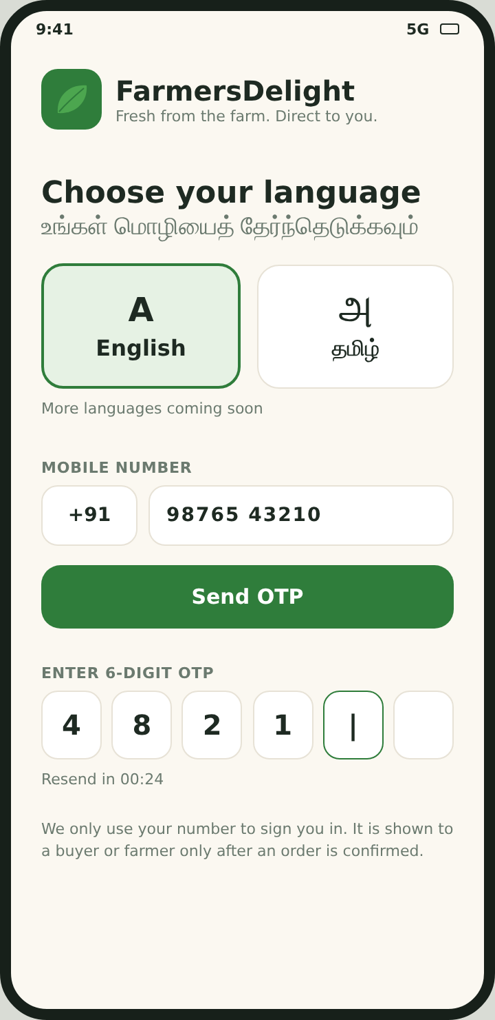  1. Language and sign-in | 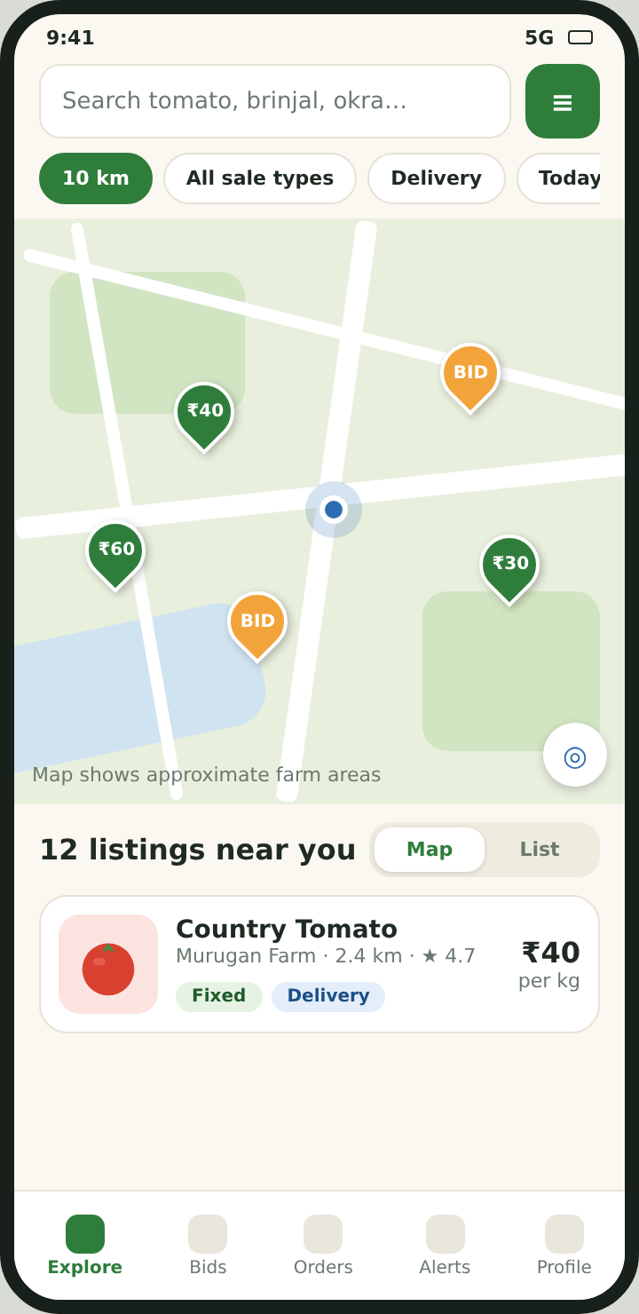  2. Consumer: nearby map
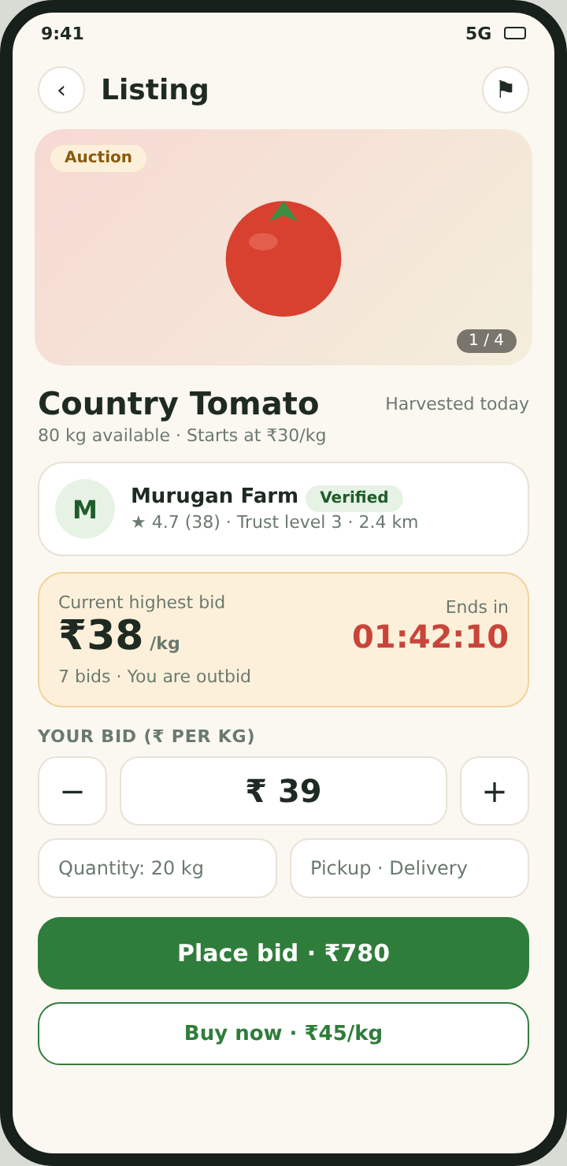  3. Listing detail (auction) | 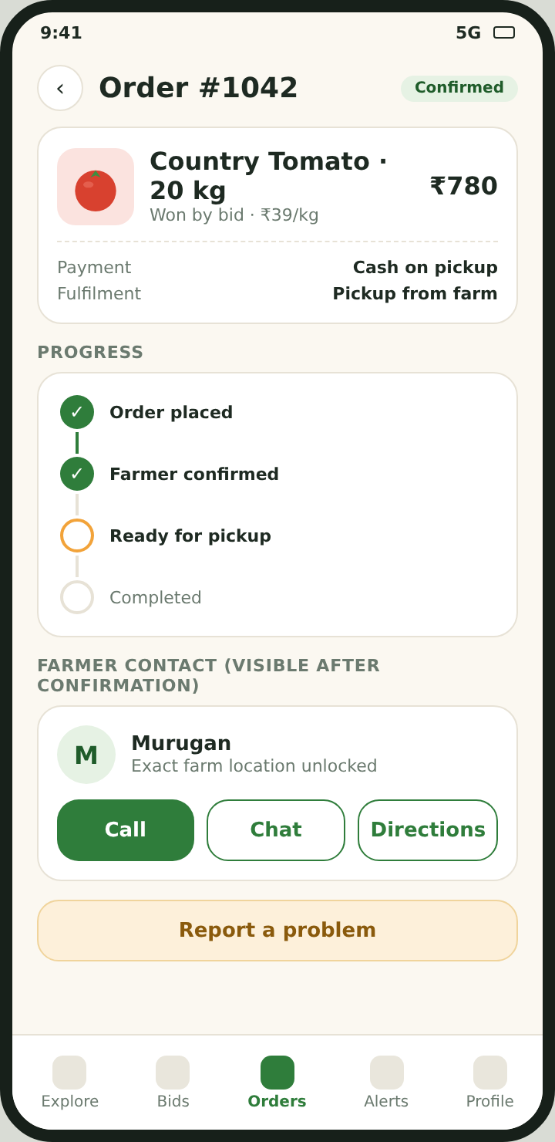  4. Order detail and contact unlock

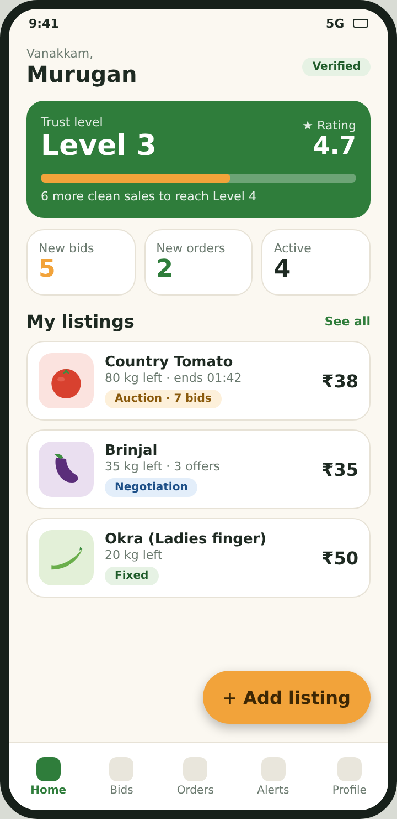  5. Farmer home and trust level | 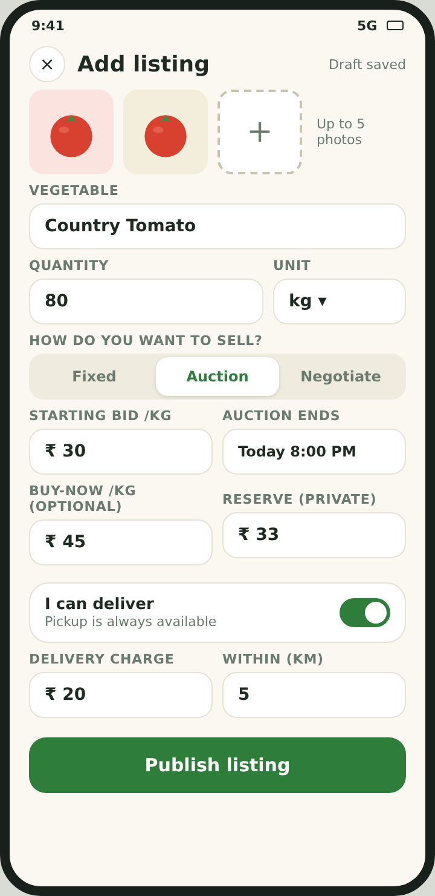  6. Add listing
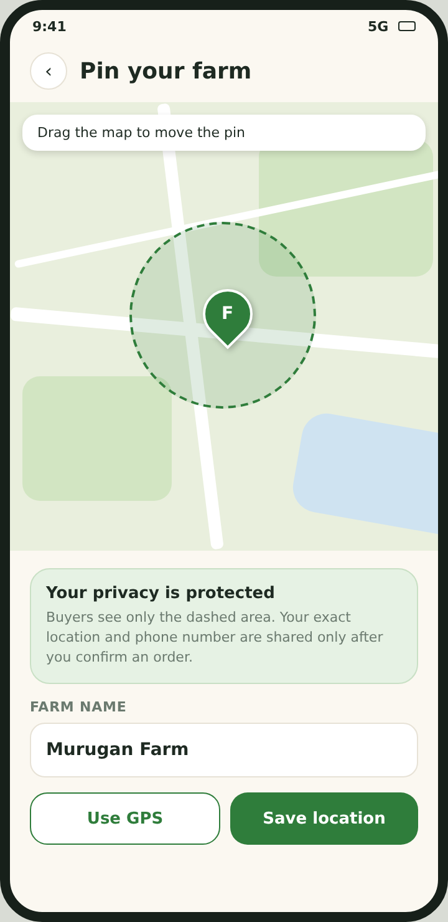  7. Pin your farm | 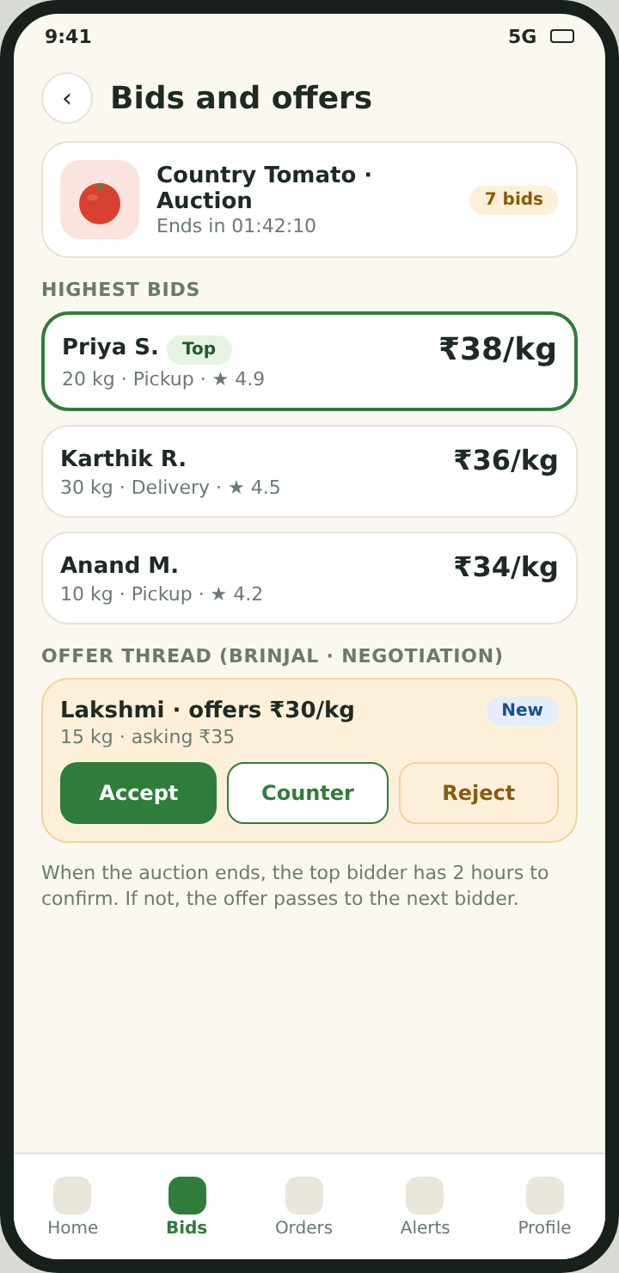  8. Bids and offers (farmer)

18. Non-functional requirements
Area | Requirement
Platform | Android first (minimum Android version to be set by development, covering low-cost devices). Cross-platform Flutter code base so iOS can follow.
Performance | Nearby search under about 2 seconds on 4G; image uploads compressed to a small size; list screens load in pages.
Offline | Farmers can draft listings offline and sync later; the app shows a clear offline message instead of failing silently.
Languages | English and Tamil at launch. All text externalised for easy addition of Telugu, Kannada, Malayalam and Hindi. Correct Tamil font rendering on all supported devices.
Accessibility | Large touch targets, high contrast, scalable text, icons with labels, simple language.
Reliability | Server-side validation for bids and orders; automatic jobs to close auctions and expire unconfirmed winners; daily database backups.
Scalability | Geo-indexed queries so nearby search stays fast as listings grow.

19. Security and privacy requirements
ID | Requirement
SEC-1 | Sign-in by mobile OTP through the authentication service. Sessions use short-lived tokens that are refreshed securely and stored in the device's secure storage.
SEC-2 | All traffic uses HTTPS. Data is encrypted at rest by the cloud platform.
SEC-3 | Row-level security is enabled on every table with deny-by-default rules, so users can read only their own orders, bids and chats.
SEC-4 | Bids and orders are created through server functions that validate every rule (price, quantity, time, ownership). The app cannot write directly to bid or order tables.
SEC-5 | Phone numbers stay in the authentication system and are never copied to public tables or views. Contact details are returned only for a confirmed order.
SEC-6 | The public farmer view excludes exact location, address and documents. Reserve price is never exposed to buyers.
SEC-7 | The app requests only the permissions it needs: location while in use, camera or photo picker for listing photos, and notifications. It does not request contacts, call logs, SMS or storage-wide access.
SEC-8 | No third-party advertising or behavioural tracking SDKs. Crash reporting and analytics, if used, are limited to anonymous technical data.
SEC-9 | Uploaded photos have location metadata removed. Verification documents are stored in a private bucket readable only by admins.
SEC-10 | Chat messages are limited in length, rate limited, and available only to the two parties of an order. Users can report abuse.
SEC-11 | Admin actions are logged. The admin panel uses a server key that never ships in the mobile app.
SEC-12 | Privacy policy and terms of use in English and Tamil; explicit consent for location; account deletion available in the app.
SEC-13 | OTP requests, sign-in attempts and bids are rate limited to prevent abuse.

20. Data model summary
The full SQL schema (farm_market_schema.sql) accompanies this document. Main entities:
Entity | Purpose and key fields
profiles | One row per user: role, name, language, blocked flag. Phone number is not stored here.
farmer_profiles | Farm name, exact location (private), public fuzzed location, verified flag, delivery offer, rating average and count, clean sales and trust level.
categories | Vegetable categories with English and Tamil names.
listings | Produce posted by a farmer: quantity, unit, sale mode, price fields, reserve (private), auction end, delivery options, public location, status.
listing_images | Up to 5 compressed photos per listing.
bids | Auction bids and negotiation offers and counters, with status and confirm-by time.
orders | Agreed quantity and price, fulfilment (pickup or delivery), cash payment, status, disputed flag.
messages | Chat between buyer and farmer for one order.
reviews, reports | Ratings after completed orders; reports about listings or users.
notifications, device_tokens | In-app notifications and push tokens.

21. Technical architecture
- Mobile app: Flutter, Android first. Clean architecture with a repository layer, local cache for offline drafts, and localisation files for English and Tamil.
- Backend: Supabase with PostgreSQL and PostGIS for distance queries, Supabase Auth for OTP, Storage for images and documents, Realtime for live bids and order updates, scheduled jobs for auction closing and expiry.
- Maps: Google Maps or Mapbox in the app; the map provider is chosen with cost and Tamil label support in mind.
- Push notifications: Firebase Cloud Messaging.
- Admin panel: Simple web dashboard using a server-side key and multi-factor login.
- Environments: Separate development, staging and production projects; database changes through versioned migrations.

22. Analytics and success metrics
Analytics are limited to anonymous, first-party counts needed to improve the product. Suggested measures:
- Activation: share of new farmers who post a first listing within 7 days; share of new consumers who open a listing within 7 days.
- Marketplace health: listings per active farmer per week; share of listings that sell; average time to first bid or offer.
- Trust: completed orders without dispute; average farmer rating; reports per 100 orders.
- Reliability: share of auction winners who confirm within 2 hours; share of orders cancelled.
- Performance: nearby search time; crash-free sessions.

23. Release plan
Phase | Scope
MVP (launch) | OTP sign-in, roles, English and Tamil, farmer location pin, three sale modes, nearby map and list, orders with cash payment, chat and call after confirmation, ratings, trust level, reports, push notifications, admin panel basics.
Phase 2 | Telugu, Kannada, Malayalam and Hindi; iOS app; optional UPI payments; delivery partner integration.
Phase 3 | Recurring orders and subscriptions, wholesale buyers, price trend insights, voice input in regional languages.
Suggested rollout: closed pilot with a small group of farmers and buyers in one district, then district-wide launch, then wider Tamil Nadu.

24. Quality and acceptance
- Every requirement above has a unique ID so test cases can trace back to it.
- Priority test areas: bid race conditions (two bids at the same time), auction end and winner hand-over, access rules (a user must never read another user's orders or contact), location fuzzing, OTP rate limits, offline drafts, Tamil text rendering on low-end devices, and low-bandwidth behaviour.
- A requirements traceability matrix and detailed test cases will be prepared from this document before development starts.

25. Open questions
- Rolling rating (can fall) versus the current lifetime average plus trust level that only grows. This document assumes the current design.
- Funding of running costs (SMS, maps, hosting) while the app stays free.
- Should delivery orders have a minimum order value or distance limit set by the platform?
- Which district will be the first launch area and which farmer groups can help with onboarding?
- Exact time for the auction confirmation window is 2 hours; confirm whether farmers may extend it for a specific order.

APPENDIX
Key user stories and acceptance criteria
ID | User story | Acceptance criteria
US-01 | As a farmer, I want to pin my farm on a map so that nearby buyers can find me. | Pin can be set by GPS and adjusted by dragging.  Buyers see a point shifted by 300 to 500 m, never the exact point.  Exact location is hidden until an order is confirmed.
US-02 | As a farmer, I want to choose how to sell each item so that I control the price. | Sale mode can be Fixed, Auction or Negotiation per listing.  Auction requires a starting bid and end time.  Reserve price is not visible to buyers.
US-03 | As a farmer, I want to offer delivery only when I can so that I am not forced to deliver. | Delivery toggle is off by default.  When on, charge and maximum distance are required.  Pickup is always available.
US-04 | As a consumer, I want to see farmers near me so that I buy fresh produce nearby. | Listings within the chosen radius appear on map and list.  Each card shows distance, price, mode and delivery badge.  My location is not stored.
US-05 | As a consumer, I want to bid in an auction so that I can get a good price. | A bid must beat the current top bid.  Two simultaneous bids are processed in order; only one becomes top.  Outbid user receives a push notification.
US-06 | As an auction winner, I want time to confirm so that I can arrange pickup. | Winner has 2 hours to confirm after the auction ends.  Reminder is sent before the window closes.  If not confirmed, the offer passes to the next bidder.
US-07 | As a buyer or farmer, I want to negotiate so that we reach a fair price. | Offer, accept, reject and counter actions are available.  Accepting creates an order at the agreed price and quantity.
US-08 | As a user, I want my phone number protected so that strangers cannot contact me. | Phone numbers are never shown on listings or profiles.  Number is revealed to the other party only after the order is confirmed.
US-09 | As a buyer, I want to rate the farmer so that others can trust good farmers. | Review allowed only after a completed order.  One review per order per person.  Farmer's star average updates.
US-10 | As a farmer, I want a trust level so that reliable sellers stand out. | Level increases by 1 for every 10 completed orders without dispute.  Disputed orders are not counted and levels are never removed.  Dashboard shows progress to the next level.
US-11 | As a Tamil-speaking user, I want the app in Tamil so that I can use it easily. | Language can be chosen at first launch and in settings.  All screens and notifications appear in the chosen language.  Tamil text renders correctly.
US-12 | As an admin, I want to handle reports so that the community stays safe. | Reports list shows reason, user and listing.  Admin can mark an order disputed, remove a listing or block a user.  Actions are logged.

