Name: | Date:
Module 2
CompTIA Security+ Exam Objectives
Domain | Lab
Threats, Vulnerabilities, and Mitigation | 2.1, 2.2, 2.3, 2.4, 2.5
Security Architecture | 2.4
Security Operations | 2.5
Security Program Management and Oversight | 2.3
Website links change frequently. If a link in the following activities no longer works, use a search engine such as Google or Bing to search for the information.

Lab 2.4 Using Windows Sandbox

Estimated Time: 45 minutes

Objectives
The Windows Sandbox feature is a virtual machine that allows you to install, run, and test programs safely. For example, you can run software patches in Windows Sandbox to ensure they are safe before installing them in a production system. You can also safely visit websites without the risk of downloading malware to your main system. Windows Sandbox offers the benefits of using a virtualized environment without downloading and installing third-party software.
This lab assumes that you have Windows Sandbox set up and available on your system. If not, complete Project 1-2 in Module 1 of the Security+ text.
After completing this lab, you will be able to do the following:
- Define the use of a virtualized environment.
- Identify the components necessary to install and run a virtual environment.

Certification Objectives
Objectives for the CompTIA Security+ exam:
- 2.3 Explain various types of vulnerabilities.
- 3.1 Compare and contrast security implications of different architecture models.

Materials Required
This lab requires the following:
- A computer running Windows 11 Pro or higher

Activity
In this lab, you work in the Windows Sandbox environment.
- You already set up Windows Sandbox in Hands-On Project 1-2. Verify that Windows Sandbox is enabled on your device by doing the following:
- Click Start on the taskbar and then click Settings.
- Click Apps in the left pane.
- Click Optional features.
- Scroll down and then click More Windows features.
- In the Windows Features dialog box, scroll down and check whether Windows Sandbox is on the features list.
- If it is not listed, complete Hands-On Project 2-1 to set up Windows Sandbox.
- If it is listed but not checked, click to insert a checkmark in the box.
See Figure 2-1.
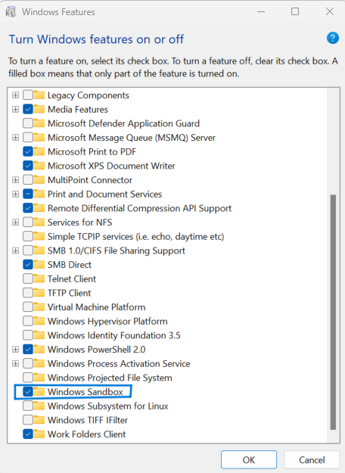
- Make sure UEFI (Unified Extensible Firmware Interface) firmware is enabled on Windows 11. If not, perform the following steps:
- Click the Search box on the taskbar, type settings, and then click Settings to open the Settings app.
- On the System window, click Recovery, click Restart now, and then click Restart now again.
- Click Troubleshoot, click Advanced Options, and then click UEFI Firmware Settings.
- Click Restart.
- In the Advanced section (which might be called Configuration or Security, depending on your computer’s manufacturer), select Virtualization Technology (which might appear as Intel Virtualization Tech or SVM Mode).
- Enable the virtualization feature and then save the UEFI settings.
- Restart the computer.
- You are now ready to use Windows Sandbox to download, install, run, and test programs in a safe way.
- Click Start on the taskbar, type Windows Sandbox, and then press Enter. Windows Sandbox opens as a window on the desktop.
- Use a web browser to go to https://www.wireshark.org. Wireshark is a network protocol analyzer, and your company, school, or personal computer might block the download and installation. Using Windows Sandbox will allow you to download, install, and run the program in a safe environment.
- Click the Get started button and download the most recent stable release of Wireshark.
- Click the File Explorer icon on the taskbar to open File Explorer and then navigate to the folder where you downloaded Wireshark.
- Copy and paste the program file to the Windows Sandbox desktop and then install it and run it in Windows Sandbox.
- Open Wireshark. Did it open and work? Did you see packets going through?

- You can also use the Windows Sandbox to navigate to untrusted websites in a safe manner. If you received a phishing email message with a link and would like to navigate to it, record the URL of the phishing website, go to the Windows Sandbox, open a browser, and navigate to the suspicious website from there. This will prevent infecting your system if the website contains malicious software.
- Close Windows Sandbox.
- When asked if you are sure you want to close Windows Sandbox, click OK. All the files you download, create, or use in the sandbox will be discarded and permanently lost, as shown in Figure 2-2. This helps prevent an attack or infecting the main system.
