Name: | Date:
Module 3
CompTIA Security+ Exam Objectives
Domain | Lab
General Security Concepts | 3.1, 3.2, 3.3, 3.5
Threats, Vulnerabilities, and Mitigation | 3.4, 3.5
Security Operations | 3.4
Security Program Management and Oversight | 3.5
Website links change frequently. If a link in the following activities no longer works, use a search engine such as Google or Bing to search for the information.

Lab 3.4 Configuring BitLocker To Go

Estimated Time: 40 minutes

Objectives
BitLocker is a full-drive encryption option available in most versions of Windows 11 (Windows Pro and Enterprise have it, but not Home) and older Windows versions have the functionality as well. BitLocker protects a hard drive at the hardware level, relying on a Trusted Platform Module (TPM) chip or a USB storage device as the hardware key for booting the hard drive. Without these hardware keys in place, the hard drive will be inaccessible. BitLocker is also available for portable devices, such as flash drives, to encrypt the entire device and protect it with a password or smart card. It is important to keep the recovery key protected, as it provides the same access as having the password or physically having the smart card.
After completing this lab, you will be able to do the following:
- Implement BitLocker To Go.

Certification Objectives
Objectives for the CompTIA Security+ exam:
- 2.5 Explain the purpose of mitigation techniques used to secure the enterprise.
- 4.1 Given a scenario, apply common security techniques to computing resources.

Materials Required
This lab requires the following:
- A computer running Windows 10 or 11 Professional or the Windows Sandbox Environment created in Lab 2.4
- A USB flash drive

Activity
In this lab, you configure BitLocker To Go on a flash drive.
- Insert a USB flash drive into a USB port on your computer.
- Open File Explorer and examine the flash drive icon and its connection notifications. Note how it looks to later compare it to the locked and encrypted drive.
- On the Windows taskbar, click the Search box and type BitLocker.
- In the search results, click Manage BitLocker. The BitLocker Drive Encryption window opens, as shown in Figure 3-1. Your drives will differ.
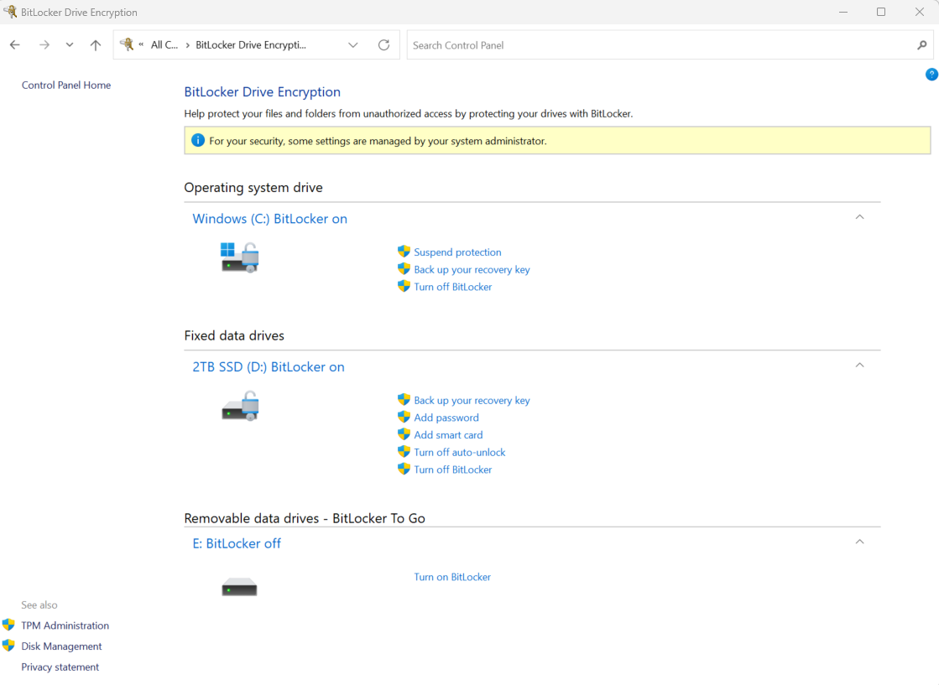
- Review the type of protection your system is using. For example, Figure 3-1 shows an Operating system drive, a Fixed data drive, and a Removable data drive labeled as BitLocker To Go.
- Click Turn on BitLocker in the Removable data drives section to open the BitLocker Drive Encryption window.
- Click the Use a password to unlock the drive check box to choose how to unlock this drive.
- Enter W3lcome! as the password, reenter your password, and then click Next.
- Select Save to a file as the way to back up your recovery key.
- Select Desktop as the file location, keep the default filename, click Save, and then click Next.
- If you receive the error message “This location can’t be used. Your recovery key can’t be saved to an encrypted drive. Choose a different location.”, select a different drive.
- Click Next to select the default option for how much of your drive to encrypt and then click Next to accept the default encryption mode to use.
- When asked “Are you ready to start encrypting this drive?”, click Start encrypting. This step might take a few minutes, depending on the contents of the drive.
- When the message “Encryption of <drive> is complete” is displayed, click the Close button to display the Removable data drives - BitLocker To Go window listing options for the USB drive, as shown in Figure 3-2.
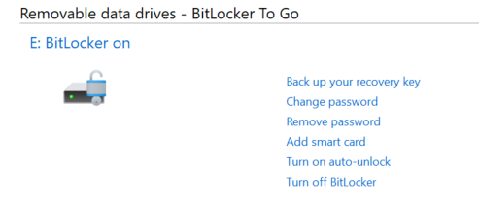
- Examine the options and then close the BitLocker Drive Encryption window.
To compare and use the BitLocker To Go USB flash drive:
- Click the Show hidden icons button on the taskbar, click the Safely Remove Hardware and Eject Media icon, and then eject your USB flash drive.
- Remove your flash drive, then reinsert it.
- Open File Explorer. What is different about the USB flash drive icon and its connection notifications compared to the original flash drive?
- In File Explorer, click your flash drive. What happens?
- Enter an incorrect password and then click Unlock. What happens?
- Enter the correct password, then click Unlock.
- Open your recovery key file and copy the recovery key to the Clipboard.
- Eject, remove, and reinsert your flash drive.
- Select your flash drive, click More options, and then click Enter recovery key to view that option in the BitLocker dialog box, as shown in Figure 3-3. You can also use this dialog box to unlock the USB drive by entering a password.
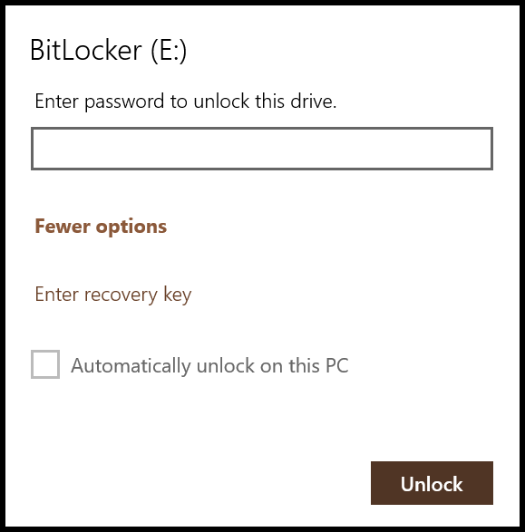
- Paste the recovery key in the text box and then click Unlock to unlock the drive using a recovery key. What could happen if your recovery key file was not protected properly?
- Make sure to safeguard the BitLocker Recovery Key file and then safely remove the USB flash drive.

