Name: | Date:
Module 4
CompTIA Security+ Exam Objectives
Domain | Lab
General Security Concepts | 4.1, 4.2, 4.3, 4.4, 4.5
Website links change frequently. If a link in the following activities no longer works, use a search engine such as Google or Bing to search for the information.

Lab 4.4 Creating and Using a Digital Signature in
Microsoft Word

Estimated Time: 30 minutes

Objectives
Digital certificates house the public key for a user in addition to a digital signature, providing both identification and nonrepudiation. Obtaining a personal digital signature and certificate for free to sign emails and documents is no longer as easy as it used to be. Instead, you can create a self-signed digital signature, allowing you to digitally sign your documents with a tool built into the Microsoft Office suite. However, this tool does not provide verification of your identity to anyone else.
After completing this lab, you will be able to do the following:
- Create a self-signed digital signature certificate.
- Apply a digital signature certificate in Microsoft Word.

Certification Objectives
Objectives for the CompTIA Security+ exam:
- 1.4 Explain the importance of using appropriate cryptographic solutions.

Materials Required
This lab requires the following:
- A computer running Windows 10 or 11 and Microsoft Word

Activity
In this lab, you create a self-signed digital signature certificate and apply it in Word.
- Open File Explorer to navigate to a tool for creating a self-signed certificate.
- Navigate to C:\Program Files\Microsoft Office\root\Office16 to locate the SELFCERT program.
- Double-click SELFCERT.exe to open the program to create a self-signed digital certificate.
- Enter your name and click OK to create a certificate, as shown in Figure 4-1.
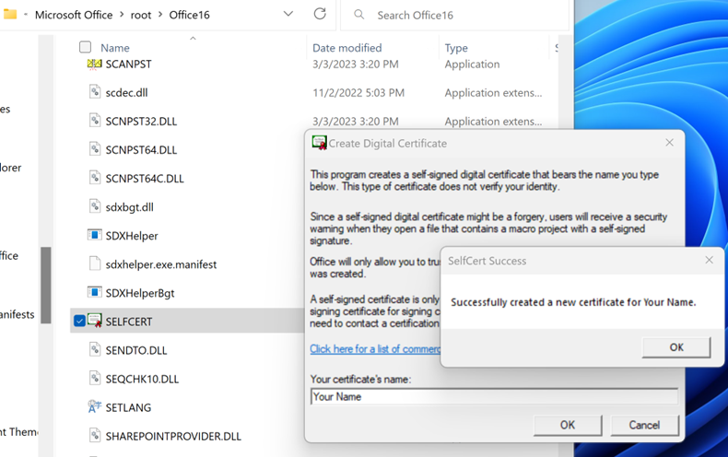
- Click OK to close the SELFCERT Success dialog box after creating your certificate.
- Start Microsoft Word and open a blank document.
- Click Insert on the ribbon and then click the Signature Line button to open the Signature Setup dialog box.
- Type your name for the Suggested signer, type Student for the Suggested signer’s title, and type your email address for the Suggested signer’s e-mail address. See Figure 4-2.
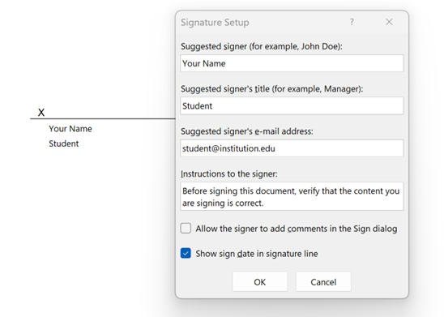
- Click OK to save the signature setup.
- Click File and then click Save As to save the file. Select This PC as the location, enter TestSignature as the filename, and then click Save to save the file.
- Double-click the signature block to open the Sign dialog box.
- Type your name in the signature box and then click Sign to sign in the signature block. See Figure 4-3.
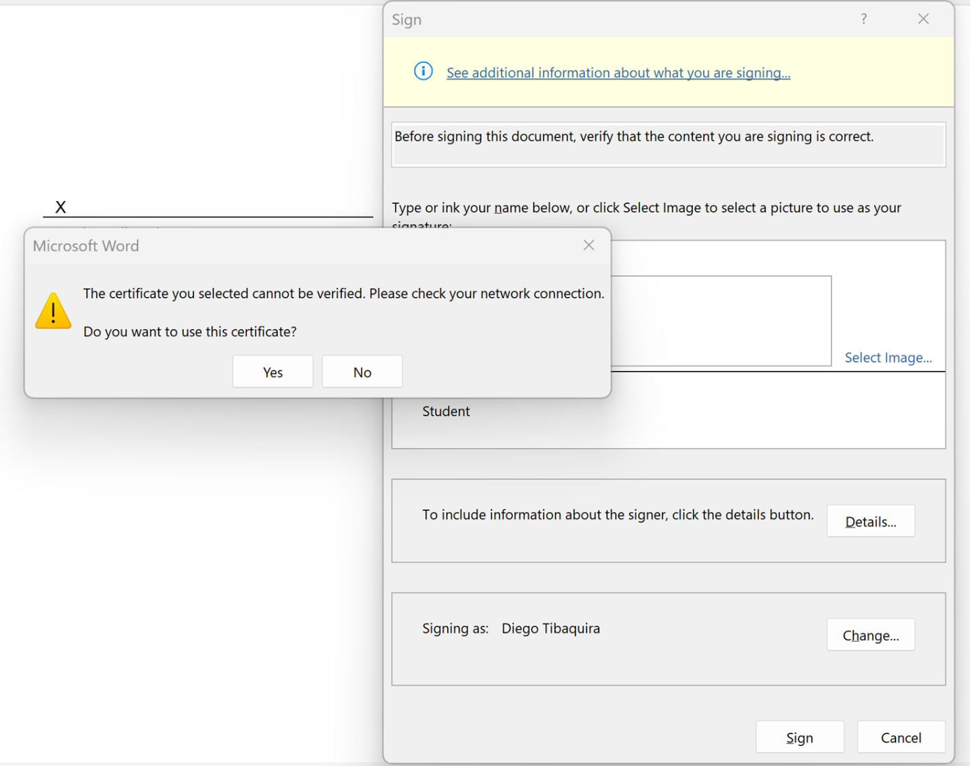
- Click Yes to continue using the self-signed certificate, which will not be verified as a CA did not issue it.
- Click OK to confirm that the signature has been successfully saved. What happens to the document when it is signed?
- Click Edit Anyway and then try to edit the document. What happens when you do this?
- Click No to retain the signature and not allow changes.
- Close TestSignature.docx and then reopen it. If you sent this document to other people, could they edit it?
- Close Microsoft Word.

