Name: | Date:
Module 6
CompTIA Security+ Exam Objectives
Domain | Lab
Threats, Vulnerabilities, and Mitigation | 6.1, 6.2
Security Architecture | 6.2, 6.4
Security Operations | 6.1, 6.2, 6.3, 6.4, 6.5
Website links change frequently. If a link in the following activities no longer works, use a search engine such as Google or Bing to search for the information.

Lab 6.1 Transferring Files Using Bluetooth

Estimated Time: 30 minutes

Objectives
Bluetooth technology was created in 1994 as an alternative to RS-232 cabling. The technology uses radio waves transmitted over a short distance. Bluetooth can be used to exchange data between devices. A device must be in discoverable mode to pair with another and exchange information. Bluetooth can be used for data transfer, location services, device networks, and audio streaming, which is one of the most popular applications today for using wireless headsets.
After completing this lab, you will be able to do the following:
- Use Bluetooth to pair a computer and a smartphone.
- Use Bluetooth to transfer a file between a computer and a smartphone.

Certification Objectives
Objectives for the CompTIA Security+ exam:
- 2.3 Explain various types of vulnerabilities.
- 4.1 Given a scenario, apply common security techniques to computing resources.

Materials Required
This lab requires the following:
- A computer running the Windows operating system and a smartphone.

Activity
In this lab, you use Bluetooth to configure a connection between a computer and a smartphone.
- Open File Explorer, go to the Documents folder, and use Word or Notepad to create a text document named Test File. Open the file, type This is a Test File, and then save and close the file. You will transfer this file to your phone.
- On the smartphone, make sure Bluetooth is turned on. On an iPhone, open Settings and then check the Bluetooth setting. On other phones, you might need to open Settings and then open Connections to make sure Bluetooth is turned on. If it is not, tap Bluetooth and then tap the slider.
- On the computer, click the Search box on the Windows taskbar, type Bluetooth, and then press Enter. In the Devices window, make sure that Bluetooth is on. If it is not, click the Off slider for the Bluetooth setting. If your smartphone is not listed as a paired device in the Other devices section, continue with steps 4–6. Otherwise, skip ahead to step 7.
- In the Devices window, click the Add device button. In the Add a device dialog box, click Bluetooth. Windows scans the network to discover any Bluetooth devices within range and lists them as shown in Figure 6-1.
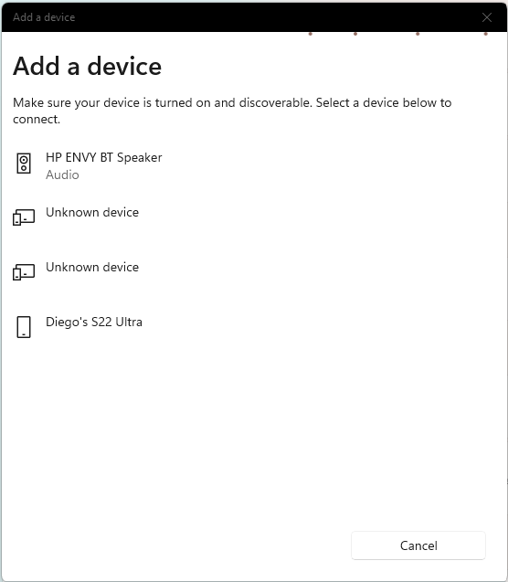

- Click the smartphone in the list of devices. A PIN is displayed to establish the connection, as shown in Figure 6-2. Check the phone to make sure the PINs match.
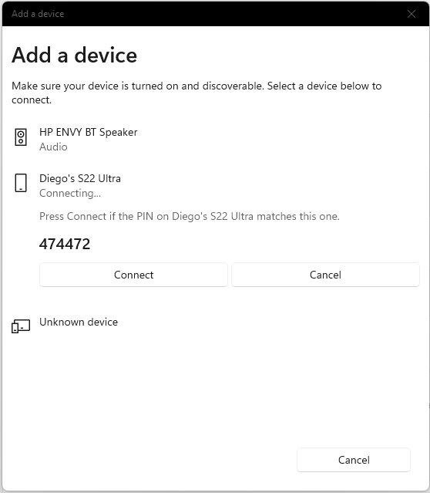
- Click the Connect button on the computer and tap the Pair button on the smartphone to connect the devices. When a message on the computer indicates your device is ready to go, click Done. Check the Bluetooth setting on the computer and on the smartphone to verify the devices have been paired.
- Scroll the Devices window to display the Send or receive files via Bluetooth setting shown in Figure 6-3.
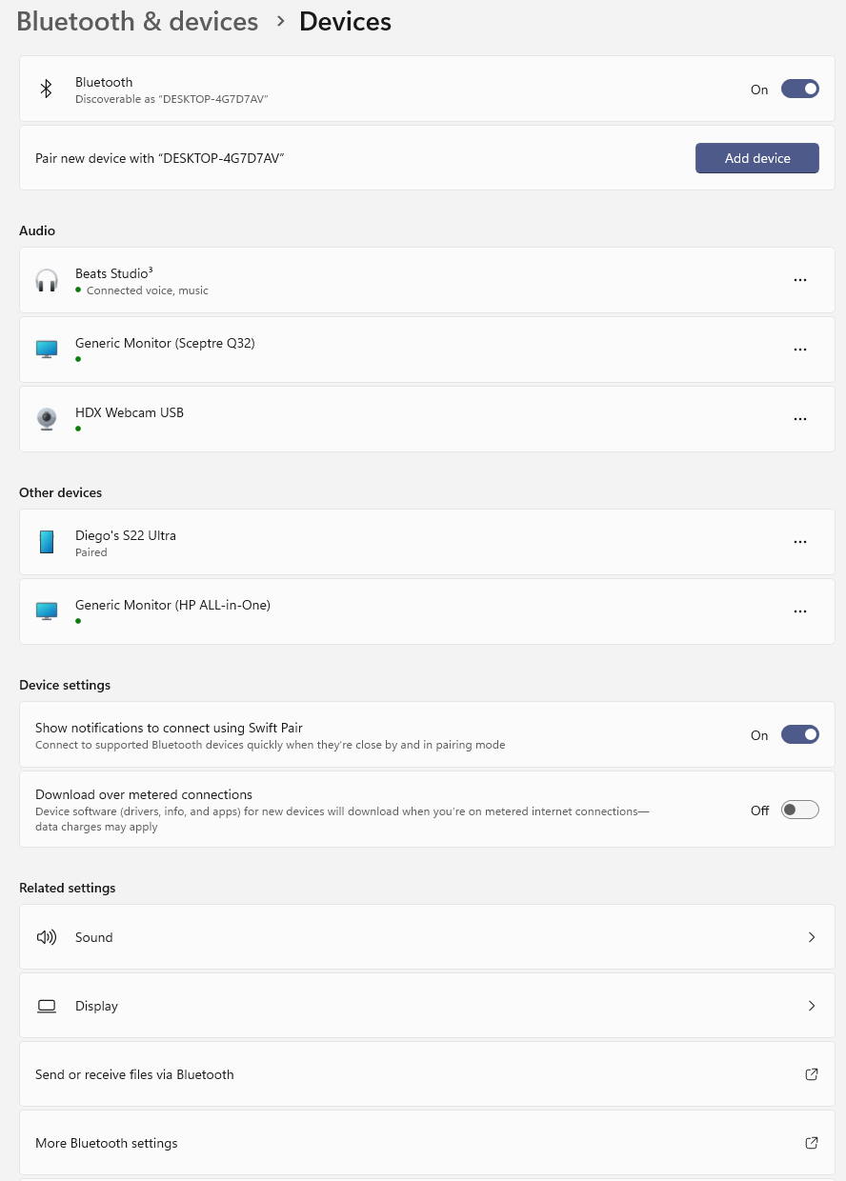
- Click Send or receive files via Bluetooth to start the Bluetooth File Transfer Wizard and open the Transfer files using Bluetooth dialog box, as shown in Figure 6-4.
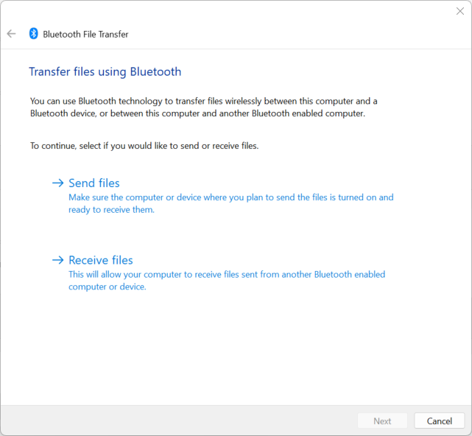
- Click Send files to display devices where you can send files.
- Click the smartphone you have paired with the computer and then click Next.
- In the Select the files to send dialog box, click Browse. Navigate to the folder where you created the Test File document, if necessary. Click Test File, and then click Open.
- Click Next to send the file to your smartphone.
- When a message to accept or decline the file appears on your smartphone, click Accept.
- The File successfully transferred dialog box is displayed on the computer, as shown in Figure 6-5. Click Finish.
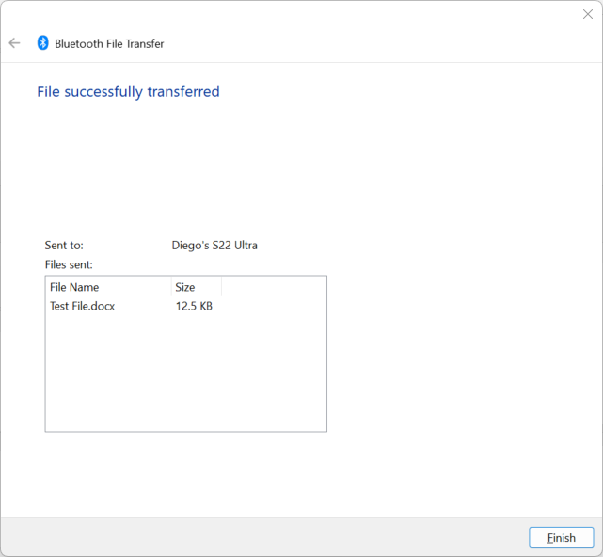
- When your smartphone indicates it received a file, open the Downloads folder on your phone and find the file.
- On your smartphone, open the Test File using a text-editing app. (If no text-editing apps are installed on your smartphone, you can install one to view and edit the file.) Read the file to confirm it contains the text This is a Test File and then close it.
You can also transfer a file from your smartphone to your computer.
- In the Devices window on your computer, click Send and receive files via Bluetooth.
- Click Receive files to open the Waiting for a connection dialog box.
- Select an image from your phone’s photo gallery.
- Tap the Share icon or the More options (three vertical dots) icon to display sharing options. You might need to tap More to see all sharing options.
- Click Bluetooth.
- On the Select Devices menu, tap the name of your computer. Windows indicates it is receiving a file.
- When an option to Save the received file to a folder in the computer appears, click Finish to save the file in the Documents folder.
- Navigate to the Documents folder on your computer to verify the image file was transferred successfully.
- Bluetooth is convenient but has security vulnerabilities. What are some security vulnerabilities of using Bluetooth? Write a one-page response detailing the possible vulnerabilities of using Bluetooth and ways to make it more secure. Submit the document to your instructor.
- Close all windows and unpair the devices.

