Name: | Date:
Module 8
Labs included in this module
CompTIA Security+ Exam Objectives
Domain | Lab
Threats, Vulnerabilities, and Mitigation | 8.1, 8.5
Security Architecture | 8.1, 8.2, 8.3, 8.4, 8.5
Security Operations | 8.2, 8.3, 8.4, 8.5

Lab 8.2 Installing the Windows Version of Kali Linux – Win-KeX

Estimated Time: 45 minutes

Objectives
One benefit of the open-source movement is the availability of high-quality, free tools for use by systems administrators, network engineers, and information security specialists. One of these tools is Kali Linux. Kali Linux can be installed on a hard drive or used as a VMware instance, meaning that you can load Kali Linux into VMware without affecting the operating system installed on the computer’s hard drive. Kali Linux contains a set of penetration-testing tools that run on a version of the Linux operating system. Penetration test teams are authorized to explore a network to try to find vulnerabilities that can be exploited. With this information, organizations can determine how effective their security controls are and how they can improve security.
Win-KeX provides a full Kali desktop experience for the Windows subsystem for Linux (WSL2). Applications started via the Kali panel share the desktop with Microsoft Windows applications. The WSL2 includes tools, utilities, and applications that can run on your Windows system.
You can reference the following websites for more information: https://learn.microsoft.com/en-us/windows/wsl/about and https://learn.microsoft.com/en-us/windows/wsl/compare-versions.
After completing this lab, you will be able to do the following:
- Load and configure Kali Linux in Windows.
- Identify components of Kali Linux.

Certification Objectives
Objectives for the CompTIA Security+ exam:
- 3.2 Given a scenario, apply security principles to secure enterprise infrastructure.
- 4.4 Explain security alerting and monitoring concepts and tools.

Materials Required
This lab requires the following:
- A computer running the Windows operating system with Internet access

Activity
In this lab, you install and run the Windows version of Kali Linux, Win-KeX.
- Type Kali Linux in the Search box on the taskbar to make sure Kali Linux is already installed in Windows 11. If not, you can go to the Microsoft Store, search for Kali Linux, and download it for no charge.
- In the Search box on the taskbar, type PowerShell.
- Right-click Windows PowerShell app in the search results and then click Run as administrator on the shortcut menu as shown in Figure 8-1. Your screen may differ.
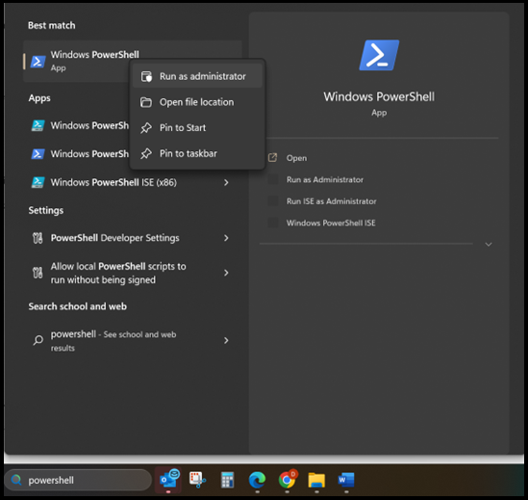
Figure 8-1
- Type wsl --install -d kali-linux and press Enter to install Kali Linux.
- Create a username and password when prompted. When the Kali Linux command line appears as shown in Figure 8-2, you are ready to use Kali Linux.
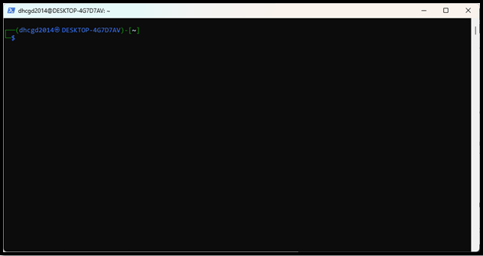
Figure 8-2
- Run the following commands to update Kali Linux on WSL2. In these commands, sudo stands for “super user do” and allows you to run all commands as root.
- sudo apt-get dist-upgrade
- sudo apt-get update
- Run the following command to install the cybersecurity tool Metasploit, a powerful tool used by network security professionals to do penetration tests, by system administrators to test patch installations, by product vendors to implement regression testing, and by security engineers across industries.
sudo apt-get install metasploit-framework
Many more tools are available that can be used with Kali Linux. For a more detailed list, visit https://www.kali.org/tools/.
To troubleshoot your installation, go to the following websites:
https://www.kali.org/docs/wsl/wsl-preparations/#enabling-wsl2-with-set-version

https://www.kali.org/blog/kali-linux-in-the-windows-app-store/
https://learn.microsoft.com/en-us/windows/wsl/install-manual
The version of Kali Linux you just installed provides the command-line interface shown in Figure 8-2. In the following steps, you install and run the full Desktop Kali Linux Experience (Win-KeX – Kali Desktop Experience for Windows). Win-KeX is the graphical user interface version of Kali Linux for Windows.
- Run the following commands at the Kali Linux command prompt, pressing Enter after each command:
- sudo apt update
- sudo apt install -y kali-win-kex
- kex –win -s
The last command starts the desktop version of Kali Linux on Windows and includes two hyphens, not a long dash.
- If the result is an error connecting to the KeX server, enter the following command:
kex –esm –ip –sound
The command contains sets of two hyphens, not long dashes.
- In the Remote Desktop Connection box, click the Connect button.
- Click Yes to verify the remote computer to display the full desktop version of Kali Linux as shown in Figure 8-3.
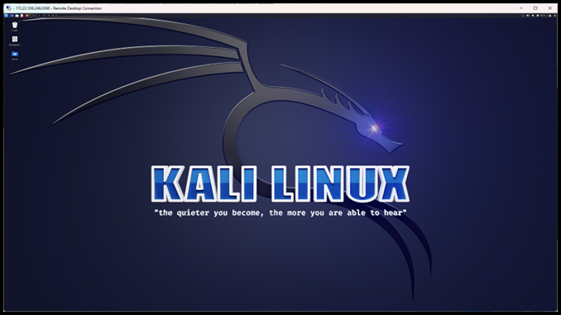
Figure 8-3
- Log out of the Kali Linux desktop version.
- On the Kali Linux command line, type kex kill and press Enter to stop running the Win-KeX environment.
- Exit and close any Kali Linux command-line windows and PowerShell windows by typing exit on the command line and then pressing Enter.
To troubleshoot the Kali Linux desktop version, go to https://www.kali.org/docs/wsl/win-kex/.
You can also download and install Windows Terminal from the Microsoft Store, which combines the command prompt, PowerShell, and WSL in one window. This might make it easier to go from PowerShell to Kali Linux and the command prompt.

