Name: | Date:
Module 8
CompTIA Security+ Exam Objectives
Domain | Lab
Threats, Vulnerabilities, and Mitigation | 8.1, 8.5
Security Architecture | 8.1, 8.2, 8.3, 8.4, 8.5
Security Operations | 8.2, 8.3, 8.4, 8.5

Lab 8.3 Using the Kali Linux Hping3 Tool with Wireshark

Estimated Time: 30 minutes

Objectives
One of the first stages of an attack is probing the target network to determine what services are running, what operating systems are in use, and what resources are accessible. Attackers often craft packets to evade security devices such as firewalls and intrusion detection systems. Using Hping3, you can test firewall rules, perform (spoofed) port scanning, test network performance using different protocols, do path maximum transmission unit (MTU) discovery, perform traceroute-like actions under different protocols, fingerprint remote operating systems, and audit TCP/IP stacks.
You can use the Kali Linux Hping3 tool with Wireshark to see and capture network traffic.
Wireshark is software you can use for learning purposes. Government agencies, businesses, and corporations can use it for packet capturing, filtering, and visualization to troubleshoot network issues.
After completing this lab, you will be able to do the following:
- Define the Hping3 tool and options to run with Hping3.
- Use Wireshark to identify packets crossing the network.

Certification Objectives
Objectives for the CompTIA Security+ exam:
- 3.2 Given a scenario, apply security principles to secure enterprise infrastructure.
- 4.1 Given a scenario, apply common security techniques to computing resources.
- 4.4 Explain security alerting and monitoring concepts and tools.

Materials Required
This lab requires the following:
- A computer running the Windows operating system with Internet access
- Windows version of Kali Linux (command prompt or desktop version) installed in Lab 8.2
- Installation of Wireshark

Activity
In this lab, you use the Hping3 tool in Kali Linux with Wireshark to see and capture network traffic.
- If you don’t have Wireshark installed, download it from www.wireshark.org. Once downloaded, install it so it is ready to use.
- In the Search box on the taskbar, type Wireshark, right-click Wireshark in the search results, and then click Run as administrator to start Wireshark as an administrator. Click Yes when asked if you want to allow this app to make changes to your device.
- In the Search box on the taskbar, type Kali Linux, right click Kali Linux in the search results, and then click Run as administrator to start Kali Linux as an administrator. Click Yes when asked if you want to allow this app to make changes to your device.
As an alternative, if you installed Windows Terminal, you can open it as an administrator and work from there.
- At the Kali Linux shell prompt, type sudo apt-get install hping3 and press Enter to make sure that Hping3 is installed. If the system asks for a password, enter the password you created during installation in Lab 8.2.
- To display all the commands and options available with Hping3, type hping3 --help using two hyphens rather than a long dash and press Enter.
- In the command results, examine the syntax and options available in Hping3. The sections titled IP, ICMP, and UDP/TCP include options that allow you to craft packets. For example, in the UDP/TCP section, you can use the –s option to specify a port address, the –R option to set a reset flag, or the –O option to set a faked TCP data offset. Use the hping3 --help command to display the help screen with all the options, as shown in Figure 8-4.
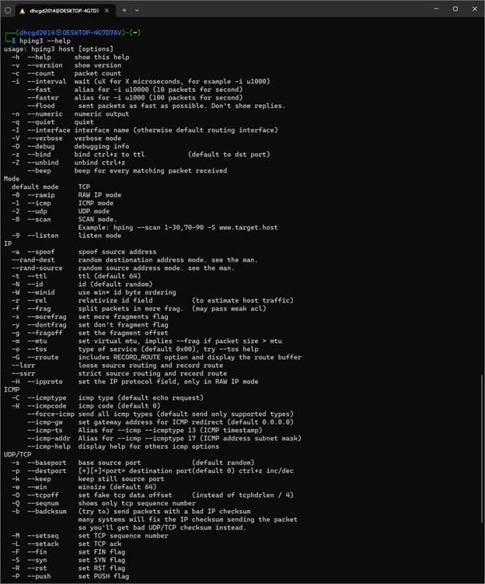
Figure 8-4

- Open a Windows command prompt by typing cmd in the Search box and pressing Enter. If you are using the Windows Terminal, open it in a new tab.
- Type ipconfig and press Enter. Note your Ipv4 address (i.e., 192.168.149.1).
- Go back to the Kali Linux command prompt, type sudo hping3 -S 192.168.149.1, and then press Enter. Replace the IP address in italics with your Ipv4 address from the previous step.
- In Wireshark, click the blue start capturing packets icon (a shark fin) to start capturing packets. If the icon is dimmed, you need to select an interface. Since this is a WSL version of Linux, select vEthernet (WSL). You can go through the list until you start seeing packets.
If you have multiple interfaces, you must select which ones to capture by clicking one or dragging to select more than one.
- In Wireshark, click the red square to stop capturing packets. Click the shark fin icon to start capturing packets again.
- At the Kali Linux command prompt, type sudo hping3 -S 192.168.149.1 -p 80 -c 5 and press Enter to send some packets to port 80.
- In Wireshark, click the red square to stop capturing packets.
- Review the Wireshark results, including the source and destination IP addresses and the protocol. Click the first line that shows your IP address as the source. On the bottom screen, expand the Internet Protocol Version 4 line. Expand the Transmission Control Protocol line and find the source port (which should be 80).
- Close Wireshark and then exit Kali Linux.

