Name: | Date:
Module 8
CompTIA Security+ Exam Objectives
Domain | Lab
Threats, Vulnerabilities, and Mitigation | 8.1, 8.5
Security Architecture | 8.1, 8.2, 8.3, 8.4, 8.5
Security Operations | 8.2, 8.3, 8.4, 8.5

Lab 8.4 Setting Up and Connecting to a VPN in Windows 11

Estimated Time: 30 minutes

Objectives
Today’s computing environment demands secure communications. To create an encrypted connection over the Internet from any device to a network, you can use a virtual private network (VPN). Having an encrypted connection guarantees that sensitive data is safely transmitted. Users can work remotely in a safer manner because the VPN prevents unauthorized people from eavesdropping on their traffic. VPN technology is widely used in corporate environments. A VPN helps extend the office environment by allowing users to use a secure connection over the Internet.
There are two main types of VPNs: remote access and site-to-site. A remote access VPN connects any device (desktop, laptop, tablet, or smartphone) from a remote location to the corporate office in a secure manner. After the VPN connection is set, all communications between the remote computer and the corporate office are encrypted and transmitted through a private tunnel.
A site-to-site VPN connects corporate offices directly to branch offices over the Internet when the geographical location of the offices is far apart (as in multi-city or multi-country locations).
VPNs extend a network in a way that is private and secure, allowing companies to work and communicate beyond geographical barriers. VPN apps can provide VPN communication, though they might come at a cost or inconvenience if the apps malfunction. In this lab, you set up a VPN using the built-in Windows option.
After completing this lab, you will be able to do the following:
- Create a secure VPN connection in Windows 11.
- Identify the components of a VPN connection in Windows 11.

Certification Objectives
Objectives for the CompTIA Security+ exam:
- 3.2 Given a scenario, apply security principles to secure enterprise infrastructure.
- 4.1 Given a scenario, apply common security techniques to computing resources.
- 4.5 Given a scenario, modify enterprise capabilities to enhance security.

Materials Required
This lab requires the following:
- A computer with Internet access running the Windows operating system
- A VPN server address and an account (username and password)

Activity
In this lab, you use a manual configuration for a virtual private network in Windows 11.
- In the Search box on the taskbar, type settings and then click the Settings app in the search results.
- In the left pane, click Network & Internet.
- In the right pane, click the VPN option.
- In the VPN connections section, click the Add VPN button.
- Click the VPN provider arrow, and then select Windows (built-in).
- In the Connection name box, type the name for this connection (i.e., My VPN Connection).
- In the Server name or address box, enter the address of the VPN server. You can use the IP address, such as 145.12.46.127, or the domain name, such as www.vpnserver.com.
- Click the VPN Type arrow and then select Automatic.
If you need a specific type, you can select it from the other options. If you are applying this to a specific provider, their settings will determine the type.
- Confirm the username and password for the VPN connection and then click the Save button. Figure 8-5 displays the complete settings.
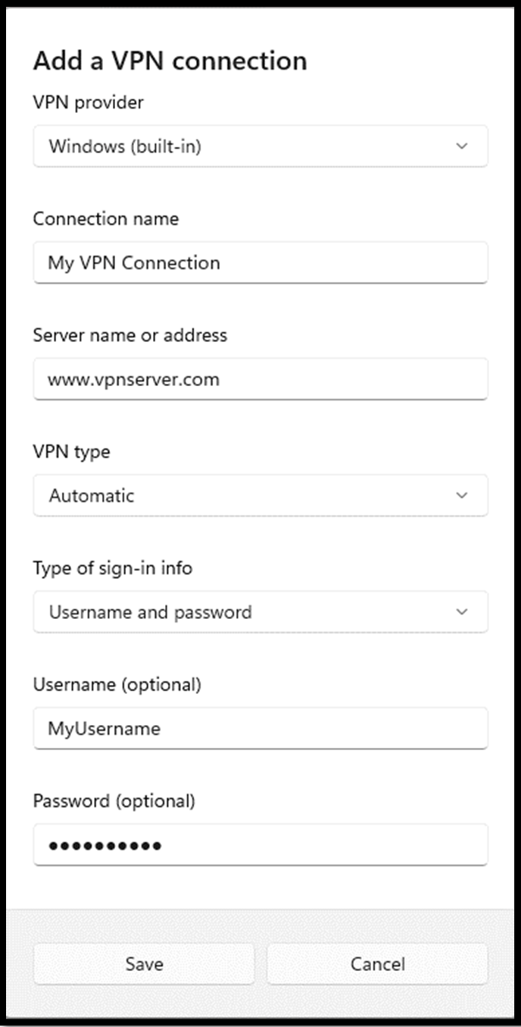
Figure 8-5

- After you create the connection and it appears on the VPN settings page, click Connect to verify and connect to the VPN server you added. Once connected, you can access information from the remote server, whether it is at work or school.
If you don’t have a VPN server, ask your instructor for one at school that you can connect to and test.
- In the Settings app, click Network & Internet.
- Click VPN and then click Disconnect next to the connection you created.
Disconnecting is important in case your VPN application stops working.

