Name: | Date:
Module 9
CompTIA Security+ Exam Objectives
Domain | Lab
General Security Concepts | 9.5
Threats, Vulnerabilities, and Mitigation | 9.1, 9.2
Security Architecture | 9.4
Security Operations | 9.1, 9.2, 9.3
Website links change frequently. If a link in the following activities no longer works, use a search engine such as Google or Bing to search for the information.

Lab 9.1 Setting Up the pfSense Hardware Firewall

Estimated time: 30 minutes

Objectives
pfSense is one of the most well-known open-source firewalls. It is available as an appliance or a virtual firewall. The operating system can also be installed in a virtual machine to mimic an appliance firewall in a virtual environment. pfSense is built on top of FreeBSD, an open-source Linux distribution. It is natively built as a router and firewall but also supports many other features.
After completing this lab, you will be able to do the following:
- Build a pfSense firewall in a virtual machine.
- Identify components of a pfSense firewall.

Certification Objectives
Objectives for the CompTIA Security+ exam:
- 2.5 Explain the purpose of mitigation techniques used to secure the enterprise.
- 4.5 Given a scenario, modify enterprise capabilities to enhance security.

Materials Required
This lab requires the following:
- A computer running the Windows operating system (OS) with Internet access

Activity
In this lab, you set up the pfSense hardware firewall.
- Open a web browser and go to https://www.vmware.com/products/workstation-player/workstation-player-evaluation.html to download VMware Workstation.
- Scroll down to Try Workstation 17 Player for Windows and click DOWNLOAD NOW.
A file is downloaded to your system, such as to your Downloads folder.
- Navigate to the downloaded file. (The filename might start with VMware-player-full-XXX, where XXX is the version number.) Double-click the file to install VMware and then click Yes on the installation launcher. Accept all the defaults and finish installing VMware.
- Use a browser to navigate to www.pfsense.org and then click Download to access the pfSense downloads.
- Under Select Image To Download, click the Architecture arrow, select AMD64 (64-bit), click the Installer arrow, select CD Image (ISO) Installer, select a mirror site, and then click the Download button to download the ISO file. A file is downloaded to your system, such as to your Downloads folder.
- Close your browser. Navigate to the downloaded file, right-click the pfSense ISO, and then select Extract All to extract the ISO file. If Extract All is not available on your system, right-click the pfSense ISO, click Open with, and then select WinRAR archiver, as shown in Figure 9-1.
If you have a different zip file extractor use that one or download one, if needed.
Figure 9-1
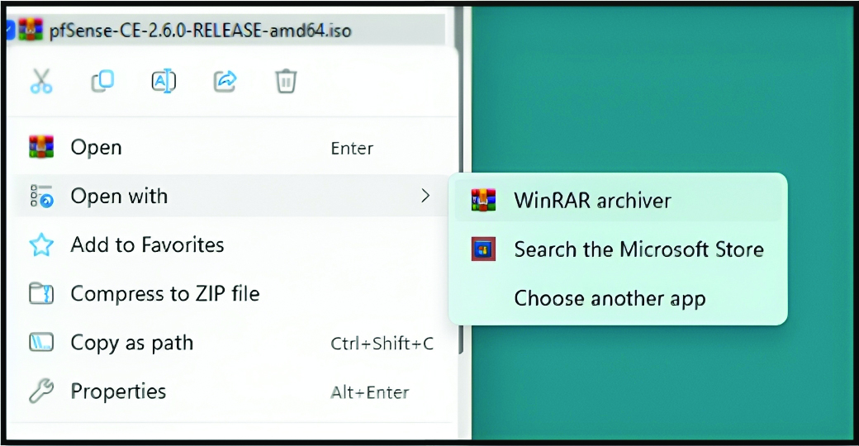

- Go back to your VMware Workstation Player or open it if you closed it.
- Click Create a New Virtual Machine to launch the New Virtual Machine Wizard.
- Select Installer disc image file (iso), click Browse to navigate to your pfSense ISO file, navigate to the pfSense ISO file and select it, and then click Open to select the ISO.
- Click Next to accept the default values and then click Finish to create the VM. Note the name of the machine.
- Press Enter to accept the copyright and distribution notice and then press Enter again to begin the installation.
- Press Enter to accept the default keymap and then press Enter to choose Auto (UFS) - Guided Disk Setup so that the system will auto-partition the virtual drive for the installation.
- Press Enter to accept the default of not opening a shell to make additional modifications, and then press Enter to reboot the system.
- After the system reboots, type n and press Enter to choose not to set up VLANs now.
- Type em0 and press Enter to use the eth0 as the WAN interface.
- Press Enter to wait to set up a LAN interface.
- Type y and press Enter to accept the changes.
- Press Ctrl+Alt to release your pointer from the pfSense VM.
- Shut down the pfSense VM and click player, power, and shutdown guest. Click yes to shut down.
- Open the VMware Workstation Player again. Click the virtual machine created for pfSense, click Edit the virtual machine settings, click Add, select Network Adapter, and then click Finish to add another network adapter to the VM.
- Select Network Adapter 2 and then select Custom: Specific virtual network – VMnet1 (Host-only) to assign the adapter to an internal network. Click OK.
- Click Play virtual machine to run the virtual machine. Click OK.
- Type 1 and press Enter to enter the interface configuration mode (Assign Interfaces).
- Type n and press Enter to decline the option to set up VLANs.
- Type em0 and press Enter to set the eth0 interface as the WAN connection.
- Type em1 and press Enter to set the eth1 interface as the LAN connection.
- Type y and press Enter to accept the changes.
- Type 2 and press Enter to set the interface(s) IP address.
- Type 192.168.91.100 as the IP address and press Enter.
- Type 24 as the subnet bit count and press Enter (it might be entered automatically).
- Press Ctrl+Alt to release your pointer from the pfSense VM.
- Shut down the pfSense VM and click player, power, and shutdown guest. Click yes to shut down.

