Name: | Date:
Module 10
CompTIA Security+ Exam Objectives
Domain | Lab
Threats, Vulnerabilities, and Mitigation | 10.1, 10.2, 10.3, 10.4, and 10.5
Security Operations | 10.1, 10.2, 10.3, 10.4, and 10.5
Website links change frequently. If a link in the following activities no longer works, use a search engine such as Google or Bing to search for the information.

Lab 10.1 SOHO Wireless Router/Access Point

Estimated Time: 30 minutes

Objectives
Wireless local area networks (WLANs) have become so standard today that, for less than $150, technically unsophisticated users can purchase a wireless router and share their Internet connections with other computers in their residences or work offices. SOHO (small office/home office) networks are so common in residential neighborhoods and office buildings that it now takes some trial and error to find a radio frequency that does not suffer from interference from neighboring WLANs or microwave ovens and wireless telephones.
The protection and security of data broadcast over WLANs have not been addressed satisfactorily. In addition, the vulnerabilities in WEP (Wired Equivalent Privacy) are well documented. Although WEP can be cracked in less than 10 minutes, WEP WLANs—and completely unprotected WLANs—are still surprisingly widespread in locations where undetected proximity, a prerequisite for cracking, is easily attainable. Although Wi-Fi Protected Access (WPA) and its upgrade, WPA2, are much more secure than WEP, there are still ways to attack an improperly configured WPA2 WLAN.
Most wireless devices connect to a wired network. Ad hoc mode wireless networks—direct connections between wireless stations, without including wired systems—are occasionally used, but access to resources on the Internet and on business networks often requires an infrastructure mode network. In infrastructure mode, an access point is used for wireless stations to communicate through a system connected to the wired network. Similar to a wireless station, an access point has an antenna and a wireless transceiver; however, it also has a wired interface to the company network.
In a SOHO network, the access point fulfills several other responsibilities and is usually not even called an access point. The most common term is a wireless router. These devices typically act as an access point for wireless stations, a switch where wired computers can be connected, a gateway to another network (typically the Internet), a network address translation device (NAT) to allow internal clients to use nonpublic IP addresses, a router to direct traffic to and from the WLAN, a Dynamic Host Configuration Protocol (DHCP) server to assign internal clients Internet Protocol (IP) addresses, a Domain Name System (DNS) server to resolve fully qualified domain names to IP addresses, and a firewall to filter traffic coming into and out of the internal network.
After completing this lab, you will be able to do the following:
- Compare WEP, WPA, and WPA2 encryption.
- Analyze the importance of a wireless access point.
- Explain the main security features of a SOHO wireless router.

Certification Objectives
Objectives for the CompTIA Security+ exam:
- 2.2 Explain common threat vectors and attack surfaces.
- 2.4 Given a scenario, analyze indicators of malicious activity.
- 4.1 Given a scenario, apply common security techniques to computing resources.

Materials Required
This lab requires the following:
- A computer running the Windows operating system with Internet access

Activity
In this lab, you explore a wireless-N router and examine some of its security features.
- Open a web browser and navigate to http://www.amazon.com.
- In the search bar, type wireless N router and press Enter.
- Browse the top three choices. What brands are they? What are some of the features they offer?
- Do they offer WPA, WPA2, WPA3, or WEP encryption? Do they offer another type of encryption?
- Do they support IPv6? Do the routers have the Extensible Authentication Protocol?
- Complete Table 10-1 with information about three different routers. Note three security features for each router. Try to find security features that are not common to all the routers.
Table 10-1 Router information
Router name | Speed | Security features

- Open a browser and search for the difference between a wireless router and an access point. How do wireless access points differ from wireless routers?
- Complete Table 10-2 with your wireless access points information.
Table 10-2 Wireless access point information
Property | Wireless access point
IP assignment
DNS server assignment
SSID
Protocol
Security type
Manufacturer
Network band
Network channel
Link speed (receive/transmit)
MAC address (physical address)

- Right-click the network icon in the system tray and select Network and Internet settings.
- Click Properties for the connection you have and then click Hardware Properties.
See Figure 10-1.

Figure 10-1 Wireless access point information
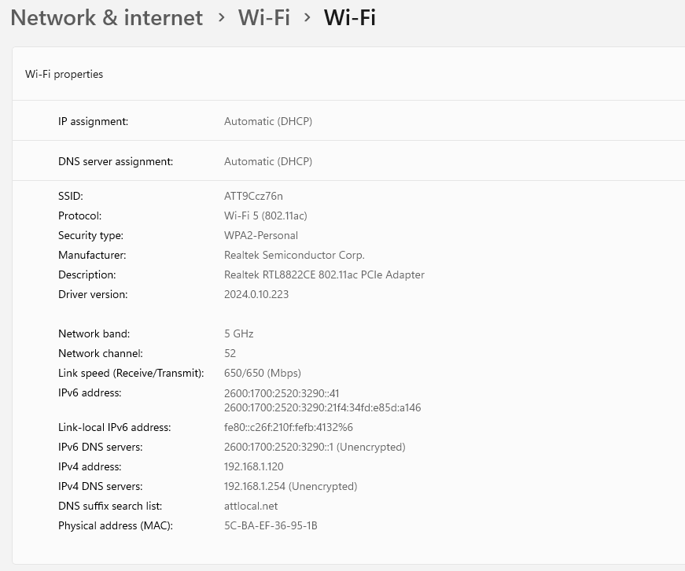
- Open a new tab in your web browser, navigate to www.howtogeek.com, and use the Search feature to find and read the article named “The Difference Between WEP, WPA, and WPA2 Wi-Fi Passwords.”
- What are some of the characteristics of the three encryption algorithms? Which one is preferred? Name some weaknesses of the encryption algorithms.

