Name: | Date:
Module 10
CompTIA Security+ Exam Objectives
Domain | Lab
Threats, Vulnerabilities, and Mitigation | 10.1, 10.2, 10.3, 10.4, and 10.5
Security Operations | 10.1, 10.2, 10.3, 10.4, and 10.5
Website links change frequently. If a link in the following activities no longer works, use a search engine such as Google or Bing to search for the information.

Lab 10.3 Exploring Network Ports with LEGION

Estimated Time: 30 minutes

Objectives
Kali Linux provides a stable environment for hacking and penetration testing. Kali Linux contains several tools, which can range from password-cracking tools to networking mapping software. The LEGION software provided with Kali offers the capability to do a robust port scan that can divulge critical information about a network. LEGION is an open-source, easy-to-use, highly extensible, and semi-automated network penetration testing tool that aids in discovering, reconnaissance, and exploiting information systems. LEGION works with Hydra network mapping software. LEGION uses network penetration tools such as Nikto, whatweb, sslyzer, vulners, SMBenum, and NMAP.
After scanning a server with a faulty configuration, LEGION may alert you to many vulnerabilities, which you should not attempt to take advantage of. You should not try to access any server or information that you do not usually have permission to access.
After completing this lab, you will be able to do the following:
- Configure LEGION for penetration testing.
- Analyze the need for port hardening.

Certification Objectives
Objectives for the CompTIA Security+ exam:
- 2.2 Explain common threat vectors and attack surfaces.
- 2.4 Given a scenario, analyze indicators of malicious activity.
- 4.1 Given a scenario, apply common security techniques to computing resources.

Materials Required
This lab requires the following:
- A computer running the Windows operating system with Internet access
- Kali Linux running on Windows 11

Activity
In this lab, you configure the LEGION penetration testing software to scan ports.
- Determine the IP address of your local college or local machine. Open the command window and use the ping command to ping your college’s web address. Note your school’s IP address. For the address of your system, run the ipconfig command and note the local IP address.
- Start your Kali Linux environment in Windows 11. If needed, follow the steps in Lab 8.2 to start.
- Open a terminal window in the Kali Linux Remote Desktop Connection.
- Click Applications, click Vulnerability Analysis, and then select LEGION (root) or type legion, if necessary.
If LEGION does not appear or open automatically, you might need to install it. In the terminal window, type sudo apt-get install legion -y. After installation, you can start LEGION by typing sudo legion in the terminal window. You need to be in superuser (root) mode to run LEGION. If needed, type sudo -s to go into superuser mode and then type legion. (You need the root user account password.)
- In the Hosts window, click Click here to add hosts(s) to scope. The Add host(s) to scan separated by semicolons window appears.
- Type the IP address of your school or personal machine. (See Figure 10-2.) Click Add to Scope.

Figure 10-2 LEGION Add host(s) to scan dialog box
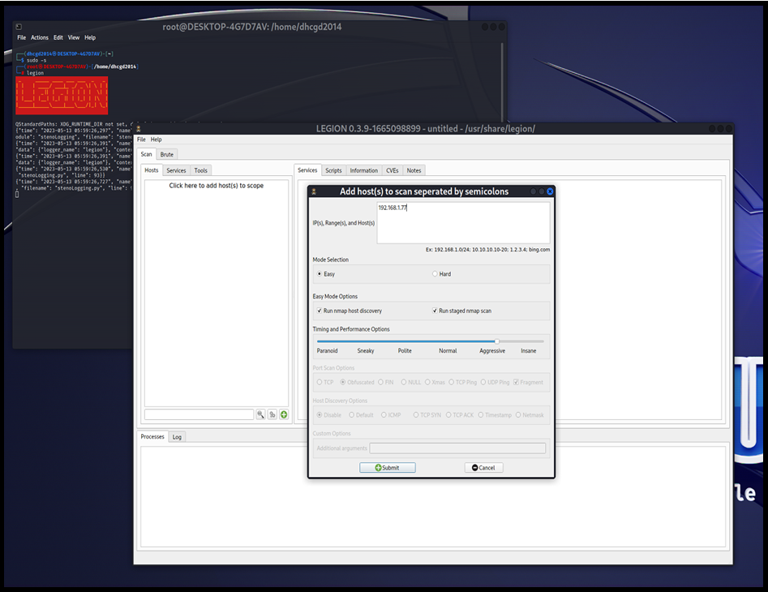
- Wait for the scan to complete. This could take as long as 20 minutes. Note the ports and items detected by the scan. Figure 10-3 shows a sample of the scan results. Yours will be different.

Figure 10-3 LEGION scan results
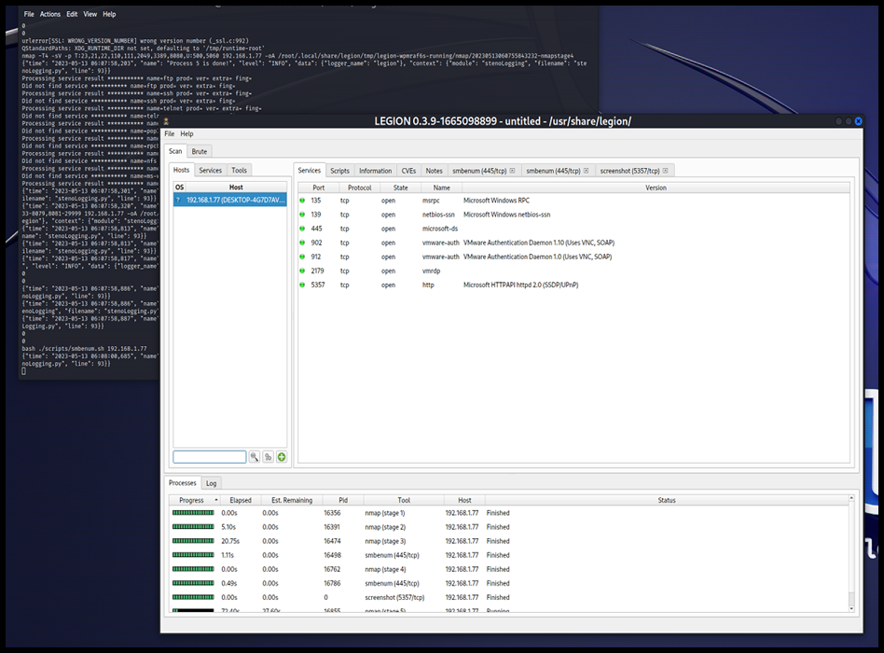
- Click the smbenum tabs near the top of the LEGION window. If you find any open ports or passwords, report them to the network administrator for the IP address you are searching for.
- Explore the other tabs in the LEGION window to learn more about LEGION’s powerful features. Note that you can use the Brute tab to begin a brute-force penetration attack against a specific IP address.
- Close all windows and log off.

