Name: | Date:
Module 10
CompTIA Security+ Exam Objectives
Domain | Lab
Threats, Vulnerabilities, and Mitigation | 10.1, 10.2, 10.3, 10.4, and 10.5
Security Operations | 10.1, 10.2, 10.3, 10.4, and 10.5
Website links change frequently. If a link in the following activities no longer works, use a search engine such as Google or Bing to search for the information.

Lab 10.4 Exploring Wireless Networks and Site
Surveys with NetSpot

Estimated time: 30 minutes

Objectives
Wireless site surveys are completed to verify the extent of the signal of the wireless networks. These surveys not only can help identify where an area might not be covered, but they can also identify where coverage extends beyond the physical perimeters of a building or home. Signal detection includes using heat maps, Wi-Fi analyzers, and channel overlays. Wireless site surveys lead the decisions for the access point or home device placement (where there is flexibility to move them) and can provide an overview of the overlapping signals and strength of the signals throughout the physical space.
After completing this lab, you will be able to do the following:
- Perform wireless network discovery with NetSpot.
- Identify a wireless site survey.

Certification Objectives
Objectives for the CompTIA Security+ exam:
- 2.2 Explain common threat vectors and attack surfaces.
- 2.4 Given a scenario, analyze indicators of malicious activity.
- 4.1 Given a scenario, apply common security techniques to computing resources.

Materials Required
This lab requires the following:
- A computer running the Windows operating system with Internet access

Activity
In this lab, you explore Discover mode and a prebuilt site survey in NetSpot.
- Open a browser window, navigate to netspotapp.com, and click the Get NetSpot button to navigate to the downloads page.
- Click the Download Now button under NetSpot FREE Edition to download the installation file for your operating system.
- Navigate to and double-click the downloaded file (probably named NetSpot).
- Click Install Now to install the app.
- Once installation is complete, click Launch and Continue to accept the free version.
If you use a Mac, follow the instructions to allow location services temporarily. Feel free to remove these services after finishing the lab.
The application has two main tabs: DISCOVER and SURVEY.
- DISCOVER Mode: NetSpot collects every detail about surrounding Wi-Fi networks and presents wireless data as an interactive table. It lets you troubleshoot and improve your network’s coverage, capacity, performance, AP configurations, signal level, interference, noise, and other settings.
- SURVEY Mode: NetSpot provides interactive color-coded heatmaps. You can outline your real-life Wi-Fi data on a map and generate flexible, professional reports.
- Click SURVEY to turn on SURVEY mode and then return to DISCOVER mode to refresh it. You will see any networks within the range listed. If you are at home, you will see your network and others within range.
- Click SSID at the top to arrange the networks alphabetically (A–Z) by SSID. You will see multiple networks.
- Click Signal to arrange the networks from highest to lowest signal strength. This helps you determine which networks have the highest signal and which network you can connect to for the best and fastest connection.
- Click SURVEY to switch back to SURVEY mode, click the Start a new survey button, and then click Home Office and family space to see what a site survey would look like for a coworking space. Review the image provided, an example, and all the networks listed. Also notice the coverage provided and the networks included. The tool allows you to determine coverage and how to implement better solutions.
- Expand each category if not expanded already to display all the access points that are being shown by default. Notice that devices are listed by MAC address. Point to any access point and notice the SSIDs, channel, and security mode. See Figure 10-4 for an example.

Figure 10-4 NetSpot home office and family space sample scan
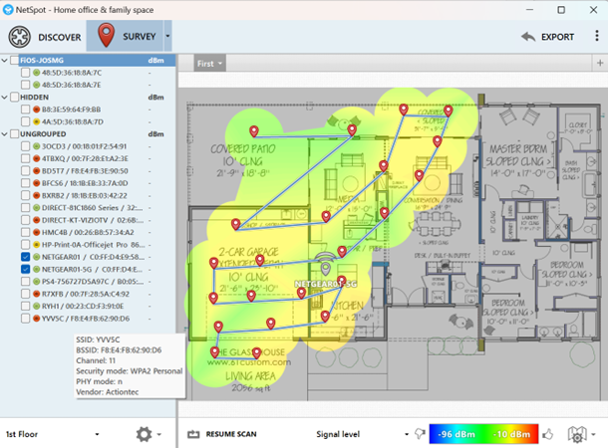

- Click the arrow next to SURVEY to display a menu, select Open Sample, and then click Single-family house to open another sample site survey. Expand each category if not already expanded and see all the access points shown by default. Notice that devices are listed by MAC address. Point to any access point and notice the SSIDs, channel, and security mode.
- Close all windows.

