Name: | Date:
Module 11
CompTIA Security+ Exam Objectives
Domain | Lab
Threats, Vulnerabilities, and Mitigation | 11.1, 11.2, 11.4, 11.5
Security Architecture | 11.1, 11.2, 11.3, 11.4, 11.5
Security Operations | 11.1, 11.2, 11.4, 11.5
Website links change frequently. If a link in the following activities no longer works, use a search engine such as Google or Bing to search for the information.

Lab 11.2 Getting Started with Cloud Operations on Amazon Web Services (AWS)

Estimated Time: 30 minutes

Objectives
Amazon Web Services (AWS) is a commonly used cloud service provider. AWS offers different cloud services, from application development to quantum computing. Virtual machines are one of the many resources available in AWS. A free AWS Educate account offers access to hundreds of hours of free, self-paced online resources designed specifically to help pre-professional learners develop in-demand cloud skills.
After completing this lab, you will be able to do the following:
- Identify the steps to create an AWS account.
- Use a virtual machine in AWS.

Certification Objectives
Objectives for the CompTIA Security+ exam:
- 2.3 Explain various types of vulnerabilities.
- 3.1 Compare and contrast security implications of different architecture models.
- 4.1 Given a scenario, apply standard security techniques to computing resources.

Materials Required
This lab requires the following:
- A computer running the Windows operating system with Internet access

Activity
In this lab, you perform tasks to get started with cloud operations on AWS.
- Open a web browser and navigate to aws.amazon.com/education/awseducate.
- Click the Register now button.
- Enter the required information:
- First name
- Last name
- Country
- Birth month
- Birth year
- Email (you can use your school email). If you created an AWS Free Tier account, use a different email from the one you used for the Free Tier Account.
- Registration code (optional). A code is already provided (EducateLP) or leave it blank.
- Click the Create Account button. You will receive a message to Verify Email.
- Log in to the student email account you used for this lab and then confirm your email address. In the email, click Verify my email. The email verification message comes from support@awseducate.com. A message appears up stating that your email is verified, the application will be reviewed shortly, and to check your email for status updates.
- Go back to your student email account or the email account you have used and find another email to get started with AWS Educate. Click the Click here to set a password button.
- Enter a password, enter the password again to confirm, and then click Submit to set your password and log in. Once a password is set, you can access resources to AWS Educate.
Confirmation usually occurs immediately but wait a couple of minutes to be certain.
- On the AWS Educate site, under Course Features, place a checkmark next to Lab.
- Click Getting Started with Cloud Operations (Lab). A new window opens displaying the course contents.
- Click Modules to see all the course contents as illustrated in Figure 11-1.
Figure 11-1. Getting Started with Cloud Operations (Lab)
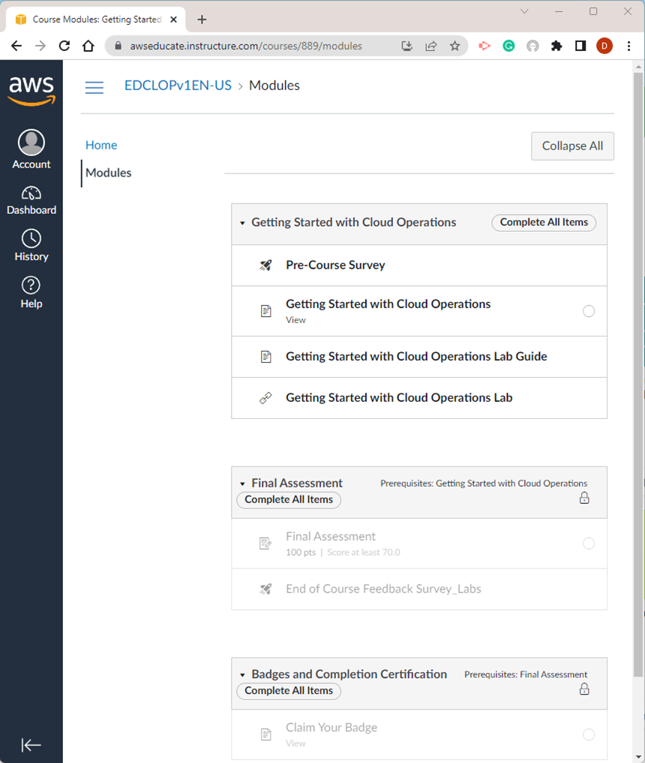
- You can go through the entire course or click the Getting Started with Cloud Operations Lab link. The system will provision (create) the lab environment for you.
- Read all the instructions provided and complete the Lab: Getting Started with Cost Estimation. You can start the lab after you read the Overview, Objectives, Duration, and Prerequisites sections.
- Follow the steps and complete the tasks assigned:
- Task 1: Launch the AWS Pricing Calculator
- Task 2: Add and configure services in AWS Pricing Calculator
- Add the load balancer to the estimate.
- Add the EC2 instance to the estimate.
- Add the RDS instance to the estimate.
- Task 3: Review and download the estimate
- Task 4: Save and share the estimate
- Read the Summary
- Lab complete
- Once completed, turn in the estimate to your professor.
- Click Next at the bottom of the window and exit the Lab environment.

