Name: | Date:
Module 11
CompTIA Security+ Exam Objectives
Domain | Lab
Threats, Vulnerabilities, and Mitigation | 11.1, 11.2, 11.4, 11.5
Security Architecture | 11.1, 11.2, 11.3, 11.4, 11.5
Security Operations | 11.1, 11.2, 11.4, 11.5
Website links change frequently. If a link in the following activities no longer works, use a search engine such as Google or Bing to search for the information.

Lab 11.3 Getting Started with Security on Amazon Web Services (AWS)

Estimated Time: 60 minutes

Objectives
AWS is a frequently used cloud service provider. AWS offers different cloud services, from application development to quantum computing. One of the many resources available in AWS is virtual machines. To help pre-professional learners obtain in-demand cloud skills, a free AWS Educate account offers access to hundreds of hours of free resources and specially designed self-paced online resources.
After completing this lab, you will be able to do the following:
- Identify the steps to create an AWS account.
- Create a virtual machine in AWS.

Certification Objectives
Objectives for the CompTIA Security+ exam:
- 2.3 Explain various types of vulnerabilities.
- 3.1 Compare and contrast security implications of different architecture models.
- 4.1 Given a scenario, apply standard security techniques to computing resources.

Materials Required
This lab requires the following:
- A computer running the Windows operating system with Internet access
- AWS Educate account created in Lab 11.2

Activity
In this lab, you perform the tasks related to getting started with security on AWS.
- If you did not perform Lab 11.2, complete steps 2-9 in this lab. If you completed Lab 11.2, use the account created in that lab.
- Open a web browser and navigate to aws.amazon.com/education/awseducate.
- Click the Register now button.
- Enter the required information:
- First name
- Last name
- Country
- Birth month
- Birth year
- Email (you can use your school email). If you created an AWS Free Tier account, use a different email from the one you used for the Free Tier Account.
- Registration code (optional). A code is already provided (EducateLP) or leave it blank.
- Click the Create Account button. You will receive a message to Verify Email.
- Log in to your student email account or the email account you have used and confirm your email address. In the email, click Verify my email. The email verification message comes from support@awseducate.com.
- A message appears stating that your email is verified, the application will be reviewed shortly, and to check your email for status updates.
- Go back to your student email account or the email account you have used and find another email to get started with AWS Educate. Click the Click here to set a password button.
- Enter a password, enter the password again to confirm, and then click Submit to set your password and log in. Once a password is set, you can access resources to AWS Educate.
Confirmation usually occurs immediately but wait a couple of minutes to be certain.
- On the AWS Educate site, under Course Features, place a checkmark next to Lab.
- Click Getting Started with Security (Lab). A new window opens displaying the course contents.
- Click Modules to see all the course contents as illustrated in Figure 11-2.

Figure 11-2. AWS Educate Started with Security (Lab)
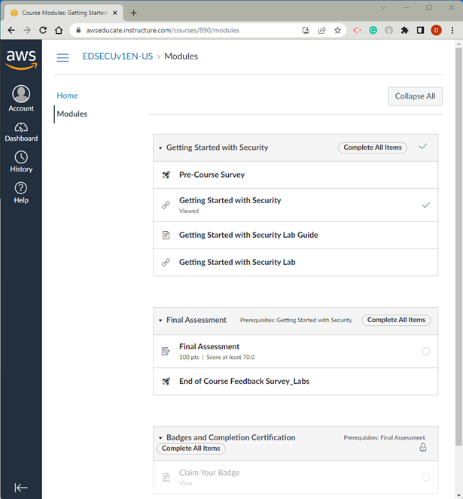
- You can go through the entire course or click the Getting Started with Security Lab link. The system will provision (create) the Lab environment for you.
- Read all the instructions provided and complete the Lab: Introduction to IAM.

- After you read the Overview, Objectives, Duration, Prerequisites, and AWS Service Restrictions, you can click the Start Lab button to launch the environment. Wait until the Lab Status: Ready message appears, and then close the Start Lab panel.
- Click the AWS button to open the console. You can set the lab instruction and AWS console windows to be displayed side by side. If you have multiple screens, you can have a window in each screen to facilitate the lab’s completion process.
- Follow the steps and complete the tasks assigned:
- Task 1: Explore the users and groups
- Task 2: Add user to groups
- Task 3: Sign in and test users
- Lab complete
- Once completed, click End Lab.

