Name: | Date:
Module 11
CompTIA Security+ Exam Objectives
Domain | Lab
Threats, Vulnerabilities, and Mitigation | 11.1, 11.2, 11.4, 11.5
Security Architecture | 11.1, 11.2, 11.3, 11.4, 11.5
Security Operations | 11.1, 11.2, 11.4, 11.5
Website links change frequently. If a link in the following activities no longer works, use a search engine such as Google or Bing to search for the information.

Lab 11.4 Configure a Container in Docker Desktop to Run a Kali Image

Estimated Time: 50 minutes

Objectives
Containers are a more effective form of virtualization than a full virtual machine. Instead of virtualizing and booting the entire operating system, the container can run only the pieces of the operating system needed to support an application, allowing it to start faster and require fewer system resources. Containers are available in Linux as pre-built options for many Linux distributions.
Docker is an open platform for developing, shipping, and running applications. Docker enables you to separate your applications from your infrastructure so you can deliver software quickly. With Docker, you can manage your infrastructure in the same way you manage your applications. By taking advantage of Docker’s methodologies for shipping, testing, and deploying code quickly, you can significantly reduce the delay between writing code and running it in production. You can download and install Docker on multiple platforms.
After completing this lab, you will be able to do the following:
- Create a container in Docker Desktop.
- Run a pre-built container in Docker Desktop.

Certification Objectives
Objectives for the CompTIA Security+ exam:
- 3.1 Compare and contrast security implications of different architecture models.

Materials Required
This lab requires the following:
- A computer running the Windows operating system with Internet access

Activity
In this lab, you explore a pre-built container with Kali Linux installed inside of the Docker Desktop.
- Open a web browser, navigate to docs.docker.com/get-docker/, and click the appropriate version of Docker Desktop for your operating system.
Do not install Docker Desktop inside of your virtual machine. For this lab, you will download the Docker Desktop for Windows, a native Windows application that delivers all Docker tools to your Windows computer.
You can install Docker Desktop for Mac or Linux later and complete the steps of those operating systems as well.
- At the bottom of the webpage, click the If you’re looking for information on how to install Docker Engine, see Docker Engine installation overview link. Read the minimum requirements to install Docker Desktop, and ensure your system meets them.
- Click Docker Desktop for Windows to start the download.
- Go to your downloaded installation file Docker Desktop Installer.exe and run it.
- Click Yes to allow this application to make changes to your system, if necessary.
- On the configuration screen, make sure the following options are selected: Use WSL 2 instead of Hyper V (recommended) and Add shortcut to desktop.
- Click OK to complete the installation.
Make sure to save all your work before the next step.
- Click the Close button and log out on the message window that states “You must log out of Windows to complete installation.”
- When the logout process is completed, log back into the system.
- When the Docker Subscription Service Agreement appears, read all the terms, and then click the Accept button. You can skip the question about the work you do. The Docker Desktop for Windows application starts as shown in Figure 11-3.
Figure 11-3. Docker Desktop for Windows
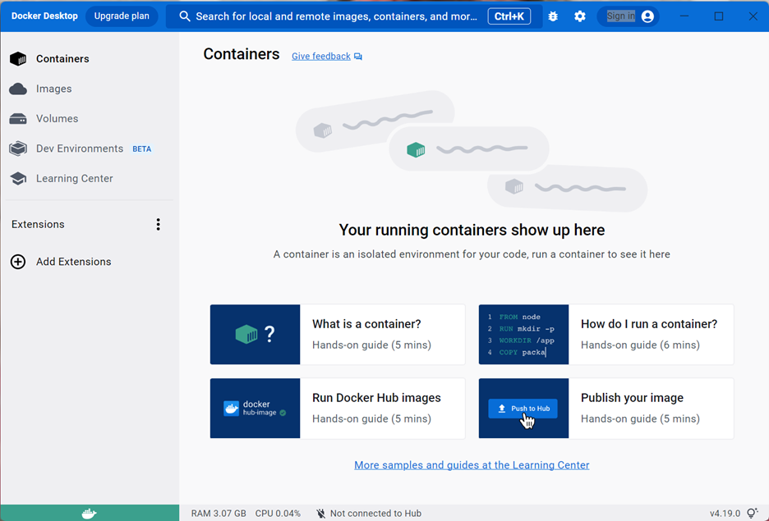

- Open a terminal window as an administrator. Type docker pull kalilinux/kali-rolling and press Enter to download a container running Kali Linux, as shown in Figure 11-4.
Figure 11-4. Downloading a container running Kali Linux
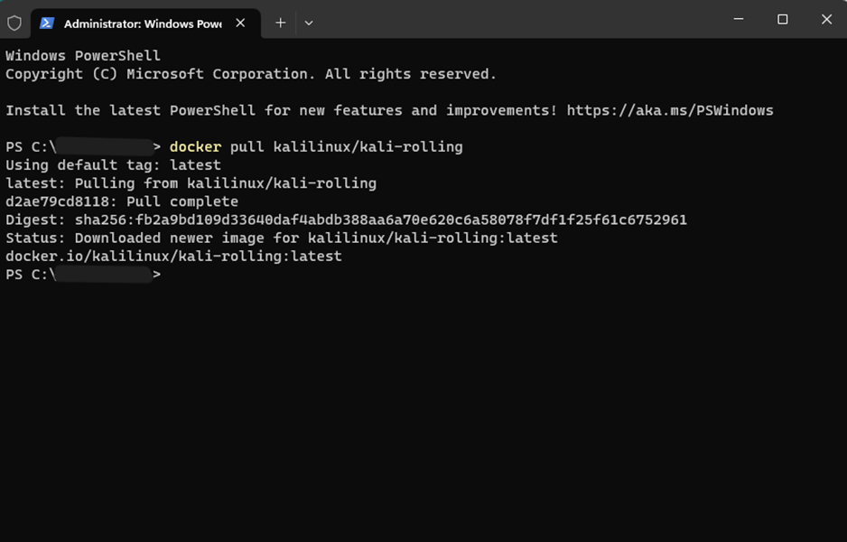
- In Docker Desktop for Windows, click Images, select kalilinux/kali-rolling, and then click Run under Actions to open the options to start your container. Note that the Run icon looks like a play button (‣).
- Click Optional Settings, type Kali for the Container Name, and then click Run to start the container.
- When Docker Desktop starts, it appears on your Container tab with a status of running. Select your Kali container, and then click the Terminal tab to open a terminal connection to the container.
- Type whoami and press Enter to display the user account you are using.
- Type pwd and press Enter to display you where you are in the file system.
- Type ls and press Enter to list everything in the current directory.
- Type ls /home and press Enter to list everything in the home directory.
- Type exit, press Enter to close the terminal connection, and then close the terminal window.
- Select the Kali container and click Stop to shut down the Kali container.
Try the following steps if your Kali container does not work.
- Type the following command on your terminal window and then press Enter: docker run -d -p 8088:80 --name welcome-to-docker docker/welcome-to-docker
- After the command runs, go back to the Docker Desktop for Windows, and then click Images to find a docker/welcome-to-docker image. Select and run it. If you don’t give a name to the container, Docker will give it one.
- Click the Containers tab and select the running container. Go to the terminal window and type the commands in steps 14-19.
- Open a web browser, type http://localhost:8088, and then press Enter.
- Type exit, press Enter to close the terminal connection, and then close the terminal window.
- Select the Kali container and click Stop to shut down the Kali container.

