Name: | Date:
Module 11
CompTIA Security+ Exam Objectives
Domain | Lab
Threats, Vulnerabilities, and Mitigation | 11.1, 11.2, 11.4, 11.5
Security Architecture | 11.1, 11.2, 11.3, 11.4, 11.5
Security Operations | 11.1, 11.2, 11.4, 11.5
Website links change frequently. If a link in the following activities no longer works, use a search engine such as Google or Bing to search for the information.

Lab 11.5 Cloud Security and Cloud Services Using Free Tier in Amazon Web Services (AWS) and Microsoft Azure

Estimated Time: 45 minutes

Objectives
Free Tier provides you the ability to explore and try out cloud services from providers like Amazon Web Services (AWS) and Microsoft Azure free of charge up to specified limits for each service. With the AWS Free Tier or Azure Free Account, you can gain free, hands-on experience with cloud platforms, products, and services. This is a great way to dive into the world of cloud computing and test drive the two major providers.
- Microsoft Azure free account: Creating an Azure free account is one way to access Azure services. When you start using Azure with a free account, you get a $200 credit to spend in the first 30 days after you sign up. In addition, you get free monthly amounts of two groups of services: popular services, which are free for 12 months, and more than 55 other services that are always free.
- Amazon Web Services (AWS): The AWS Free Tier provides customers the ability to explore and try out AWS services free of charge up to specified limits for each service. The Free Tier is comprised of three different types of offerings: a 12-month Free Tier, an Always Free offer, and short-term trials. Services with a 12-month Free Tier allow customers to use the product for free up to specified limits for one year from the date the account was activated. Services with an Always Free offer allow customers to use the product for free up to specified limits if they are AWS customers.
After completing this lab, you will be able to do the following:
- Identify the steps to create an AWS account to use the free tier.
- Identify the steps to create a Microsoft Azure account to use Azure free account.

Certification Objectives
Objectives for the CompTIA Security+ exam:
- 2.3 Explain various types of vulnerabilities.
- 3.1 Compare and contrast security implications of different architecture models.
- 4.1 Given a scenario, apply standard security techniques to computing resources.

Materials Required
This lab requires the following:
- A computer running the Windows operating system with Internet access

Activity
In this lab, you set up an Amazon Web Services (AWS) Free Tier account and a Microsoft Azure Free Account.
- Open a web browser and go to https://azure.microsoft.com/en-us/.
- Click the Try Azure for free button.
- Click Start Free.
- Sign in or sign up for a Microsoft account using an email address and password, and then click Next.
- Complete your profile with the following information, read and agree to the customer agreement and privacy statement, and then click Next.
- Country/Region
- First name
- Middle name (Optional)
- Last name
- Email address
- Phone – Once you enter the phone number ask for a verification code to be sent to it. Enter the code to verify your number.
- Address
- Enter a credit or debit card number, though you will not be charged. Click Sign up. You have created a Microsoft Azure free account and have a $200 Azure credit.
- Click Portal on the top right corner of the screen or go to https://portal.azure.com/ to access the Microsoft Azure Portal Dashboard and create/provision Virtual machines and Services, as shown in Figure 11-5.

Figure 11-5. Microsoft Azure Portal Dashboard
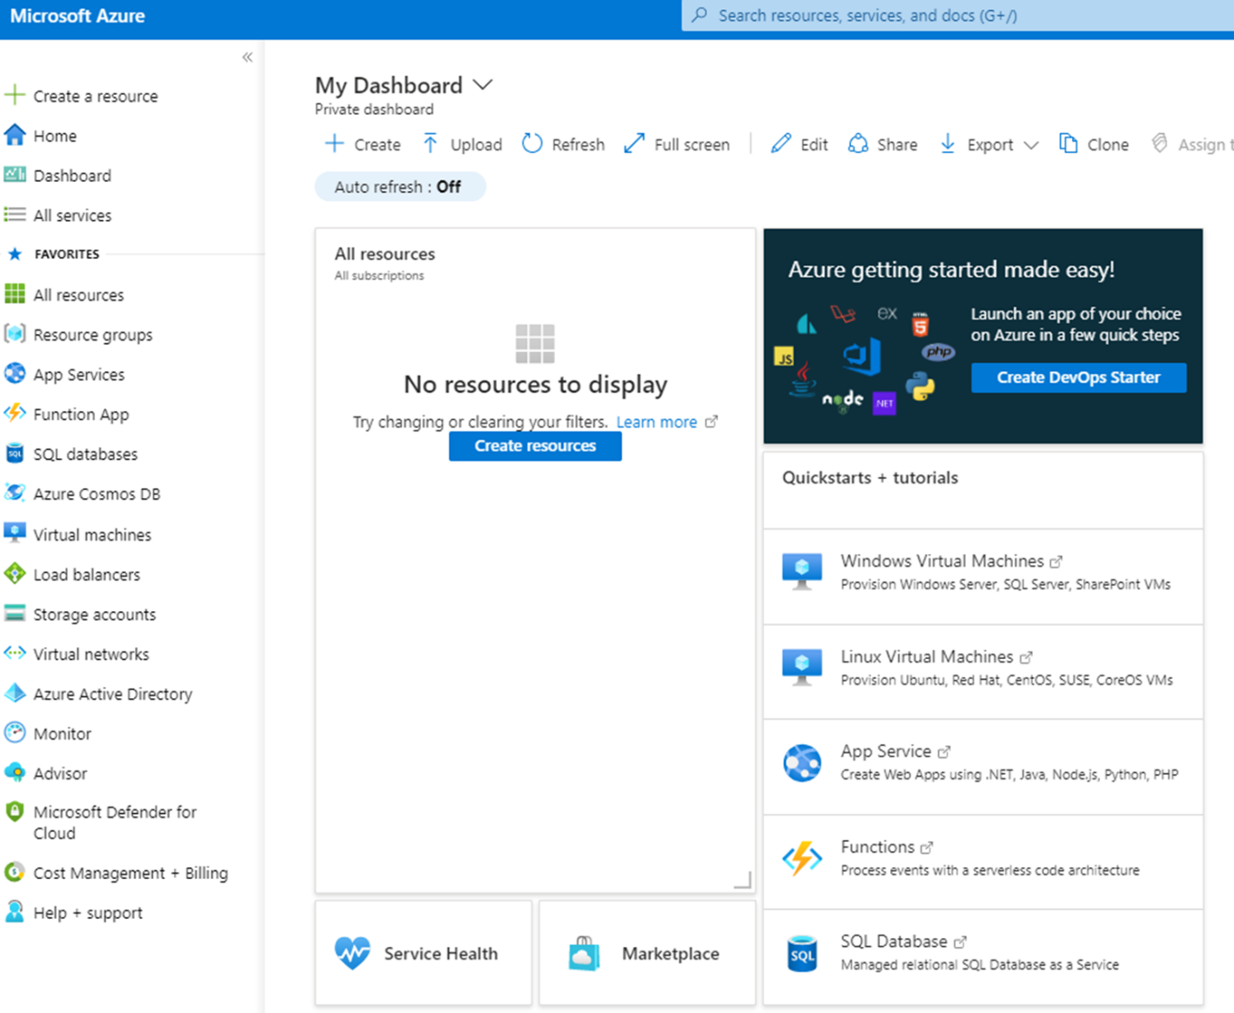
- Open a web browser and go to https://aws.amazon.com/free.
- Click Create a Free Account.
- Enter the details required, including Root user email address and AWS account name, and then click Verify email address to have AWS send you an email verification code.
- Go to your email, retrieve the code, and enter it on the Sign up for AWS page.
- Once verified, you can enter a password for your account. Click Continue (step 1 of 5).
- Select Personal for the account type, complete the following required information. Read and agree to the terms of the AWS Customer Agreement. and then click Continue (step 2 of 5).
- Full Name
- Phone number
- Country or Region
- Address
- Fill in your credit or debit card number and information, make sure the billing address is correct, and then click Verify and Continue (step 3 of 5).
AWS will not charge you for usage below AWS Free Tier limits. AWS may temporarily hold up to $1 USD (or an equivalent amount in local currency) as a pending transaction for 3–5 days to verify your identity.
- On the next screen, confirm your identity by verifying your phone number. Select the country or region code and then enter your Mobile phone number. Enter the captcha code. Click Send SMS (step 4 of 5).
- Enter the verification code received on your phone and then click Verify Code.
- Select Basic Support – Free plan.
AWS offers a selection of support plans to meet any business needs. There is a cost depending on the support selected.
- Click Complete sign up. The confirmation page appears after you complete all the steps. Services might be available right away, though it can sometimes take from 30 minutes to an hour to receive the email message confirming that your account is activated.
- Click the Go to the AWS Management Console to open the console. You are now on the AWS Management Console and are ready to create/provision Virtual machines and Services as shown on Figure 11-6.

Figure 11-6. Amazon Web Services (AWS) Management Console
