Name: | Date:
Module 14
CompTIA Security+ Exam Objectives
Domain | Lab
Security Operations | 14.1, 14.2, 14.3, 14.4
Security Program Management and Oversight | 14.3, 14.4, 14.5
Website links change frequently. If a link in the following activities no longer works, use a search engine such as Google or Bing to search for the information.

Lab 14.1 Threat Hunting (Threat Hunting Simulator)

Estimated Time: 60 minutes

Objectives
Threat hunting is the proactive practice of searching for cyber threats that are undetected in a network and isolating those threats. Cyber threat hunting digs deep to find threat actors that have slipped past initial endpoint security defenses such as firewalls. In this lab, you use a simulator to discover the weaknesses in the Internet of Things (IoT) network in a hospital and help stop someone from using this information before it's too late. Simulation topics include ransomware, distributed denial-of-service (DDoS) attacks, weak passwords, outdated firmware, vulnerability assessment, check point cloud guard, training a firewall, team building, and penetration testing.
After completing this lab, you will be able to do the following:
- Perform a threat-hunting exercise.

Certification Objectives
Objectives for the CompTIA Security+ exam:
- 4.7 Explain the importance of automation and orchestration related to secured operations.
- 4.8 Explain appropriate incident response activities.

Materials Required
This lab requires the following:
- A computer running the Windows operating system with Internet access

Activity
In this lab, you perform a simulated threat-hunting exercise. You can play the game alone or in teams, according to your instructor’s preference.
- Open a web browser and go to Mission Critical, a cybersecurity gamified online escape room from CheckPoint, at https://escaperoom.checkpoint.com/. After the game loads, do not close the main tab. See Figure 14-1.
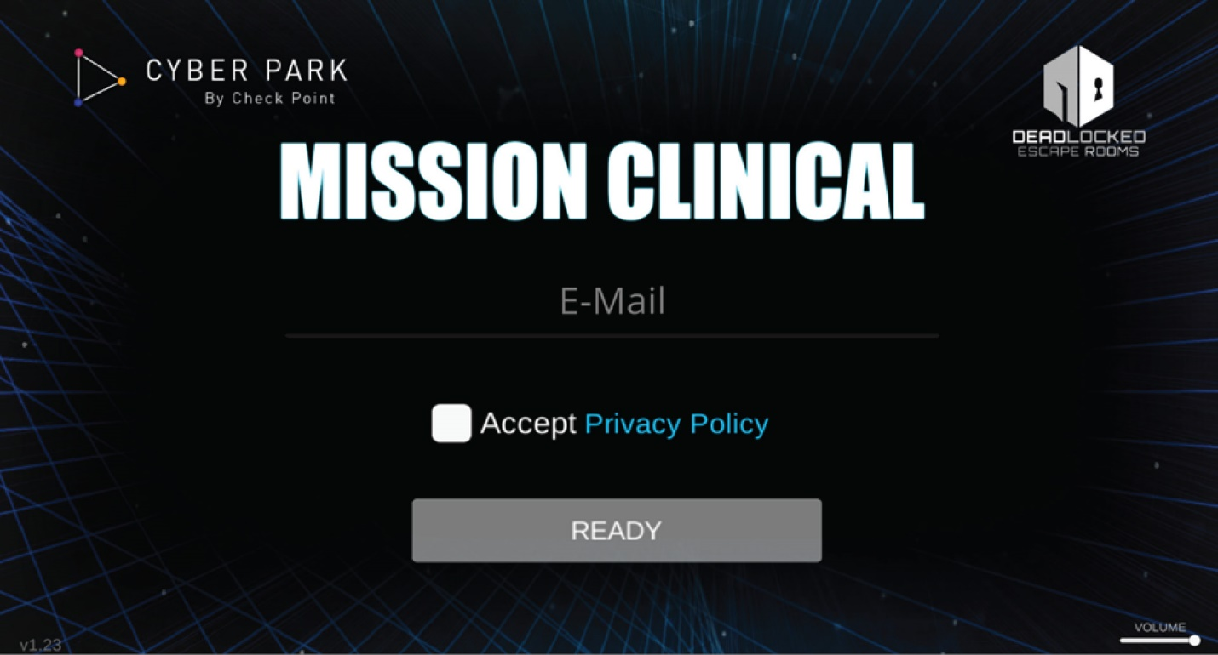
- Enter your student email address and click the Accept Privacy Policy check box. Click the Privacy Policy to read it before accepting.
- Click READY to start the simulation. Watch the video and respond to the prompts.
- After completing the simulation, answer the following questions:
- How long did it take you to complete the exercise?
- How many hints did you use?
Checkpoint provides more simulators free of cost at https://cyberpark.checkpoint.com/.

