Name: | Date:
Module 14
CompTIA Security+ Exam Objectives
Domain | Lab
Security Operations | 14.1, 14.2, 14.3, 14.4
Security Program Management and Oversight | 14.3, 14.4, 14.5
Website links change frequently. If a link in the following activities no longer works, use a search engine such as Google or Bing to search for the information.

Lab 14.5 Implementing Time-Based Restrictions on a Standard User Account in Windows 11

Estimated Time: 30 minutes

Objectives
Time-based login restrictions are one of many restrictions that can be set up for accounts in Windows using Windows Group Policy. Windows Group Policy can be implemented locally or through Active Directory, although it is more likely to be implemented through Active Directory in an enterprise setting. Time-based restrictions can be set locally through a graphical environment or the command prompt. However, the account on which the restrictions are set must be a standard user account.
After completing this lab, you will be able to do the following:
- Implement time-based login restrictions on a local account in Windows 11.

Certification Objectives
Objectives for the CompTIA Security+ exam:
- 5.1 Summarize elements of effective security governance.
- 5.4 Summarize elements of effective security compliance.

Materials Required
This lab requires the following:
- A computer running Windows 11 other than the Education or Home editions with Internet access

Activity
In this lab, you complete and evaluate a sample user awareness training session.
- Press the Windows+R keys to open the Run dialog box.
- Type compmgmt.msc and press Enter to open the Computer Management window.
- Click Local Users and Groups in the left pane.
- Double-click Users to open the folder.
- Right-click the blank space in the middle pane and then select New User to open the New User dialog box.
- Type student3 for the username, type student3 for the password, and then type student3 again to confirm the password.
- Uncheck the box for the user to change password at next logon, click Create, and then click Close.
- Right-click student3, select Properties, and then click the Member Of tab to view the groups that the user is assigned to by default. Users should be the only group listed, which makes this account a standard user account.
- Close the Properties dialog box and the Computer Management window.
- Click the Start button, type command prompt, right-click Command Prompt, and then select Run as administrator to run an elevated command prompt.
- Type net user student3 /time:Sa,1am-11pm and press Enter. Notice the time limitation to log in. A line that reads “The command completed successfully” will appear, as shown in Figure 14-2.
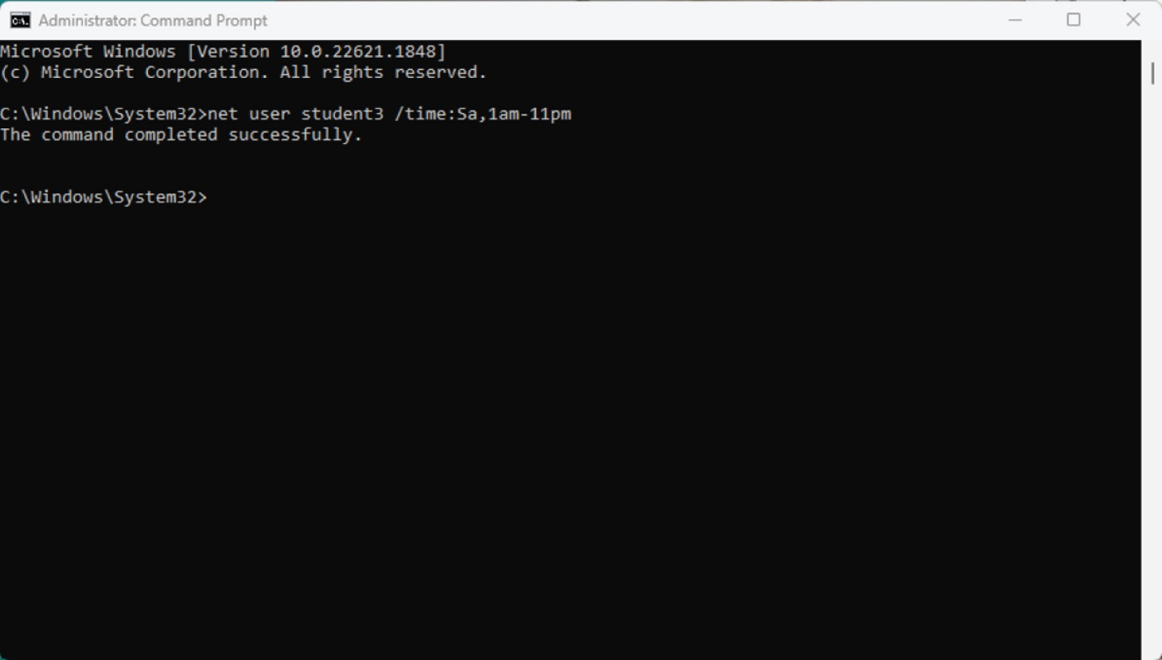
- Click the Start button, select the user icon, and then select Sign out.
- Try to log in as student3. If you log in at a different time than the one you set, you will not be able to log in.
- Click OK and then log back in with your account.
- Click the Start button, type command prompt, right-click Command Prompt, and then select Run as administrator to run an elevated command prompt.
- Type net user student3 /time:M-F,1am-11pm and press Enter. Notice the extended login time period.
- Click the Start button, select the user icon, and then select Sign out.
- Try to log in as student3. If you are trying to login within the newly set time period, you should be able to log in.
If you happen to be working on this lab on a weekend, change M-F to Sa-Su instead.
- Click the Start button, select the user icon, and then select Sign out.
- Log in with your regular account.
- Click the Start button, type command prompt, right-click Command Prompt, and then select Run as administrator to run an elevated command prompt.
- Type net user student3 and press Enter to display the time log in restrictions for the user, as shown in Figure 14-3.

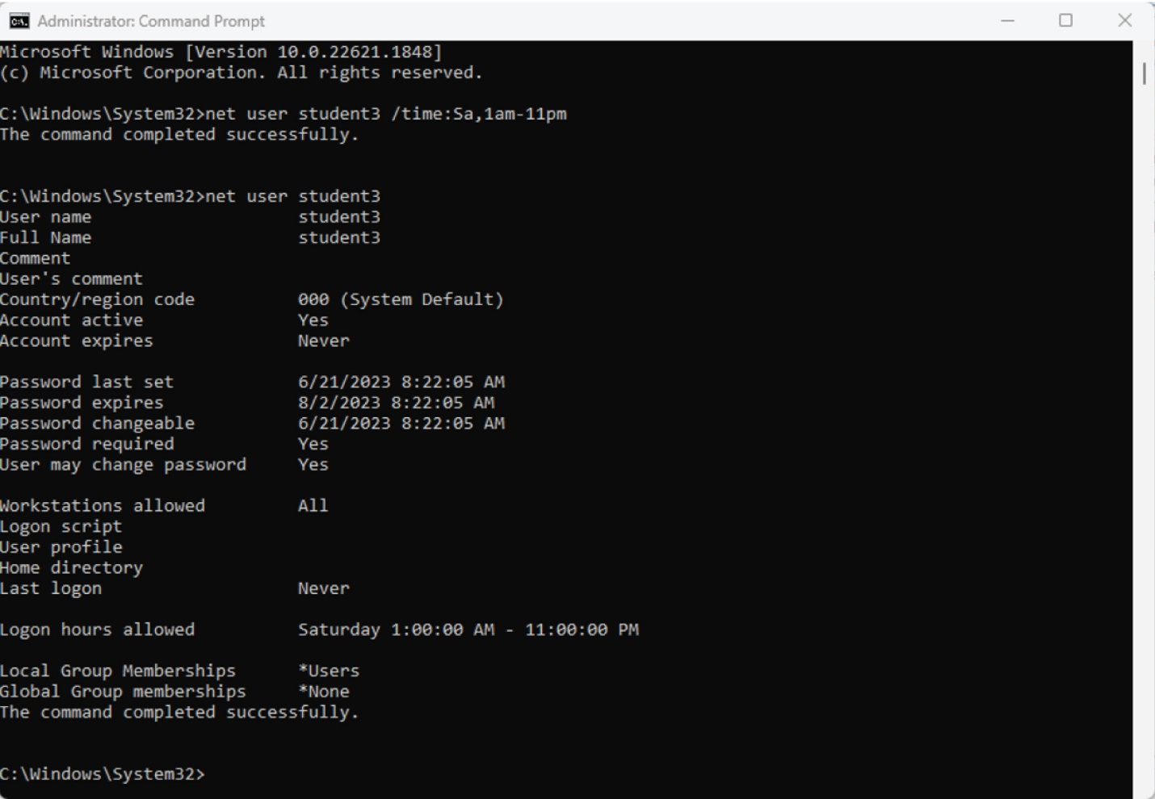
- Exit the command prompt.
- Close all windows.

