**77.** From the following table, write a SQL query to find those departments where no employee works. Return department ID.

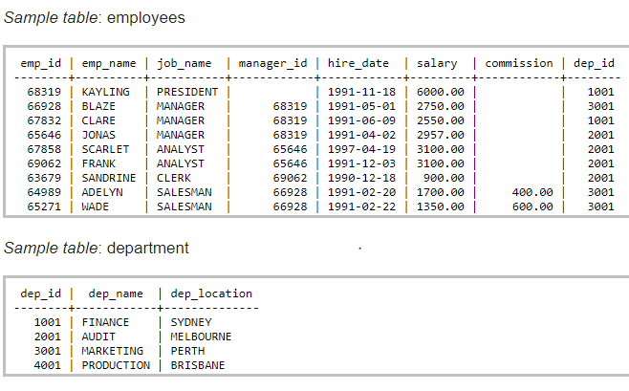

SELECT b.dep_id,

count(a.dep_id)

FROM department b

LEFT OUTER JOIN employees a ON a.dep_id=b.dep_id

GROUP BY b.dep_id

HAVING count(a.dep_id) <1;