**ENVIRONMENTAL SCIENCE (B. VOC 3005)**

**UNIT - 1**

**Environmental Science:**

A simple **environmental science** definition is a culmination of scientific fields, integrating physics, biology, geology, chemistry, meteorology, and oceanography all in order to study the interactions between the physical, chemical, and biological components that make up ecosystems. Environmental science should not be confused with *environmentalism* which is a social movement. Though environmental science has the intention of studying environmental systems in order to help solve environmental problems, it as a scientific discipline only intends to describe and explain the *what* and *how* related questions about natural phenomena. Whereas, *environmentalism* is a broad philosophy and ideological social movement which intends to enact political, legal, and social change in order to solve environmental problems.

An environmental scientist might collect samples of rainwater in order to test its pH in order to find and graph a causal relationship between carbon dioxide in that region's atmosphere and the acidity of its rainwater. Whereas, an environmentalist might instead organize a protest in order to push for political action toward solving issues surrounding pollution and acid rain.

**Environment:**

Literary environment means the surrounding external conditions influencing development or growth of people, animal or plants; living or working conditions etc. This involves three questions:

1. *What is surrounded*

The answer to this question is living objects in general and man in particular.

1. *By what surrounded*

The physical attributes are the answer to this question, which become environment. In fact, the concern of all education is the environment of man. However, man cannot exist or be understood in isolation from the other forms of life and from plant life. Hence, environment refers to the sum total of condition, which surround point in space and time. The scope of the term Environment has been changing and widening by the passage of time. In the primitive age, the environment consisted of only physical aspects of the planted earth' land, air and water as biological communities. As the time passed on man extended his environment through his social, economic and political functions.

1. *Where surrounded*

The answer to this question. It is in nature that physical component of the plant earth, via land, air, water etc., support and affect life in the biosphere. According to a Goudie environment is the representative of physical components of the earth where in man is an important factor affecting the environment.

**Scope of Environment:**

The environment consists of four segments as under:

**1. Atmosphere:** The atmosphere implies the protective blanket of gases, surrounding the earth:

(a) It sustains life on the earth.

(b) It saves it from the hostile environment of outer space.

(c) It absorbs most of the cosmic rays from outer space and a major portion of the electromagnetic radiation from the sun.

(d) It transmits only here ultraviolet, visible, near infrared radiation (300 to 2500 nm) and radio waves. (0.14 to 40 m) while filtering out tissue-damaging ultra-violate waves below about 300 nm.

The atmosphere is composed of nitrogen and oxygen. Besides, argon, carbon dioxide, and trace gases.

**2. Hydrosphere:** The Hydrosphere comprises all types of water resources oceans, seas, lakes, rivers, streams, polar icecaps, glaciers, and ground water.

(i) Nature 97% of the earth’s water supply is in the oceans,

(ii) About 2% of the water resources is locked in the polar icecaps and glaciers.

(iii)Only about 1% is available as fresh surface water-rivers, lakes streams, and ground water fit to be used for human consumption and other uses.

**3. Lithosphere:** Lithosphere is the outer mantle of the solid earth. It consists of minerals occurring in the earth’s crusts and the soil e.g. minerals, organic matter, air and water.

**4. Biosphere:** Biosphere indicates the realm of living organisms and their interactions with environment, via atmosphere, hydrosphere and lithosphere.

**Element of Environment:**

Environment is constituted by the interacting systems of physical, biological and cultural elements inter-related in various ways, individually as well as collectively. These elements may be explained as under:

**(1) Physical elements:**

Physical elements are as space, landforms, water bodies, climate soils, rocks and minerals. They determine the variable character of the human habitat, its opportunities as well as limitations.

**(2) Biological elements:**

Biological elements such as plants, animals, microorganisms and men constitute the biosphere.

**(3) Cultural elements:**

Cultural elements such as economic, social and political elements are essentially manmade features.

**ENVIRONMENT STUDIES: IMPORTANCE**

At present a great number of environment issues, have grown in size and complexity day by day. We study about these issues besides and effective suggestions in the Environment Studies. Environment studies have become significant for the following reasons:

1. **Environment Issues Being of International Importance:**

It has been well recognised that environment issues like global warming and ozone depletion, acid rain, marine pollution and biodiversity are not merely national issues but are global issues and hence must be tackled with international efforts and cooperation.

1. **Explosively Increase in Pollution:**

World census reflects that one in every seven persons in this planted lives in India. Evidently with 16 per cent of the world's population and only 2.4 per cent of its land area, there is a heavy pressure on the natural resources including land. Agricultural experts have recognized soils health problems like deficiency of micronutrients and organic matter, soil salinity and damage of soil structure.

1. **Need for An Alternative Solution:**

It is essential, especially for developing countries to find alternative paths to an alternative goal. We need a goal as under:

(1) A goal, which ultimately is the true goal of development an environmentally sound and sustainable development.

(2) A goal common to all citizens of our earth.

(3) A goal distant from the developing world in the manner it is from the over-consuming wasteful societies of the “developed” world.

**4. Need To Save Humanity From Extinction:**

It is incumbent upon us to save the humanity from extinction. Consequent to our activities constricting the environment and depleting the biosphere, in the name of development.

**NEED FOR PUBLIC AWARENESS:**

It is essential to make the public aware of the formidable consequences of the Environmental Degradation, if not retorted and reformative measures undertaken, would result in the extinction of life. We are facing various environmental challenges. It is essential to get the country acquainted with these challenges so that their acts may be eco-friendly. Some of these challenges are as under:

1. **Growing Population:**

A population of over thousands of millions is growing at 2.11 per cent every year. Over 17 million people are added each year. It puts considerable pressure on its natural resources and reduces the gains of development. Hence, the greatest challenge before us is to limit the population growth. Although population control does automatically lead to development, yet the development leads to a decrease in population growth rates. For this development of the women is essential.

1. **Poverty:**

India has often been described a rich land with poor people. The majority of our people are directly dependent on the nature resources of the country for their basic needs of food, fuel shelter and fodder. About 40% of our people are still below the poverty line. Environment degradation has affected the poor who depend upon the resources of their immediate surroundings.

1. **Agricultural Growth:**

The people must be acquainted with the methods to sustain and increase agricultural growth with damaging the environment. High yielding varieties have caused soil salinity and damage to physical structure of soil.

1. **Need to Ground water:**

It is essential of rationalizing the use of groundwater. Factors like community wastes, industrial effluents and chemical fertilizers and pesticides have polluted our surface water and affected quality of the groundwater. It is essential to restore the water quality of our rivers and other water bodies as lakes is an important challenge.

1. **Air and water Population:**

Majority of our industrial plants are using outdated and population technologies and makeshift facilities devoid of any provision of treating their wastes. A great number of cities and industrial areas that have been identified as the worst in terms of air and water pollution. Acts are enforced in the country, but their implement is not so easy. The reason is their implementation needs great resources, technical expertise, political and social will. Again the people are to be made aware of these rules. Their support is indispensable to implement these rules.

**CONCEPT OF ECOSYSTEM**

What is an Ecosystem?

An ecosystem is a structural and functional unit of ecology where the living organisms interact with each other and the surrounding environment. In other words, an ecosystem is a chain of interactions between organisms and their environment. The term “Ecosystem” was first coined by A.G.Tansley, an English botanist, in 1935.

## Structure of the Ecosystem

The structure of an ecosystem is characterised by the organisation of both biotic and abiotic components. This includes the distribution of energy in [**our environment**](https://byjus.com/biology/our-environment/). It also includes the climatic conditions prevailing in that particular environment.

The structure of an ecosystem can be split into two main components, namely:

* Biotic Components
* Abiotic Components

The biotic and abiotic components are interrelated in an ecosystem. It is an open system where the energy and components can flow throughout the boundaries.

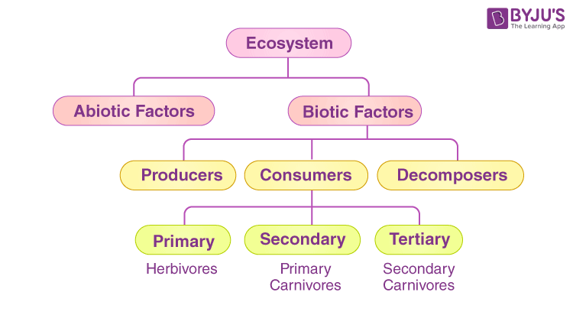

### **Biotic Components**

Biotic components refer to all living components in an ecosystem.  Based on nutrition, biotic components can be categorised into autotrophs, heterotrophs and saprotrophs (or decomposers).

* **Producers**include all autotrophs such as plants. They are called autotrophs as they can produce food through the process of photosynthesis. Consequently, all other organisms higher up on the food chain rely on producers for food.
* **Consumers**or heterotrophs are organisms that depend on other organisms for food. Consumers are further classified into primary consumers, secondary consumers and tertiary consumers.
  + ***Primary consumers*** are always herbivores as they rely on producers for food.
  + ***Secondary consumers*** depend on primary consumers for energy. They can either be carnivores or omnivores.
  + ***Tertiary consumers*** are organisms that depend on secondary consumers for food.  Tertiary consumers can also be carnivores or omnivores.
  + **Quaternary consumers**are present in some food chains. These organisms prey on tertiary consumers for energy. Furthermore, they are usually at the top of a food chain as they have no natural predators.
* **Decomposers**include saprophytes such as fungi and bacteria. They directly thrive on the dead and decaying organic matter.  Decomposers are essential for the ecosystem as they help in recycling nutrients to be reused by plants.

### **Abiotic Components**

Abiotic components are the non-living component of an ecosystem.  It includes air, water, soil, minerals, sunlight, temperature, nutrients, wind, altitude, turbidity, etc.

## Functions of Ecosystem

The functions of the ecosystem are as follows:

* 1. It regulates the essential ecological processes, supports life systems and renders stability.
  2. It is also responsible for the cycling of nutrients between biotic and abiotic components.
  3. It maintains a balance among the various trophic levels in the ecosystem.
  4. It cycles the minerals through the biosphere.

The abiotic components help in the synthesis of organic components that involve the exchange of energy.

So the functional units of an ecosystem or functional components that work together in an ecosystem are:

* **Productivity –** It refers to the rate of biomass production.
* **Energy flow –** It is the sequential process through which energy flows from one trophic level to another. The energy captured from the sun flows from producers to consumers and then to decomposers and finally back to the environment.
* **Decomposition –** It is the process of breakdown of dead organic material. The top-soil is the major site for decomposition.
* **Nutrient cycling –**In an ecosystem nutrients are consumed and recycled back in various forms for the utilisation by various organisms.

## What is a Biogeochemical Cycle?

**“Biogeochemical cycles mainly refer to the movement of nutrients and other elements between biotic and abiotic factors.”**

The term biogeochemical is derived from **“bio”** meaning **biosphere**, **“geo”** meaning the **geological components** and “**chemical**” meaning the **elements that move through a cycle**.

The matter on Earth is conserved and present in the form of atoms. Since matter can neither be created nor destroyed, it is recycled in the earth’s system in various forms.

The earth obtains energy from the sun which is radiated back as heat, rest all other elements are present in a closed system. The major elements include:

* Carbon
* Hydrogen
* Nitrogen
* Oxygen
* Phosphorus
* Sulphur

These elements are recycled through the biotic and abiotic components of the [ecosystem](https://byjus.com/biology/ecosystem/). The atmosphere, hydrosphere and lithosphere are the abiotic components of the ecosystem.

### **1. Food Chain**

The sun is the ultimate source of energy on earth. It provides the energy required for all plant life. The plants utilise this energy for the process of photosynthesis, which is used to synthesise their food.

During this biological process, light energy is converted into chemical energy and is passed on through successive trophic levels. The flow of energy from a producer, to a consumer and eventually, to an apex predator is called the food chain.

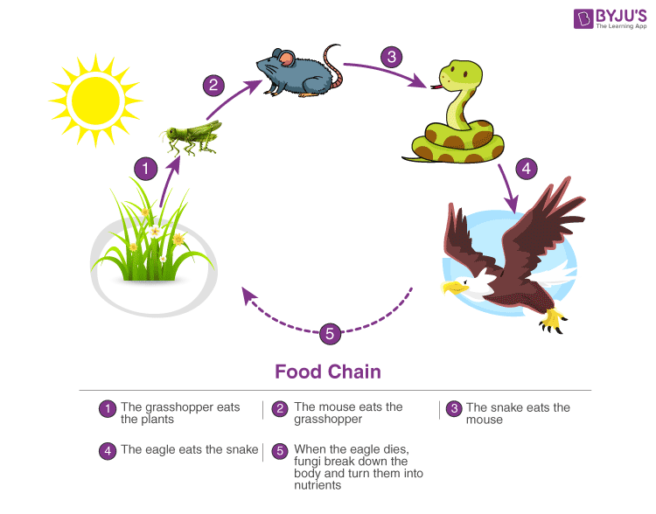

### **2. Ecological Pyramids**

An ecological pyramid is the graphical representation of the number, energy, and biomass of the successive trophic levels of an ecosystem. Charles Elton was the first ecologist to describe the ecological pyramid and its principals in 1927.

The biomass, number, and energy of organisms ranging from the producer level to the consumer level are represented in the form of a pyramid; hence, it is known as the ecological pyramid.

The base of the ecological pyramid comprises the producers, followed by primary and secondary consumers. The tertiary consumers hold the apex. In some food chains, the quaternary consumers are at the very apex of the food chain.

The producers generally outnumber the primary consumers and similarly, the primary consumers outnumber the secondary consumers. And lastly, apex predators also follow the same trend as the other consumers; wherein, their numbers are considerably lower than the secondary consumers.

For example, Grasshoppers feed on crops such as cotton and wheat, which are plentiful. These grasshoppers are then preyed upon by common mouse, which are comparatively less in number. The mice are preyed upon by snakes such as cobras. Snakes are ultimately preyed on by apex predators such as the brown snake eagle.

In essence:

|  |
| --- |
| **Grasshopper →Mouse→  Cobra → Brown Snake Eagle** |

### **3. Food Web**

Food web is a network of interconnected food chains. It comprises all the food chains within a single ecosystem. It helps in understanding that plants lay the foundation of all the food chains. In a marine environment, phytoplankton forms the primary producer.

**Main article:** [Food web](https://byjus.com/biology/food-web/)

**UNIT – 2**

**Segments of Environment:**

There are four segments of the environment which are as follows:

1. Atmosphere
2. Hydrosphere
3. Lithosphere (Geosphere)
4. Biosphere

### **Atmosphere**

The atmosphere is that segment of the environment where life sustains. It has gases that surround the earth which is known to be a protective blanket and the reason for calling it so is that it protects the beings on earth from outer hostile space. The mixture of gases that constitutes the atmosphere is extended from the surface of the earth and covers the region of the earth’s crust.

The major gases that are constituents of the atmosphere are:

* Nitrogen (78%)
* Oxygen (21%)
* Carbon Dioxide (0.03%)
* Argon (0.9%)

### **Hydrosphere**

We all are aware of the fact that water is an element that makes life possible on earth. More simply it is essential. The 97% percent of the overall water present on earth is regarded unfit for drinking or irrigation purposes because it is seawater that contains dissolved salts. Out of the rest 3%, 2% exist in frozen form in polar caps, glaciers, etc., and hence just 1% suits human consumption. Due to this reason, water is considered to be quite precious and hence is not worthy of getting wasted.

The figure below represents the major usage of freshwater:

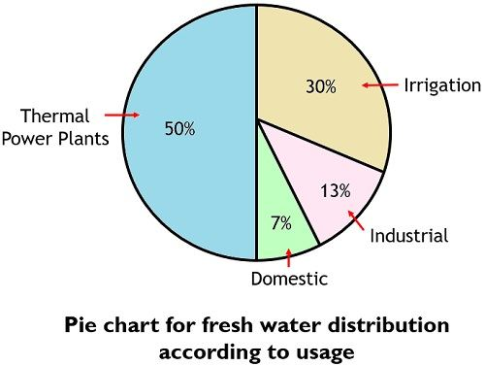

### **Lithosphere**

It is sometimes known as Geosphere and belongs to that part of earth where minerals, organic matters, metals, rocks, soils, etc. exist. It is the outer surface of earth mainly constitutes the earth’s crust and soil. In simplest terms, the lithosphere constitutes the solid component of earth.

### **Biosphere**

The biosphere represents that portion of earth where life is possible. The above discussed three segments of the environment i.e., atmosphere, lithosphere, and hydrosphere are known to be the subdivisions of the biosphere. Basically, all parts of earth do not show suitability regarding the existence of life and this is so because some parts can be very cold or some can be very hot. Thus, the biosphere belongs to the region where life is possible.

**Causes of environmental pollution:**

Given below are the top 10 causes of pollution –

1. Burning of Fossil Fuels – such as coal, oil, gasoline to produce energy for electricity or transportation
2. Automobiles – gases emitted from vehicles
3. Agricultural Activities – the insecticides, pesticides and fertilizers emit harmful chemicals. [Burning stubble](https://byjus.com/free-ias-prep/stubble-burning/) and farm residue also contribute to pollution.
4. Factories and Industries – emits carbon monoxide, organic compounds, hydrocarbons and chemicals.
5. Mining Activities – dust and chemicals are released while extracting minerals from the earth
6. Domestic Sources – household cleaning products and paints contain toxic chemicals
7. Construction and Demolition – raw materials such as bricks and concrete cause haze and foul air
8. Open burning of Garbage waste
9. Microbial Decaying process – Decaying of the microorganisms present in the surrounding releases methane gas which is highly toxic.
10. Volcanic eruptions- volcanoes release enough Sulphur dioxide into the air and influence global cooling.

**Transformation of pollutants:**

Transformation means a process of reduction of waste by volume and weight and recovering the energy from them.

Typically waste transformations are used to improve the efficiency of solid waste and management systems, to recover reusable and recyclable materials, and to recover conversion products and energy which include the following method they are -

* 1) Physical transformation
* 2) Chemical transformation
* 3) Biological transformation

**1. Physical transformation**

Physical transformations of solid waste typically involve a change of phase. To reduce the volume and to recover conversion products, the principal physical processes used to transform municipal solid waste include:

* a) component separation
* b) Mechanical volume reduction
* c) Mechanical size-reduction

All three of these processes are often classified as volume reduction processes

**2. Chemical transformations**

Chemical transformations of solid waste typically involve a change of phase. To reduce the volume and to recover conversion products, the principal chemical processes used to transform municipal solid waste include:

* a) Combustion
* b) Pyrolysis
* c) Gasification

All three of these processes are often classified as thermal processes

**3. Biological transformation**

The biological transformations of the organic fraction of Solid Waste may be used:

* a) to reduce the volume and weight of the material
* b) to produce compost
* c) to produce methane and include: aerobic composting, low-solids anaerobic digestion, high-solids anaerobic digestion

**Population Explosion:**

Population explosion means a sudden increase in the number of individuals in a particular species. The term is used to refer to the world’s human population. In India, Population explosion has become a severe matter of concern because the increase in population leads to poverty and illiteracy. In this situation, it is difficult to cope up with the economy of the country with the rapid growth of the population. The Government of India is now looking into the matter seriously, and many states have framed laws to tackle the problem of population explosion.

## Major Causes of Population Explosion

### **1. Increase in Birth Rate**

One of the major causes responsible for the growth of the population is the high birth rate. During the 1891-1990 period, the birth rate declined from 45.8 per thousand in India, but it is still considered high. So, unfortunately, in India, the birth rate number has not seen a decrease in spite of the framing laws in terms of family planning, population education, campaigns, etc.

### **2. Decrease in Death Rate**

In recent years, the decrease in the death rate is another factor contributing to the rapid growth of the population. In 2001, the death rate in India was about 8.5 per thousand. The death rate has seen a decrease due to advancements in the medical field. For example, Chronic diseases like typhoid, chickenpox, etc., are no longer dreaded. Even the infant mortality rate has decreased because of proper sanitation facilities, cleanliness, and better prenatal and postnatal care.

### **3. Early Marriage**

Early marriage is also an essential factor for the rapid increase in population. In India, the marriage age of a girl is 18, which is very low compared to other countries, which is about 23 to 25 years. It leads to a longer span of reproductive activity and increases in children.

### **4. Religious and Social Reasons**

In India, marriage is considered a compulsory social institution, and every person should marry. Every individual in a joint family takes equal responsibility and has access to an equivalent level of consumption. So, people don’t hesitate to increase their family size in a joint family. In India, most people think that one male child is necessary, and in the expectation of getting a male child, they increase their family size.

### **5. Poverty**

Another major cause of population explosion is poverty. In most families, children become the source of income. From a very young age, children start working for their families instead of going to school, and they become a precious asset for the family. So, every individual becomes an earning member and additional income for the family.

### **6. Standard of Living**

It is seen that people with a low standard of living wish to have additional children as it will be an asset for them rather than a liability. As we know, most of India’s population is uneducated, so they don’t understand the importance of family planning. They are unaware that they can enjoy a better quality of life with a small family.

### **7. Illiteracy**

In India, 60% of the population is either illiterate or has minimum education, which leads to minimal employment opportunities. So, due to the high illiteracy rate and belief in social customs, child marriage and preference for a male child still prevail. As a result, there is a rapid population growth rate in India.

## Effects of Population Explosion

### **1. The problem of Unemployment:**

An increase in population leads to a vast army of the labour force. But, it is difficult to employ such an extensive labour working force due to a shortage of capital resources. In rural areas, disguised unemployment and in urban areas, open unemployment are fundamental features of an underdeveloped country like India.

### **2. More Pressure on Land**

Overpopulation creates more pressure on land. It adversely affects the economic development of the country. On the one hand, per capita availability of land goes on diminishing and on the other, the problem of subdivision and fragmentation of holdings increases.

### **3. Environmental Degradation**

Extensive use of natural resources and energy production of oil, natural gas, and coal negatively impacts the planet. An increase in population also leads to deforestation, which directly affects the environment, and it also degrades the soil’s nutrition value and causes landslides and global warming.