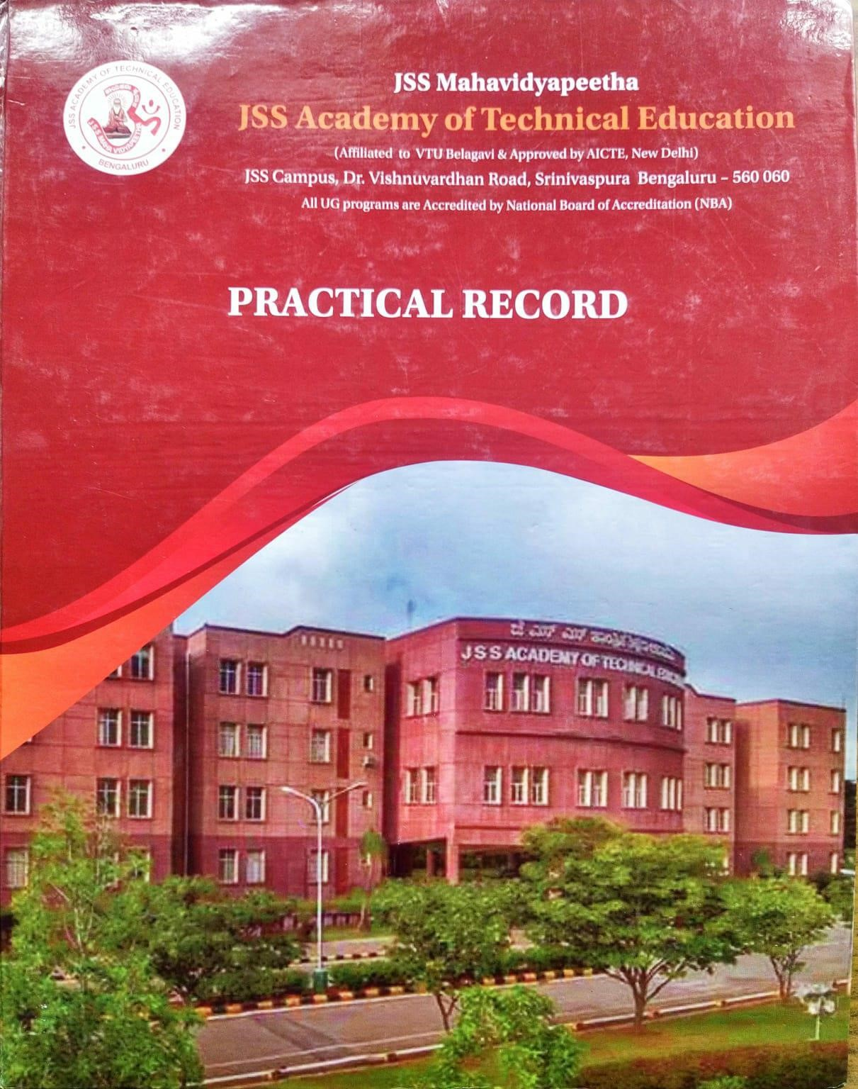

**J.S.S MAHAVIDYAPEETA**

**J.S.S ACADEMY OF TECHNICAL EDUCATION,**

# Srinivaspura,Bangalore-60



# Laboratory Certificate

Department of Computer Science

This is to certify that Mr./Ms………………………………………………………

………………………………………………………………………..has satisfactorily

Completed the course of Experiments prescribed by VTU, Belagavi, for the degree course B E in CSE SEM III the Laboratory in the year 2022-2023.

Signature of Facutly in-charge Head of the Department

Date: ……-………..-2023

Name of the Candidate: ……………………………………

USN: ………………………………………………………

Examination Center: ………………………………………. Date of Practical Examination: …………………………….

# Contents

|  |  |  |  |  |  |
| --- | --- | --- | --- | --- | --- |
| Sl.NO | Date | Name of the Experiment | Page Number | Marks Awarded | Initials of the Teacher |
|  |  | Prepare a Biodata with the cover letter. |  |  |  |
|  |  | Prepare a project synopsis |  |  |  |
|  |  | Prepare a JSSATE College canteen menu list with bullets |  |  |  |
|  |  | Prepare a Newspaper report on your interest. |  |  |  |
|  |  | Prepare a Timetable of your class using Ms-excel |  |  |  |
|  |  | Prepare a Result sheet of a student using Ms-excel |  |  |  |
|  |  | Create a chart using Ms-excel |  |  |  |
|  |  | Create a Student Daily Attendance Sheet using Msexcel for one month |  |  |  |
|  |  | Create an introduction Slide of the topic chosen |  |  |  |
|  |  | Create slides including Diagrams or Tables or charts, etc. |  |  |  |
|  |  | Create slides including images or clip art. |  |  |  |
|  |  | Create an animation slide or Small Video or Audio |  |  |  |
|  |  | Create a hyperlink in any of the slides |  |  |  |
|  |  | Using Access Create an  Employee First Name, Last Name, Date of Birth, Designation, Salary, Email-ID, Phone Number, Address. |  |  |  |
|  |  | Create a table called Publisher for the structure given |  |  |  |
|  |  | Write the steps to start an outlook account |  |  |  |
|  |  | Add an email account in outlook express and automatically set up the account. |  |  |  |
|  |  | Add an email account in outlook express and manually set up the account |  |  |  |
|  |  |  |  |  |  |
|  |  |  |  |  |  |

**1. Module-1 MS-Word**

1. **Prepare a Biodata with the cover letter.**
2. **Prepare a project synopsis.**
3. **Prepare a JSSATE College canteen menu list with bullets, footers, and**

**Headers.**

1. **Prepare a Newspaper report on your interest. (Example Environmental day, Independence Day, Sports, etc.)**

**Module-1 MS-Word**

1. **Prepare a Biodata with the cover letter**

**AIM:** To create and design effective documents, you need to know how to format text for biodata and cover letter by using Text Manipulation

* Change the font size and type
* Aligning and justification of Text
* Underlining the Text
* Indenting the Text

**STEPS :**

**Step 1:** Start the programme -> menu -> All Programs -> Ms office.

**Step 2 :** Click File - > New Document-> ok

**Step 3:** Enter the Bio data content and related information.

**Step 4:** Click insert menu-> Pictures->choose the passport size photo and insert inside the resume and set the same Font Size box on the Home tab.

**Step 5**: Select the font you want to use and choose the colour of the font. The font will change in the document.

**Step 6:** Save the Document with filename in directory.

**Step 7:** Exit the program.

**Output:**

1. Biodata with USN

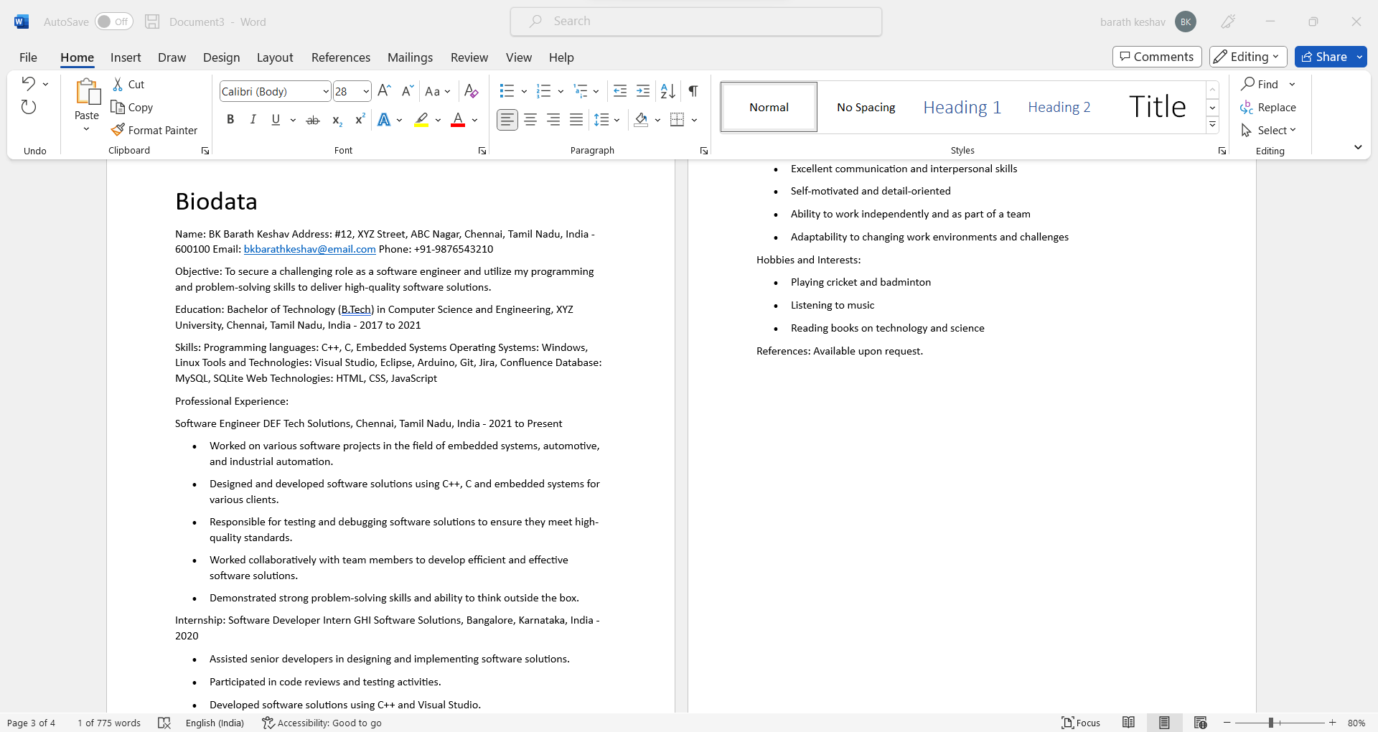

1. Cover letter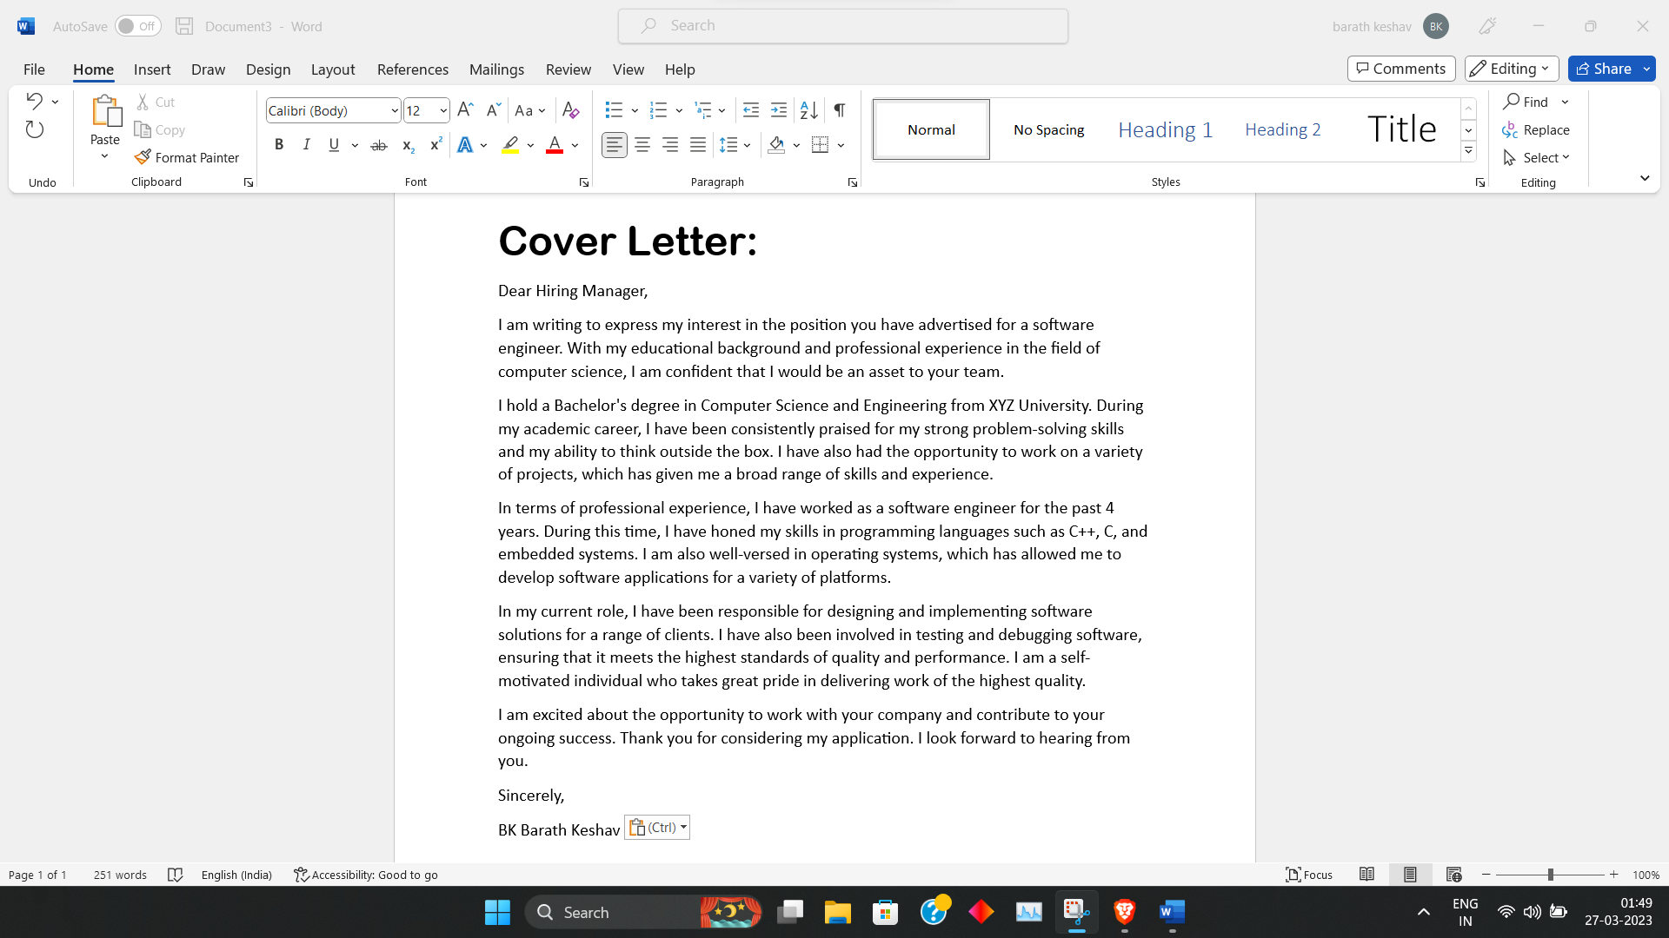
   1. **Prepare a project synopsis.**

**Steps:**

1. Open Microsoft Word and create a new document.
2. Type the title of the project at the top of the page.
3. Enter the objective of the project, describing the purpose of the project and what it aims to achieve.
4. Define the scope of the project, specifying what will be included in the project and what will be excluded.
5. Describe the methodology that will be used to carry out the project, including the approach, process, and tools that will be used.
6. List the expected outcomes of the project, including the benefits, deliverables, and impact of the project.
7. Use headings, bullet points, and formatting to make the synopsis easy to read and visually appealing.
8. Review and edit the synopsis to ensure that it is clear, concise, and free of errors.
9. Save the document and share it with stakeholders as needed.

**Output:**

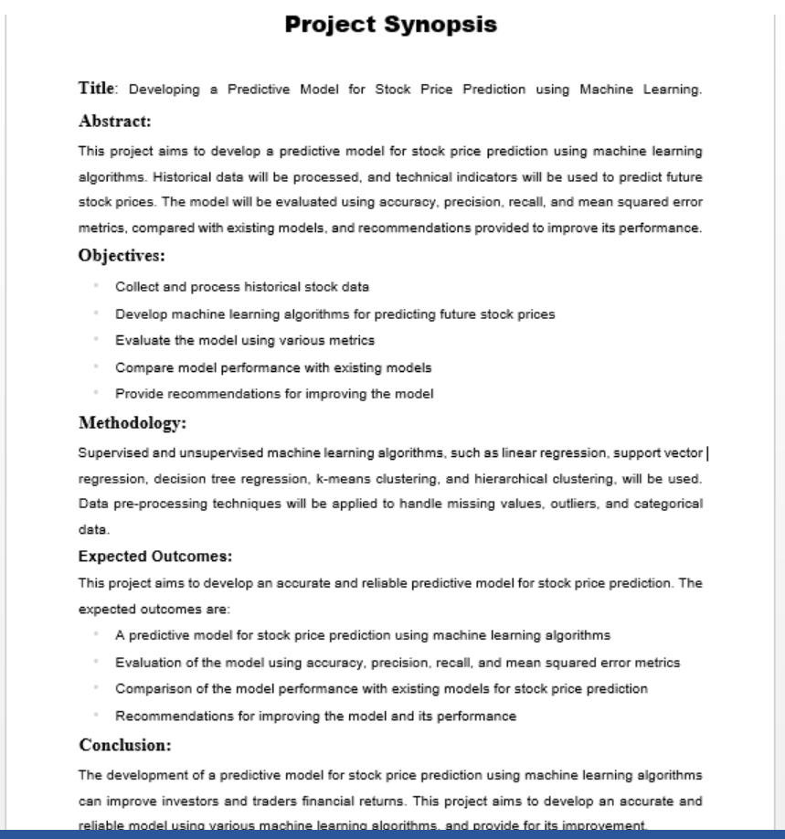

* 1. **Prepare a JSSATE College canteen menu list with bullets, footers, and Headers.**

**AIM**: Prepare a JSSATE College canteen menu list with bullets, footers, and Headers

**STEPS**:

**Step 1:**Open the Microsoft Office -> New-> Blank document.

**Step 2**: insert the Canteen image by insert->image->source file ->ok

**Step 3**: Change the Color of Your Background. You Change the Color of Your Background. By Click on the page layout section then click on the page color.

**Step 4:** Add a Border-> page layout section and click on page border.

**Step 5:** Add the Appropriate Text menu. Add the Appropriate Text and Add menu items by clicking Bullets->choose ->ok

**Step 6:** Add the Clip Art. to Insert and click on Clip Art. Microsoft Word consists of many kinds of images you can pick and use.

**Step 7**: save the file

**OUTPUT:**

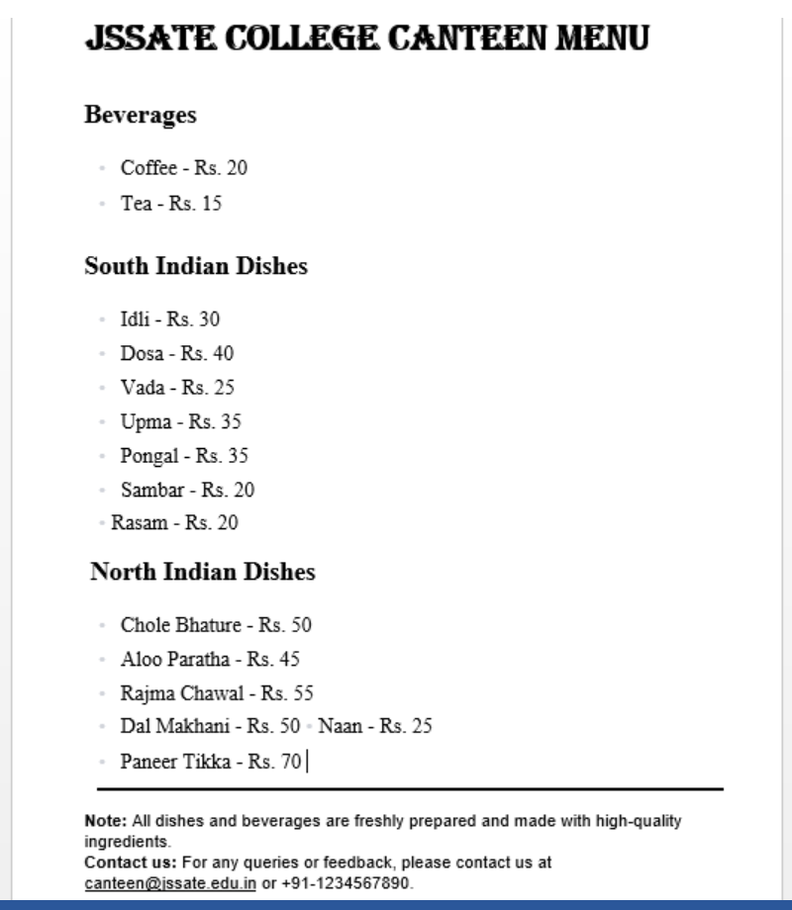

**d. Prepare a Newspaper report on your interest. (Example Environmental day, Independence Day, Sports, etc.)**

**AIM**: Prepare a Newspaper report to publish in the newspapers or any topic of your Interest.

**STEPS:**

**Step 1**: Start the programme -> menu -> All Programs -> Ms office.

**Step 2** : Click File - > New Document-> ok

**Step 3**: insert the College Logo and other pictures to the letter.

**Step 3**: Type your two paragraph for college events, and function details with timing and others by Highlight a section of text in the paper, click the “Home” tab, and then click the “Justify” button on the Paragraph section of the ribbon. This gives your paper the full-justification look most newspapers have rather than Word’s default left alignment.

**Step 4:** Select the text -> Column in the drop-down menu.

**Step 5:** Find and replace by clicking -> Replacement -> Type the text-> Click

->Replace ->Close

**Step 6:** Check the grammar mistake by On the Word menu, click

Preferences > Spelling & Grammar. In the Spelling &

Grammar dialog box, under Spelling, check or clear the Check spelling as you type box. Under Grammar, check or clear the Check grammar as you type box. Close the dialog box to save your changes.

**Step 7** :Save the Document **Step 8**: Exit the Programme.

**OUTPUT:**

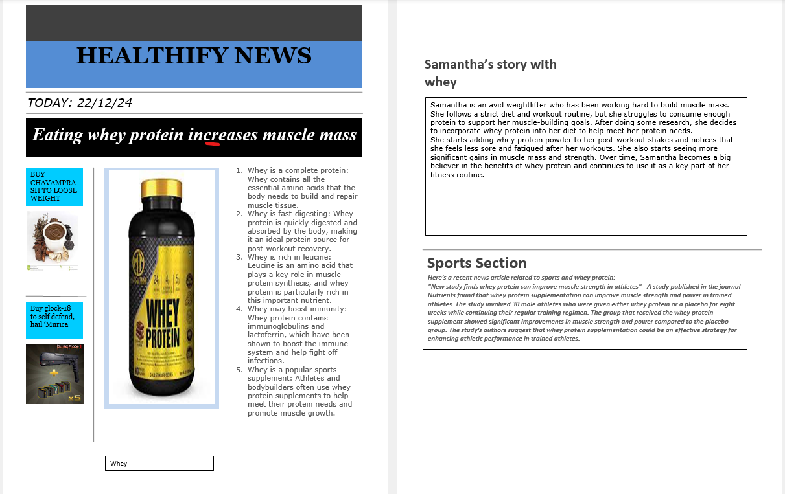

**Module -2 MS-Excel**

1. **Prepare a Timetable of your class using Ms-excel.**
2. **Prepare a Result sheet of a student using Ms-excel.**
3. **Create a chart using Ms-excel.**
4. **Create a Student Daily Attendance Sheet using Ms-excel for one month.**

1. **Prepare a Timetable of your class using Ms-excel.**

**STEPS:**

1. Open Microsoft Excel and create a new worksheet.
2. Label in the first few rows with appropriate headings.
3. In column A, list the days of the week, starting from Monday and continuing until Friday.
4. In Row 5, list the time slots for each day. For example, from 8:00 AM to 9:00 AM in cell B2, 9:00 AM to 10:00 AM in cell B3, and so on.
5. Now enter the subject for each time slot. For example, English in cell C6, Math in cell C4, and so on.
6. Similarly fill the faculty details.

**OUTPUT:**

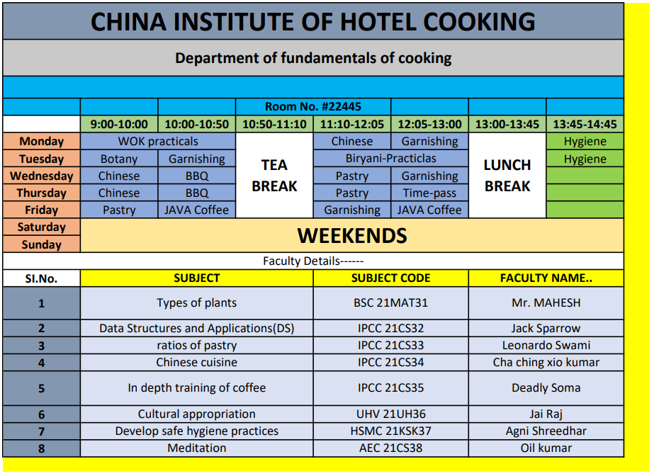

**RESULT:** Thus, Class time table is prepared using Ms-excel

1. **Prepare a Result sheet of a student using Ms-excel.**

**AIM**: To prepare students mark list is Ms-excel by using Formulas.

i) Data sorting – Ascending and Descending (both numbers and alphabets) ii) Draw three type graphs for the marks statement.

**STEPS:**

**STEP 1:** First go to file menu and choose new sub menu and select work sheet option and click ok.

**STEP 2:** Enter the fields Reg No, students name, subject-Tamil, English, Maths, Science, Social, Total, Average, Result and grade.

**STEP 3:** Enter the Register number, names, and marks and grade.

**STEP 4:** To find the total, Enter the Formula = sum (ex: C3:H3) this will give the total at the marks.

**STEP 5:** Enter the formula in the formula bar finding average =average (total/no of subjects)

**STEP 6:** In the result column type the formula in the formula menu as = IF (AND (Tamil>=40, English>=40,Maths>=40,Science>=40,Science>=40), “pass”,

“fail”) the result of the student will be displayed.

**STEP 7:** In the grade column the formula in the formula bar =IF (cellNo>=100,

“Distinction”, IF(cell No>=60, “First”, IF(cell No>=50, “SE(NO)”, IF(cell No>=40, “NIL”). This will give the grade of the student.

**STEP 8:** save the file.

**OUTPUT:**

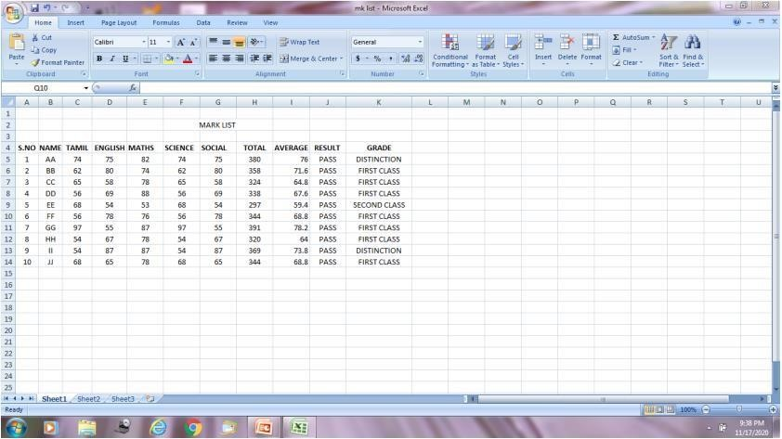

**RESULT:** Thus, student mark sheet is prepared using Ms-excel.

c. **Create a chart using Ms-excel.**

**AIM:** To prepare a chart using Ms-excel.

**STEPS:**

**1:** open a new work sheet in Ms-excel

**2:** Go to file menu and select new sub-menu and click work sheet option.

**3:** Enter the data in the work sheet and select the data table.

**4:** Choose the chart wizard from insert menu be the chart type.

**5:** Give the chart like and define X-axis and Y-axis.

**6:** Finally click the finish button new we get the chart for the data table selected.

**7:** Save the File.

**OUTPUT:**

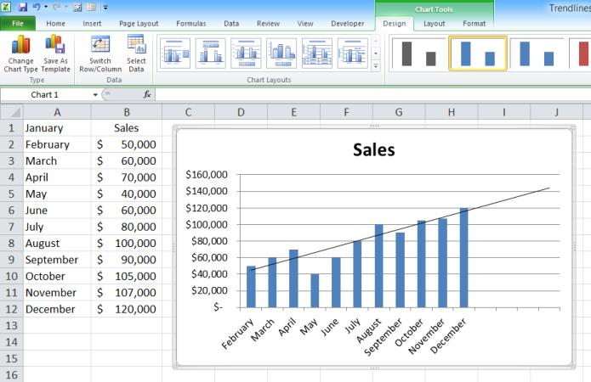

**RESULT:** Thus a chart is prepared using Ms-excel.

d. **Create a Student Daily Attendance Sheet using Ms-excel for one month.**

**STEPS:**

1. Open Microsoft Excel and create a new workbook.
2. Rename the first sheet as "February 2023 Attendance".
3. In the appropriate row, create columns for the following headings: “Sr. No.”, "Name", "1st Feb", "2nd Feb", "3rd Feb", ..., "28th Feb".
4. Enter the names of all the students in the "Name" column and their roll numbers in the "Roll Number" column.
5. In the "1st Feb" column, Add “P” for Present and “A” for absent similarly for all date columns.
6. To calculate the total number of days present, absent for each student, use the "COUNTIF" formula.
7. Also for each student to calculate attendance percentage.
8. Use “Cell styles” to color your cells and make it more attractive.

**OUTPUT:**

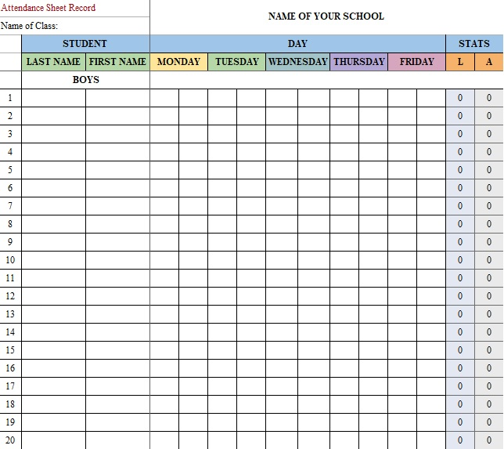

**RESULT:** Thus a Student Attendance Register is prepared using Ms-excel.

**1. Module -3 MS-PowerPoint**

Create a PowerPoint presentation of your interested topics like stacks, queues, your favourite personality information, games, college, etc.

The presentation should include the following.

1. **Create an introduction Slide of the topic chosen.**
2. **Create slides including Diagrams or Tables or charts, etc.**
3. **Create slides including images or clip art.**
4. **Create an animation slide or Small Video or Audio.**
5. **Create a hyperlink in any of the slides.**
6. **Create an introduction Slide of the topic chosen.**

**STEPS:**

**Step 1**: Start the program.

**Step 2**: Click file.-> new->filename-

**Step3:** Select the power point theme

**Step4**: Enter the Introduction

**Step5**: Save the programme

**OUTPUT:**

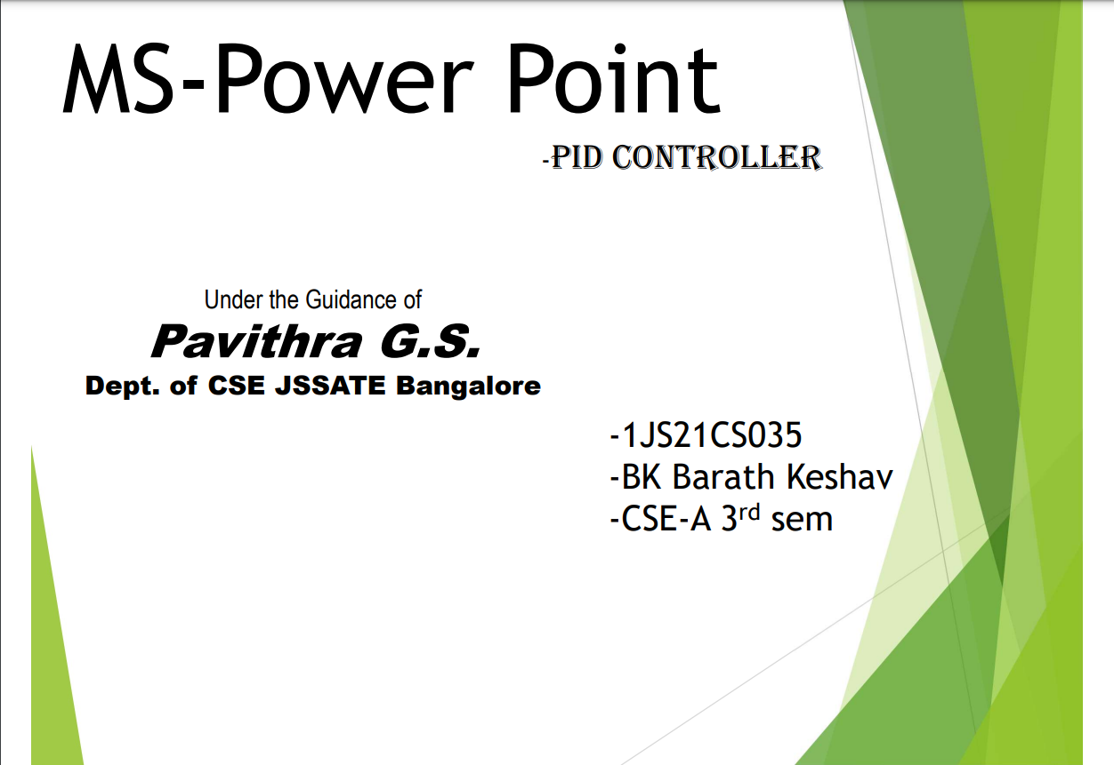

1. **Create slides including Diagrams or Tables or charts, etc.**

**OUTPUT:**

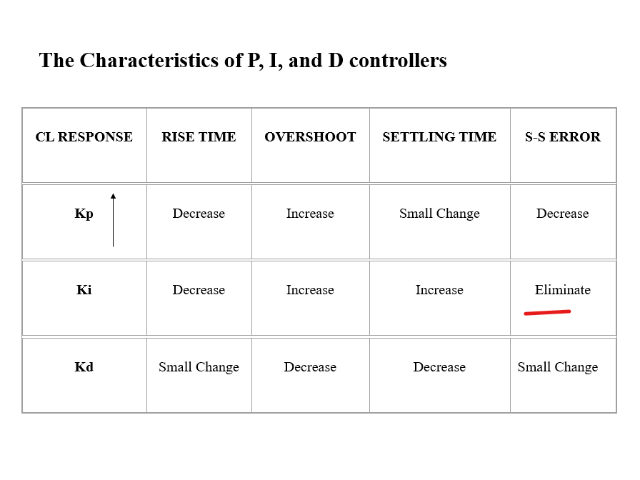

1. **Create slides including images or clip art.**

**OUTPUT:**

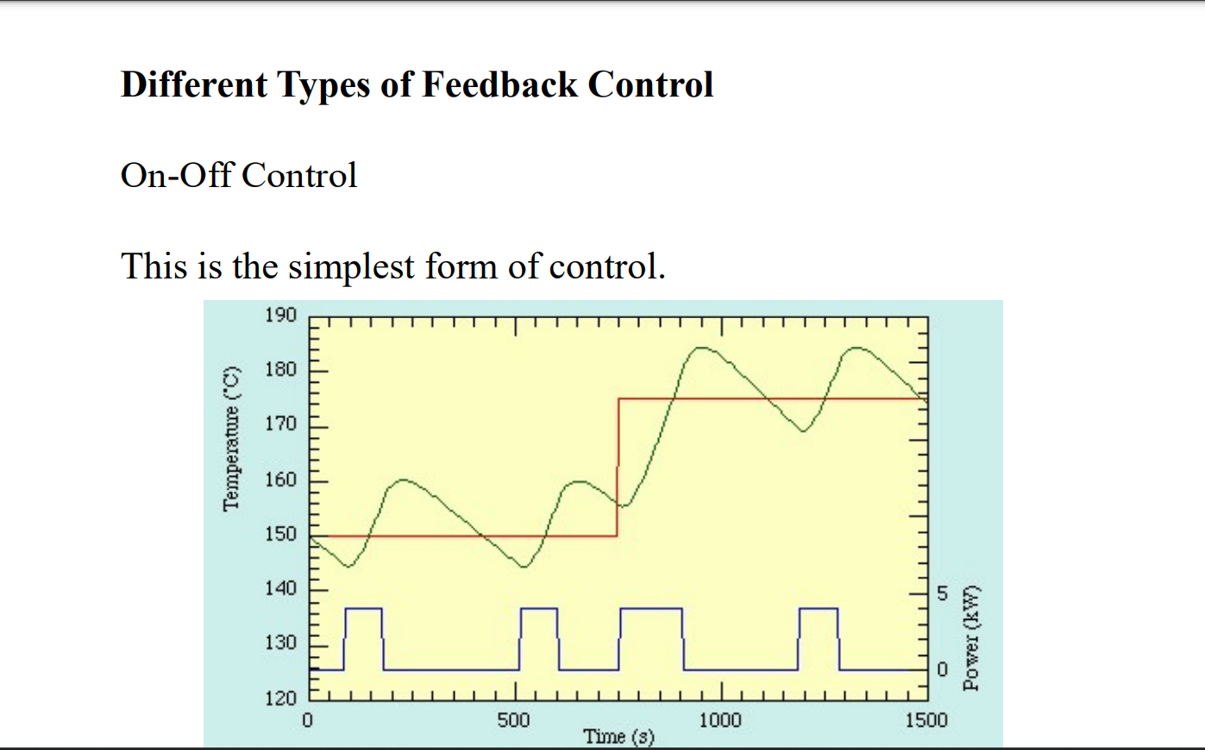

1. **Create an animation slide or Small Video or Audio.**

**OUTPUT:**

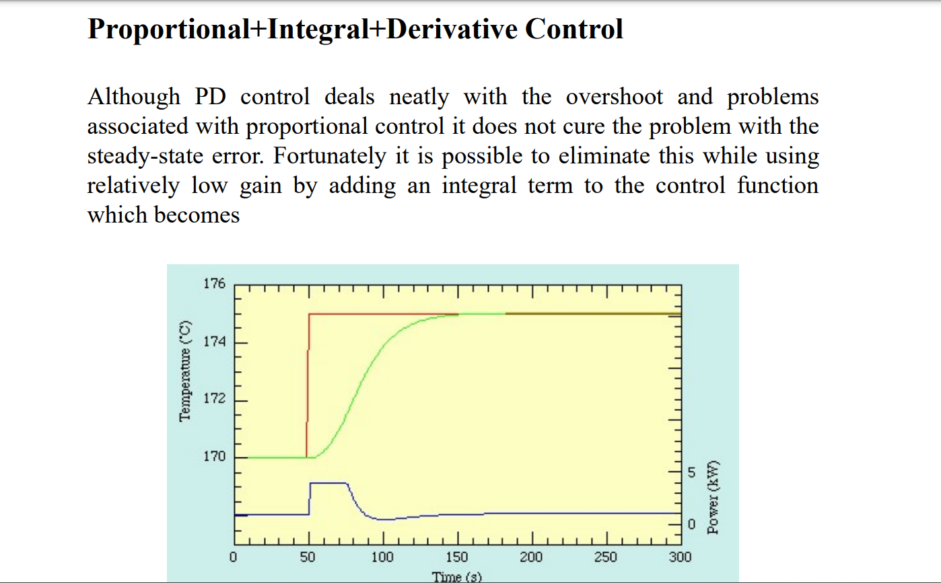

1. **Create a hyperlink in any of the slides.**

**OUTPUT:**

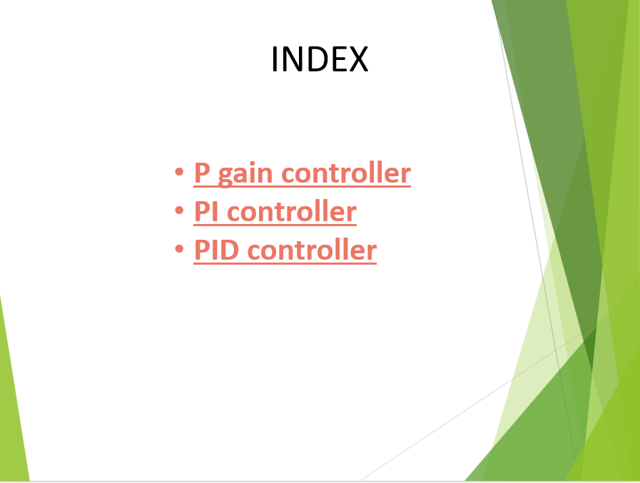

**Module -4 MS-Access**

1. **Using Access Create an Employee First Name, Last Name, Date of Birth,**

**Designation, Salary, Email-ID, Phone Number, Address.**

1. **Create a table called Publisher having the following structure:**

|  |  |
| --- | --- |
| **Field Name** | **Data Type** |
| **Pub ID** | **Short Text** |
| **Pub Name** | **Short Text** |
| **URL** | **HyperLink** |

* + **Set the field PubID as the primary key**
  + **Set the Field Size field property of the field PubID to 5**

**Save and print the database created.**

1. **Using Access Create an Employee First Name, Last Name, Date of Birth, Designation, Salary, Email-ID, Phone Number, Address.**

|  |  |
| --- | --- |
| Field Name | Datatype |
| Employee First Name | Short text |
| Last Name | Short text |
| Date of Birth | Short text |
| Designation | Short text |
| Salary | Currency |
| Email-ID | Short text |
| Phone Number | Number |
| Address | Short text |

**STEPS:**

1. Open Microsoft Access and create a new blank database.
2. Click on the "Table" tab in the top menu bar and select "Table Design" to create a new table.
3. In the table design view, create columns for each of the fields you want to store.

* For example, create columns for "First Name", "Last Name", "Date of Birth", "Designation", "Salary", "Email-ID", "Phone Number", and "Address”.
* Be sure to select the appropriate data type for each field. For example, you may want to use "Short Text" for the employee names, "Date/Time" for the date of birth, "Currency" for the salary, etc.

1. Set the primary key by selecting the "Primary Key" option from the top menu bar and then clicking on the column that will uniquely identify each record. In this case, you may want to use an Employee ID column.
2. Save the table by giving it a name and clicking "Save".

**OUTPUT**

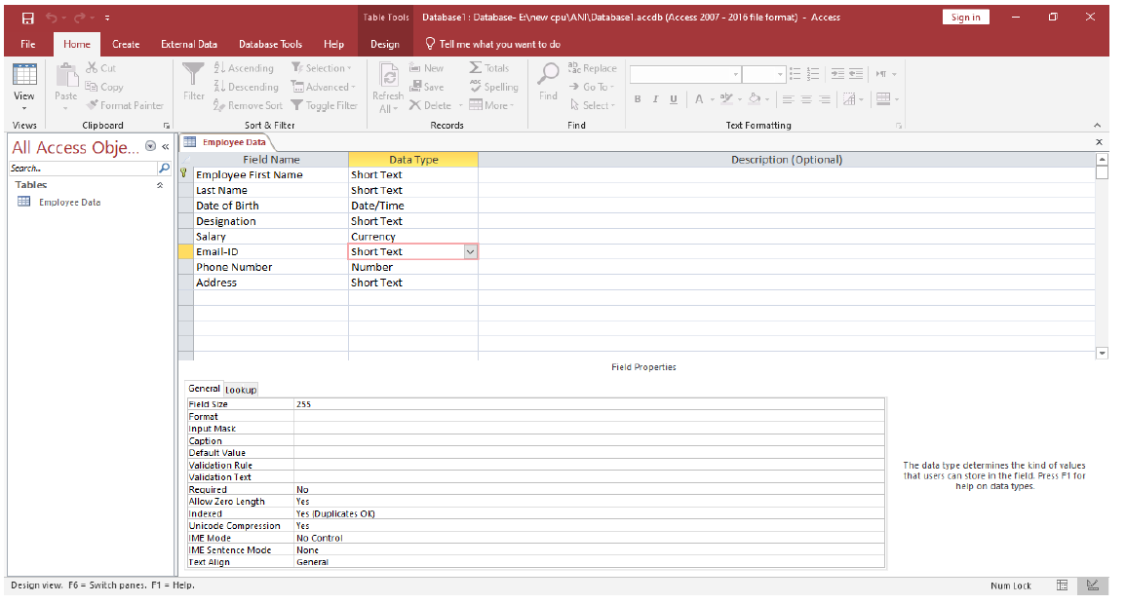

1. Create a table called Publisher having the following structure:

|  |  |
| --- | --- |
| Field Name | Data Type |
| Pub ID | Short Text |
| Pub Name | Short Text |
| URL | HyperLink |

* + Set the field PubID as the primary key
  + Set the Field Size field property of the field PubID to 5 Save and print the database created.

* + - Set the field **PubID** as the primary key.
    - Set the **Field Size** field property of the field **PubID** to **5**.
    - Set the **Field Size** field property of the field **PubName** to **50**. Set the caption property of the **PubID** field to **Publisher ID**.
    - Set the caption property of the **PubName** field to **Publisher’s Name**.

**STEPS:**

**Step 1 :** Open Microsoft Access

**Step 2 :** click on Blank Desktop Database & Define Database Name and click Create.

**Step 3 :** click on Design View

**Step 4 :** Type Table Name Publisher and click ok

**Step 5 :** Type Field Name PubID and set data type to Short Text and at the bottom of the microsoft Access Screen you will find Field size 255 is default Field size Erase 255 and type 5 and Type Caption as well Publisher’s Name

**Step 6 :** Use Tab Key for goto Next Cell

**Step 7 :**In Row Two Type PubName and set Data Type to Short Text Follow step 5 instruction for Field size and Caption

**Step 8 :** In Next Row Type URL and Select Data Type Hyperlink by pressing H on keyboard.

**Step 9:** Save the program

**OUTPUT:**

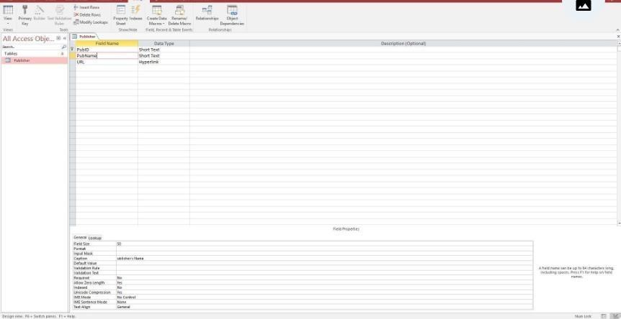

**Module -5 Microsoft Outlook**

1. **Write the steps to start an outlook account.**
2. **Add an email account in outlook express and automatically set up the account.**
3. **Add an email account in outlook express and manually set up the account.**

1. **Write the steps to start an outlook account.**

**STEPS:**

1. Go to the Outlook website: Visit the official website of Outlook, which is https://www.outlook.com/.
2. Click on "Create Account": On the Outlook homepage, you will see the option to create an account. Click on it to proceed.
3. Enter your details: You will be asked to enter your basic details like your name, birthdate, and gender.
4. Choose an email address: You will now be asked to choose a unique email address. You can either choose the default email address provided by Outlook or create a custom email address.
5. Create a password: Create a strong password that is easy for you to remember but difficult for others to guess.
6. Enter your mobile number: You will be asked to enter your mobile number to verify your account.
7. Enter the verification code: After entering your mobile number, you will receive a verification code via SMS. Enter this code to verify your account.
8. Agree to the terms and conditions: Read and agree to the terms and conditions of using Outlook.
9. Verify your account: Once you have completed all the above steps, your account will be created. You will be asked to verify your email address by clicking on a link that is sent to your email.

1. **Add an email account in outlook express and automatically set up the account.**

Step 1: Open Outlook.

Step 2: Click the File menu tab.

Step 3: Click Add Account.

Step 4: Enter fields as shown below:

Your Name: Bob Cat

Email address:bob.cat@student.montana.edu

User name: NetID@msu.montana.edu

Password: NetID Password

Step 5: Make sure the radio button next to Manual setup... is NOT selected.

Step 6 : Click the Next button ->The Windows Security panel open prompting for your password.

Step 7: Replace the auto populated User name with:

User name: NetID@msu.montana.edu

Password: NetID password Then click the OK button.

Your account should now be set up.

**OUTPUT**:

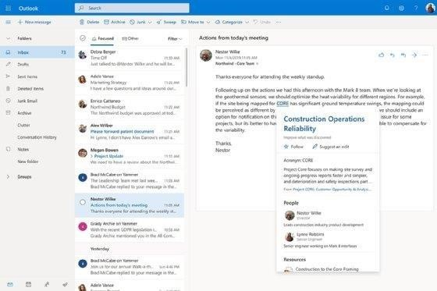

**RESULT:** The result has been shown above.

**c. Add an email account in outlook express and manually set up the account.**

Step 1 :Click the radio button next to Manually setup... and then click the Next button.

Step 2: Click the radio button next to POP and IMAP and then click the Next button.

Step 3: Enter fields as shown below:

Your Name: Bob Cat

Email address: bob.cat@student.montana.edu

Account type: IMAP

Incoming Mail server: outlook.office365.com

Outgoing SMTP server: smtp.office365.com

User Name: netid@msu.montana.edu

Password: NetID password

Step 4: Click the More Settings button. The Internet E-mail Settings panel opens.

Step 5: Click the Outgoing Server tab.

Step 6: Check the box next to My outgoing server (SMTP) requires authentication and the radio button next to Use the same settings... as shown in image below.

Step 7: Click the Advanced tab.

Enter the following under Server Port Numbers:

Incoming server (IMAP): 993

Use the following type of encryptied connection: SSL

Outgoing server (SMTP): 587

Use the following type of encrypted connection: Auto

Step8: Click the OK button.

•Test Account Settings should start automatically. If it doesn't, click the Test Account Settings button to verify info entered.

•Click the Close button, then click Finish.

**OUTPUT**:

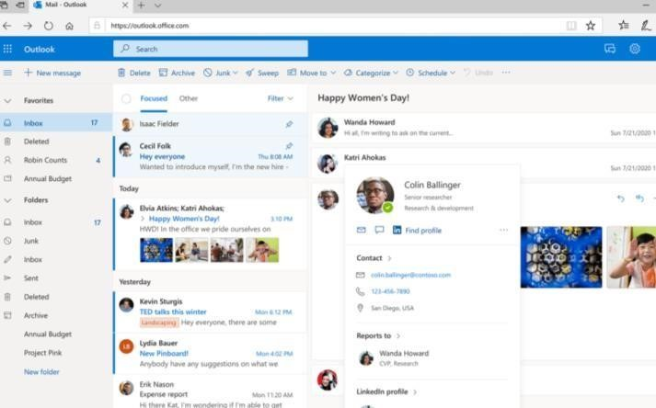

**RESULT:** The result has been shown above.