**ASSIGNMENT-1**

1. Write a java program to print your biodata?

public class Assignment1{

public static void main(String[] args) {

System.out.println("NAME : MRUTYUNJAYA PATRA");

System.out.println("Roll_No"+": 404028");

System.out.println("Regd_No"+": 2105105026");

System.out.println("Branch"+": MCA");

System.out.println("Phone_No"+": 6371655140");

System.out.println("Address"+" : At- Chasapada PO-Chasapada Dis-Cuttack Pin-754027");

}

}

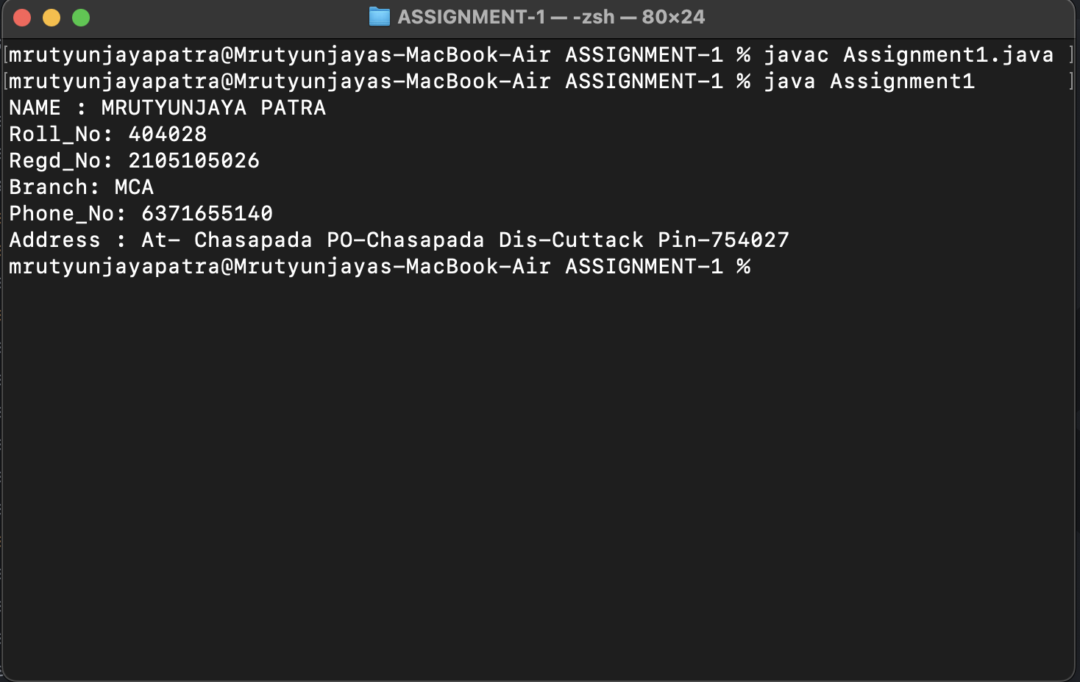

­

1. Write a java program to find simple interest?

import java.util.Scanner;

public class Assignment2 {

public static void main(String[] args) {

double amount=15000.00;

int time =2;

float rate=7.5f;

double SI=0;

System.out.println("The time is = "+time);

System.out.println("The rate is = "+rate);

System.out.println("The principal amount is = "+amount);

SI=amount*rate*time;

System.out.println("The simple Interest is= "+ SI);

}

}

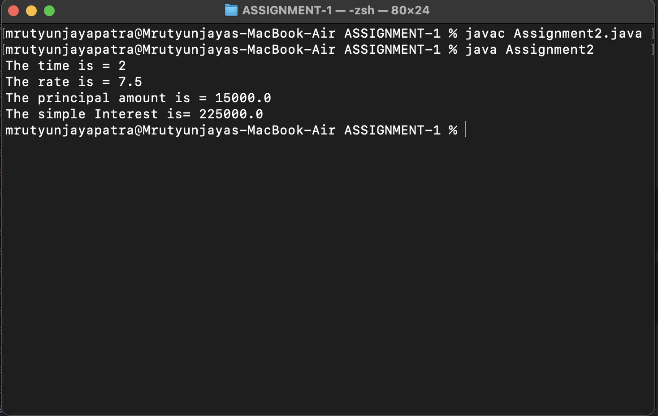

3. Write a java program for temperature conversion?

public class Assignment3 {

public static void main(String[] args) {

float celsius = 90;

double temp_in_kelvin = 0;

double temp_in_fahrenheit = 0;

temp_in_kelvin = celsius + 273.15;

temp_in_fahrenheit = celsius * (9 / 5) + 32;

System.out.println("Temperature in kelvin=" + temp_in_kelvin);

System.out.println("Temperature in Fahrenheit=" + temp_in_fahrenheit);

}

}

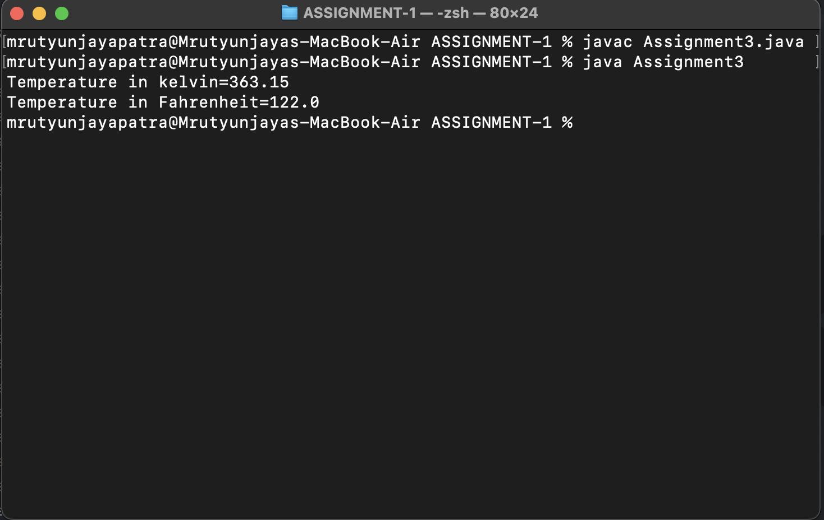

4. Write a java program to implement adder circuit and booth algorithm using bitwise operator?

public class Assignment4 {

public static void main(String[] args) {

int num1=0, num2=0 , C_In=0, C_Out;

int sum;

//for half adder circuit

sum = num1 ^ num2;

C_Out = num1 & num2;

System.out.println("Sum = "+ sum);

System.out.println("C_out= "+C_Out);

//for full adder

sum=C_In ^ (num1 ^ num2);

C_Out = (num1 & num2) | (num2 &C_In) | (num1&C_In);

System.out.println("Sum ="+ sum);

System.out.println("C_out="+C_Out);

}

}

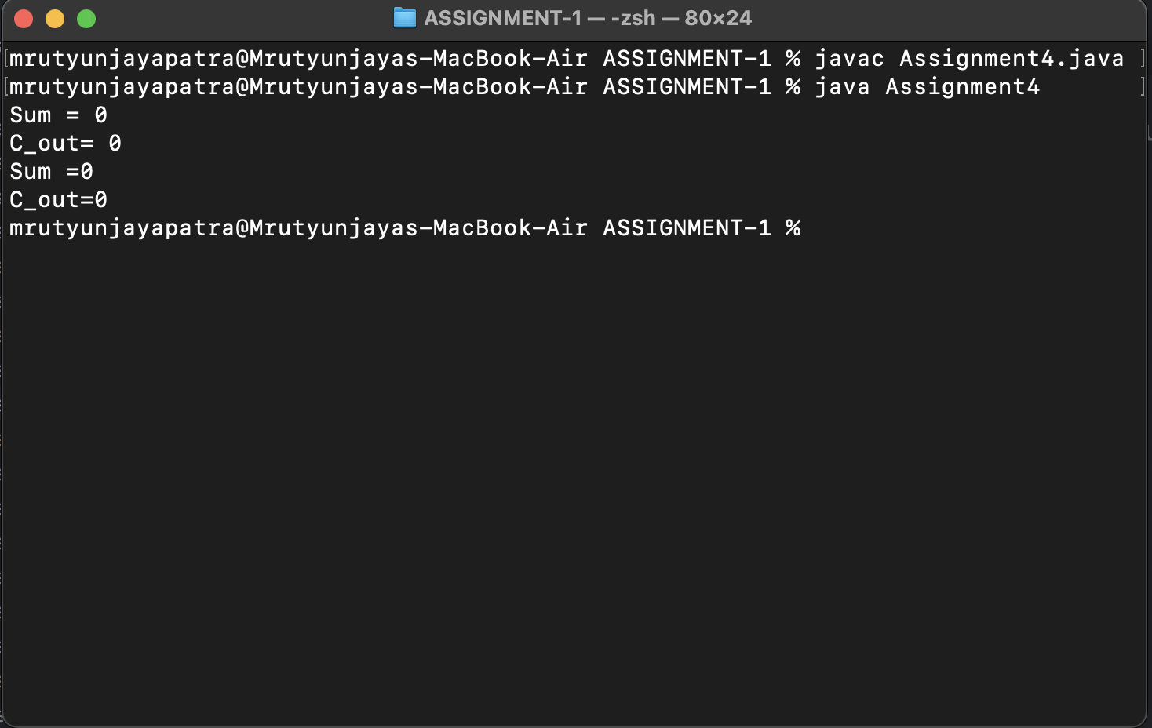

5. Write a java program to find following without using looping and decision making

1. Sum of all digits of any 4 digit numbers

public class Assignment5_1 {

public static void main(String[] args) {

int num = 1624;

int sum = 0, rem;

rem = num % 10;

sum += rem;

rem = 0;

num = num / 10;

rem = num % 10;

sum += rem;

rem = 0;

num = num / 10;

rem = num % 10;

sum += rem;

rem = 0;

num = num / 10;

rem = num % 10;

sum += rem;

rem = 0;

num = num / 10;

System.out.println(sum);

}

}

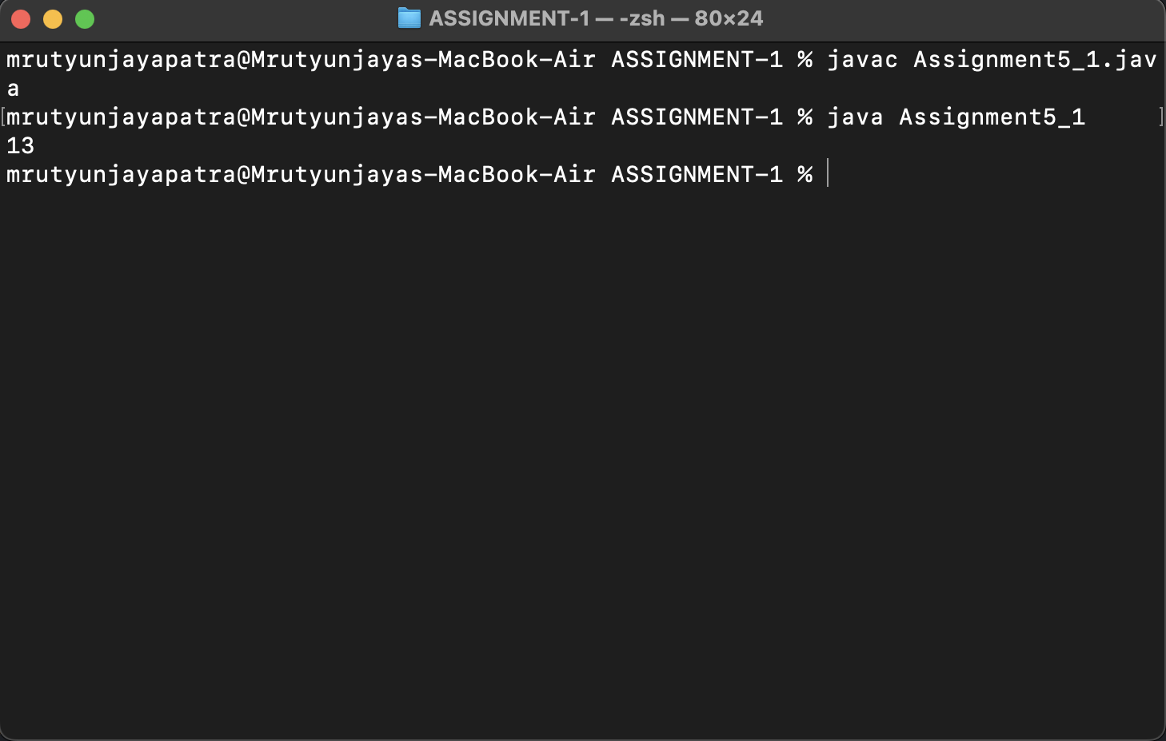

1. find the face value and position value of any 4 digit number?

public class Assignment5_2 {

public static void main(String[] args) {

int num;

num = 6319;

System.out.println("First number\n\tface value:"+(num/1000)+" \n\tposition value: "+(num - num % 1000));

System.out.println("First number\n\tface value:"+(num/100%10)+" \n\tposition value: "+(num/100%10 * 100));

System.out.println("First number\n\tface value:"+(num/10%10)+" \n\tposition value: "+(num/10%10 * 10));

System.out.println("First number\n\tface value:"+(num%10)+" \n\tposition value: "+(num%10));

}

}

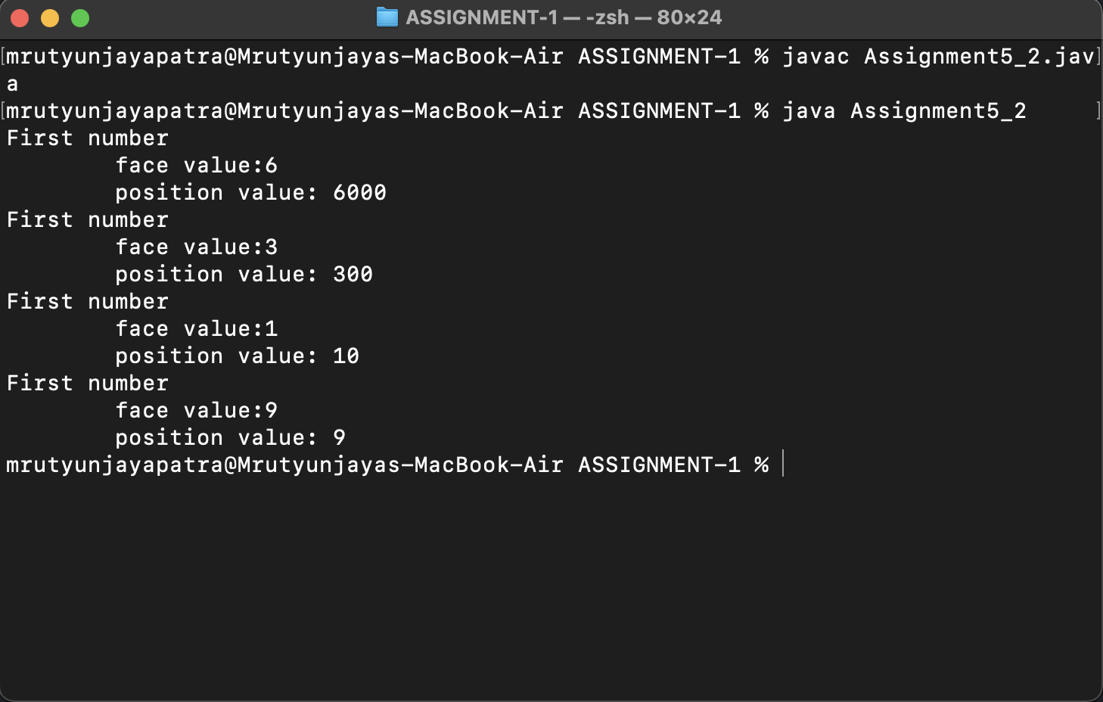

1. Find the value available at position required by user it may be 10,100 or 1000?

public class Assignment5_3 {

public static void main(String[] args) {

int num=6198;

System.out.println("The number: "+num);

System.out.println("Value available at position 1000: "+(num/1000));

System.out.println("Value available at position 100: "+(num/100%10));

System.out.println("Value available at position 10: "+(num/10%10));

System.out.println("Value available at position 1: "+(num%10));

}

}

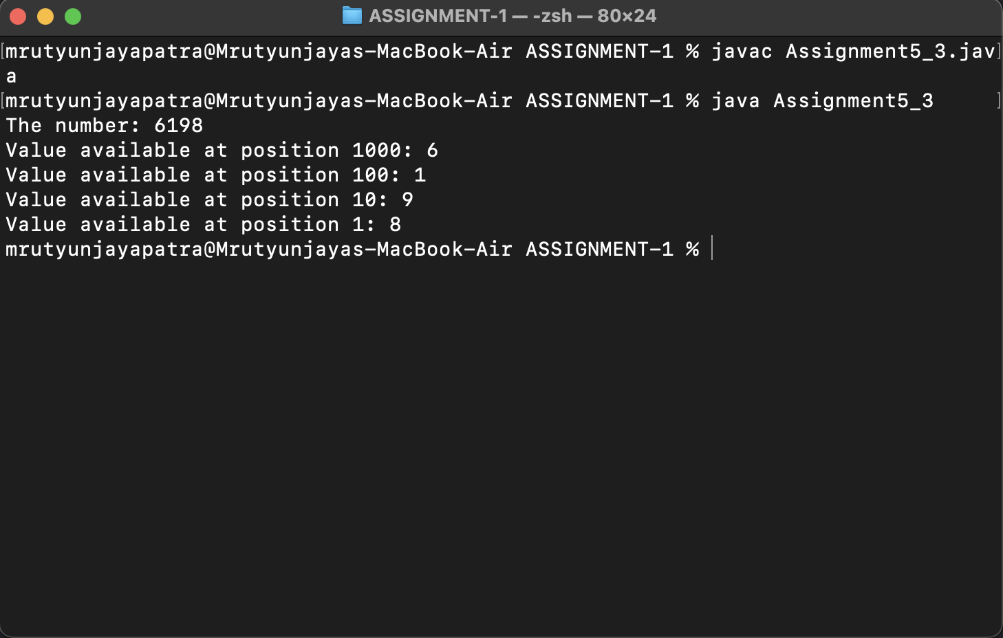

1. Sum of product of consecutive digits of any 4 digit number? Supoose num=1234 then output= 4*3+3*2+2*1

public class Assignment5_4 {

public static void main(String[] args) {

int num=6198;

int a,b,c,d,ans=0;

a=num%10;

num/=10;

b=num%10;

num/=10;

c=num%10;

num/=10;

d=num%10;

num/=10;

ans=(a*b)+(b*c)+(c*d);

System.out.println("Sum of product of consecutive digits is : "+ans);

}

}

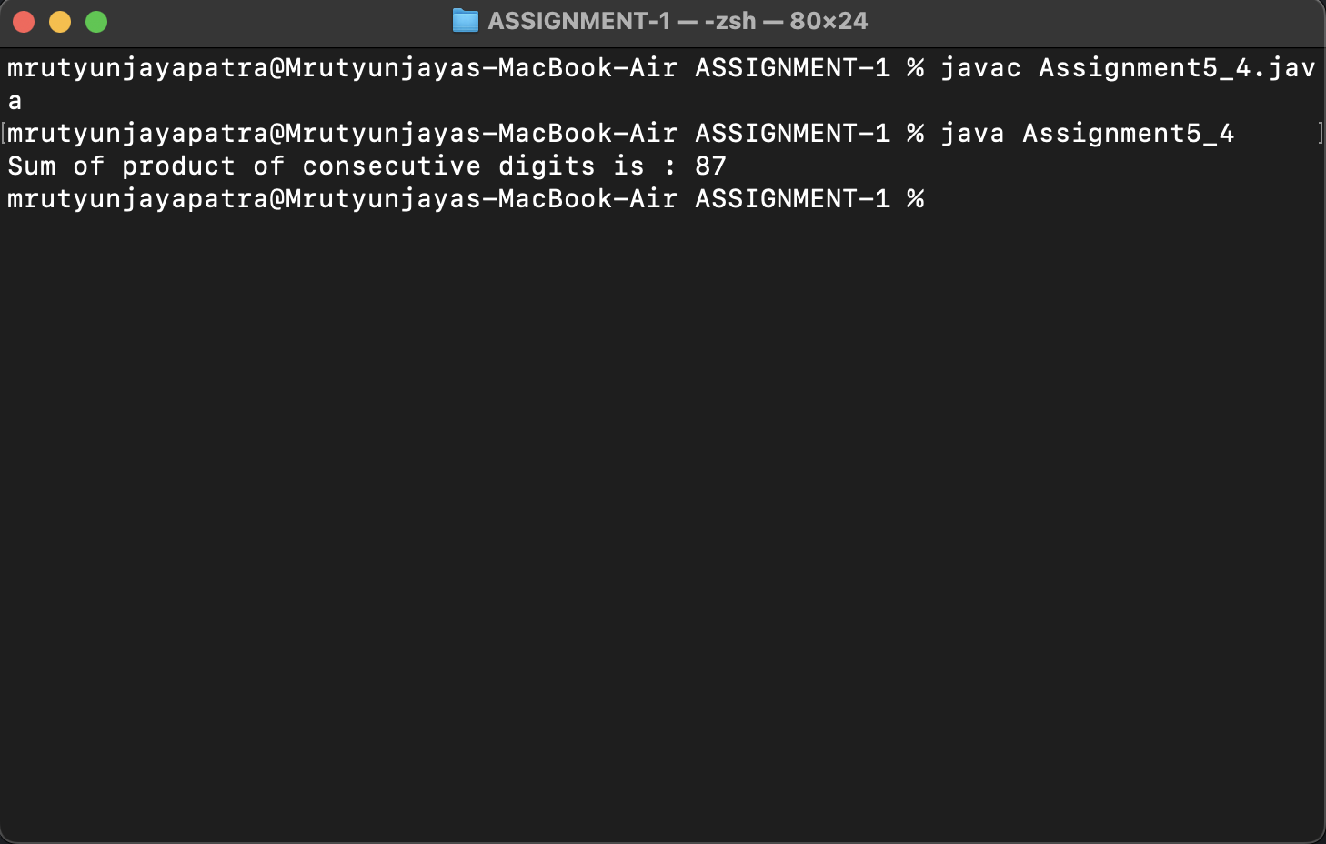

1. find sum of product of corresponding digits of two any 4 digit

number Such as n=1234 m=7896 output=6*4+9*3+8*2+7*1

public class Assignment5_5 {

public static void main(String[] args) {

int n = 1234, m = 7896, sum = 0;

int a1, b1, c1, d1;

int a2, b2, c2, d2;

a1 = n % 10;

n /= 10;

b1 = n % 10;

n /= 10;

c1 = n % 10;

n /= 10;

d1 = n % 10;

n /= 10;

a2 = m % 10;

m /= 10;

b2 = m % 10;

m /= 10;

c2 = m % 10;

m /= 10;

d2 = m % 10;

m /= 10;

sum = a1 * a2 + b1 * b2 + c1 * c2 + d1 * d2;

System.out.println("Sum of product of corresponding digits n=1234 and m=7896 is : "+sum);

}

}

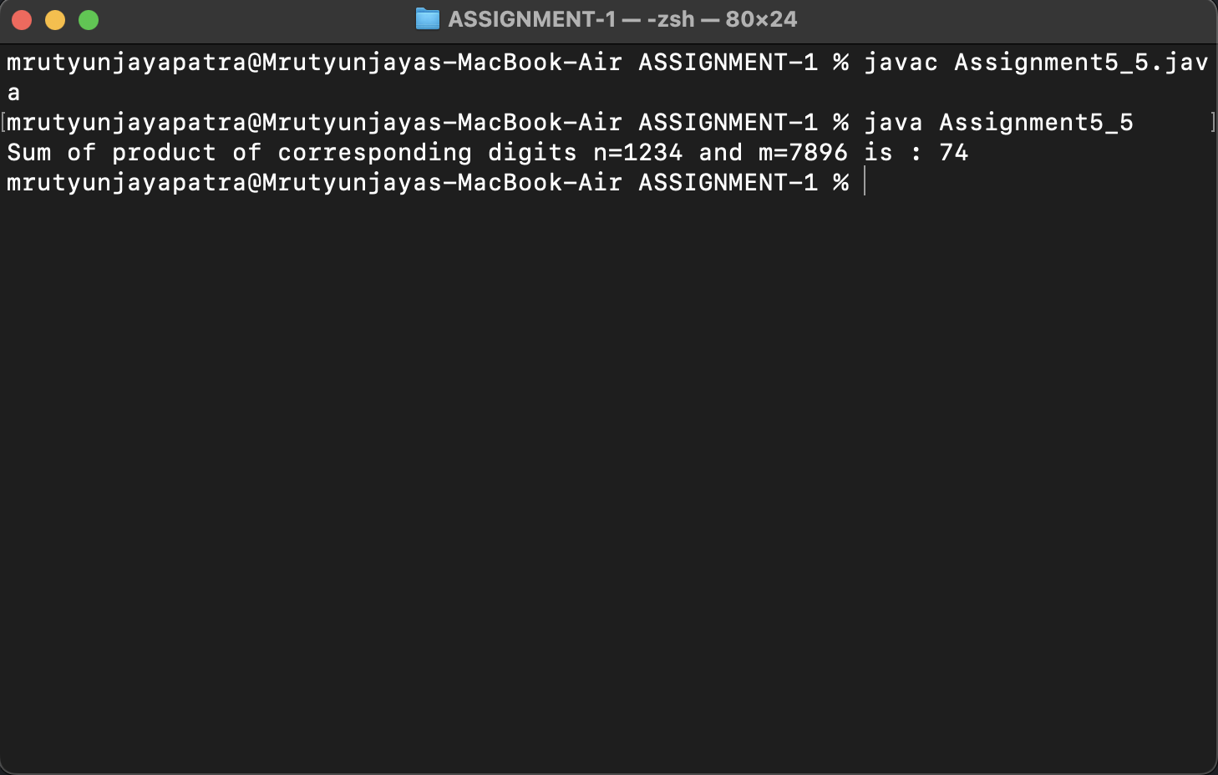

1. find bitwise and , or , and xor of 2nd and 4th digit of any 4 digit number?

public class Assignment5_6 {

public static void main(String[] args) {

int num=1234;

int m, n, temp;

m=((num/10) %10);

n=((num/1000) %10);

temp=m|n;

System.out.println("Bitwise OR Value of 2nd: "+m+" and "+" 4th "+n+" is ="+temp);

temp=m&n;

System.out.println("Bitwise AND Value of 2nd: "+m+" and "+" 4th "+n+" is ="+temp);

temp=m^n;

System.out.println("Bitwise XOR Value of 2nd: "+m+" and "+" 4th "+n+" is ="+temp);

}

}

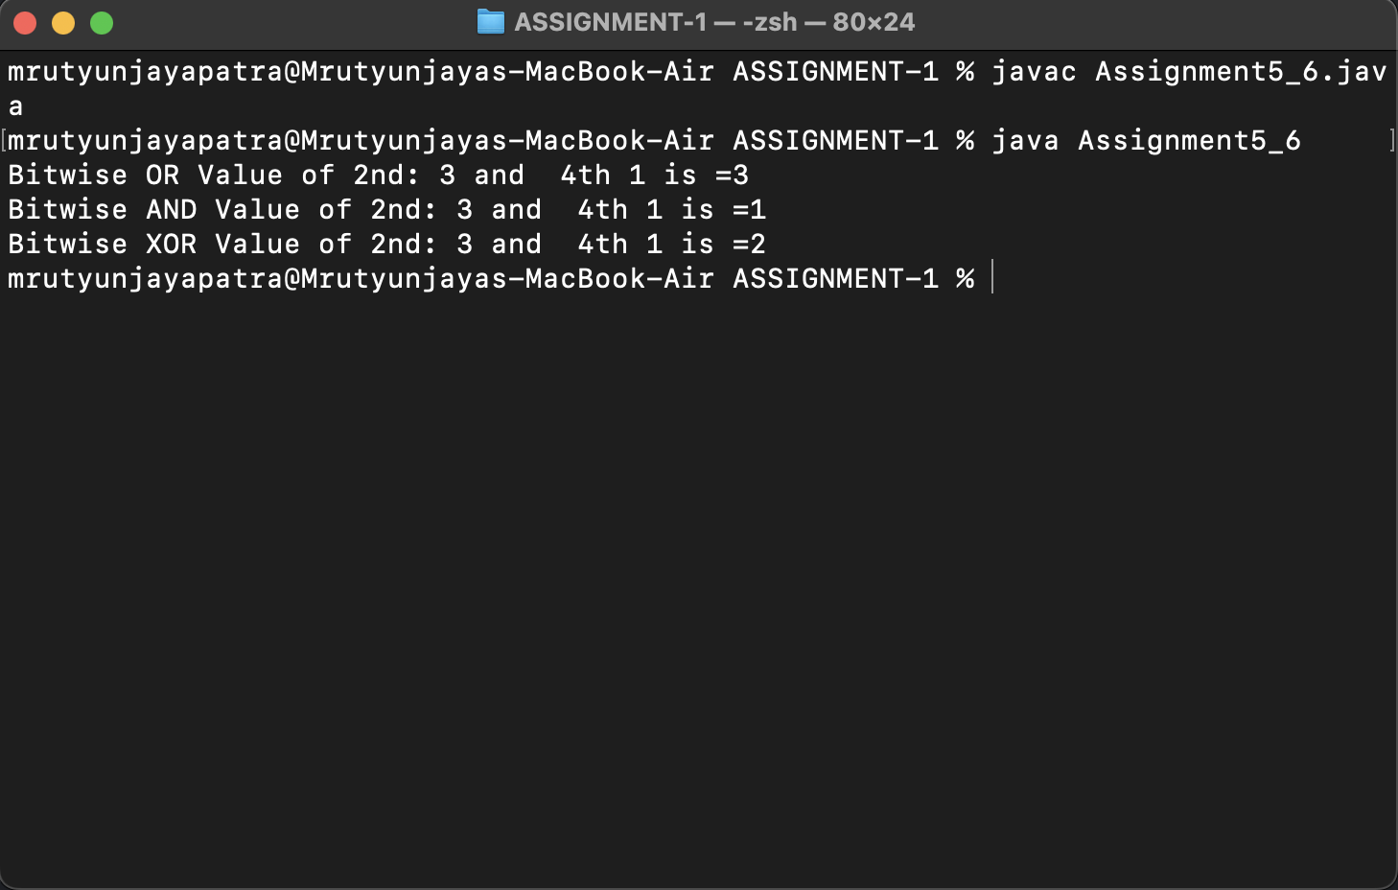

1. Find left shit, right shift and zero fill of summation of all digits of any 4 digit number and it will be shifted by 3rd digit of any 4 digit number?

public class Assignment5_7 {

public static void main(String[] args) {

int num, sum, d1, d2, d3, d4;

num = 9728;

d1 = num / 1000;

d2 = num / 100 % 10;

d3 = num / 10 % 10;

d4 = num % 10;

sum = d1 + d2 + d3 + d4;

System.out.println("The number is: " + num);

System.out.println("The Sum of the digits is: " + sum);

System.out.println("Left shift upto " + d3 + " to sum is: " + (sum << d3));

System.out.println("Right shift upto " + d3 + " to sum is: " + (sum >> d3));

System.out.println("Right shift and zero fill upto " + d3 + " to sum is: " + (sum >>> d3));

}

}

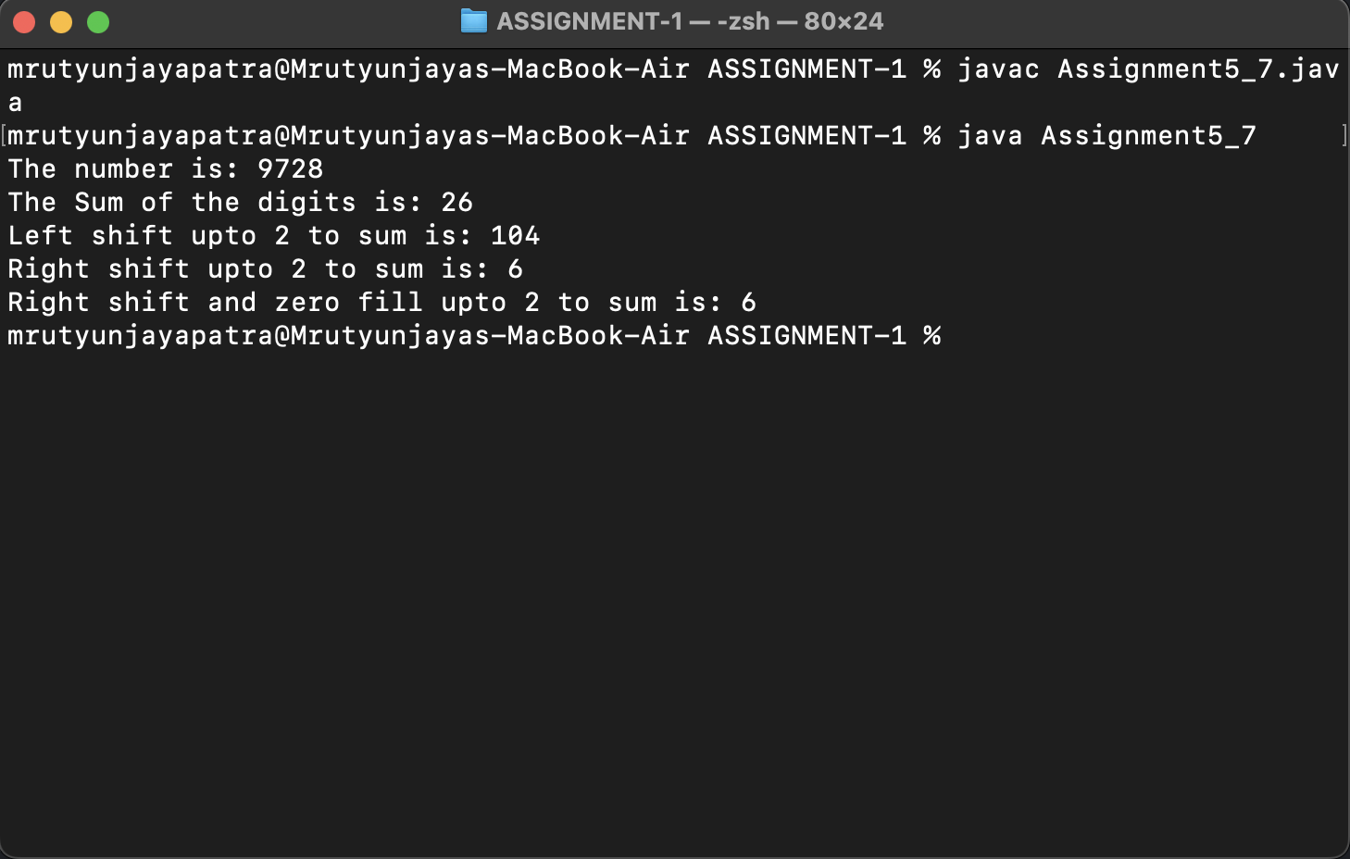

6. Write a java program to find following using conditional operator and without using looping and decision making ?

a. Sum of all even digits of any 4 digit number

public class Assignment6_1 {

public static void main(String[] args) {

int num = 2242, rem = 0, sum = 0;

rem = num % 10;

sum += rem % 2 == 0 ? rem : 0;

num = num / 10;

rem = 0;

rem = num % 10;

sum += rem % 2 == 0 ? rem : 0;

num = num / 10;

rem = 0;

rem = num % 10;

sum += rem % 2 == 0 ? rem : 0;

num = num / 10;

rem = 0;

rem = num % 10;

sum += rem % 2 == 0 ? rem : 0;

num = num / 10;

rem = 0;

System.out.println("Sum of the even digit number is : " + sum);

}

}

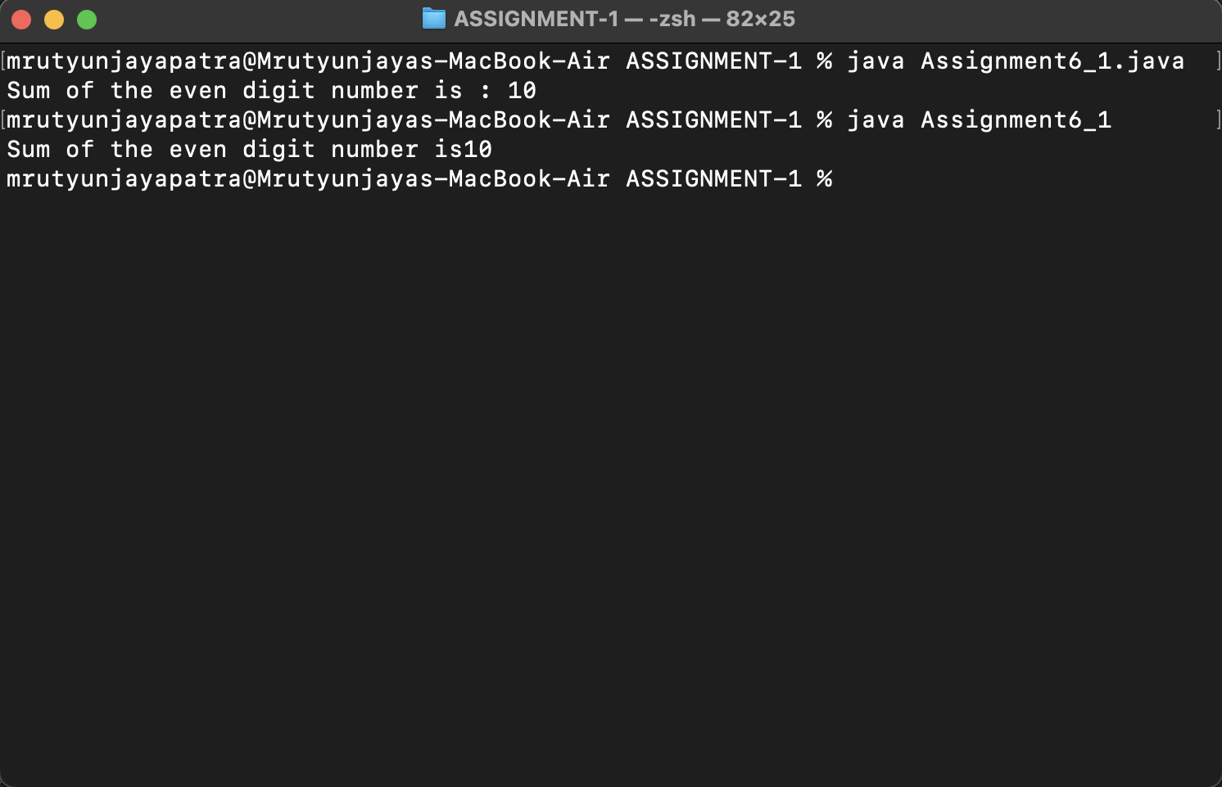

b) Sum of all odd digits of any 4 digit number

public class Assignment6_2 {

public static void main(String[] args) {

int num = 1243, rem = 0, sum = 0;

rem = num % 10;

sum += rem % 2 != 0 ? rem : 0;

num = num / 10;

rem = 0;

rem = num % 10;

sum += rem % 2 != 0 ? rem : 0;

num = num / 10;

rem = 0;

rem = num % 10;

sum += rem % 2 != 0 ? rem : 0;

num = num / 10;

rem = 0;

rem = num % 10;

sum += rem % 2 != 0 ? rem : 0;

num = num / 10;

rem = 0;

System.out.println("Sum of all odd digit number is : " + sum);

}

}

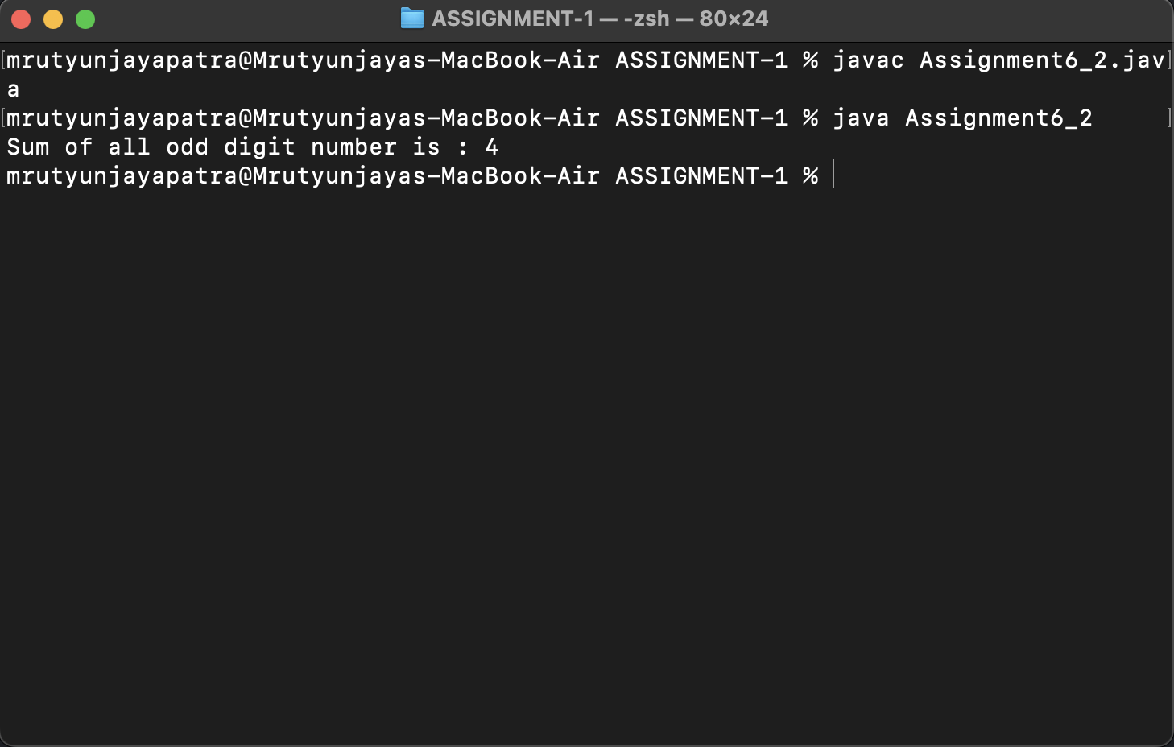

c) Difference between average of all even digits except divisible by 4 and avearge of all odd digits except divisble by 3 of any 4 digit number

public class Assignment6_3 {

public static void main(String[] args) {

int num=1334;

int sum1=0,sum2=0,rem=0;

rem=num%10;

sum1+=(rem%2==0?(rem%4!=0?rem:0):0);

sum2+=(rem%2!=0?rem:0);

rem=0;

num=num/10;

rem=num%10;

sum1+=(rem%2==0?(rem%4!=0?rem:0):0);

sum2+=(rem%2!=0?rem:0);

rem=0;

num=num/10;

rem=num%10;

sum1+=(rem%2==0?(rem%4!=0?rem:0):0);

sum2+=(rem%2!=0?rem:0);

rem=0;

num=num/10;

rem=num%10;

sum1+=(rem%2==0?(rem%4!=0?rem:0):0);

sum2+=(rem%2!=0?rem:0);

rem=0;

num=num/10;

System.out.println("The difference tween average of all even digits except divisible by 4 and avearge of all odd digits except divisble by 3 of any 4 digit number is : "+(sum1-sum2));

}

}

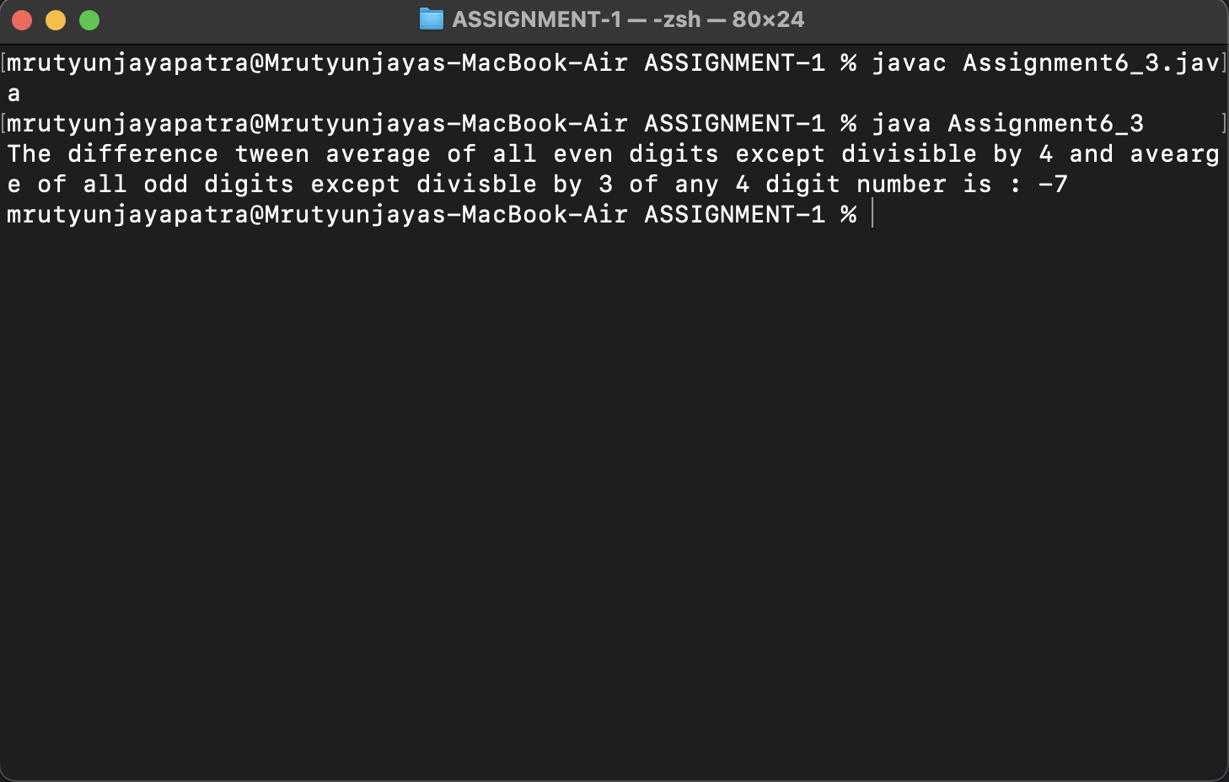

d) Sum of product of consecutive even digits of any 4 digit number? Supoose num=1624 then output= 4*2+2*6

public class Assignment6_4 {

public static void main(String[] args) {

int num=1624;

int a=0,b=0,c=0,d=0,rem=0;

rem=num%10;

a=rem%2==0?rem:0;

num/=10;

rem=0;

rem=num%10;

b=rem%2==0?rem:0;

num/=10;

rem=0;

rem=num%10;

c=rem%2==0?rem:0;

num/=10;

rem=0;

rem=num%10;

d=rem%2==0?rem:0;

num/=10;

rem=0;

int sum=0;

sum+=((a!=0 && b!=0)?(a*b):0);

sum+=((b!=0 && c!=0)?(b*c):0);

sum+=((c!=0 && d!=0)?(c*d):0);

System.out.println("Sum of product of consecutive even digits of any 4 digit number? Supoosenum=1624"+sum);

}

}

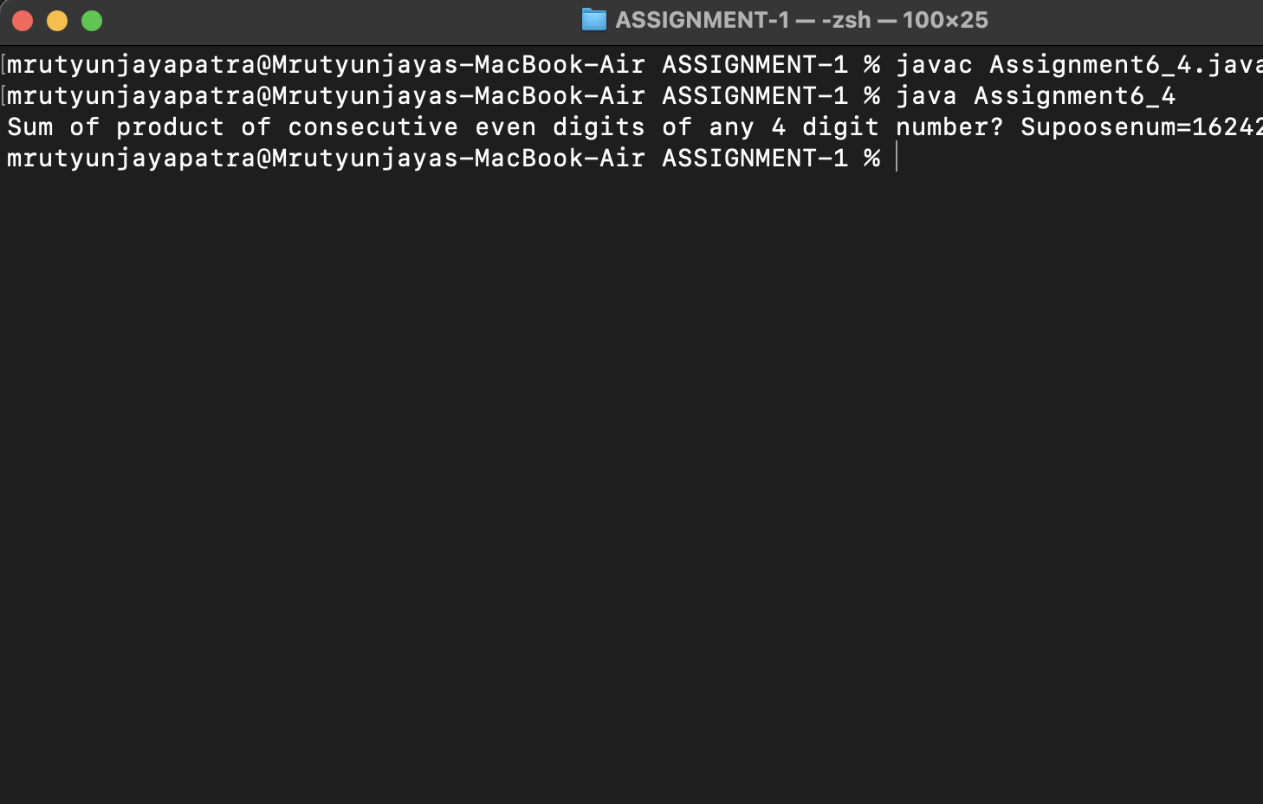

e) Sum of product of consecutive odd digits of any 4 digit number? Supoose num=1356 then output= 5*3+ 3*1

public class Assignment6_5 {

public static void main(String[] args) {

int num=1356;

int a=0,b=0,c=0,d=0,rem=0;

rem=num%10;

a=rem%2!=0?rem:0;

num/=10;

rem=0;

rem=num%10;

b=rem%2!=0?rem:0;

num/=10;

rem=0;

rem=num%10;

c=rem%2!=0?rem:0;

num/=10;

rem=0;

rem=num%10;

d=rem%2!=0?rem:0;

num/=10;

rem=0;

int sum=0;

sum+=((a!=0 && b!=0)?(a*b):0);

sum+=((b!=0 && c!=0)?(b*c):0);

sum+=((c!=0 && d!=0)?(c*d):0);

System.out.println("Sum of product of consecutive odd digits of any 4 digit number? Supoose num=1356"+sum);

}

}

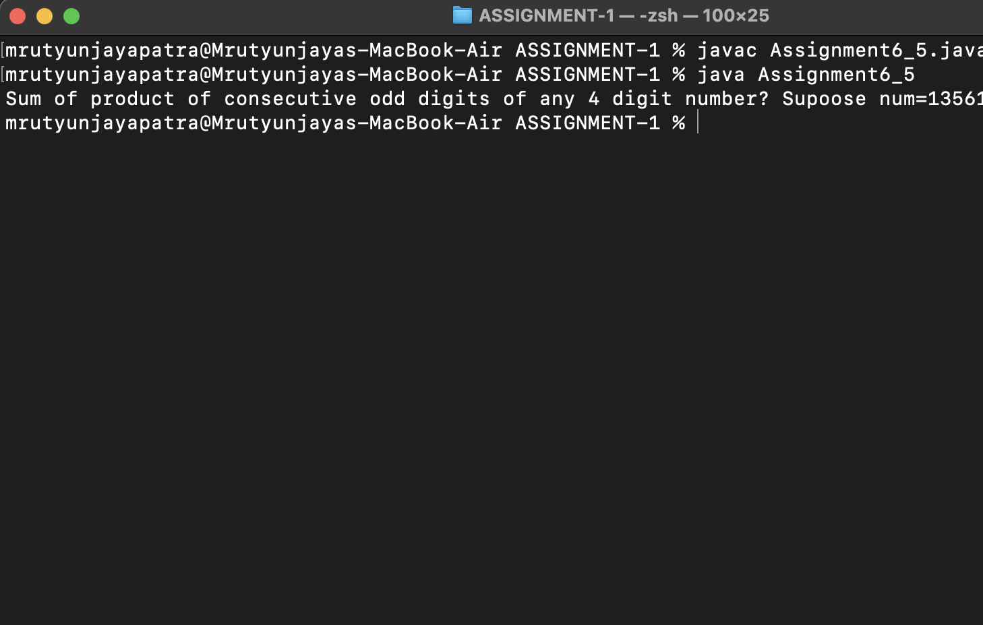

f) Difference between Sum of product of consecutive even digits except 2 and 6 and Sum of product of consecutive odd digits except 3 and 7 of any 4 digit number

public class Assignment6_6 {

public static void main(String[] args) {

int num=1122;

int rem=0,a1,b1,c1,d1,a2,b2,c2,d2;

rem=num%10;

a1=((rem%2==0)?(rem!=2 && rem!=6?rem:0):0);

a2=rem%2!=0?(rem!=3 && rem!=7?rem:0):0;

num/=10;

rem=0;

rem=num%10;

b1=((rem%2==0)?(rem!=2 && rem!=6?rem:0):0);

b2=rem%2!=0?(rem!=3 && rem!=7?rem:0):0;

num/=10;

rem=0;

rem=num%10;

c1=((rem%2==0)?(rem!=2 && rem!=6?rem:0):0);

c2=rem%2!=0?(rem!=3 && rem!=7?rem:0):0;

num/=10;

rem=0;

rem=num%10;

d1=((rem%2==0)?(rem!=2 && rem!=6?rem:0):0);

d2=rem%2!=0?(rem!=3 && rem!=7?rem:0):0;

num/=10;

rem=0;

int sum1=0,sum2=0;

sum1+=(a1!=0 && b1!=0)?(a1*b1):0;

sum1+=(b1!=0 && c1!=0)?(b1*c1):0;

sum1+=(c1!=0 && d1!=0)?(c1*d1):0;

sum2+=(a2!=0 && b2!=0)?(a2*b2):0;

sum2+=(b2!=0 && c2!=0)?(b2*c2):0;

sum2+=(c2!=0 && d2!=0)?(c2*d2):0;

System.out.println("Difference between Sum of product of consecutive even digits except 2and 6 and Sum of product of consecutive odd digits except 3 and 7 of any 4 digit number : "+(sum1-sum2));

}

}

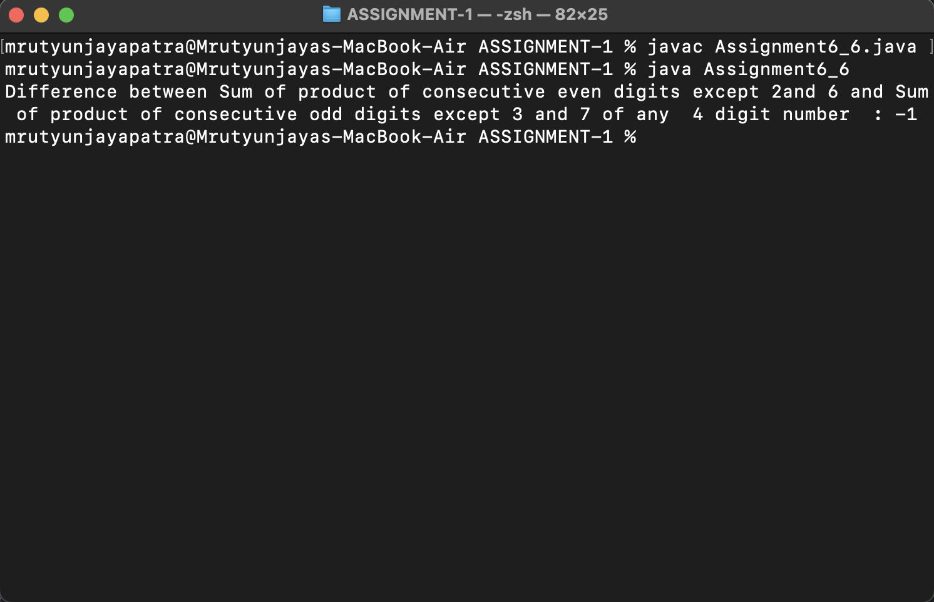

g) Write a java program to find sum of product of corresponding even digits of first any digit number and corresponding odd digit of any 4 digit number Such as n=1234 m=4567 output=4*7+2*5

public class Assignment6_7 {

public static void main(String[] args) {

int m = 1234, n = 4567;

int ans = 0, rem = 0;

int a1, b1, c1, d1;

int a2, b2, c2, d2;

//First number

rem = m % 10;

a1 = rem % 2 == 0 ? rem : 0;

rem = 0;

m /= 10;

System.out.println(a1);

rem = m % 10;

b1 = rem % 2 == 0 ? rem : 0;

rem = 0;

m /= 10;

rem = m % 10;

c1 = rem % 2 == 0 ? rem : 0;

rem = 0;

m /= 10;

rem = m % 10;

d1 = rem % 2 == 0 ? rem : 0;

rem = 0;

m /= 10;

// second number

rem = n % 10;

a2 = rem % 2 != 0 ? rem : 0;

rem = 0;

n /= 10;

rem = n % 10;

b2 = rem % 2 != 0 ? rem : 0;

rem = 0;

n /= 10;

rem = n % 10;

c2 = rem % 2 != 0 ? rem : 0;

rem = 0;

n /= 10;

rem = n % 10;

d2 = rem % 2 != 0 ? rem : 0;

rem = 0;

n /= 10;

ans += (a1 != 0 && a2 != 0) ? a1 * a2 : 0;

ans += (b1 != 0 && b2 != 0) ? b1 * b2 : 0;

ans += (c1 != 0 && c2 != 0) ? c1 * c2 : 0;

ans += (d1 != 0 && d2 != 0) ? d1 * d2 : 0;

System.out.println("Sum of product of corresponding even digits of first any digit number and corresponding odd digit of any 4 digit number Such as n=1234 m=4567"+ans);

}

}

