

# Report title

#### Caveats for analysis

#### Headlines

### Subject title

#### 2. Question title

* 47% of respondents said …

*Chart 1*

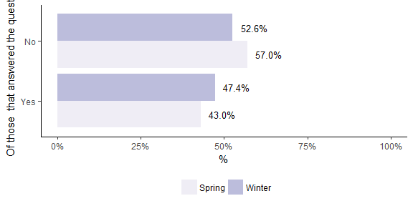

#### 3. Question title

* 51% of respondents said …

*Chart 2*

