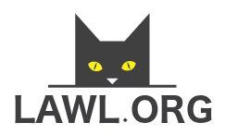  Abram Tatham |  | Bernetta Molton |  | Colene Farner
Kay Fauver |  | Lyle Brumbelow |  | Jorge Sergent
Dylan Dunfee |  | Jenelle Pleasants

