Abstract

The rapid pace of technological change is having a transformative effect on industries, including a decline in the industry labour-share of income and falling middle-skilled employment. These changes have predominantly been attributed to automation and global trade. As technologies increasingly replace tasks previously performed by workers, researchers have used three separate approaches to model the risk of automation: specific measures of technological adoption, such as robotic adoption; omnibus measures, such as Total Factor Productivity; and measures of employment and labour-share consequences, such as occupation- or task-based models. While some studies have predicted complete labour immiseration, recent studies have found that the elasticity of capital-labour substitution is less than one, suggesting that labour-share immiseration may not necessarily occur. Furthermore, self-employed, and entrepreneurial occupations, which make up a growing share of the workforce, may be resistant to automation and are likely to maintain endogenous growth in the long-run.

The negative effects of automation on the labour market highlight the importance of developing better models for assessing the risk of automation. To improve existing estimates for occupational automation, the author proposes a model that incorporates results of recent empirical studies through PIAAC survey data, with EC/OECD and GEM labour statistics, to measure the risk of automatability for groups with the most secure endogenous growth. Such improved data with accurate probabilities of automation for all occupations could be used in policymaking to ensure fair and efficient redistribution of the capital benefits of technological change.

Contents

Abstract....................................................................................................... 2
Introduction................................................................................................. 3
Literature Review
Historical Framework: The Canonical Model.................................... 3
The New Model.................................................................................. 4
Occupational- and Task-Based Models of Automation...................... 5 Discussion
Comparison of the Literature............................................................. 5
Requirements for Labour Immiseration............................................. 6
Proposal & Methodology…............................................................... 7
Conclusion…….......................................................................................... 8
Bibliography............................................................................................... 9
Figures....................................................................................................... 13

1. Introduction

Over the last three decades, many developed economies have undergone significant changes in their workforces, including declines in the labour-share of income, and falls in middle-skilled employment. The largest causes of these changes have been attributed to automation, and global trade, which has led to the offshoring of labour and import competition (Acemoglu & Autor, 2011; Goos, et al. 2014).

The labour-share of income (the percentage of a country's GDP paid to workers in the form of wages), has declined on average by 10% since the 1980s in advanced economies, and since the 1990s for the largest developing economies (see Figure 1, Panel A; Karabarbounis & Neiman, 2014). While recent studies have found that import competition from abroad accounted for 25% of the decline in US manufacturing employment between 1990 and 2007, technological change has decreased the marginal cost and improved diversity among goods and services domestically while diminishing the labour-share (Figure 2, Aghion & Howitt, 1994). What is difficult, Autor, et al. (2015) notes, is determining whether newer generations of technology are more or less labour-displacing than earlier generations.

As a result, empirical research has focused on three main approaches for modelling automation without incorporating endogenous forces from international trade: (1) specific measures of technological adoption, such as robotics adoption and patent filings; (2) omnibus measures, such as total factor productivity; and (3) occupation- and task-based models for measuring the risk of automation for groups within the workforce. Increasingly, attention is being paid to policies concerning redistribution systems such as Universal Basic Income, rights for workers, and regulation³.

This study focuses primarily on the literature concerning occupational exposure and predicted employment levels within the workforce (Frey & Osborne, 2013; Arntz, et al., 2016; PwC, 2018; ONS, 2019). These studies are contextualised using research on the elasticity of capital-labour substitution and the potential for total labour-share immiseration (Acemoglu and Restrepo, 2018; Gechert, et al., 2022). By analysing the methods used to measure occupational exposure, I highlight the potential for an improved model for measuring the risk of automation on tasks and present the variables and datasets that can be used for an empirical study.

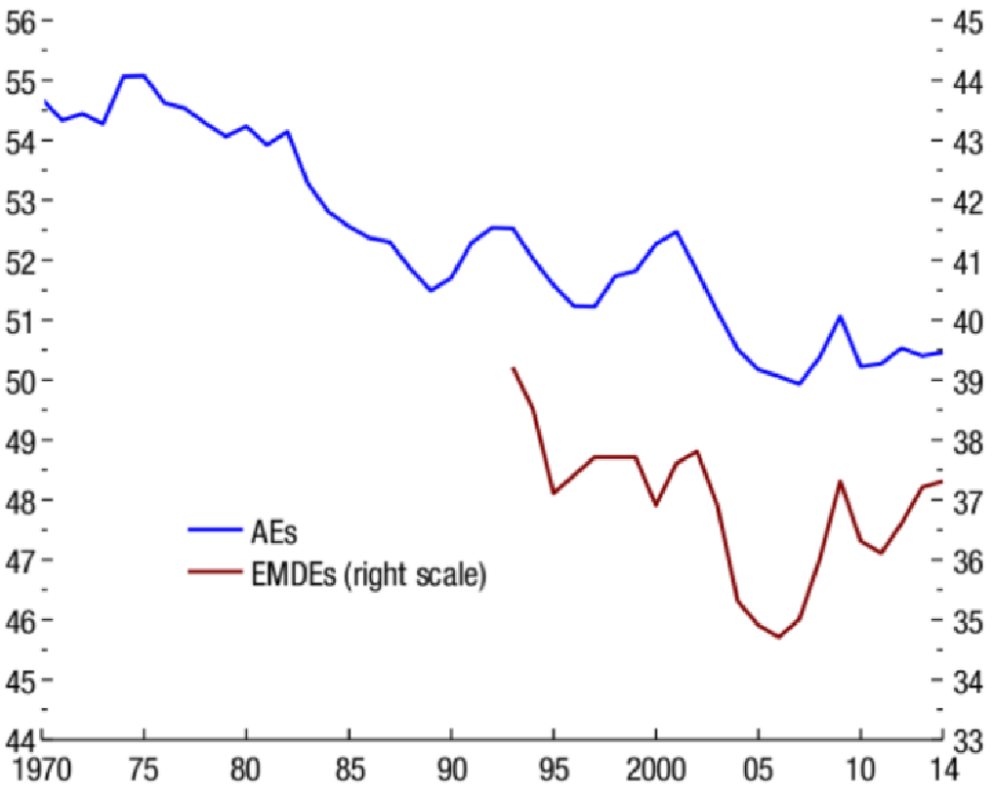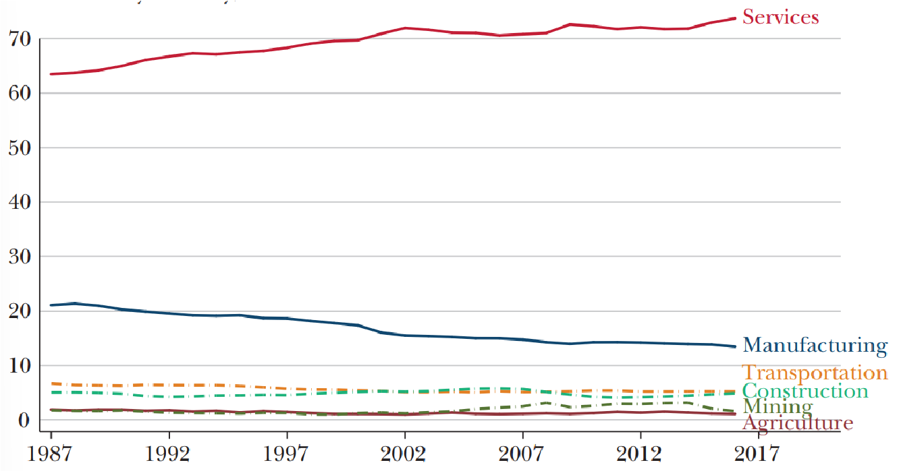

Figure 1. Panel A. Evolution of the Labour Share of Income, 1970-2014 (percent)
Panel B. Share of GDP by Industry, 1987-2017

2.1. Historical Framework: The Canonical Model

To model automation, Mortensen and Pissarides’ (1994; 2000) view the labour market as a job matching system, where ‘matches’ produce productive efficiency, causing prices to fall and real income to rise in the long term. As preferences adjust, demand is created for new tasks such as software development, web design, and data engineering (Lin, 2011). The creation of new tasks in which labour has a competitive advantage produces reinstatement effects for the workforce (Acemoglu & Restrepo, 2018).

Many of these dynamics between supply and demand for skills were captured by the canonical model (also known as the “textbook model”; Atkinson, 2008), which assumed positive returns to education, with balanced growth, and employment levels, despite the large increase in the supply of college educated workers (Tinbergen, 1974; Acemoglu, 2002; Elsby, et al., 2013). Kaldor (1963) summarised this in his “stylised facts” of modern economics, noting that under the canonical model, as technology always raises productivity and wages, output per capita increases while the capital-output ratio, interest rate, and the distribution of income between capital and labour remain roughly constant.

The canonical model elegantly captured cross-country differences in the demand for labour throughout the twentieth century (Goldin & Katz, 2008; Jones & Romer, 2010), but the model is silent on some central empirical results of the last three decades, such as falling real wages for low-skill workers in developed economies, and skill-replacing (not augmenting) technologies, as computerisation enters more cognitive domains (Acemoglu and Autor, 2011). The declining labour share is indicative of a challenging workforce for terminated matches to reinstate themselves (Figure 2; Brynjolfsson & McAfee, 2011). Autor & Salomon (2018) find that as technologies can complete a greater array of tasks, there are diminishing labour-augmenting effects and more pronounced labour-displacing effects on the workforce.

This economic environment is fundamentally different to the past, as historically factories replaced the artisan shop and decomposed work into smaller, specialised tasks that required more workers than before (Habakkuk, 1962, p.22). Acemoglu and Restrepo (2018) show that there are no similar composition effects in today’s workforce, leading to greater job turnover and a higher natural rate of unemployment (also see Pissarides, 2000).
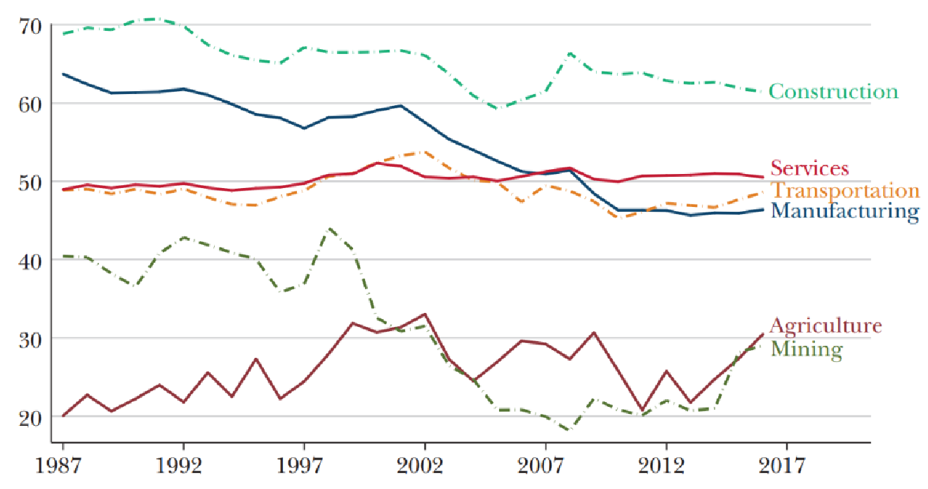

Figure 2. Labour Share within Each Industry, 1987-2017

2.2. The New Model

Given these developments, Acemoglu & Autor (2011) argue for a richer model that makes the distinction between occupations and tasks, to better represent the changing workforce. They propose a model that better captures the capital-labour substitution effect that occurs as capital productivity increases for certain tasks and creates negative demand shocks for labour (Aghion & Howitt, 1994). Automation has a direct displacement effect on jobs, as shown by the observed decline in the price of investment goods, and the subsequent impact on the labour-share (MGI, 2019).

While this view of ‘technological unemployment’ was espoused by John Maynard Keynes (1933) who predicted that “our discovery of means of economising the use of labour will outrun the pace at which we can find new uses for labour”, as well as in principles outlined by David Ricardo (capitalists able to replace labourers with cheaper machines will choose to do so, in order to stay competitive; 1819), in hindsight, these predictions have failed because they do not recognise the endogenous evolution of technology and the role of new economic institutions that shape factor prices (Acemoglu & Robinson, 2015).

Evidence that displacement effects have not resulted in net long-term unemployment among developed countries comes in the form of the declining labour-share; the product of diminishing opportunities for workers to re-skill, leading to real earnings declines for low-skilled workers and shifts in occupational composition (Böhm, 2020). Karabarbounis & Neiman (2014) found that since the early 1980s, firms have allocated investment away from labour and towards capital as a result of the declining relative price of technology.

A second explanation for this trend is the transition of labour from routine to nonroutine work both within and between industries; Autor & Dorn (2013; 2014) observed a reallocation of labour supply both within industries from middle-income to binarily high- and low-income professionals, as well as between industries, from manufacturing to service occupations. The service industry, which makes up a significant portion of GDP in both the US (74.5%) and the EU (64.7%), has experienced strong employment growth and a 2% increase in the labour-share of income since 1987 (BLS, 2022; OECD, 2015; Acemoglu & Restrepo, 2018).

Technically, these nonroutine tasks, be they cognitive or manual, are more difficult to substitute for capital than their routine counterparts. This concept is the manifestation of "Polanyi's paradox", named after economist Karl Polanyi, which suggests that the challenges for machines to overcome tasks that require adaptability, common sense, and creativity, remain immense (Polanyi, 1944). The implication is that tasks, such as sales, require a high degree of rich, tacit knowledge, making them difficult to codify relative to truck-driving or legal writing, which can be substituted by narrower learning algorithms and robotic systems (Autor, 2014). Job security is directly related to the nature of nonroutine tasks, such as client interaction and persuasion (Goos and Manning, 2007).

2.3. Occupational- & Task-Based Models of Automation

Several studies have estimated the potential impact of automation on the labour market by adapting the constant-returns-to-scale Cobb-Douglas production function (Figure 3) of Autor, et al. (2003). In the iteration proposed by Frey & Osborne (2013; hereafter ‘FO’), the measure of labour input accounts for both routine and nonroutine tasks (such as perception, manipulation, creative intelligence, and social intelligence tasks), capturing the essence of the new model proposed by Acemoglu & Autor (2011). They achieve this by manually categorizing occupations as either automatable or not, by using O*NET job description data and training a learning algorithm on estimates of 70 occupations, which is then used to optimise the probability of computerisation across 702 jobs in the O*NET database. This approach considers a more precise array of cognitive roles than the original, specifically those at risk of substitution by machine learning and mobile robotics. However, it also presents repeatability limitations as all inputs are estimates. FO determined that 47% of jobs in the US are at high risk of being automated before 2032.

Arntz, Gregory & Zierahn (2016; hereafter ‘AGZ’) criticise the approach of FO (2013), arguing that they assume whole occupations rather than single job-tasks are automated by technology. They build on this model by making estimates with more granular, heterogenous, task data, and regional demographic data from the PIAAC in 2012, which was not available to FO. AGZ then used a 43-variable regression model (Figure 4) to estimate predictions based on the task composition of jobs within occupations, such as their involvement in consulting tasks (between 0 and 1). AGZ find significantly fewer occupations are at risk in the US at only 9% before 2032 (10% for the UK).

A more balanced interpretation of the methodology is given by PwC (2017) who apply different predictive features, between estimates of FO and AGZ to the task-based algorithm used in the latter study (Figure 4) on grounds that the proportion of jobs with ‘high automatability’ in AGZ’s study is an artefact of their predictive model. PwC (2017) show that automation is closer to 38% (US) and 30% (UK) for the period 2018-2037, while PwC (2018) enhances this by weighting single-country PIAAC data with averages across 29 countries, further striking a balance between FO (where probabilities concentrate at the extreme ends of the distribution) and AGZ (where results bias towards the middle).

3.1. Comparison of the Literature

Using O*NET data, the UK Office for National Statistics (2019; hereafter ‘ONS’) show that the methodology of AGZ (2016) indicates nonroutine jobs involve planning, research, and advisory tasks, while routine tasks involve machinery operation. Similarly, PwC (2017) use PIAAC data to show the risk of job automation is 8% higher in the US than in the UK and attributes this difference to the higher proportion of routine tasks composing service occupations in the US⁶. These results are consistent with studies by Brynjolfsson & McAfee (2011), Karabarbounis & Neiman (2014), and Autor, et al. (2017) which show that routine occupations are more at risk of automation, while nonroutine occupations are least at risk.

However, when the authors of ONS (2019) plot the most at-risk 20 occupations (from 702 O*NET occupations in total) against employment change between 2011 and 2017, they find a sharply negative distribution, with as much as 55% employment growth for the most at-risk occupations. The authors suggest that this could be because automation has already occurred within these occupations, although industry-level data by Autor & Salomon (2018) show that the corresponding labour-share has not changed, suggesting this may not be the case.

A central assumption of the models proposed by Autor, et al. (2003), and subsequently by FO and AGZ, is that when algorithms and robotics outperform human judgement, they inevitably are adopted by business decision-makers (given that all tasks have above-zero chance of automation). These studies depend critically on the elasticity of capital-labour substitution being greater than one. As with other models that predict complete labour immiseration in the long-run, such as those of Piketty (2014), Karabarbounis & Neiman (2014), and Susskind (2017), when elasticity is greater than one, declining prices of capital and increased capital accumulation immiserate the labour-share in the long-run.

However, Gechert, et al. (2022) show, through regression analysis using a rich set of variables with current datasets, that the majority of empirical estimates of the elasticity of substitution are in fact less than one. Furthermore, Glover & Short (2020) assert several issues that lead to the high elasticity estimates used in a variety of studies, including that of Karabarbounis & Neiman (2014).

3.2. Requirements for Labour Immiseration

An economy with complete automation would lack incentives to create new labour-intensive tasks, which is something humans have maintained a strong comparative advantage in (Lin, 2011). New titles and roles have composed around 60% of the additional employment growth since 1987, with service industry labour-share increasing amid declines in routine-intensive sectors in the last two decades (Figure 1, Panel B; Acemoglu and Restrepo, 2018).

An important characteristic of the workforce was noted by Mokyr in 1998, whereby individuals that impact the verdict of the immediate market will choose to protect their own jobs if their earnings are at stake. Furthermore, in a model proposed by Berg, et al. (2017), individuals who act ‘entrepreneurial’ by investing in their own forms of capital (human or industrial), and who do not take wages from an employer, are protected from labour immiseration.

In 2022, self-employed, cognitive occupations such as consultancy, contractors, sole traders, and chief executives are rapidly growing sectors of the workforce. Self-employment composed 10-15% of developed workforces and this segment is growing, with 28.2% of US workers self-employed at least one day per week (BLS, 2021; Intuit, 2019). Headd (2021) finds that self-employed households in the US are three times wealthier than average households, which may contribute to this trend. Moreover, Ramos & Nieto (2016) find that globally, most self-employment is a product of individuals unable to find satisfactory jobs, rather than to exploit business opportunities.

The ability to employ oneself depends on an individual’s ability to generate revenue organically, something that Burke (2012) observes has become easier as a product of technology; working as a freelancer, entrepreneur or contractor is considerably easier than in previous generations, given the leverage of the internet and online platforms. In the context of labour immiseration, Acemoglu & Restrepo (2018) argue that as long as humans act as consumers and technological progress induces labour scarcity, new labour-intensive tasks or labour-complementing technologies will be created. This contrasts with theories of labour immiseration, where automation and technological change must diminish the demand for all care assistants, professional athletes, entrepreneurs, AI developers, as well as freelancers and influencers in the long-run.

While many current occupations may be susceptible to automation in the long-run, these studies suggest that a growing share of nonroutine occupations are resistant to automation on grounds other than cost. For endogenous, labour-generating task effects to reverse completely, machines must be able to maintain long-term profitability and alignment in the economy without human assistance.

3.3. Proposal & Methodology

In the model developed by AGZ (2016), no task or demographic variables address the impact of economic ‘status’, characterised akin to Berg, et al. (2017) as the ability to employ oneself in nonroutine tasks, or to resist the termination of a match, by nature of tacit, human characteristics. A potential opportunity would be to explore the degree to which personable tasks like customer service, assistance, persuasion, and communication demand some residual, uniquely human requirement. If this property exists to any degree, we can expect an increasing effect as the ability to self-employ and earn ‘status’ grows for the average individual. Subsequently, the resistance of labour to automation can be factored into the models of FO (2013) and AGZ (2016).

In the data used by Arntz, et al. (2016), employment status is limited to whether an individual has ‘responsibility for staff’. While specific occupations and tasks each require convolutions of empirical data and industry knowledge to predict precisely, a useful improvement could be explored by adding a dimension for nonroutine tasks to the existing task-based methodology.

To approach this, a task-based regression model (Figure 4) could be developed to reflect sociodemographic characteristics (e.g., gender, age, employment status, education, fields of professional experience) and several items related to self-employment or nonroutine service-based activities, such as an individual’s main sources of income (e.g. such as sponsorship, freelancer contract, or passive income), employment status (e.g. if currently engaged in operating their own business, is employing others, or is self-employed by some other means such as asset ownership and receives dividend income or rent), and employment motivation (e.g. job satisfaction, or self-assessed capabilities to start a business, which correlate to self-employment; Ramos & Nieto, 2016). Regressing these variables against task characteristics such as complex problem solving, selling, or negotiating, would serve to reduce endogeneity bias when making estimates. Similarly, the more income that is derived by means of self-employment, the more economically independent an individual is likely to be, as they can afford to employ themselves. EC & OECD (2021) provide annual data on the task composition of entrepreneurial and self-employed work.

These empirical data exist in the PIAAC survey - conducted by the OECD in 39 countries between 2011 and 2022 to assesses the proficiency of adults from age 16 onwards in tasks (including solo self-employed and employer responsibilities that accurately represent labour statistics provided by BLS, 2021, and Intuit, 2019) in a set with greater than 43 task variables. Silva (2007) notes that PIAAC data does not allow controlling for individual observed heterogeneity but can still be used after controlling for several individual characteristics. For data on entrepreneurial motivation and activity, the Global Entrepreneurship Monitor (GEM) gives up-to-date data on 140,000 people from 46 economies and includes the Adult Population Survey and National Expert Survey.

Combined with the UK Annual Population Survey (APS), which has a larger sample size than PIAAC, these data include granularity of occupational group, gender, education level, manager status, industry sector, age, firm size, region and full or part-time in the UK. Pooling historical panel data may be a necessary decision for mapping missing values in the less densely populated APS data. Similarly, O*NET data can be used to track a description of occupations at the task level.

To monitor the model’s accuracy, it would be useful to replicate the results of FO and AGZ and gauge the distribution of probabilities generated relative to these studies, while also using a range of estimates similar to the work of PwC (2017), to measure input sensitivity. This would generate an estimate for the automatability for the sections of the workforce with the most secure endogenous growth characteristics, and subsequently provide new weights for the probabilities of automation for all previously tested occupations.

4. Conclusion

The labour market can be viewed as a job-matching system where labour has traditionally maintained a competitive advantage (Lin, 2011). As automation enters more cognitive task domains, the declining labour-share and increasing residual employment turnover may make it more challenging for labour to reinstate itself; studies modelling the portion of jobs at risk of automation within 20 years have ranged from 47% labour immiseration (Frey & Osborne, 2013) to as low as 5% (MGI, 2015). PwC (2017; 2018) offers a more balanced interpretation built on the methodology developed by Arntz, et al. (2016) that allows for greater granularity and task-based results. This methodology estimates the risk of job automation at 38% in the US and 30% in the UK for the period 2018-2037.

While these studies have suggested that a large portion of jobs are at risk of automation, others have found that the elasticity of capital-labour substitution is less than one, meaning that labour-share immiseration may not necessarily occur (Gechert, et al., 2022). Similarly, Acemoglu and Restrepo (2018) argue that if humans continue to act as consumers and technological progress leads to labour scarcity, new labour-intensive tasks will be created.

Furthermore, evidence suggests that self-employed and entrepreneurial occupations, which make up a growing share of the workforce, may be resistant to automation (Berg, et al., 2017; Burke, 2012; Ramos & Nieto, 2016). Nonroutine occupations including service-based tasks such as judgment and persuasion, are generally less at risk of automation and have been growing since the 1980s (Goos and Manning, 2007). While an important protected segment of the workforce may be growing, displacement effects of automation have disproportionately affected workers in routine jobs (Autor and Salomon, 2018), leading to job polarisation for most industries.

This inequality has increased returns to education for those in nonroutine, cognitive roles, and increased competition for the rest of the workforce (both against labour and capital), resulting in reduced decision-making power (Krueger, 1993; Goldin and Katz, 2009). Using a broad measure of national income, the bottom half of the income distribution grew by only 1% between 1980 and 2014, compared to an average of 42% in the next four deciles and 121% in the top decile (Piketty, et al., 2018).

Additionally, shares of national income going to the bottom half of the population fall from 25% in 1980 to less than 20% in 2014, signifying a shift towards the skilled workforce. This raises concerns about an increasing share capital share of income flowing to a small elite (e.g. the owners or robot patents) receiving a larger share of income from capital and calls for fairer distribution have been made by many to investing in education and training programmes, and supporting distributional systems such as Universal Basic Income (Hoynes & Rothstein, 2019).

To improve existing estimates of the roles exposed to automation, I propose a model that improves on the literature by accounting for specific endogenous productivity effects on the workforce and incorporates more automation-resistant variables such as the prevalence of self-employment and entrepreneurship, income sources, and job satisfaction.

Bibliography

Acemoglu, D. (2002). Technical change, inequality, and the labor market. Journal of economic literature, 40(1), 7-72.

Acemoglu, D., & Autor, D. (2010). Skills, Tasks and Technologies. NBER Working Paper, 16082.

Acemoglu, D., & Restrepo, P. (2018). The race between man and machine: Implications of technology for growth, factor shares, and employment. American Economic Review, 108(6), 1488-1542.

Acemoglu, D., & Restrepo, P. (2019). Automation and new tasks: How technology displaces and reinstates labor. Journal of Economic Perspectives, 33(2), 3-30.

Acemoglu, D., & Robinson, J. A. (2015). The rise and decline of general laws of capitalism. Journal of economic perspectives, 29(1), 3-28.

Acemoglu, D., Autor, D., Dorn, D., Hanson, G., and Price, H. (2016). “Import Competition and the Great US Employment Sag of the 2000s.” Journal of Labor Economics. 34 (S1): S141–98.

Aghion, P. and Howitt, P. (1994). Growth and unemployment. The Review of Economic Studies, vol. 61, no. 3, pp. 477–494.

Aghion, P., Antonin, C., & Bunel, S. (2020). On the Effects of Artificial Intelligence on Growth and Employment. OpenMind BBVA.

Arntz, M., Gregory, T., and Zierahn, U. (2016), ‘The risk of automation for jobs in OECD countries: a comparative analysis’, OECD Social. Employment and Migration Working Papers. No 189

Atkinson, A. B. (2008). The Changing Distribution of Earnings in OECD Countries (The Rodolfo De Benedetti Lecture Series). New York: Oxford University Press.

Autor, D. and A. Salomons (2019, February). What Works in the Future?

Autor, D. H. (2014). Skills, education, and the rise of earnings inequality among the “other 99 percent”. Science, 344(6186), 843-851.

Autor, D. H., & Salomon, M. (2017). Skills, education, and the rise of earnings inequality among the "other 99 percent". Science, 356(6345), 1335-1339.

Autor, D. H., Dorn, D., & Hanson, G. H. (2015). Untangling trade and technology: Evidence from local labour markets. The Economic Journal, 125(584), 621-646.Ford (2015)

Autor, D. H., Dorn, D., and Hanson, G. H. (2013). "The China Syndrome: Local Labor Market Effects of Import Competition in the United States." American Economic Review, 103 (6): 2121-68.

Autor, D. H., Levy, F., & Murnane, R. J. (2003). The skill content of recent technological change: An empirical exploration. The Quarterly journal of economics, 118(4), 1279-1333.

Autor, D., Katz, L., and Kearney, M., (2008) “Trends in U.S. Wage Inequality: Re-Assessing the Revisionists.” Review of Economics and Statistics, 90(2), 300-323.

Bloom, N., Jones, C. I., Van Reenen, J., and Webb, M. (2020) "Are Ideas Getting Harder to Find?" American Economic Review, 110 (4): 1104-44.

BLS (2021) Self-Employment in the United States. Spotlight on Statistics. US Bureau of Labour Statistics.

BLS (2022) Displaced Workers Summary. Economic News Release. US Bureau of Labour Statistics. August 26.

Brynjolfsson, E., & McAfee, A. (2011). Race against the machine: How the digital revolution is accelerating innovation, driving productivity, and irreversibly transforming employment and the economy.

Brynjolfsson, E., & McAfee, A. (2014). The second machine age: Work, progress, and prosperity in a time of brilliant technologies. WW Norton & Company.

Burke, A. (2012) The Role of Freelancers in the 21st Century British Economy Report. PCG.

Dao, M. C., Das, M. M., Koczan, Z., & Lian, W. (2017). Why is labor receiving a smaller share of global income? Theory and empirical evidence. International Monetary Fund.

Dauth, W., Findeisen, S., Südekum, J., & Woessner, N. (2017). German robots-the impact of industrial robots on workers.

David, H., & Dorn, D. (2013). The growth of low-skill service jobs and the polarization of the US labor market. American economic review, 103(5), 1553-97.

Dechezleprêtre, A., Einiö, E., Martin, R., Nguyen, K. T., & Van Reenen, J. (2016). Do tax incentives for research increase firm innovation? An RD design for R&D (No. w22405). National Bureau of Economic Research.

Ebenstein, A., Harrison, A., McMillan, M., & Phillips, S. (2014). Estimating the impact of trade and offshoring on American workers using the current population surveys. Review of Economics and Statistics, 96(4), 581-595.

EC & OECD (2021), The Missing Entrepreneurs 2021: Policies for Inclusive Entrepreneurship and Self-Employment, European Commission, OECD Publishing, Paris, https://doi.org/10.1787/71b7a9bben.

Elsby, M. W., Hobijn, B., & Şahin, A. (2013). The decline of the US labor share. Brookings Papers on Economic Activity, 2013(2), 1-63.

Feenstra, R. C., Inklaar, R., & Timmer, M. P. (2015). The next generation of the Penn World Table. American economic review, 105(10), 3150-82.

Frey, C. B., & Osborne, M. A. (2017). The future of employment: How susceptible are jobs to computerisation?. Technological forecasting and social change, Oxford Martin School, University of Oxford. 114, 254-280.

Gechert, S., Havranek, T., Irsova, Z., & Kolcunova, D. (2022). Measuring capital-labor substitution:
The importance of method choices and publication bias. Review of Economic Dynamics, 45, 55-82.

Glover, A., & Short, J. (2020). Can capital deepening explain the global decline in labor's share?. Review of Economic Dynamics, 35, 35-53.

Goldin, C., & Katz, L. F. (1998). The origins of technology-skill complementarity. The Quarterly journal of economics, 113(3), 693-732.

Goldin, C., Katz, L., (2008). The Race between Education and Technology. Cambridge: Harvard University Press.

Goos, M., & Manning, A. (2007). Lousy and lovely jobs: The rising polarization of work in Britain. The review of economics and statistics, 89(1), 118-133.

Goos, M., Manning, A., & Salomons, A. (2014). Explaining job polarization: Routine-biased technological change and offshoring. American economic review, 104(8), 2509-26.

Habakkuk, H. J., (1963). American and British Technology in the Nineteenth Century: The Search for Labour-Saving Inventions. Cambridge: Cambridge University Press, 1962. Pp. ix, 222. $6.00. The Journal of Economic History, 23(1), 104-106.

Headd (2021) The Importance of Business Ownership to Wealth. Small Business Facts Report. U.S. Small Business Administration Office of Advocacy.

Hoynes, H., & Rothstein, J. (2019). Universal basic income in the United States and advanced countries. Annual Review of Economics, 11, 929-958.

Intuit (2019) Gig Economy and Self-Employment Report. Intuit, Quickbooks and Gallup.

Jones, C. I., & Romer, P. M. (2010). The new Kaldor facts: ideas, institutions, population, and human capital. American Economic Journal: Macroeconomics, 2(1), 224-45.

Kaldor, N, (1963). “Capital Accumulation and Economic Growth.” in Friedrich A. Lutz and Douglas C. Hague, eds., Proceedings of a Conference Held by the International Economics Association, London, Macmillan.

Karabarbounis, L., & Neiman, B. (2014). The global decline of the labor share. The Quarterly Journal of Economics, 129(1), 61-103.

Krueger, N. (1993). The impact of prior entrepreneurial exposure on perceptions of new venture feasibility and desirability. Entrepreneurship theory and practice, 18(1), 5-21.

Levy, F. and Murnane, R.J. (2004). The new division of labor: How computers are creating the next job market. Princeton University Press.

Lin, Jeffrey. 2011. “Technological Adaptation, Cities, and New Work.” Review of Economics and Statistics 93 (2): 554–74.

Manning, A. (2014). Lovely and Lousy Jobs: Job polarisation continues to be an important feature of the way that Britain’s labour market is evolving. LSE Impact Blog.

MGI (2015) Four fundamentals of workplace automation. McKinsey Quarterly Report. McKinsey Global Institute. November 1, 2015.

MGI. (2019) A New Look at the Declining Labour Share of Income in the United States. McKinsey Global Institute.

Michael, J., Netrag, M., & Reenen, J. V. (2014). The impact of computerisation on productivity growth: Evidence from 18 countries. The Review of Economics and Statistics, 96(3), 524-539.

Mokyr, Joel. 1990. The Lever of Riches: Technological Creativity and Economic Progress. New York: Oxford University Press.

Mortensen, D. T., & Pissarides, C. A. (1994). Job creation and job destruction in the theory of unemployment. The review of economic studies, 61(3), 397-415.

OECD (2015) The Labour Share in G20 Economies. International Labour Organisation for Economic Co-operation and Development. February Report.

ONS (2019) The Probability of Automation in England: 2011 and 2017. Authors: White, S., Lacey, A., Ardanaz-Badia, A. Economics Report, Office for National Statistics.

Pierce, J. R., & Schott, P. K. (2016). The surprisingly swift decline of US manufacturing employment. American Economic Review, 106(7), 1632-62.

Hoynes, H., & Rothstein, J. (2019). Universal basic income in the United States and advanced countries. Annual Review of Economics, 11, 929-958.

Piketty, Thomas. (2014). Capital in the Twenty-First Century. Harvard University Press.

Piketty, T., Saez, E., Zucman, Z., (2018) Distributional National Accounts: Methods and Estimates for the United States, The Quarterly Journal of Economics, Volume 133, Issue 2, May 2018, Pages 553– 609.

Pissarides, C. A. (2000). Equilibrium unemployment theory. MIT press.

Polanyi, K. (1944). The self-regulating market and the fictitious commodities: labor, land and money.

PwC (2017) “Will Robots Steal Our Jobs? The Potential Impact of Automation on the UK and Other Major Economies.” Economics Report, PriceWaterhouseCooper.

PwC (2018) “Will Robots Really Steal Our Jobs? An International Analysis of the Potential Long Term Impact of Automation.” Economics Report, PriceWaterhouseCooper.

PwC (2021) The Potential Impact of Artificial Intelligence on UK Employment and the Demand for Skills. Department for Business, Energy and Industrial Strategy Report. PriceWaterhouseCooper.

Ramos & Nieto (2016) Do entrepreneurs use different skills? Evidence from PIAAC.

Ricardo, D. (1819). The principles of political economy and taxation. World Scientific.

Susskind, D. (2020). A world without work: Technology, automation and how we should respond. UK: Penguin.

Susskind, Daniel. 2017. “A Model of Technological Unemployment.” Oxford University Working Paper,
April.

Tinbergen, J. (1975) Income Difference: Recent Research, Amsterdam: North-Holland Publishing Company.

Wirtz, J., Patterson, P. G., Kunz, W. H., Gruber, T., Lu, V. N., Paluch, S. and Martins, A. (2018).
"Brave new world: service robots in the frontline", Journal of Service Management, Vol. 29 No. 5, pp. 907-931.

Woolf, B. P. (2010). A roadmap for education technology.

Figures

Figure 1



Panel A. Evolution of the Labour Share of Income, 1970-2014 (percent)

Sources: CEIC database; Karabarboumis and Neiman (2014); naitonal authorities; Organisation for Economic Co-operation and Development; IMF staff calculations.
Note: AEs = advanced economies; EMDEs = emerging market and developing economies. For AEs the figure shows averages weighted by nominal GDP in current U.S. dollars. For EDMEs the figure shows year fixed effects weighted least squares regressions (using nominal GDP weights) that also include country fixed effects. Normalised to reflect the level of the labour share in 2000.



Panel B. Share of GDP by Industry, 1987-2017

Source: Acemoglu and Restrepo (2019) using data from the US Bureau of Economic Analysis industry accounts and the Bureau of Labor Statistics.
Notes: Shows the share of value added in these sectors relative to GDP.

Figure 2



Figure 2. Labour Share within Each Industry, 1987-2017

Source: Acemoglu and Restrepo (2019) using data from the US Bureau of Economic Analysis industry accounts and the Bureau of Labour Statistics
Notes: Shows the labour share in value added in services, manufacturing, construction, transportation, mining, and agriculture between 1987 and 2017.

Figure 3
The Frey and Osborne (2013) task model assumes for tractability an aggregate, constant-returns-toscale, Cobb-Douglas production function of the form:
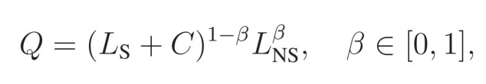

Figure 4
AGZ (2016) regress the automatability y on the N characteristics x of the jobs:
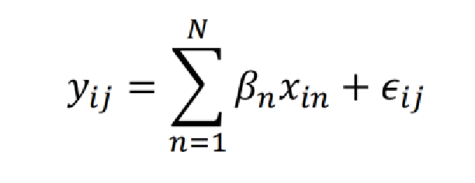 where i are the individuals in the PIAAC-data and j are the duplicates of these individuals, since multiple automatabilities yij are assigned to each individual i. βn are the parameters to be estimated, which represent the influence of the job-related characteristics on the automatability of each job. The automatability is restricted to the interval 0% to 100%.

While technological change and globalisation have been the major contributors to labour-share in advanced economies, minor factors include changes in labour market institutions and falling minimum wages (Lee, 1999), declining worker mobility (Molloy, et al., 2016), declining unionisation, and bargaining power (Card, 1996; Weil, 2014).
Recent studies producing similar results include Autor, et al. (2013); Elsby, et al. (2013); Pierce & Schott, (2016); Acemoglu et al. (2016); and Feenstra, et al. (2017). Also, Ebenstein, et al. (2014) discusses the endogenous effects of international trade on worker productivity. 3 Redistribution systems such as UBI enable displaced workers to maintain subsistence levels, as well as the ability to reinstate themselves in the workforce through education and training (see Hoynes & Rothstein, 2019; Woolf, 2010). Aghion, et al. (2020) propose that training programs may be more appropriate than broader tax instruments, which may encounter difficulty if they require taxing corporations based on their adoption of technology.
According to Dechezleprêtre, et al. (2016), part of the incentive for labour divestment comes from governmental tax codes. US tax codes, for instance, aggressively subsidise the use of equipment through tax credits and accelerated amortisation. They also disincentivize labour employment by enforcing payroll taxes.
As in the studies by the Bureau of Labour Statistics (US); and PwC (UK) (BLS, 2022; PwC, 2021).
 Figure 3. The Frey and Osborne (2013) task model assumes for tractability an aggregate, constant-returns-to- scale, Cobb-Douglas production function of the form:
In the UK, the financial and insurance sector typically requires higher education levels, which reflects the focus on the international market in the City of London. In contrast, the US has a focus on the domestic retail market, which is assessed to have significantly more routine tasks (PwC, 2017). Similar analysis applies to Japan and Germany (Böhm, 2020).
Figure 4. AGZ (2016) regress the automatability y on the N characteristics x of workforce jobs:  where i are individuals in the PIAAC-data and j are duplicates of these individuals, since multiple automatabilities y_ij are assigned to each individual i. β_n are the parameters to be estimated, which represent the influence of the job-related characteristics on the automatability of each job. The automatability is restricted to the interval 0% to 100%.

