Contents
1.0 Deliveroo's Transformation Process: Inputs, Transformation, Outputs.......................................................1
2.0 Volume, Variety, Variation and Visibility Before and During the Pandemic ..............................................2
3.0 Operations Performance Objectives: ..........................................................................................................4
3.1. Service Quality.....................................................................................................................................5
3.2. Dependability.......................................................................................................................................5
3.3. Speed....................................................................................................................................................5
3.4. Flexibility.............................................................................................................................................5
3.5. Cost......................................................................................................................................................6
4.0 Further Analysis...........................................................................................................................................6
Bibliography.......................................................................................................................................................8

Deliveroo, established in the United Kingdom, operates a comprehensive online food delivery platform encompassing restaurants, fast-food establishments, and grocery services. The company's innovative business model functions as a hyperlocal three-sided marketplace, facilitating connections between consumers, delivery partners, and food service establishments, with an average delivery time of 20 minutes.

As a pioneer in the gig economy alongside ride-sharing services, Deliveroo has fundamentally transformed the food delivery industry through its logistics-enabled marketplace model. This innovation has driven exceptional financial performance, evidenced by an average annual revenue growth rate of 103% since 2015 (Index Ventures, 2014; Financial Times, 2022; Goel, 2022). Furthermore, the UK deliveries market size doubled from 2015-2021 to £13.3bn and growth is expected to continue (Lumina intelligence, 2022). Delivery is expected to comprise 18% of the fast-food market in 2025, up from 8% in 2019.

1. Deliveroo’s Transformation Process

Operating under the brand promise "Food, We Get It," Deliveroo's core business model centres on a sophisticated marketplace that integrates three key stakeholders: delivery partners (riders), restaurant establishments (partners), and end consumers. This integrated approach positions Deliveroo as more than a mere delivery service, but rather as a comprehensive food service logistics platform.
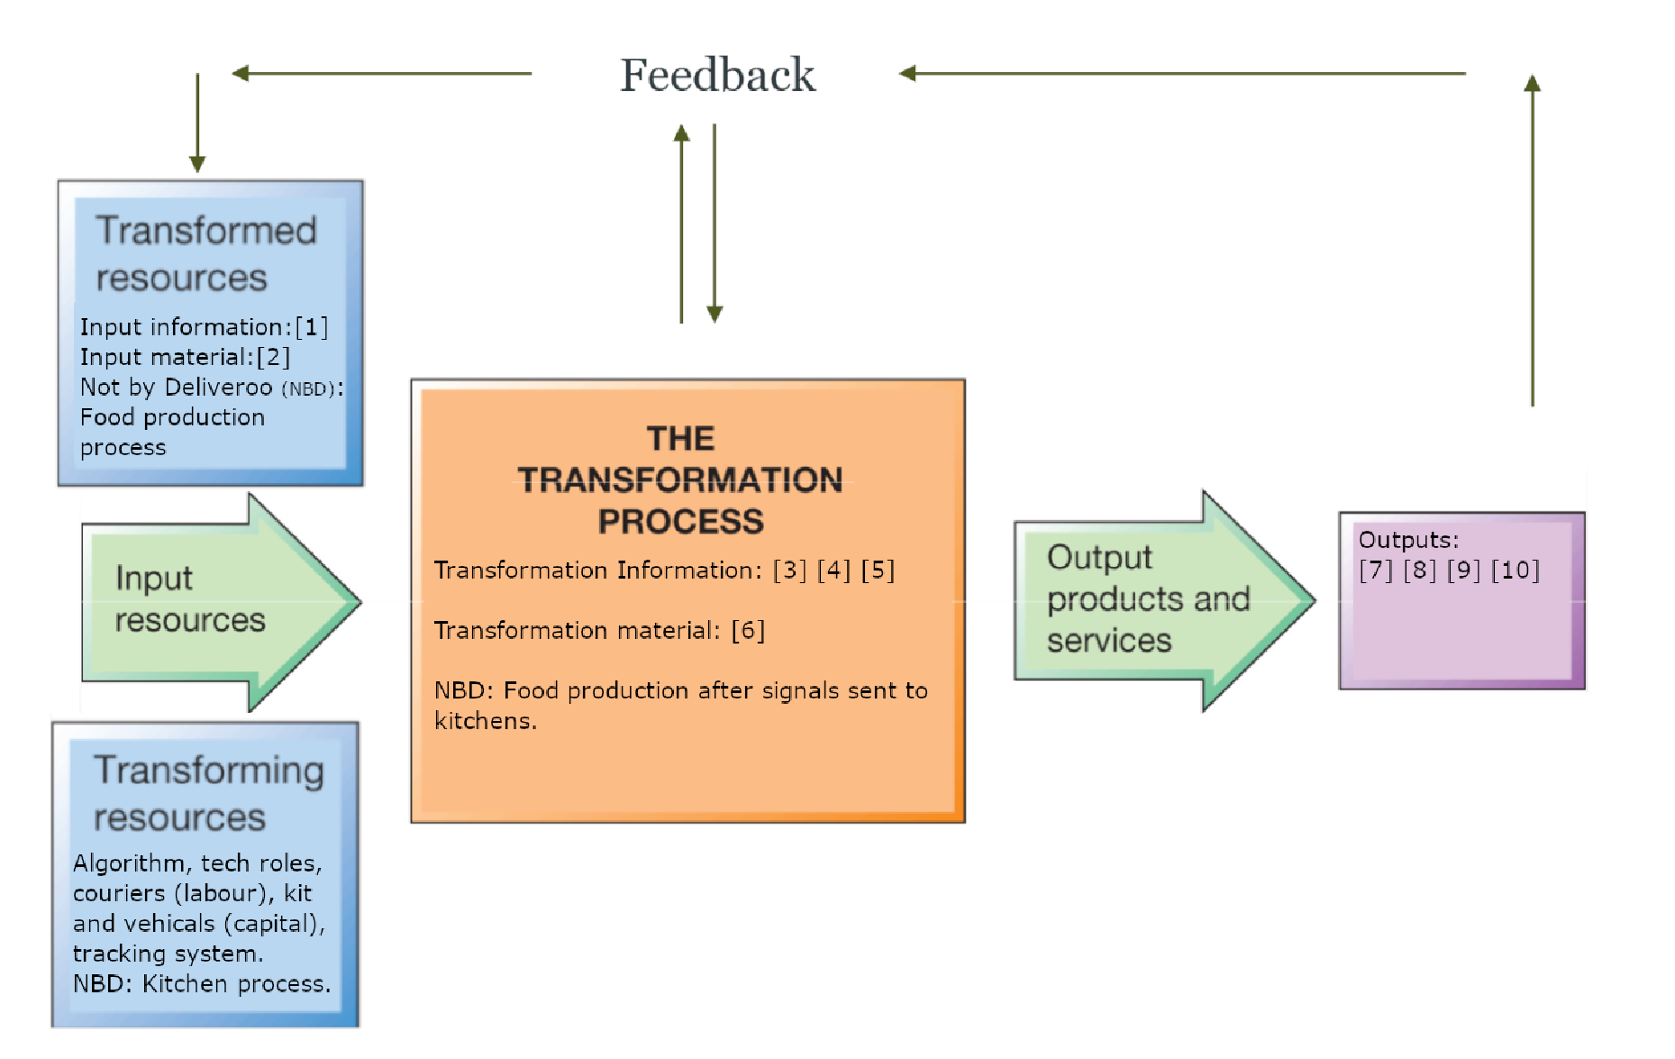

Figure 1. Transformation Process for Deliveries at Deliveroo.
1.1. Inputs

Information: [1] Ordering operation: Customer purchase requests for meal listings (via-app) are received by restaurant kitchens and algorithm. Material: [2] Training process: couriers are trained on EduMe, provided with uniform, and given support. (Deliveroo, 2020d).

1.2. Transformation

Information: [3] Algorithm (“Frank”) is used to “maximise courier and restaurant income share, and to minimise customer waiting time” (Deliveroo, 2022a) by allocating specific riders to orders based on dish, location, date, time, volume of riders, and distance, potentially allocating bulk orders to a single pick-up. [4] For Deliveroo’s restaurant partners, a purchase signal triggers the food production operation (Deliveroo requires production but does not actively partake). [5] Couriers are then given a signal to collect food by restaurants.
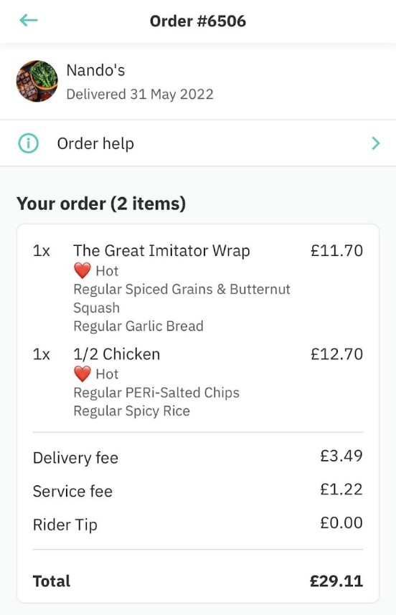
Material: [6] Fulfilment operation: couriers given information are then engaged in collection of purchase, dispatch, transportation, and the delivery process all in under 30 minutes. This process is tracked and shown to customers live.

1.3. Outputs

[7] For customer, high-quality food delivery in under 30 minutes from their chosen restaurant. [8] For restaurants, revenue from customer purchase; around 68% of the order fee (Shaed, 2020a). [9] For courier, income from customer purchase; around 20% of the order fee, £3-£22.50 per hour (accounts vary between £9.80 and over £10 on average), depending on number of completed deliveries (Masters, 2022; Deliveroo, 2018). [10] For Deliveroo, a share of income from customer purchase; around 13% (plus VAT), and more for some orders as a service charge (Shaed, 2020b).

Figure 2. Example of a Deliveroo Order on Customer App with Delivery Taking 20m.

Thus, Deliveroo maintains two main operations, generating income from (1) its software-as-a-service marketplace; covering restaurant logistics (overheads, delivery fleet investment, payment processing, etc.) for a monthly commission, and (2) its fulfilment process (the delivery fleet), taking up-to-35% of orders overall. Deliveroo also generates revenue from ‘Pick Up’, a service where customers collect orders themselves. They also charge restaurants a signup fee offering a menu photoshoot, and tablet with restaurant software, for £425 (pre-pandemic) (Shaed, 2020a; Dephna, 2022).

2. Volume, Variety, Variation and Visibility Before and During the Pandemic

Deliveroo has consistently scaled operations year-on-year since 2013, with revenue up 62% and volume up 64% in 2019, making direct comparison of the transformation process before and after the first lockdown complex (Deliveroo, 2020a).

2.1. Volume

6-in-10 British people ordered delivery each month before 2020 (Which?, 2021). This figure increased to 7-in-10 during 2020, resulting in a combined volume of 150 million orders between January-June 2021 from 140,000 restaurants in 800 agglomerations (up from 200 in 2018) and 12 markets (Iqbal, 2022; Browne, 2021). For couriers, repetition is 2-5 deliveries per hour during shifts, making for high levels of systemisation but also high labour intensity. For independent restaurants, online orders can account for up-to-half of all orders; 8-60 per day on average (Kathleen et al., 2017). For fast-food restaurants this is typically lower at 8-18% (Lumina, 2020). The increased volume restaurants get from delivery orders enables scaled production with lower marginal costs.

When COVID-19 first sent the UK into lockdown in February 2020, takeout orders plummeted particularly due to the top-five foodservice brands closing, constituting 29% of deliveries market share, but also due to loss of office deliveries and fears about contamination (Shaed, 2020a; Carterer, 2022). This had a detrimental impact on couriers who reportedly earned as low as £2-3 an hour in April (Shaed, 2020b). Deliveroo laid off 367 staff (16% of the workforce) and furloughed over 50 others (Telegraph, 2020).

Deliveroo adjusted their transformation process by abiding to hygiene laws, but also changed their transformation process; accelerating expansion into groceries and medical delivery; providing exclusive delivery for 400 Co-op, 129 Aldi, and 30 Waitrose stores by November 2020; and offering groceries at a further 3,800 locations (Deliveroo, 2020g; 2020b). Deliveroo also stimulated demand volume by distributing 70,000 discounts for front-line workers and over 600k free meals for NHS staff in 2020 (Deliveroo, 2020c).

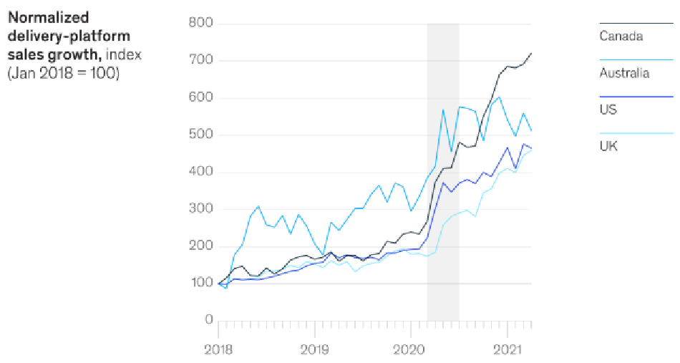
Figure 3. Sales Growth by Delivery Market (Edison Trends, 2021)
Given reduced lockdown regulations for businesses, the reopening of restaurants saw a surge in consumer demand for takeout, with orders increasing by 17% against pre-COVID levels (Which?, 2021). Deliveroo reduced onboarding fees from £425 to £50, set up teams to assist new restaurants, and saw rider sign-ups reach 110,000, or 2% of the gig economy (400% on 2017 levels) (Deliveroo, 2020c; Dephna, 2022). There are now over 180,000 riders (Deliveroo, 2022c).

2.2. Variety
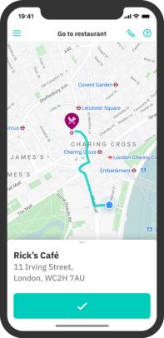
Before and during the pandemic, each delivery route is unique from restaurant to dwelling, meaning route variety is extremely high. However, each order (including groceries and medical supplies), can fit in the standard Deliveroo bag (1.96kg), meaning orders are low by variety of size and weight (1-12kg) (Deliveroo, 2022b). However, the transition into groceries and medical supplies did increase order variety overall and this is expected to remain (McKesson, 2020). For restaurants, delivery menu variety typically stayed identical, though establishments, such as Dominos, removed items and reduced menus to cut costs and meet safety regulations (Dominos, 2020).
Figure 4. Delivery Route Example on the
Rider Version of App.

Over 2020, Deliveroo looked to assist the survival of their restaurant partners (and variety of listings) by leading a government appeal for swift action on key issues such as slashing VAT on restaurant food and maintaining Job Retention Scheme (including subsidised wages of staff if they return full-time) for restaurants while social distancing measures were in place (Sayeed, 2020). Deliveroo revealed 75% of restaurant partners were concerned about making a profit and 52% faced three months before bankruptcy with forced levels of reduced capacity. They proposed new subsidies to help meet the cost of becoming COVID-secure two months before the announcement of the “Eat Out to Help Out” campaign, and are a recognised proponent (Propel, 2020). This initiative was paired with Deliveroo’s near-removal of joining fees.

2.3. Variation
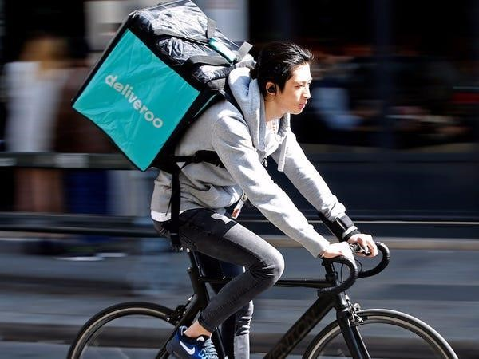
Deliveroo do not deliver after closing times and consider “super-peak” times between 6pm-9pm Friday and Saturday (Deliveroo, 2022d). Weekly demand is generally reliable with more orders than normal on big holidays, where riders can deliver and earn more, making for a natural demand-meets-supply mechanism during volume-heavy periods. There are reports of increased volatility over COVID, with extremely low demand in April (Shaed, 2020b; Scott-Delany, 2021). Increased grocery and medical orders have distributed daily variation more evenly with more orders falling outside of lunch and dinner periods, making longer shifts viable for riders.

Figure 5. Deliveroo Rider Completing Order.

2.4. Visibility

Visibility is characterised by waiting tolerance, customer contact, and exposure to customer opinions (Russell & Taylor, 2011). Couriers interact with both restaurants and customers on virtually every delivery, making satisfaction highly dependent on their service skills and waiting tolerance. Riders have an incentive to be fast to earn more given their high hourly fulfilment demand, leading to an agency problem and potential frictions with restaurants that are even a few minutes behind expected levels (Law & Smullen, 2008).

Physically, Deliveroo couriers on bikes have become hallmarks of the gig economy with UK-wide, consumer-facing exposure. Backpacks have been used to feature missing people in the “Ride-to-Find” campaign (Deliveroo, 2020h). With lower congestion over 2020, cyclists were more obvious but less regularly sighted by the public.

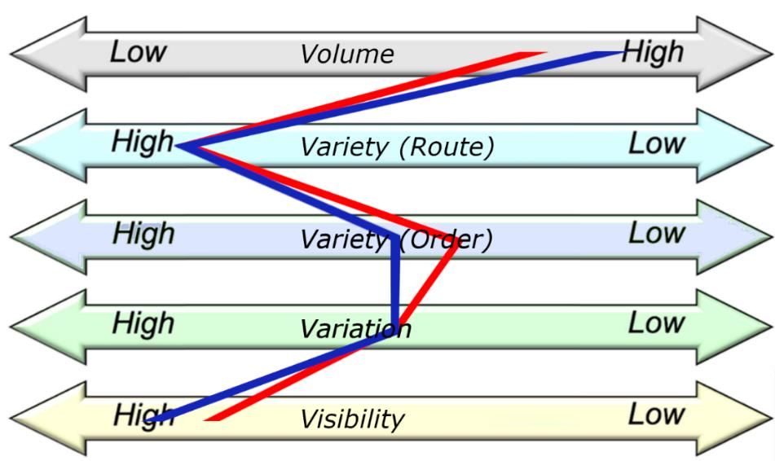
Figure 6. “Four Vs” Before (Red) and During (Navy) COVID-19.
As discussed above, over the latter half of 2020, COVID-19 resulted in greater volume and order variety, similar route variety and variation, and marginally increased visibility. These points are plotted relative to traditional restaurant industry trends; variation and order variety are similar, while volume, route variety, and visibility score comparatively highly for deliveries, of which Deliveroo is a primary provider (Dephna, 2022).

3. Operations Performance Objectives

The degree to which Deliveroo perform competitively can be measured by its degree of service quality, speed, dependability, flexibility, and cost, in comparison to competition and customer, supplier, and employee expectations. As the third largest UK delivery company, Deliveroo serves an important market operation used by 70% of the British population each year (Which?, 2021).
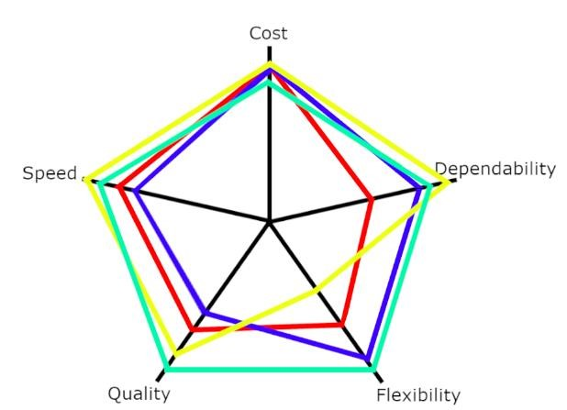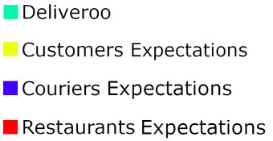

Figure 7. Polar Diagram for Deliveroo.
3.1. Service Quality

Deliveroo advertise themselves as the “gold standard of food delivery” (Deliveroo, 2022i), being founded over grounds that “great quality food was nearly impossible to get delivered”. This requires: packaging maintain meal temperature; restaurants exhibit best food-hygiene practice; riders have minimal meal contact; and orders are accurate and reliable. Deliveroo’s provision of restaurant meals disrupted the market by exceeding customer expectations in quality and speed relative to independent delivery systems. Couriers have access to £20 to cover hygiene product purchases, extensive hygiene guidance on the rider website, training (including safety) via EduMe and RideTo, and customer feedback (via-app) (Deliveroo, 2020d; 2021; 2022c). Restaurants must score 2+ in Food Hygiene Rating Scheme inspections and can get re-rated by Deliveroo partner SureFoot (Deliveroo,
2022c; 2022e).

3.2. Dependability

Increasing dependability of restaurants on Deliveroo has been an objective. Striking exclusive rights partnerships with brands has increased the role Deliveroo plays in their operation, along with the proliferation of dark kitchens (see Figure 10), and Frank the algorithm updates, their role is becoming increasingly reliable. Though without Greggs and McDonalds, Deliveroo loses out on a share of the 43% growth Just Eat saw upon their partnership (BBC, 2020). For couriers who are dependent on Deliveroo for income, expectations are high and increasingly met.

3.3. Speed

Deliveroo advertise 32 minutes or less but with notable efficiencies like Frank the algorithm, times have been reduced by 20% to 29 minutes in the UK (Shaed, 2017). Yet, the pressure to deliver fast to increase earnings drives hurriedness that has been known to cause boycotts in rare cases (Bristol Post, 2019). Deliveroo competes with all delivery companies in speed, with delivery times ultimately tending towards the ideal: zero minutes.

3.4. Flexibility

In terms of flexibility, Deliveroo demonstrates a strong ability to pivot into relevant trends; their proactivity during COVID included volume-boosting discounts, abidance to hygiene laws, customer support and free meals, investment in virtual brands, and striking of exclusive partnerships with grocery stores. Between 19th-25th December 2020 and then in January 2021, Deliveroo matched customer tips for tier 3 and 4 restaurants to help maintain mix flexibility and rider supply over fears of reduced fleet and long-term restaurant livelihood (Gazette, 2021). With thousands of gig economy couriers (working anytime between open and close) and many restaurants, Deliveroo’s platform is naturally flexible and short delivery times are generally guaranteed by Frank the algorithm (Bureau, 2021). 80% of riders identified ‘flexible work’ as their favourite feature of working for Deliveroo (Deliveroo, 2018).

3.5. Cost

Cost is arguably Deliveroo’s hardest challenge; high variety and visibility combined with reasonable variation and customers demanding reasonably priced meals make for low or zero profit margins on every order. Couriers expect to earn at least minimum wage for two-three deliveries-per-hour and tend to earn more than what other jobs (such as in supermarkets and on factory floors) offer (Deliveroo, 2018; Butler, 2022). Restaurants demand costs at-or-below their usual level (Backman, 2021).

For customers expecting to pay near-usual prices for meals, delivery and service costs are ideally zero, making it hard for Deliveroo to sustainably meet operating expenses of 2,000 full-time employees. Inflationary pressures also impact all parties, according to CEO Will Shu, along with the removal of economic stimulus and broad political conflict (Haine, 2022).

4. Further Analysis

Analysis of Deliveroo's financial performance reveals a gross margin per order of 8.8% in 2020 (Goel, 2022). The company derives 51% of its revenue from operations in the United Kingdom and Ireland, where it maintains a 22% market share, with the remainder generated from international markets. In 2021, subtracting marketing expenses, Deliveroo made £186m pre-tax profit (Sants, 2021).

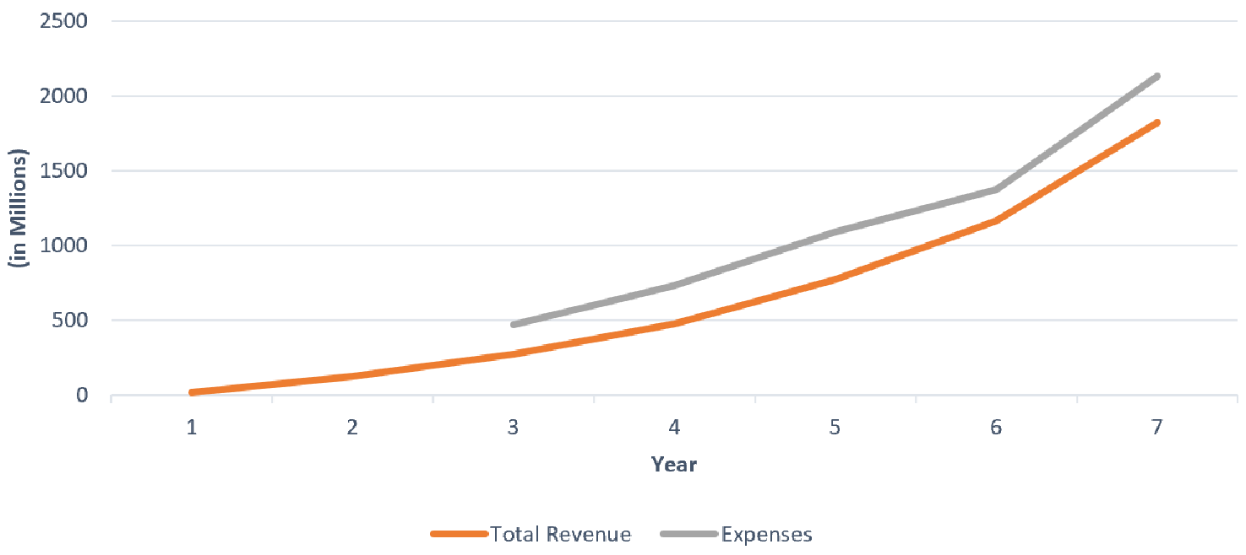
Figure 8. Deliveroo Income Trends 2015-2021 (Financial Times, 2022).
While analyst Peter Backman (2021) believes “delivery will not make much money in its current form”, as Deliveroo gains greater market prominence, shareholders will anticipate widening margins by cutting back marketing, increasing fees, and utilising ever-larger delivery fleets. Deliveroo enjoys greater margins than both Just Eat Takeaway (JET) and Uber Eats, strengthening their appeal to investors, while other companies trade off extended credit/cost (Uber Eats) or reduced operational oversight/quality (JET) in exchange for cheaper fees (Goel, 2022; Wilhelm, 2020). Over COVID, JET lost significant market share as they couldn’t rely on restaurants to deliver their own food, a pivotal feature of their model.
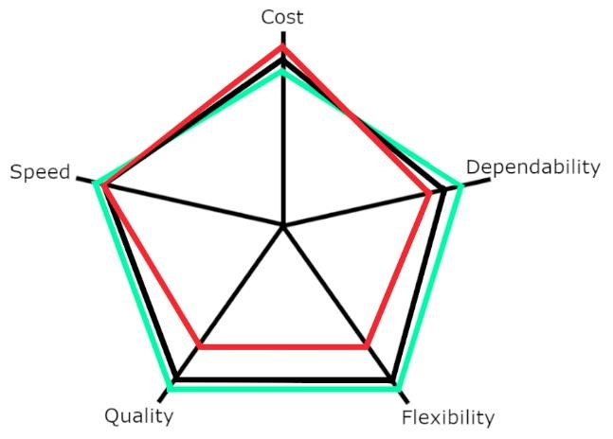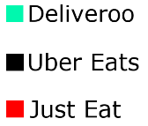
Figure 9. Polar Diagram for Delivery Market Competitors.
In the short-term, Deliveroo can increase competitivity by investing in their marketplace; ‘Table Service’ is a promising feature to encourage in-person ordering and could lead to new commission sources. In-platform support gives Deliveroo a market lead over Just Eat, along with the recent growth in product offering (McDonalds is now available). Growing a base of exclusive supplier partnerships, especially grocery offering, extend their advantage.

Other methods include:
- Expanding ‘Editions’ (cloud/dark kitchens; less cost-intensive premises entirely dependent on deliveries) to promote restaurant dependence on Deliveroo,
- Providing electric bikes for faster, equally cheap fulfilment,
- Investing in automated delivery (drones, autonomous vehicles) to reduce costs,
- Improving ‘Deliveroo Plus’, a monthly subscription service for free delivery, to increase customer share and networking economies of scale, thus efficiencies in speed, reliability and flexibility, and
- Investing in chef and courier skills with online training courses and apprenticeships, offered as part of the on-boarding package, leading to further competitiveness with JET and Uber Eats in 2022 and beyond (Deliveroo, 2020e; 2022d).

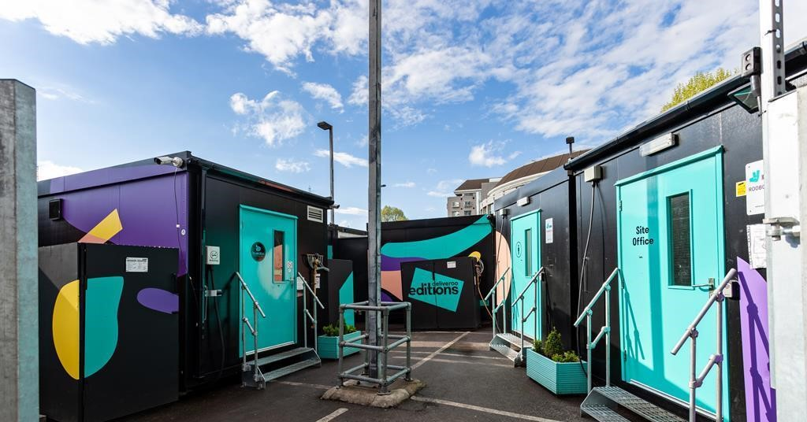
Figure 10. Deliveroo Has Pioneered Dark Kitchens ('Editions') During the Pandemic.

Bibliography

Backman, P. (2021) How to Make Money from Restaurant Delivery. Peter Blackman. Available at:
https://www.peterbackmanfs.com/how-to-make-money-from-restaurant-delivery [Accessed: 23/05/2022]

BBC (2020) Just Eat: McDonald's and Greggs help boost orders by 40%. BBC News. Available at:
https://www.bbc.co.uk/news/business-54538188 [Accessed: 23/05/2022]

Bristol Post (2019) Bristol Deliveroo Riders Boycott Orders from Wagamama Restaurants. Bristol Live. Available at: https://www.bristolpost.co.uk/whats-on/food-drink/bristol-deliveroo-wagamama-orders-boycott-3427307
[Accessed: 23/05/2022]

Browne, R. (2021) Deliveroo doubled orders and trimmed losses in the first six months of 2021. CNBC. Available at: https://www.cnbc.com/2021/08/11/deliveroo-doubles-orders-in-first-half-of-2021.html [Accessed: 23/05/2022]

Bureau (2021) Deliveroo riders can earn as little as £2 an hour during shifts, as boss stands to make £500m.
Bureau of Investigative Journalism. Available at: https://www.thebureauinvestigates.com/stories/2021-03-
25/deliveroo-riders-earning-as-little-as-2-pounds [Accessed: 23/05/2022]

Butler, S. (2022) Deliveroo accused of ‘cynical PR move’ with union deal for couriers. The Guardian. Available at: https://www.theguardian.com/business/2022/may/12/deliveroo-union-deal-couriers-minimum-wage-gmbiwgb [Accessed: 23/05/2022]

Caterer Licensee Hotelier (2022) UK Foodservice Delivery Market to Grow +5.3% in 2022, to a Value of £13.3
Billion. Caterer Licensee Hotelier News. https://catererlicensee.com/uk-foodservice-delivery-market-to-grow-
5-3-in-2022-to-a-value-of-13-3billion/#:~:text=According%20to%20the%20new%20Lumina,to%20%C2%A312.6bn%20currently [Accessed: 23/05/2022]

Deliveroo (2018) Gig economy set to double as workers shun traditional employment. Deliveroo Newsroom. Available at: https://uk.deliveroo.news/news/public-first.html [Accessed: 23/05/2022]

Deliveroo (2020a) Deliveroo Growth Accounts. Available at: https://uk.deliveroo.news/news/deliveroo-growthaccounts-2019.html [Accessed: 23/05/2022]

Deliveroo (2020b) Deliveroo Waitrose Expansion. Available at: https://uk.deliveroo.news/news/deliveroowaitrose-expansion-2020.html [Accessed: 23/05/2022]

Deliveroo (2020c) Deliveroo NHS COVID-19. Available at: https://uk.deliveroo.news/news/deliveroo-nhs-covid-
19.html [Accessed: 23/05/2022]

Deliveroo (2020d) Deliveroo Training Program. Available at: https://uk.deliveroo.news/news/deliverootraining-program.html [Accessed: 23/05/2022]

Deliveroo (2020e) Chef Apprenticeships Training. Available at: https://uk.deliveroo.news/news/chefapprenticeships-training.html [Accessed: 23/05/2022]

Deliveroo (2020f) Deliveroo Restaurants Safety. Available at: https://uk.deliveroo.news/news/deliveroorestaurants-safety.html [Accessed: 23/05/2022]

Deliveroo (2020g) Deliveroo Customers Groceries. Available at: https://uk.deliveroo.news/news/deliveroocustomers-groceries.html [Accessed: 23/05/2022]

Deliveroo (2020h) Ride to Find. Deliveroo Newsroom. Available at: https://uk.deliveroo.news/news/deliverooride-to-fine.html [Accessed: 23/05/2022]

Deliveroo (2020i) Deliveroo Food Hygiene Rating Policy. Deliveroo. Available at: https://help.deliveroo.com/en/articles/3198655-deliveroo-food-hygiene-rating-
policy#:~:text=Inspected%20restaurants%20are%20given%20a,you%20fall%20within%20an%20Exception [Accessed: 23/05/2022]

Deliveroo (2021) London riders: Free in-person safety training. Deliveroo. Available at:
https://riders.deliveroo.co.uk/en/news/london-riders-free-in-person-safety-training [Accessed: 23/05/2022]

Deliveroo (2022a) How and why am I offered specific orders? Deliveroo. Available at:
https://riders.deliveroo.co.uk/en/support/orders/how-and-why-am-i-offered-specific-orders [Accessed: 23/05/2022]

Deliveroo (2022b) NL Rider Support. Deliveroo. Available at: https://riders.deliveroo.nl/en/support/kits/do-ihave-to-use-the-deliveroo-backpack-and-what-is [Accessed: 23/05/2022]

Deliveroo (2022c) Become a Deliveroo Partner. Deliveroo. Available at: https://restaurants.deliveroo.com/engb/ also, Top Tips for Maximising Your Earnings. Deliveroo Plc. Available at: https://riders.deliveroo.co.uk/en/top-tips-fees [Accessed: 23/05/2022]

Deliveroo (2022d) Introducing Editions, our delivery-only kitchens. Deliveroo. Available at:
https://restaurants.deliveroo.com/en-gb/editions [Accessed: 23/05/2022]

Deliveroo (2022e) Terms and Conditions. Deliveroo. Available at: https://restaurants.deliveroo.com/engb/terms#delivery [Accessed: 23/05/2022]

Dephna (2022) Who Delivers? Best Food Delivery Apps in the UK for Sellers! Dephna Insights. Available at: https://www.dephna.com/insights/who-delivers-best-food-delivery-apps-in-the-uk-for-sellers [Accessed: 23/05/2022]

Dominos (2020) Why We’ve Stopped Domino’s Gluten Free Pizzas (For Now…). Dominos Plc. Available at: https://www.dominos.co.uk/blog/why-weve-stopped-dominos-gluten-free-pizzas-for-now/ [Accessed:
23/05/2022]

Edison Trends (2021) Research Reports. Edison Trends. Available at: https://trends.edison.tech/research.html

Financial Times (2022) ROO:LSE. The Financial Times. Available at:
https://markets.ft.com/data/equities/tearsheet/directors?s=ROO:LSE

Gazette, Dublin. (2021) Deliveroo to match customers’ tips to restaurants for January. The Dublin Gazette. Available at: https://dublingazette.com/dublinlife/food-drink/deliveroo-tips-45902/

Goel, S. (2020) How Does Deliveroo Make Money, Business Model. The Strategy Story. Available at:
https://thestrategystory.com/2022/02/07/how-does-deliveroo-make-money-business-model/

Haine, A. (2022) Deliveroo losses rise to £298m despite pandemic boost. The National News. Available at: https://www.thenationalnews.com/business/2022/03/17/deliveroo-losses-rise-to-298m-despite-pandemicboost/

Iqbal, M. (2022) Deliveroo Revenue and Usage Statistics. Business of Apps. Available at:
https://www.businessofapps.com/data/deliveroo-statistics/

Law, J. & Smullen, J. (2008) A Dictionary of Finance and Banking. 4th Edition. Oxford University Press. eISBN: 9780191726668

Lumina Intelligence. (2022) UK Foodservice Delivery Market Report 2022. Lumina Intelligence. https://store.lumina-intelligence.com/product/uk-foodservice-delivery-market-report-2022/

M. Mignot (2014) “Building a local food delivery network”. Index Ventures. Available:
https://www.indexventures.com/news-room/blog/building-a-local-food-delivery-network

Masters, L. (2022) How Much Does Deliveroo Pay? NimbleFins. https://www.nimblefins.co.uk/businessinsurance/courier-insurance-uk/deliveroo-pay

McKesson (2020) LloydsPharmacy and Deliveroo Launch Partnership to Deliver Medical Essentials. Available at:
https://mckesson.uk/lloydspharmacy-and-deliveroo-launch-partnership-to-deliver-medical-essentials/

Propel (2020) Sector CEOs and Deliveroo write to PM calling for urgent support for industry. Propel Info. Available at: http://www.propelinfonews.com/pi-Newsletter.php?datetime=2020-06-16%2003:00:00

Russel, R. S. & Taylor B. W. (2011) Operations Management: Creating Value Along the Supply Chain. 7th Edition. John Wiley & Sons.

Sants, A. (2021) Delivery companies still fighting to turn a profit. Investors Chronicle. Available at:
https://www.investorschronicle.co.uk/news/2021/08/18/delivery-companies-still-fighting-to-turn-a-profit/

Sayeed, I. (2020) Deliveroo and Restaurant Partners Warn of Grave Damage to Industry. Deliveroo Newsroom.
https://uk.deliveroo.news/news/deliveroo-restaurants-government.html

Scott-Delany, F. (2021) The Unstoppable Growth of Delivery. Big Hospitality. Available at: https://www.bighospitality.co.uk/Article/2021/02/17/The-unstoppable-growth-of-delivery-in-the-restaurantsector-Deliveroo-Just-Eat-Uber-Eats

Shaed, S. (2017) Deliveroo is using an algorithm called 'Frank' to cut food delivery times by 20%. Business Insider. Available at: https://www.businessinsider.com/deliveroo-uses-frank-algorithm-to-cut-delivery-timesby-20-2017-7?r=US&IR=T

Shaed, S. (2020a) Restaurant owners in Britain call on Deliveroo to drop commission fees. CNBC. https://www.cnbc.com/2020/05/01/restaurant-owners-in-britain-call-on-deliveroo-to-drop-commissionfees.html

Shaed, S. (2020b) ‘Driven to destitution’: Delivery riders in Britain are struggling as takeout orders plummet. CNBC. https://www.cnbc.com/2020/04/23/uber-eats-and-deliveroo-riders-in-uk-struggling-as-takeout-ordersfall.html [Accessed: 23/05/2022]

Telegraph (2020) Deliveroo to Axe over 300 Staff as Virus Hits Demand. The Telegraph. Available at:
https://www.telegraph.co.uk/technology/2020/04/28/deliveroo-let-go-300-staff/ [Accessed: 23/05/2022]

Which? (2021) The hidden costs of the food delivery revolution: the surprising premium added to your next takeaway. Which? Available at: https://www.which.co.uk/news/article/the-hidden-costs-of-the-food-deliveryrevolution-the-surprising-premium-added-to-your-next-takeaway-a9kAZ8K7lB30 [Accessed: 23/05/2022]

Wilhelm, A. (2020) SoftBank wants its on-demand portfolio to stop losing so much money. TechCrunch. Available at: https://techcrunch.com/2020/01/30/softbank-wants-its-on-demand-portfolio-to-stop-losing-somuch-money/ [Accessed: 23/05/2022]

