Contents
1.0. Introduction 2
1.1. Porter’s Five Forces 3
2.0. Supply Chain Management 3
2.1. Vertical Integration 4
2.2. Supply Chain Stage-Gate Model 4
2.4. Sustainable Supply Chain & Forecasts 5
2.5. Recommendations 5
3.0. Process Design Management 6
3.1. Production Line Layout 6
3.2. Gigafactory Automation 7
3.3. Structured High-Speed Iterations Framework 7
3.4. Drawbacks and Recommendations for Assembly Line Manufacturing 8
4.0. Quality Management 9
4.1. Performance, Features, and Aesthetics 9
4.2. Safety and Durability 10
4.3. Dependability, Speed, and Serviceability Failures 10
5.0. Conclusion 11
Appendix 13
References 17

1.0. Introduction

This essay analyses three strategic operational process used to create customer value at Tesla Inc, an American electric vehicle automaker generating 82.5% of revenue from manufacturing and selling automotives to customers (Tesla,2022a). Embodying Joseph Schumpeter’s creative destruction, Tesla has focused on ‘accelerating the advent of sustainable energy in the automotive industry’ by validating a global market for electric cars with their four-car line-up (Tesla,2023e). Many predictions believe that the cross-over point away from ICE to electric or hybrid engines is 2030 (Munro,2022).

Tesla also focus on services, (7.5% of revenue), energy generation and storage (4.8%), leasing (3%) and regulatory credits (2.2%) (Tesla,2022a). In 2020, Tesla became the most valuable automaker, topping Toyota, Volkswagen, Ford, GM, and later becoming the sixth US company to reach $1-trillion market capitalisation (WSJ,2021).

By considering existing internal processes and resource limitations, this essay offers recommendations for beneficial operational processes to enhance Tesla’s efficiency and competitivity as the EV market matures.

1.1. Porter’s Five Forces

Applying Porter's Five Forces (Oxford,2023), competitive rivalry among EVs is intensifying, with traditional automakers launching increasingly competitive electric models, including Han-EV and F150 (BYD,2023; Ford,2023). However, Tesla remains the market leader in EV innovation, with unparalleled customer loyalty and new-generation vehicle development of Cybertruck and Tesla Semi (J.D.Power,2022). These have granted Tesla uniquely low consumer buyer power, evidenced with unprecedented reorders and unrivalled EV margins (Reuters,2022).
Threat of substitution by ICE vehicles remains a significant, yet diminishing force for Tesla, with environmental awareness, government incentives, and advancements in battery technology (EnergyCentral,2022). In 2022 the Model-Y became the best-selling vehicle in Europe, while in US EV markets, sold 191,451 units compared to the closest competitor the Ford Mustang Mach-E’s 28,089 (Appendix 1).
Threat of entry is low but increasing; advanced technology, vast supercharging infrastructure and economies of scale create high barriers to entry by Tesla (Shelby,2023). However, particularly Chinese original equipment manufacturers (OEMs) are increasing dominance in non-American markets, and Chinese subsidies are driving rapid production scaling (ITC,2019).
Tesla relies on third-party suppliers for battery materials, particularly cobalt and nickel (Tesla,2022b). Supply chain disruptions, increasing demand, and limited availability of these materials have increased market supplier power, however Tesla's scale grants them unique bargaining power, keeping production costs comparatively low (Tesla,2022a).

2.0. Supply Chain Management

Cars are getting more complex; an average car has 15,000 components, creating cumulative inefficiencies such as increased costs, reduced responsiveness, and lack of accountability in the supply chain (Slack & Lewis,2020). According to CFO Zach Kirkhorn (2023), ‘in the automotive industry, companies live or die based on their ability to cut costs’, and long-run, lower manufacturing and warranty expenses improve profitability (Slack&Lewis,2020).

Tesla have adopted a production approach with two major cost advantages over incumbent firms; creating cost reductions for Model-3-andY of 50% since 2018 (Thomas,2023).
- First, vertical integration in the supply chain has enabled greater control of data visibility and proximal integration into gigafactories (Bushan,2023). This reduces time, fuel consumption and continual iteration without needing to navigate the complexity of a majority outsourced network (Munro, 2022).
- Second, through increasingly automating away labour: the most expensive fixed-cost (see Section.3.0.).

2.1. Vertical Integration
From a cost perspective, end-to-end ownership enables efficiencies through economies of scale. Director Pete Bannon (2022) notes component-level supply chain control has been critical for Tesla becoming the leader in the electric vehicle industry. Tesla’s first model, the Roadster, was produced 2,400 times, built using a Lexus chassis and each model since has been produced increasingly in-house, for instance between Models-S-and-3, Tesla moved from 20% internally-designed and manufactured controllers to 100% (Bannon,2023).
Tesla avoids the Bullwhip effect with uniquely consistent consumer demand levels (Appendix 2). Pursuing a four-car strategy, the affordable sedan, Model-3 accrued 325,000 pre-orders within one week of unveiling, equating to $14-billion in sales, or the biggest one-week product launch ever (Dean,2016). Model-Y, their affordable SUV has emerged as the best-selling car in Europe (Pappas,2023). This consistent high consumer demand allows Tesla to optimise for volume and repeatability, justifying substantial fixed-cost investment. Management can also monitor purchase statistics live due to Tesla’s exclusively online-purchasing policy (Faber,2023).
To manage this demand efficiently, Tesla produce locally in major markets to reduce tariffs, fuel cost, and transport times. They actively manage five gigafactories (final assembly points) and their California production facility (Appendix 5), while logistically managing ‘Tier-1’ suppliers (producing 8,300 parts for gigafactory assembly) and ‘Tier-2’ suppliers (sourcing 47,000 parts for Tier-1). By vertically integrating service centres and delivering straight-to-consumer, Tesla maintain dyadic relations with customers, unlike competitors (triadic relationship).

2.2. Supply Chain Stage-Gate Model

Tesla employs a highly integrated supply chain that addresses the ‘supplier improvement gap’ by maximising data visibility, while traditional original equipment manufacturers (OEMs) use contractors (Budhiraj,2023). Cooper’s Stage-gate Model (1986) illustrates Tesla’s supply chain management approach.

- Stages 1 & 2: Design Component – Tesla’s engineers with specialisms in manufacturing, battery chemistry, supply chain design, and software programming collaborate in the same workspace, fostering innovation (Budhiraj, 2023). Traceability is ensured with name and department procedurally tagged to each requirement (Munro, 2022).
- Stage 3: Development – Tesla’s specialised ‘Supply Industrialisation Engineering’ (ISE) department works closely with partner factories to achieve desired output yield and quality.
This leverages 10,000 ‘Tier-1’ and ‘Tier-2’ factories across 45 countries.
- Stage 4: Testing – ISE comprehensively tests of the new designs using five internallydeveloped steps (see Figure 2). Core decision-makers can monitor progress through near-live Internet-of-Things (IoT) dashboards, allowing for efficient data dissemination by providing digital platforms for all labourers (Brynjolfsson & McAfee, 2017).
- Stage 5: Integrate – Gigafactories absorb major subcomponent production using robotics and automation software. By reducing labour costs, Model-3 experienced cost reductions of 30% since 2018 while improving performance features.

Designing and manufacturing essential components in-house like powertrain provides a wider locus of control and informational sharing efficiencies, enabling faster iterations in the engineering process, improving quality and reducing costs long-term (Thomas,2023).
This robustness was tested during the COVID-19 pandemic, when average ETA accuracy dropped to 35% (for reference, it is now around 60%), Tesla grew vehicle production from 110,000 vehicles to 1.15 million per year, or 10.5x growth (CNN,2023). Rapid conveyance of supply problems were transmitted in real-time to adjust scheduling, material movements (channel alignment), and storage capacities at high velocity.

2.4. Sustainable Supply Chain & Forecasts
Using triple bottom line analysis, Tesla’s commitment to (1) planet involves opening their completely renewable, 25,000-strong supercharger network to rivals, underscoring Tesla's commitment to planet over profit by reducing barriers to entry among EV producers. 90% of gigafactory waste is recycled, while Gigafactory Nevada is powered entirely by clean-energy sources (Tesla,2022b). Tesla's corporate social responsibility (CSR) centralises in lifetime emissions for consumers, outlined in ‘Master Plan 3’. Pre-2022, their fleet avoided 13.4Mmt of CO2e emissions against ICE averages, the equivalent of Croatian yearly emissions (OWID, 2023). Similarly, over vehicle lifespans, customers will avoid 55 tons of CO2e, being 60% less emissive than competitor vehicles.

Through research and development, Tesla are pioneering resource-light components. In 2018, Tesla adopted an ST-Microelectronics silicon carbide-based inverter for the Model-3, reducing dependencies on rare earth materials by 25%, while creating 50% reductions in the electrical-pack size, 65% reductions in cost, and allowing for greater voltages, frequencies, and temperatures compared to before (Shelby,2023).

Regarding (2) people, Tesla engages in environmental and social issues by tracing mines to the source for ethical standards (Munro,2022). All Tier 1 partnerships include ethical clauses for compliance with social code, expectations, and company policy related to conflict minerals, slavery, child labour, and human trafficking, and these are enforced by third-party auditors (Tesla,2022b). New suppliers have a 10-week period for validating their conformance, and currently over 800 suppliers are engaged in responsible sourcing.
Regarding (3) profit, the company aims to produce 20-million electric vehicles annually by 2030 (or 5% of global production)—double the output of Toyota, the largest incumbent manufacturer of fuel powered cars (Insider). They have unparalleled vehicle profit margins.

2.5. Recommendations

While in 2022, Tesla produced 6.8x more Model-Ys than their closest American EV competitor, Chinese competitor BYD produced around 60% of Tesla’s production, and are growing 2.5x faster than Tesla (Barrons,2023). BYD outperform Tesla’s semi-conductor supply chain by producing cells in-house, while Tesla relies on external suppliers (Tesla,2023b). Accordingly, battery-grade materials sourcing and semiconductor production should be priorities for Tesla, possible by vertically integrating lithium refineries to increase speed and control (Tesla, 2023d). Sharing this aptitude of research with existing materials suppliers would accelerate Tier-2 production (Thomas,2023).
To reduce supply-chain weaknesses, Tesla should invest their $22.4bn reserves into LFP batteries to enhance price competitiveness (DOT,2023; Tesla,2023c). Some LFP-supported Chinese EVs sell for $16,000 against Tesla’s $32,000 (Carson,2023). LFP also has lower degradation rates, reducing recalls and servicing.
Another recommendation involves modifying their service network from 168 locations (Tesla,2023a) to a more interoperable, triadic model with third-party dealers. Tesla’s vertical service integration has been cumbersome, with service capabilities lagging sales volumes, overwhelming service capabilities and potentially diminished customer loyalty (Rathi,2022).
Furthermore, by encouraging Total Quality Management (TQM) within third-party suppliers and downstream service centres, Tesla can operate with more autonomy and concentrate efforts on production efficiencies, better facility training (Deming’s 5th Step), and the tension between worker productivity and wellbeing (ASQ,2023; Deming,2018).

3.0. Process Design Management

Tesla is the first US car company to achieve volume production since Chrysler over one-hundred-years ago, and the first US automotive startup to avoid going bankrupt since Ford (Stringham, et al.,2015; Barnard,2019). Musk has emphasised that building prototypes is easy but reaching volume production (5,000-to-10,000 vehicles per week) is challenging (Bellan, 2021). Tesla accomplished this by prioritising internally designed and manufactured components, and large-scale automation (Campbell, 2023).

3.1. Production Line Layout

The production line layout originated in the automotive industry due to the Four-V characteristics (Appendix 6), to leverage divisions of labour for vehicle assembly (McMullen, 2000). Traditionally, automotives lack variation, with low colour and custom hardware availability. This process involves stamping the metal, building the body, painting, and final construction on assembly lines with minimal variational complexity and high manufacturing volume. That said, consumer demand fluctuates seasonally (Faber,2023).
Tesla have been heavily influenced by Toyota’s Lean Manufacturing principles (EMF,2020) across all gigafactories, using manufacturing visibility to improve equipment utilisation rate, create marginal cost reductions, and minimise residual wastage and work-in-process inventories (BlackLab, 2022). As of 2021, about 1,000 robots were employed in the Model-3 production line (Munro, 2022).
Utilizing fixed-path material handling, Model-3 conveyors move at approximately one-mile-per-hour, progressing through a series of workstations differentiated by specific technological processing requirements (Brownlee, 2019). Assembly lines facilitate continuous product movement, with each workstation executing model-specific operations; the ‘paint shop’ is the sole area where a shared cell is used (Munro,2022). This approach enables streamlined accounting, purchasing, and inventory control, as well as simplified training and supervision. Moreover, automation potential is enhanced, and economies of scale contribute to reducing the marginal cost of raw material inputs.

3.2. Gigafactory Automation

Tesla fosters workforce productivity by prioritizing major actions over incremental changes. With enhanced agility and adaptability, they rapidly scale traditional assembly lines, outpacing competitors. This drive for automation and efficiencies is exemplified in Factory Fremont, a 5.3-million-sq.ft. facility producing more cars weekly than any other North American facility. It achieves over double the industry average labour efficiency, despite having half the footprint of Toyota's 9-million-sq.ft. plant in Georgetown (Evannex, 2022). For instance, labour for in-vehicle computer production has dropped 95% since 2017 (Brownlee,2019).

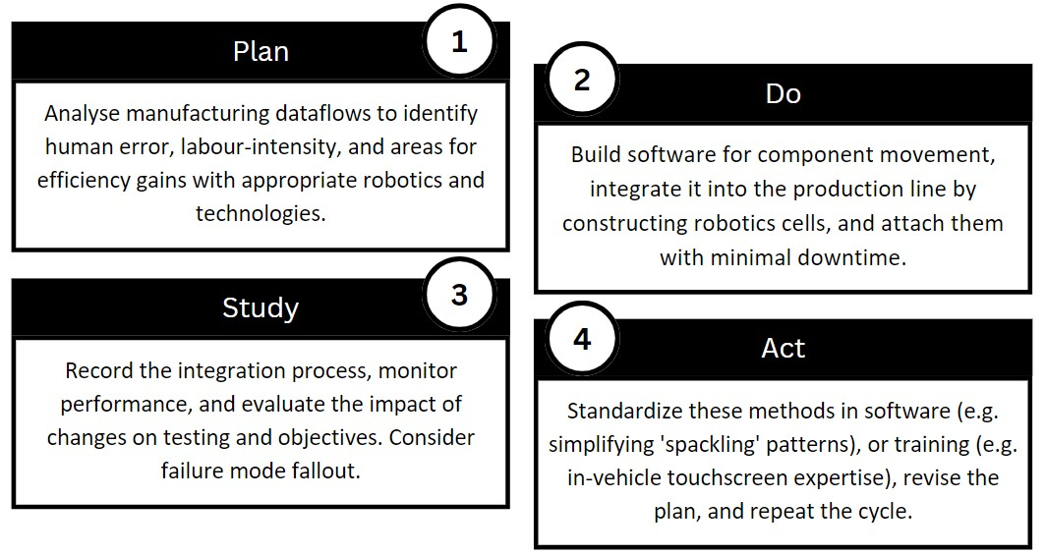

Figure 1: Applying PDSE at Tesla: how to optimise production systematically.

3.3. Structured High-Speed Iterations Framework

Within each gigafactory, Continuous Flow Manufacturing (CFM) necessitates effective material handling systems to increase throughput, minimise lead times, and work-in-process inventory levels (Choudhary&Singh,2010). Applying the ‘Fewer things not more’ simplification philosophy (Figure 2), they replaced 300 robots by single-piece casting the Model-Y rear-piece, rather than spackling on sealant, which is ‘arguably the most arduous job in the factory’ according to Musk (Munro,2022). Their latest build, Gigafactory Texas (Appendix 3) is projected to produce 2x the existing record at 20,000units-per-week within 8-million-sq.ft. (Lambert,2022).

This approach for continuous improvement (kaizen) involves constantly reducing deviation from the target value, as prescribed by Taguchi’s Quality Loss Function (TQLF) (Slack&Lewis,2020). With the Model-Y, Tesla reduced the length of the assembly line by 10% by building the battery into the floor, improving handling and weight-distribution while reducing cost. This enabled parallel production as opposed to sequential processing. These inefficiencies are targeted in real-time using a five-step process (Figure 2), developed between SpaceX and Tesla.
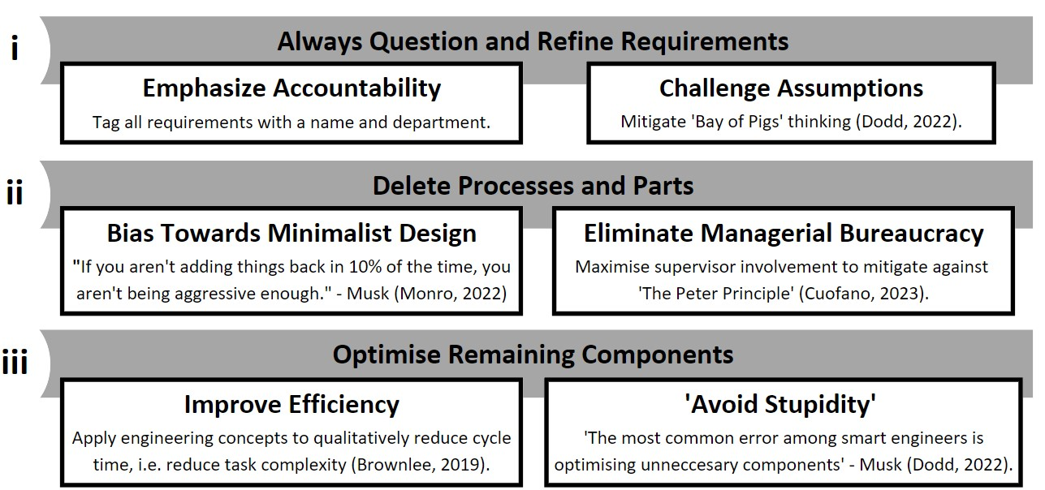
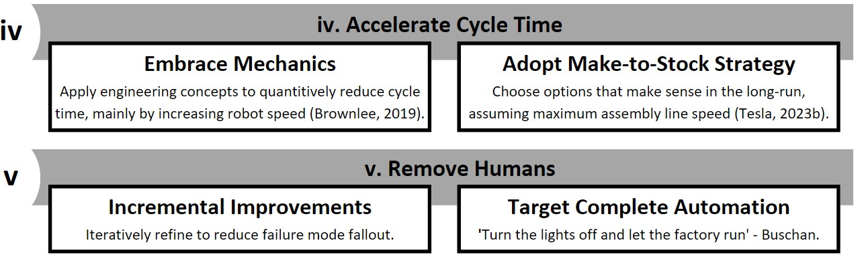
Figure 2: Tesla’s Five-Step Kaizen Framework (Dodd,2022).

3.4. Drawbacks and Recommendations for Assembly Line Manufacturing

By adopting front-body casting, an estimated 300 robots could be removed from Model-Y’s assembly line, while single-piece casting (rear-and-front) would reduce the body shop length by a further 30% (Munro,2022). With less complexity, Tesla’s “Production Hell” period in 2017-2018 could have been avoided. “Production Hell” resulted from ‘engineering backwards: automating, accelerating, simplifying, then deleting’. After falling short of estimates, Tesla ramped up production to 10,000 Model-3s-per-week by Q1-2019, reducing unit costs by 30% by removing unnecessary robotics cells (Forbes,2018).
Assembly line layouts have (1) high fixed equipment cost disadvantages, (2) repetitive jobs leading to stress and low morale, (3) and bottleneck stoppages (Slack&Lewis,2020).
Tesla should continue by training employees for complex tasks, while automating routine sections. By expanding their internal platform, “Take Charge”, for employee suggestions (Shelby,2023), they can leverage tacit knowledge of labourers, keep work engaging, and recognise diminishing returns to automation: fully autonomous systems require advanced robotics technicians on 24-hour standby, creating diseconomies of scale.

By parallelising some serial assembly processes, Tesla could reduce manufacturing footprint by over 40% and factory build costs by 50% (Musk,2023). Intelligent design of new vehicles that use steel as an exoskeleton will reduce production footprint and eliminate the paint shop. Tesla should also develop rear- and front-casting production using proprietary alloys to avoid heat quench steps and warping issues, potentially ‘deleting’ six-hundred robotics (60%) from the assembly line (Munro,2022).

OEMs like Tesla can capitalize on EV architecture by merged battery cells and chassis into singular structural packs with many benefits: high moment-of-inertia, body stiffness, fire retardancy, improved handling, and build quality greater than BMW’s 7-series (Munro,2022). Another cost-free improvement would be using the in-vehicle touchscreen to improve efficiency in manufacturing, with live-monitoring of sensory failures, enabling built-in quality assurance, and instantly alerting manufacturing issues, reducing recalls.

4.0. Quality Management

In the automotive industry, strict conformance quality specifications for safety and durability are upheld by certifications agencies, while specification quality is essential for consumer satisfaction. Tesla changed the historic EV stigma when their first scale production vehicle, the Model-S, won Carsales’ prestigious Car-of-the-Year in 2013 (Alvarez,2019). Improved product quality leads to better reputation, leading to premium prices and increased market share, ultimately improving profitability (Slack&Lewis,2020).
Using their premium specification series (Models S-and-X), Tesla leveraged economies of scale to produce an affordable range (Models 3-and-Y). Musk labelled this scaling step “excruciatingly painful” (Munro,2022), evidenced by “production hell” and damaged expectations to speed and quality. We will assess Tesla’s adherence to key dimensions of automotive quality (Garvin,1987).

4.1. Performance, Features, and Aesthetics

In line with Crosby's (1979) "prevention, not appraisal" principle, Tesla aims to minimise defects and errors in vehicular design, before scaling production. This ensures issues are identified and resolved early in development, reducing the risk of small problems leading to significant consequences (Dodd,2022).
In terms of ‘hard’ specification quality, Tesla’s entire product line-up delivers maximum torque instantaneously from a standstill, unlike any ICE vehicle. The electric motor can provide constant power without the need for gear-boxes, enabling 0-60 in under 3-seconds for the Model-S, outpacing supercars like Ferrari and Lamborghini while maintaining greater efficiency than the Toyota Prius (Campbell,2023). The Model-3 offers the best 0-60 time for its price in the market, with a powertrain as powerful as a jet engine, pound-for-pound.
The company's design philosophy, spearheaded by Franz von Holzhausen, emphases futuristic beauty, with unique exterior and interior aesthetics, including the Model X's "Falcon wing" doors, the Semi's single seat with touchscreens, and the Model X's "bioweapon defence mode" air-filtration system. These features were cited by Consumer Reports (2017), the leading review agency, when Tesla’s Model-S was awarded the best car they have ever tested.

4.2. Safety and Durability

In adherence to Taguchi’s Quality Loss Function, Tesla improved the durability of their batteries at
Gigafactory Nevada in 2020, achieving 88% retention after 200,000 miles. The 'per-mile-cost' for Model-3 owners is comparable to a Toyota Corolla (Shahan,2019), while also being $4,930-to-$13,888 more-affordable than the average new car bought in the US depending on tax credit (CBS,2022). Electric motors require no filtration or fluid replacement, slowing deviations away from Taguchi’s target conformance quality, and reducing depreciation rate relative to competitors.
Additionally, free supercharger station access lowers the average cost-per-mile to 45p, or over 40% below average ICEs (Forbes, 2021a). Tesla have pledged to offer free charging, forever (Musk, 2012a), and are currently the only OEM capable of rolling-out autonomous driving software to an existing fleet, later this year (Faber,2023). This update will enable autonomous ‘robotaxi’ services akin to Uber, potentially earning customers income above what they paid initially, over the vehicle’s lifetime. Through revenue sharing, Tesla’s profit margins could increase 5x per unit produced.
Tesla's focus on Total Quality Management (TQM) involves adopting practices like Total Quality
Control (Feigenbaum,1940), data-driven decision-making, employee empowerment, and failsafing (Juran,2004). These principles contribute to Tesla's continuous improvement and customer satisfaction; their internal system “Take Charge” has enabled shared decision-making for workers, reducing workplace injuries by 30% in Q4-2022 alone, with 6,145 suggestions (Shelby,2023).
This commitment to conformance excellence is evident in their vehicles' high safety ratings; Model-Y achieved the highest safety score (92%) under Euro NCAP's newest and toughest test, while competitors scored a maximum of 89% (Forbes,2022; Tesla,2021). As of 2023, Model-3 is the safest car ever built, earning a perfect 5-star safety rating in every standardised category and sub-category (Moser,2022; Appendix 4).
Finally, conformance quality improves over time. Tesla's integration of hardware and software has enhanced vehicle safety post-purchase. For example, seatbelt tensioning adjustments were made using crash data collected by Tesla's sensor systems. In 2023, Tesla collected 123-million miles of driving data every day, making adjustments to suspension based on detected road roughness and GPS. In Q3-2022, Tesla vehicles covered 1.7 million miles before an accident, 3.4x greater than the US average. With Tesla Autopilot engaged, this figure increased to 6.3 million miles, 12.6x the US average (Tesla, 2023b).
They also test new algorithms ‘in the background’, ensuring only stable algorithms are implemented. This comes with specification quality advantages; their custom-software and cloud-storage facilities have minimised engine cost, weight, size, and noise (Elluswamy,2023).

4.3. Dependability, Speed, and Serviceability Failures

In 2021, Tesla ranked 2nd last in Consumer Reports annual ‘reliability’ rankings, and 19th of 21 in 2022 (CNN,2022). J.D.Power’s (2020) ‘Initial Quality Study’ ranked Tesla bottom for quality with 250 problems per 100 vehicles, though notably with cosmetic items (Berman,2020), finding more complaints within 30 days than the other 31 US automakers in the study. Furthermore, Tesla had a severe problem with battery fires with Model-S in 2019, requiring a shielding system to prevent punctures of the battery pack (Quach,2021).
Tesla have not conformed traditionally to the ISO or other manufacturing standards, and some evidence suggests as little as 73% conformance to ISO 9001 (Ruffo,2022). Regulatory agencies have allowed them to self-certify, though by adopting more conventional assessments, Tesla could achieve better conformance to requirements, meeting industry standards for “zero defects” target quality (Crosby,2012).
Historically, recalls for Models S-and-X resulted from early quality-control problems (Insider,2017). The entire Model-S fleet was recalled in 2015 because a seat-belt assembly could fail, and the initial production run was recalled as seats could pitch forward in a crash (Insider, 2017). Crosby emphasized the importance of prevention over inspection, management commitment, and a "do it right the first time" culture. Moreover, incorporating Six Sigma methodologies suit Tesla’s data-driven infrastructure, and involve ‘Defining, Measuring, Analysing, Improving, and Controlling’ issues, rather than inefficiencies. This change of focus could mitigate losses from future recalls.
Musk has acknowledged that the earliest cars and those with levelled-off yield have the best quality; it is those produced during the ramping of scale that suffer (Munro,2022). For instance, while scaling Model-3 production, paint would not dry fast enough by a matter of minutes, requiring materials science research before correction. Musk has said “if we knew [problems] in advance, we would fix them in advance”, suggesting these problems will diminish in frequency and severity with greater experience and continued high-speed cycle iteration (Figure 2).
Tesla topped J.D.Power’s 2022 ‘Tech Experience Study Innovation Index’, which suggests that they have greater capabilities in implementing these changes than rivals, though having a decentralised service network with triadic consumer interactions could add third-party quality assurance (as proposed in Section 2.5).
An example where Crosby’s “zero defects” philosophy has visibly improved production is in the design of the Cybertruck: when the Model-X experienced significant stress and cost problems (Brownlee, 2019), delivery speed and firm-side costs were increased, reducing profit margins and deviating actual from target TQLF value. Musk has noted that these challenges provided valuable learning experiences (‘mental scar tissue’), and Tesla has simplified job shop requirements for Cybertruck include steel finish and minimal welding (Munro,2022).

5.0. Conclusion

This essay has provided detailed analysis of Tesla Inc.'s strategic operational processes in the rapidly evolving EV market. Applying Porter’s Five Forces to Tesla, we can identify significant challenges and opportunities that the company faces in the current competitive landscape.
Regarding Competitive Rivalry, the EV market is witnessing a surge of competition as regulation forces automakers to offer electric products. New entrants and Chinese competitors are launching higher specification, increasingly affordable electric models and for Tesla to remain market leaders, they must grow their consumer loyalty by targeting new audiences with engaging advertising campaigns. With excellent specification quality and safety, evidenced by their awards including Best Overall, Value, Refined, Performance, and Styling at Kelley Blue Book awards (Schmidt,2020), Tesla must broadcast their strong offering globally, while increasing soft specification quality to fix cosmetic issues, and adopting more conventional manufacturing conformity. Tesla should re-centre objectives around continuous improvements to quality and TQM above all else, despite the tensions with scaling decisions.
Bargaining Power of Buyers is anticipated to grow as more product variety emerges from rivals like
Ford. Tesla can improve serviceability by adopting a licensed-based model with dealers, and a triadic relationship with users. This will enable service supply to scale with demand, reducing overwhelmed service stations. Long-term, this will secure customer loyalty and satisfaction.
Furthermore, with large economies of scale in EV production, Tesla has an advantage that can be exploit by cutting prices, improving customer adoption rates while raising barriers to entry against New Entrant Threat. Tesla faces increasing competition from Chinese original equipment manufacturers (OEMs) and incumbent ICEs. By increasing affordability at the scale of Model-3 and Y, Tesla will increase customer expectations, reducing rivals’ ability to breakeven through competitive pricing.
Tesla should invest in reducing costs long-term by integrating supply chains further. With growing political tensions, Tesla must relocate and diversify their gigafactory supply chain by investing in lithium production and relocate production facilities. This will reduce Supplier Bargaining Power and accelerate sourcing of existing Tier-2 materials through information sharing. These developments represent large expenses in the short run, but could reduce the cost in the long run compared to the current procurement operations. Tesla’s high value culture makes them uniquely positioned to exploit this opportunity with tacit industry knowledge and high workforce human capital.
As Tesla rolls out autonomous driving, ICE vehicles will become less Threatening Substitutes. Rising fuel prices makes them increasingly unviable for new buyers, and EVs stand to thrive in the foreseeable future. Greater supercharging infrastructure influence, and full self-driving. The introduction of the full self-driving software update could potentially transform Tesla's vehicles into the most advanced product offering in the automotive industry. This technological leap, coupled with Tesla's commitment to scaling production, is expected to sustain and enhance consumer demand, positioning Tesla to outpace all competition by 2030.
Tesla's emphasis on automation, continuous improvement (kaizen) (Section 2.0.), process design management (Section 3.0.), and high specification quality (Section 4.0.) has enabled it to become market leaders in EVs. The recommendations provided in this essay, including further automation, increased focus on quality control and assurance, and the adoption of more conventional manufacturing standards, could help Tesla to achieve market dominance in the long-run, and drive Earth towards a sustainable future.

Appendix

Appendix 1

Statistica (2022) https://www.statista.com/statistics/314741/revenue-of-tesla-by-segment/
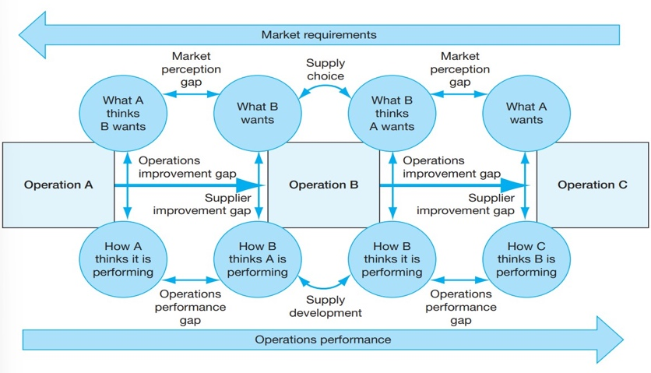
Appendix 2
(Slack & Lewis, 2020) Figure 5.11 potential perception mismatches in supply chains. Supply chain complexities, that are reduced with centralised operations.

Appendix 3:

Workflow for assembly-line layout, used in all gigafactories.
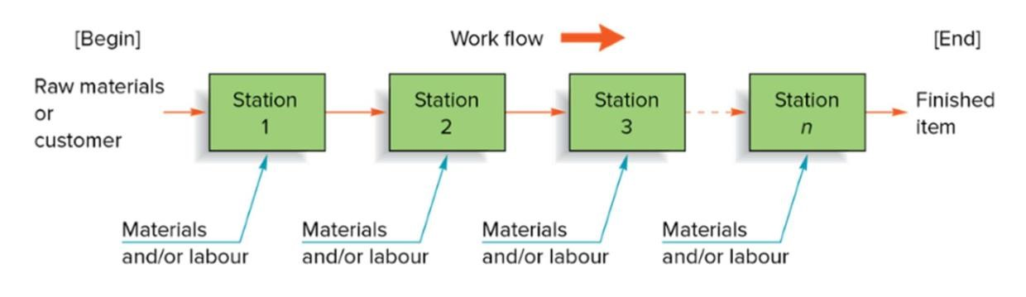
Giga Texas: Building the Cybertruck, Semi, Model Y, and Model 3.
Three buildings in parallel, with the first structure covering about 1.7 million square feet, the second covering 900,000 square feet, and the third one being just over 1 million square feet. Gaps between the buildings will be roads for semi trucks, which enables large machines to drive inside the factory.
Giga Texas will be the first Tesla factory that will have parts of it open to the public. It has boardwalks along the Colorado River with a biking trail. Musk has said they will build an ‘ecological paradise’ with birds in the trees, butterflies, fish in the stream, and public access.
(Roberts,2020) https://www.youtube.com/channel/UCDmfM1DRiTC9E7fuBbul2SQ
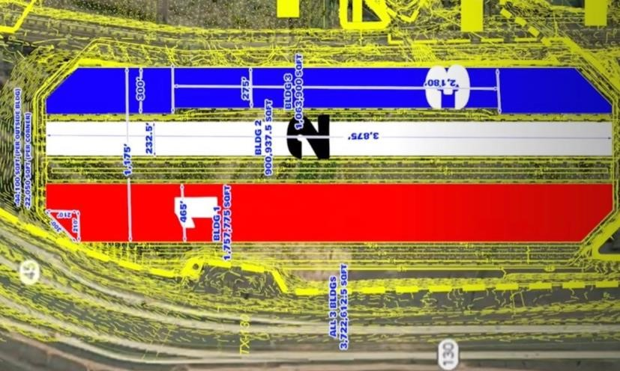

Appendix 4
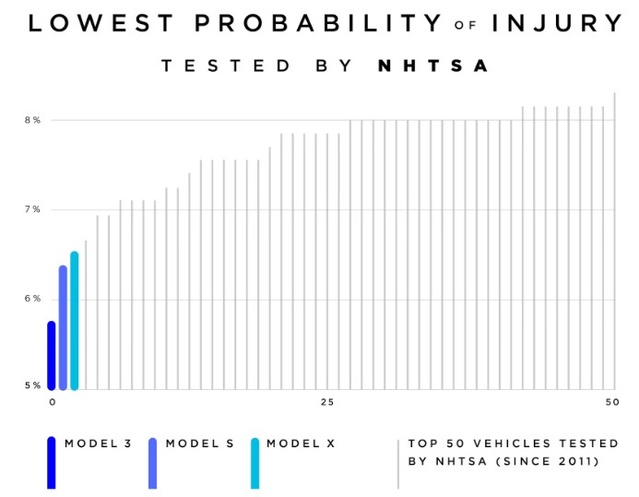

Appendix 5
Production facilities: Fremont, California (Models-S and X),
And Gigafactories:
- Nevada (Batteries)
- Texas (Models-3 and Y)
- New York (solar cells)
- Shanghai (Models-3 and Y)
- and Berlin (Model-Y)
(Budhiraj, 2023).

Appendix 6
Using 4-Vs to compare: Tesla (yellow), against rivals:
Mercedes (Red), and Toyota (Blue).

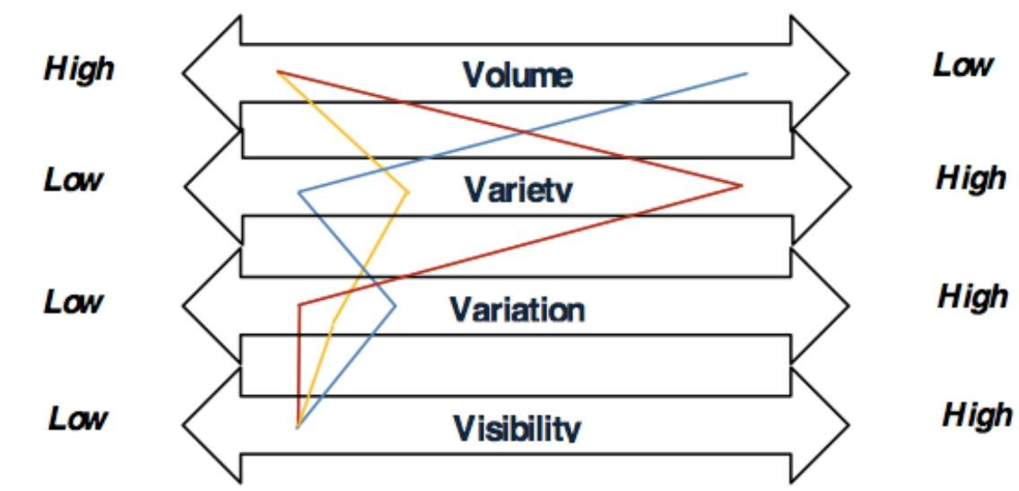
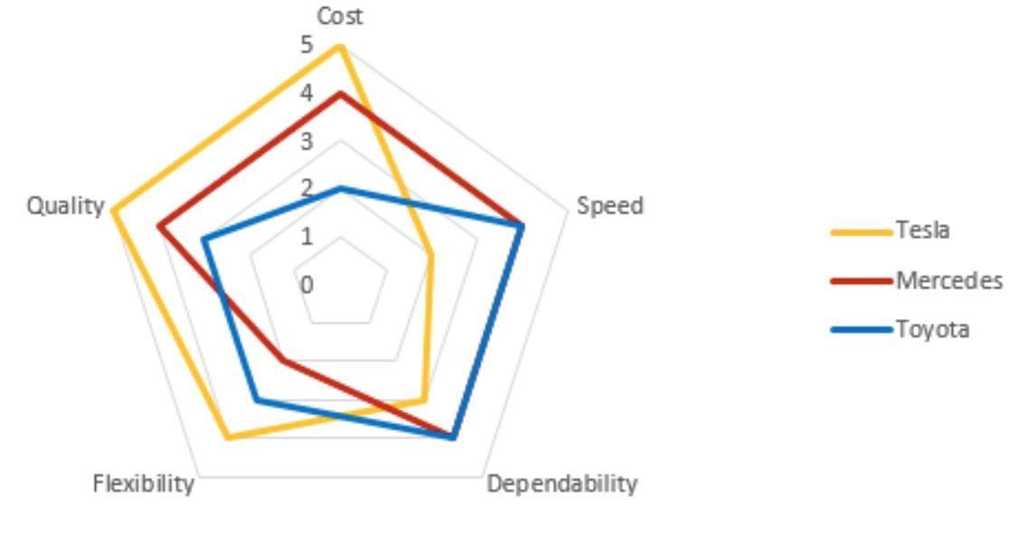
Polar analysis across five dimensions:

Tesla Motors Superchargers Polar Analysis. (n.d.). ‘Tesla Motors Superchargers’. Prezi. Retrieved May 19, 2023, from https://prezi.com/hvdblfxf3u09/tesla-motorssuperchargers/?frame=211534c8018

References

Alvarez, S. (2019). ‘Tesla Model S beats 70 years of motoring legends to win MotorTrend’s Ultimate Car of the Year award’. Teslarati. Available at: https://www.teslarati.com/tesla-model-s-winsmotortrend-ultimate-car-of-the-year-award/ [Accessed 5 May 2023].
Feigenbaum, A.V. (1940). ‘In Agile-TQM’. Retrieved May 19, 2023, from https://www.agiletqm.com/origin-of-total-quality-management/ [Accessed 6 May 2023].
Bannon, P. (2023) Director at Tesla. Quote taken from investor day. Tesla. [Accessed 6 May 2023].
Barnard, M. (2019). ‘What car companies have never gone bankrupt?’ [Quora post]. https://www.quora.com/What-car-companies-have-never-gone-bankrupt-Is-it-really-only-Ford-andTesla [Accessed 10 May 2023].

Barrons. (2023). ‘BYD Grew EV Sales 2.5 Times Faster Than Tesla in the Latest Quarter.’ Barrons.
Retrieved from https://www.barrons.com/articles/byd-deliveries-first-quarter-
9e1082ad#:~:text=For%20the%20first%20quarter%20of,the%20same%20time%20last%20year. [Accessed 6 May 2023].
Bellan, S. (2021). ‘Tesla hosts festival at Berlin Gigafactory to announce start of production by December’. TechCrunch. https://techcrunch.com/2021/10/10/tesla-hosts-festival-at-berlingigafactory-to-announce-start-of-production-by-december/
Berman, B. (2020) ‘Tesla Ranks Lowest on J D Power 2020 Quality Study’. Electrek.
https://electrek.co/2020/06/24/tesla-ranks-lowest-on-j-d-power-2020-quality-study/ [Accessed 6 May 2023].
Blacklab. (2022). ‘In-House Design is Key to Tesla's Advantage.’ Blacklab Design. Retrieved May 7, 2023, from https://blacklab.design/in-house-design-tesla-advantage/
Brownlee, M. (2019). ‘Tesla Factory Tour with Elon Musk!’ [Video]. YouTube. https://www.youtube.com/watch?v=mr9kK0_7x08
Brynjolfsson & McAfee (2017) ‘Machine Platform Crowd’. Penguin Publishers.
Budhiraj, K. (2023) Head of Supply Chain, Tesla Investor Day. Tesla.
Insider. (2017). ‘Tesla Cars Look Amazing: Strategy, Design.’ Business Insider. Retrieved May 3, 2023, from https://www.businessinsider.com/tesla-cars-look-amazing-strategy-design-201710?r=US&IR=T
BYD. (2023) BYD Home Page. BYD. https://www.byd.com/us/car/han
Campbell, C. (2023). Head of Powertrain Engineering, Tesla Investor Day. Tesla.
Carson, E. (2023, May 3). ‘Tesla Stock Vs. BYD Stock As Of May 3, 2023.’ Investor's Business Daily. https://www.investors.com/news/tesla-stock-vs-byd-stock-comparing-ev-giants-tsla-byddf-ev-stock/

CBS. (2022). ‘An entry-level Tesla now costs less than the average new car.’ CBS News. Retrieved May 19, 2023, from https://www.cbsnews.com/news/tesla-car-price-model-3-price-below-averagenewcar/#:~:text=Even%20without%20the%20tax%20credit,according%20to%20a%20Bloomberg%20anal ysis.
Choudhary, S. K., & Singh, S. K. (2010). ‘Implementation of continuous flow manufacturing (CFM) system in a contract manufacturer’. International Journal of Production Research, 54(7), 2099-2113.
CNN (2023) ‘Tesla Deliveries Production’. CNN. https://edition.cnn.com/2023/01/02/investing/tesla-deliveries-production/index.html
CNN. (2022). ‘Tesla plunges seven spots in annual Consumer Reports ranking.’ CNN. https://edition.cnn.com/2022/02/17/cars/tesla-consumer-reports-drop/index.html

Consumer Reports. (2017). ‘Tesla Model S Tops Consumer Reports' Ratings After Getting AEB’. Consumer Reports. https://www.consumerreports.org/car-safety/tesla-model-s-tops-consumerreports-ratings-after-getting-aeb/

Cooper, R.G. (1986). ‘Winning at New Products.’ Basic Books.
Crosby, P. (2012). ‘Crosby’s Quality Management Maturity Grid.’ Quality and Products. https://www.qualityandproducts.com/2012/07/09/crosbys-quality-management-maturity-grid/
Crosby, P.B. (1979) ‘Quality Is Free: The Art of Making Quality Certain.’ McGraw-Hill, New York.

Cuofano, G. (2023, April 4). ‘Peter Principle in a Nutshell.’ FourWeekMBA. Retrieved May 7, 2023, from https://fourweekmba.com/peter-principle-in-a-nutshell/
Dean, A. (2016). ‘Tesla Model 3 Preorders Exceed 325,000 After One Week.’ Manufacturing.NET. Retrieved May 6, 2023, from https://www.manufacturing.net/automotive/news/13106907/teslamodel-3-preorders-exceed-325000-after-one-week
Deming, W. E. (2018). ‘Dr. Deming's 14 Points for Management.’ The W. Edwards Deming Institute. Retrieved May 2, 2023, from https://deming.org/explore/fourteen-points/
Dodd, T. (2022) ‘Starbase Tour with Elon Musk.’ [online] YouTube. Available at: https://www.youtube.com/watch?v=t705r8ICkRw&t=1065s [Accessed 5 May 2023].
DOT. (2023). ‘Tesla Is Now Using Lithium-Iron Batteries. Here's Why That Matters.’ Dot LA.
https://dot.la/tesla-lithium-iron-battery-2657227393.html

Elluswamy, A. (2023) Full Self-Driving Director, Tesla Investor Day. Tesla.
EMF. (2020). Lean Manufacturing: Tesla vs. Toyota. Retrieved May 19, 2023, from https://epicmfg.com/lean-manufacturing-tesla-vs-toyota-61/
EnergyCentral. (2022) ‘US ICE Vehicle Phaseout’. Energy Central. https://energycentral.com/c/ec/usice-vehicle-phaseout
Evannex (2022) ‘Tesla Factory Efficiency Tops Industry.’ Inside EVs. https://insideevs.com/news/565337/tesla-factory-efficiency-tops-industry/
Faber, D. (2023). ‘Broad Subject Interview with CNBC.’ CNBC. Available at :
https://twitter.com/elonmusk/status/1658594572837036034
Forbes (2021a) ‘Study Confirms this upside for Tesla EVs over gas cars.’ Forbes.
https://www.forbes.com/sites/brookecrothers/2021/08/15/study-confirms-this-upside-for-teslaevs-over-gas-cars/
Ford. (2023) Ford Home Page. Ford. https://www.ford.com/trucks/f150/models/
Garvin, D. A. (1987). ‘Competing on the Eight Dimensions of Quality.’ Harvard Business Review. Retrieved from https://hbr.org/1987/11/competing-on-the-eight-dimensions-of-quality
Insider (2020) ‘Elon Musk Interview’. Business Insider. https://www.businessinsider.com/elon-muskinterview-axel-springer-tesla-accelerate-advent-of-sustainable-energy?r=US&IR=T
ITC. (2019). ‘Chinese Auto Parts Final Report.’ United States International Trade Commission.
Retrieved from https://www.usitc.gov/publications/332/working_papers/id-19-
060_chinese_auto_parts_final_080519-compliant_0.pdf
J.D. Power. (2022) ‘Tesla Model-Y’. J.D.Power. https://www.jdpower.com/cars/2022/tesla/model-y
Juran, J. M. (2004). ‘Architect of quality: the autobiography of Dr. Joseph M. Juran.’ McGraw Hill Professional.
Kirkhorn, Z. (2023) Chief Financial Officer, Tesla Investor day, Tesla.
Koetsier, J. (2022) ‘Tesla Model Y Gets Highest Safety Score Ever In European Test.’ [online] Forbes. Available at: https://www.forbes.com/sites/johnkoetsier/2022/09/07/tesla-model-y-gets-highestsafety-score-ever-in-european-test/ [Accessed 7 May 2023].
Lambert, F. (2022) ‘Tesla Operates Most Productive Car Factory in the US’. Electrek. https://electrek.co/2022/01/24/tesla-operates-most-productive-car-factory-us/
McMullen, P.R. (2000). ‚ASSEMBLY LINE DESIGN.’ Encyclopedia of Production and Manufacturing Management. Springer, Boston, MA . https://doi.org/10.1007/1-4020-0612-8_55
Moser, E. (2022) ‘A Complete Guide to Tesla Safety Ratings’. GetJerry. https://getjerry.com/carinsurance/a-complete-guide-to-tesla-safety-ratings
Munro, S. (2022). ‘Tesla Model Y teardown with Sandy Munro.’ [Interview]. YouTube. https://www.youtube.com/watch?v=YAtLTLiqNwg
Musk, E. (2012a) ‘Blogpost on supercharging.’ Tesla. https://www.tesla.com/blog/tesla-approachdistributing-and-servicing-cars
Musk, E. (2023) CEO Elon Musk, Tesla Investor Day. Tesla.
NTA (2023) ‘Tesla Wins Big’. Not a Tesla App. Available at:
https://www.notateslaapp.com/news/1231/tesla-wins-big-at-annual-awards-dethrones-ford-foroverall-loyalty-and-wins-most-improved [Accessed 7 May 2023].
OWID. (2023). ‘CO2 emissions in Croatia’. Our World In Data. Retrieved May 6, 2023, from https://ourworldindata.org/co2/country/croatia
Oxford (2023) Oxford Reference Title. Oxford Reference. https://www.oxfordreference.com/display/10.1093/oi/authority.20110803100338355;jsessionid=E3 4CEF9487F94235EF9180E26F126A0F
Pappas, T. (2023). ’Tesla Model Y Was Europe's Best-Selling Car In Q1 2023’. Carscoops. https://www.carscoops.com/2023/04/tesla-model-y-was-europes-best-selling-car-in-q1-2023/
Quach, K. (2021) ‘Tesla Battery’. The Register. https://www.theregister.com/2021/10/05/nhtsa_tesla_battery/
Rathi, A. (2022). ‘Elon Musk puts aggressive growth ahead of customer service. It may come back to bite him’. Business Insider. https://www.businessinsider.com/elon-musk-customer-service-teslaspacex-prioritize-aggressive-growth-2022-2?r=US&IR=T.
Reuters. (2022) ‘Tesla Uses Its Profits As a Weapon in EV Price War.’ Reuters.
https://www.reuters.com/business/autos-transportation/tesla-uses-its-profits-weapon-an-ev-pricewar-2023-01-19/
Ruffo, G. H. (2022) ‚Tesla Lacks Major Certifications’. AutoEvolution. https://www.autoevolution.com/news/tesla-lacks-major-automotive-quality-certifications-the-iatf16949-and-iso-9001-203551.html
Shahan, Z. (2019). ‚Tesla Model 3 vs. Toyota Corolla – Cost Comparisons Over 5 Years’. CleanTechnica. Retrieved from https://cleantechnica.com/2019/06/22/toyota-corolla-vs-teslamodel-3-5-year-cost-comparison/
Shelby, L. (2023) Environmental, Health, Safety, and Sustainability Lead, Tesla Investor Day. Tesla. https://www.youtube.com/watch?v=Hl1zEzVUV7w
Slack, N. & Lewis, M. (2020). ‘Operations Strategy’. Pearson Education Limited.

Stringham, E. P., Miller, J. K., & Clark, J. R. (2015). ‘Overcoming barriers to entry in an established industry: Tesla Motors’. California Management Review, 57(4), 85-103. doi:
10.1525/cmr.2015.57.4.85.

Tesla. (2021) ‘Model-Y Achieves 5 Star Overall Safety Rating’. Tesla. https://www.tesla.com/blog/model-y-achieves-5-star-overall-safety-rating-nhtsa
Tesla. (2022a) ‘Annual Report’. Tesla. https://annualreport.stocklight.com/nasdaq/tsla/22878151.pdf
Tesla. (2022b). ‘2022 Tesla Impact Report Highlights.’ Tesla. Retrieved May 6, 2023, from https://www.tesla.com/ns_videos/2022-tesla-impact-report-highlights.pdf
Tesla. (2023a). ‘Tesla Service Centers in United States.’ Tesla. Retrieved May 6, 2023, from https://www.tesla.com/findus/list/services/United%20States
Tesla. (2023b). ‘Manufacturing.’ Tesla. Retrieved May 7, 2023, from https://www.tesla.com/en_eu/manufacturing
Tesla. (2023c). ‘Q1 2023 Update’ [PDF]. Tesla. Retrieved from https://teslacdn.thron.com/static/ZXSBN8_TSLA_Q1_2023_Update_ABMJPG.pdf?response-contentdisposition=inline%3Bfilename%3D%22e826b065-cc14-467c-8c9c-e1feb7189ba8.pdf%22
Tesla. (2023d) ‘Content by Tesla’. Tesla. https://www.youtube.com/watch?v=DmnNrrnXrts
Tesla. (2023e) ‘About Us’. Tesla. https://www.tesla.com/about
Thomas, R. (2023). Supply Chain and Inventory Lead, Tesla Investor Day. Tesla.
WSJ (2021). ‘Tesla $1T’. WSJ. https://www.wsj.com/articles/tesla-hits-1-trillion-stock-marketcapitalization-elon-musk-electric-car-subsidies-11635197106

