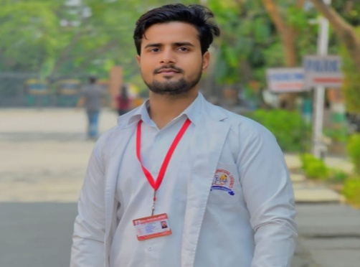 | SHAHBAZ HUSSAIN  OPTOMETRIST
CONTACT    Address :  Bhadasiya, Badaun (U.P.)    Phone number  7078415834    Email :  Shahwazhusain1@gmail.com  SKILLS :  - Visual acuity  - Refraction  - Auto refractometer  - Tonometry  - Lensometer  - Slit lamp examination  - Retinoscopy  - Keratometer  - Sac syringing  STRENGTH :  - Honesty  - Hard working  - Self-motivated  - Good listener  - Positive thinking  LANGUAGES :  - English  - Hindi | ABOUT ME  Dedicated and driven optometry student with a passion for vision care and improving patient quality of life. Possesses strong knowledge in ocular anatomy, physiology, and pathology with hands-on clinical experience. Skilled in conducting eye examinations, diagnosing visual disorders, and patient counselling.  EDUCATION  2023–2026  Bachelor in Science B.Sc. Optometry  Bareilly International University, Bareilly  High School  Completed from U.P. Board Allahabad in 2021.  Intermediate  Completed from U.P. Board Allahabad in 2023.  CONFERENCE/WORKSHOP  - Attended One-Day National Workshop at Bareilly International University on April 19, 2024.  - Attended Workshop on Prosthetic Eye at Bareilly International University on October 12, 2023.  - Attended Ortho-K Contact Lens Workshop at Bareilly International University on May 26, 2026.  DECLARATION  I hereby declare that all above facts are true. If a chance is given, I assure that I will win your trust.

