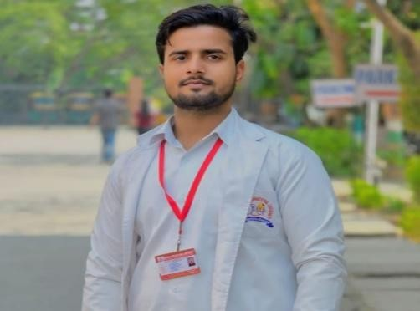
CONTACT

Address :
Bhadasiya, Badaun (U.P.)

Phone number
7078415834

Email :
Shahwazhusain1@gmail.com

SKILLS :
- Visual acuity
- Refraction
- Auto refractometer
- Tonometry
- Lensometer
- Slit lamp examination
- Retinoscopy
- Keratometer
- Sac syringing
STRENGTH :
- Honesty
- Hard working
- Self-motivated
- Good listener
- Positive thinking
LANGUAGES :
- English
- Hindi

SHAHBAZ HUSSAIN
OPTOMETRIST

ABOUT ME

Dedicated and driven optometry student with a passion for vision care and improving patient quality of life. Possesses strong knowledge in ocular anatomy, physiology, and pathology with hands-on clinical experience. Skilled in conducting eye examinations, diagnosing visual disorders, and patient counselling.

EDUCATION
2023–2026
Bachelor in Science B.Sc. Optometry Bareilly International University, Bareilly
High School
Completed from U.P. Board Allahabad in 2021. Intermediate
Completed from U.P. Board Allahabad in 2023.

CONFERENCE/WORKSHOP
- Attended One-Day National Workshop at Bareilly International University on April 19, 2024.
- Attended Workshop on Prosthetic Eye at Bareilly International University on October 12, 2023.
- Attended Ortho-K Contact Lens Workshop at Bareilly International University on May 26, 2026.

DECLARATION

I hereby declare that all above facts are true. If a chance is given, I assure that I will win your trust.

