CSIT128 Assignment 1 Report – Parts 1, 2 and 3
This report explains the HTML code for Parts 1, 2 and 3 of our web page. For each part, there is a screenshot of the code (with the real line numbers from our file), followed by a simple explanation of what each piece of code does and why we used it.

A few key words first
These words come up a lot in the explanations below:
- Tag: an instruction written inside angle brackets, like <p>. Tags tell the browser what each part of the page is (a heading, a paragraph, a picture, and so on).
- Opening and closing tags: most tags come in pairs. <p> starts a paragraph and </p> (with a slash) ends it. Whatever is in between belongs to that tag.
- Element: the opening tag, the closing tag, and everything in between, counted as one item.
- Attribute: an extra setting added inside an opening tag, like width="80%". It changes how that element looks or behaves.
- Style: the style="…" attribute lets us change the look of one element directly, such as its colour, size or spacing.
- Pixel (px): one tiny dot on the screen. We use pixels to measure sizes and spaces, such as 20px.

Part 1: Student Information
In Part 1 we made a table that shows our group name and each member's student number, name and email. This is what it looks like when the page is opened in a browser:
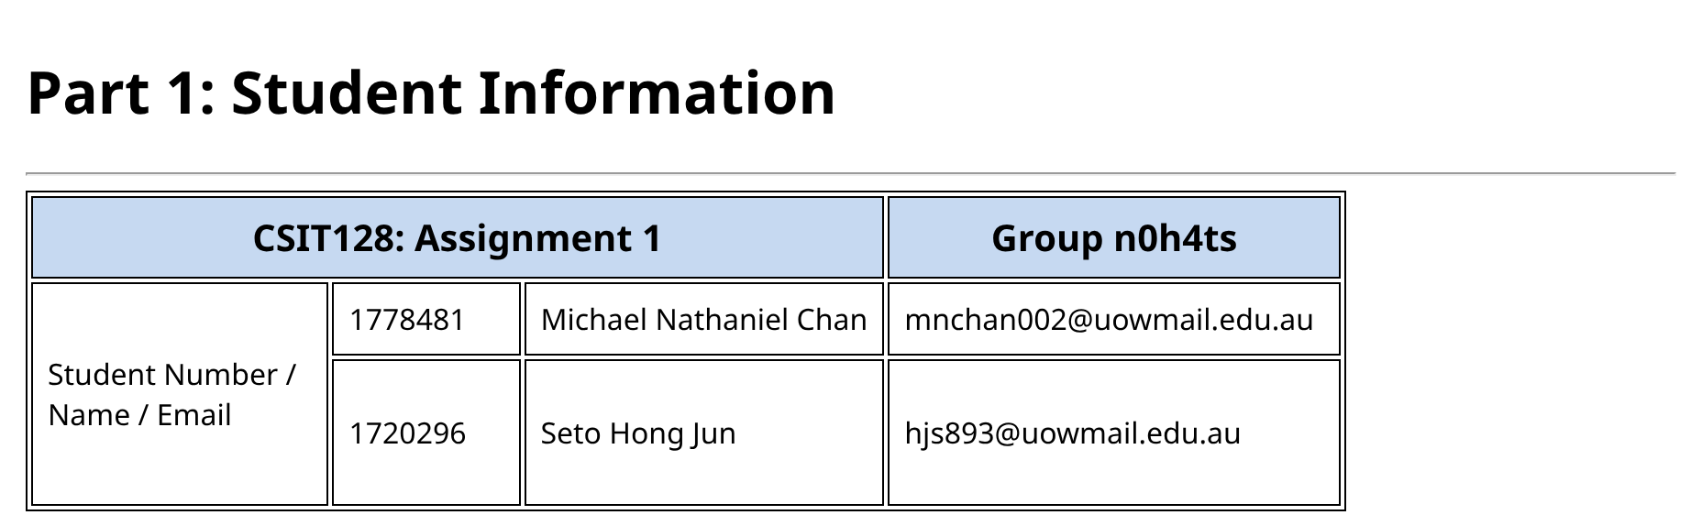
Figure 1: Part 1 as it appears in the browser

1.1 Setting up the page (lines 1–10)
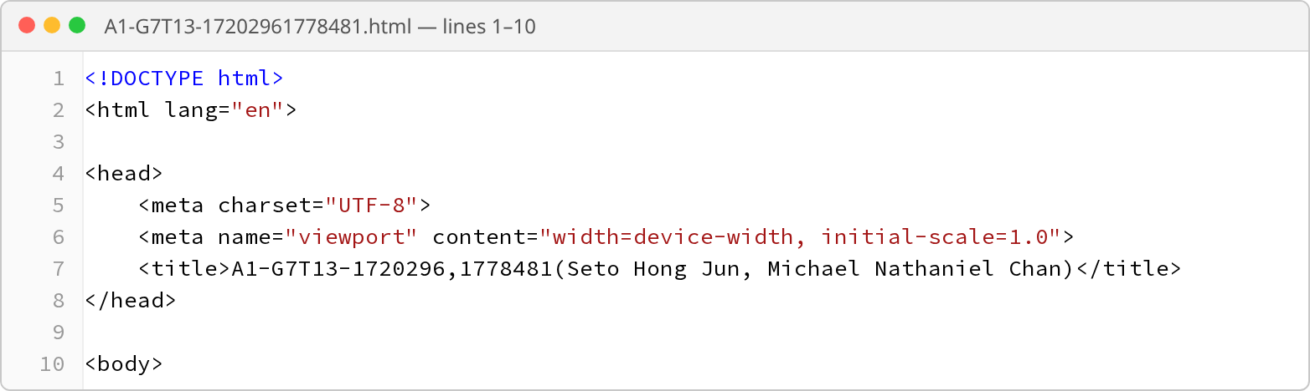
Figure 2: Basic page setup
Every HTML page starts with the same basic setup. You can think of it like the cover and information page of a book: it doesn't appear on the page itself, but it tells the browser important things about the page before it starts showing anything.
Code | What it means
<!DOCTYPE html> | The very first line. It tells the browser "this is a modern HTML page", so the browser knows which rules to follow when showing it.
<html lang="en"> | This tag wraps around the whole page. Everything else goes inside it. lang="en" says the page is written in English, which helps screen readers (tools that read pages out loud) and search engines.
<head> … </head> | The "behind the scenes" section. It holds information about the page, such as its title. Nothing in here shows up on the page itself.
<meta charset="UTF-8"> | Tells the browser which set of characters to use. UTF-8 covers almost every letter and symbol, so all our text shows up properly instead of turning into strange symbols.
<meta name="viewport" …> | Makes the page fit properly on any screen size, including phones. width=device-width means "make the page as wide as the screen", and initial-scale=1.0 means "start at normal zoom".
<title> … </title> | The text shown on the browser tab at the top of the window. As the assignment asked, we put our group code, student numbers and names here.
<body> | The start of the visible page. Everything the user actually sees (headings, tables, pictures, text) goes inside the body.

1.2 The heading and the start of the table (lines 11–13)
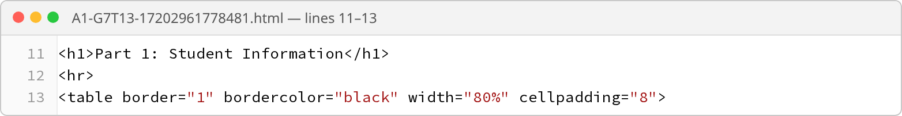
Figure 3: Part 1 heading and the opening table tag
Code | What it means
<h1> | A heading. The "1" means it's the biggest and most important heading size (sizes go from <h1> down to <h6>). We use <h1> for the title of each Part.
<hr> | Draws a straight horizontal line across the page to separate sections. It has no closing tag because there is nothing to put inside it.
<table> | Starts the table. Everything up to </table> is part of it.
border="1" | Draws lines around the table and around every box (cell) in it. The "1" means the lines are 1 pixel thick. Without this, the table would have no visible lines at all.
bordercolor="black" | Makes those lines black.
width="80%" | Makes the table 80% as wide as the page. Because it's a percentage, the table gets wider or narrower when the browser window is resized.
cellpadding="8" | Adds 8 pixels of empty space inside each box, between the text and the box's border. It works like the margin on a sheet of paper, so the text isn't squashed against the lines.

How a table is built: a table is built one row at a time, from top to bottom. <tr> ("table row") starts a new row. Inside each row, we add the boxes from left to right: <th> is a header box (its text is bold and centred automatically) and <td> is a normal box for data.

1.3 Row 1 – the title row (lines 14–18)
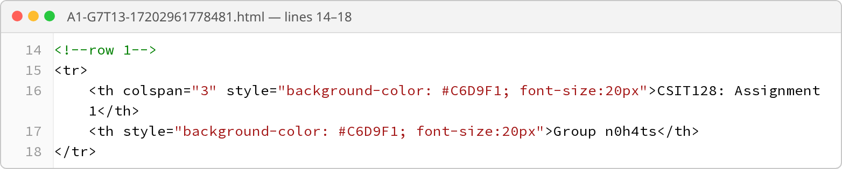
Figure 4: Row 1: assignment title and group name
Code | What it means
<!--row 1--> | A comment. Anything between <!-- and --> is a note for whoever reads the code. The browser skips it completely, so it never appears on the page. We used comments to label each row.
<tr> | Starts the first row of the table.
<th colspan="3"> | A header box. colspan="3" means "make this box as wide as 3 boxes". It's like merging 3 cells together in Excel. That's why "CSIT128: Assignment 1" stretches across most of the top of the table.
<th>Group n0h4ts</th> | The second header box, which fills the last (4th) column. Our table has 4 columns, so every row must add up to 4: here that's 3 (the merged box) + 1 = 4.
background-color: #C6D9F1 | Colours the box light blue. #C6D9F1 is a colour code: the browser turns these letters and numbers into one exact colour.
font-size:20px | Makes the text in these boxes bigger (20 pixels tall) so the title row stands out.
</tr> | Ends the first row.

1.4 Row 2 – the label and the first member (lines 19–25)
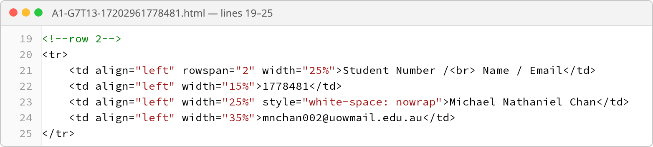
Figure 5: Row 2: the label box and Michael's details
Code | What it means
rowspan="2" | Makes the "Student Number / Name / Email" box 2 rows tall. It's the same idea as colspan, but downwards instead of sideways. This one label box sits beside both group members' details, so we don't need to write it twice.
<br> | Short for "line break". It's like pressing Enter: the text after it ("Name / Email") starts on a new line.
align="left" | Lines the text up against the left side of its box, like left-aligned text in Word.
width="25%" / "15%" / "25%" / "35%" | Sets how wide each of the 4 columns is, as a share of the table's width. They add up to 100% (25 + 15 + 25 + 35). We only set this in row 2 because every box below lines up with the box above it.
1778481 … mnchan002@uowmail.edu.au | The actual details for the first member: student number, name and email, each in its own box.
white-space: nowrap | "No wrap" means "don't split this text onto two lines". It keeps "Michael Nathaniel Chan" on one line, even when the box is narrow.

1.5 Row 3 – the second member (lines 26–32)
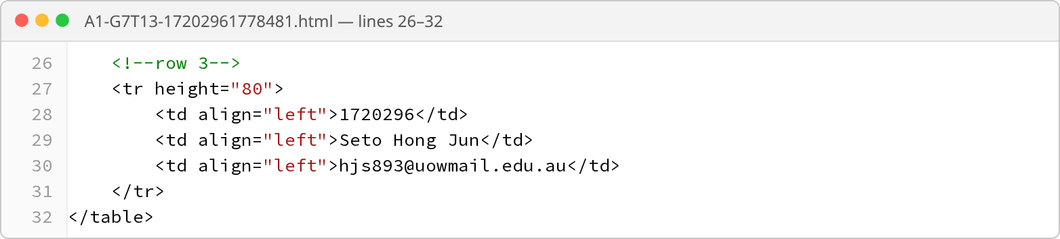
Figure 6: Row 3: Seto Hong Jun's details
Code | What it means
<tr height="80"> | Starts the third row and makes it 80 pixels tall. The label box on the left also gets taller, because it stretches across both rows 2 and 3.
Only 3 <td> boxes | This row only has 3 boxes instead of 4. That's because the first column is already taken by the tall label box from row 2. If we added a 4th box here, it would stick out past the edge of the table.
</table> | Ends the table.

This diagram shows how the merged boxes fit together to make a neat 4-column table:
CSIT128: Assignment 1  colspan="3" → covers columns 1–3 |  |  | Group n0h4ts  column 4
Student Number / Name / Email  rowspan="2" → covers rows 2–3 | 1778481 | Michael Nathaniel Chan | mnchan002@…
Student Number / Name / Email  rowspan="2" → covers rows 2–3 | 1720296 | Seto Hong Jun | hjs893@…

Part 2: Hello World program in different languages
A "Hello World" program is the simplest program you can write: it just shows the words "Hello World". Part 2 shows this program in four languages: C++, C#, Python and HTML. Each language has a heading, its logo, and the code shown next to the logo. At the top, there is a list of links that jump straight to each language.

2.1 The heading and the jump links (lines 34–42)
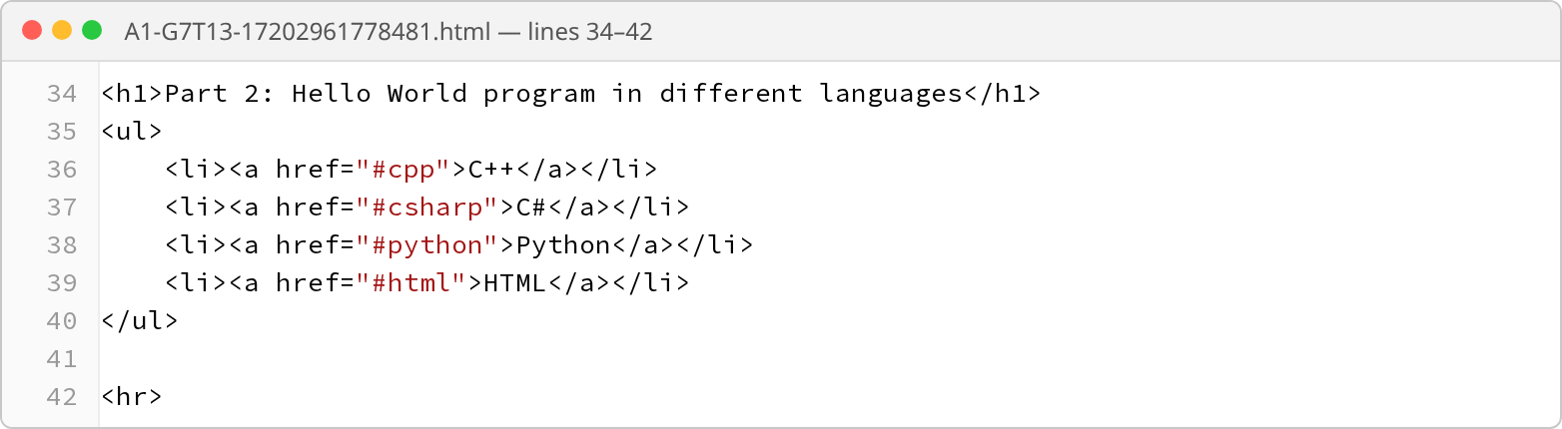
Figure 7: Part 2 heading and the list of links
Code | What it means
<ul> | Starts a bullet-point list. "ul" stands for "unordered list", meaning the items have bullet points instead of numbers.
<li> | One item (one bullet point) in the list. We have 4 items, one for each language.
<a> … </a> | A link: something the user can click. The text between the tags (like "C++") is the part that shows up blue and underlined.
href="#cpp" | href tells the link where to go. Starting with # means "go to a place on this same page" instead of a different website. #cpp jumps to whatever has the name tag id="cpp", which is the C++ heading further down.
#csharp, #python, #html | The other links work the same way. Each one jumps to the heading with the matching name. We used "csharp" instead of "c#" because # already means "on this page" in a link, so using it in the name too would confuse the browser.
<hr> | A line separating the list from the first language.

2.2 C++ section (lines 44–53)
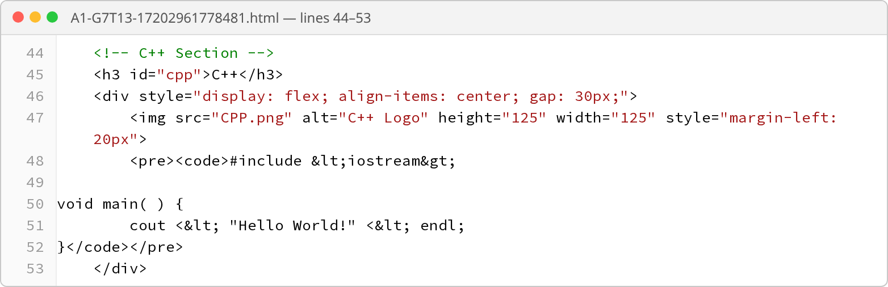
Figure 8: The C++ section
All four language sections are built in the same way, so this first one is explained in the most detail.
Code | What it means
<!-- C++ Section --> | A comment labelling this section, so we can find it easily in our code. It doesn't show on the page.
<h3 id="cpp"> | A smaller heading (size 3) showing the language name. id="cpp" gives the heading a unique name, like a name tag. This is what the #cpp link at the top looks for. Two things on the same page can't share an id.
<div> | An invisible box that groups things together. Here it holds the logo and the code, so we can arrange them as a pair.
display: flex | Normally, a picture and a block of code would sit one on top of the other. display: flex lines up everything inside the box side by side in a row, so the logo sits to the left of the code.
align-items: center | Lines up the logo and the code by their middles, so the logo sits halfway down the code instead of at the top.
gap: 30px | Puts 30 pixels of empty space between the logo and the code, so they don't touch.
<img> | Shows a picture. It has no closing tag.
src="CPP.png" | "src" (source) is the name of the picture file to show. The file sits in the same folder as our HTML file, so we only need its name.
alt="C++ Logo" | Backup text. If the picture can't load, these words show instead. Screen readers also read it out to people who can't see the screen.
height="125" width="125" | Makes the logo a 125 × 125 pixel square. We used the same size for every logo so all the sections match.
margin-left: 20px | A margin is empty space outside an element. This adds 20 pixels of space to the left of the logo, so it isn't stuck to the edge of the page.
<pre> | Normally, HTML squashes extra spaces into one and ignores the Enter key. Code needs its spaces and line breaks, so <pre> ("preformatted") shows the text exactly as typed, in a font where every letter is the same width.
<code> | Labels the text inside as computer code.
&lt; and &gt; | Special codes for the < and > symbols ("lt" = less than, "gt" = greater than). Browsers treat anything inside < > as a tag and hide it. If we typed <iostream> directly, it would disappear from the page. Writing &lt;iostream&gt; makes it show as <iostream>.
<&lt; | Shows on the page as <<. The first < can be typed normally because it isn't followed by a tag name, so the browser shows it as plain text.

What the C++ program itself does: #include <iostream> loads the tools needed to show text on the screen. main() is where the program starts running. cout << "Hello World!" << endl; shows "Hello World!" on the screen, and endl moves to the next line (like pressing Enter).
Why lines 49–52 start right at the left edge: <pre> keeps every space exactly as typed. If we had indented these lines in our HTML file like the rest of our code, that extra space would also show up on the page.

2.3 C# section (lines 57–70)
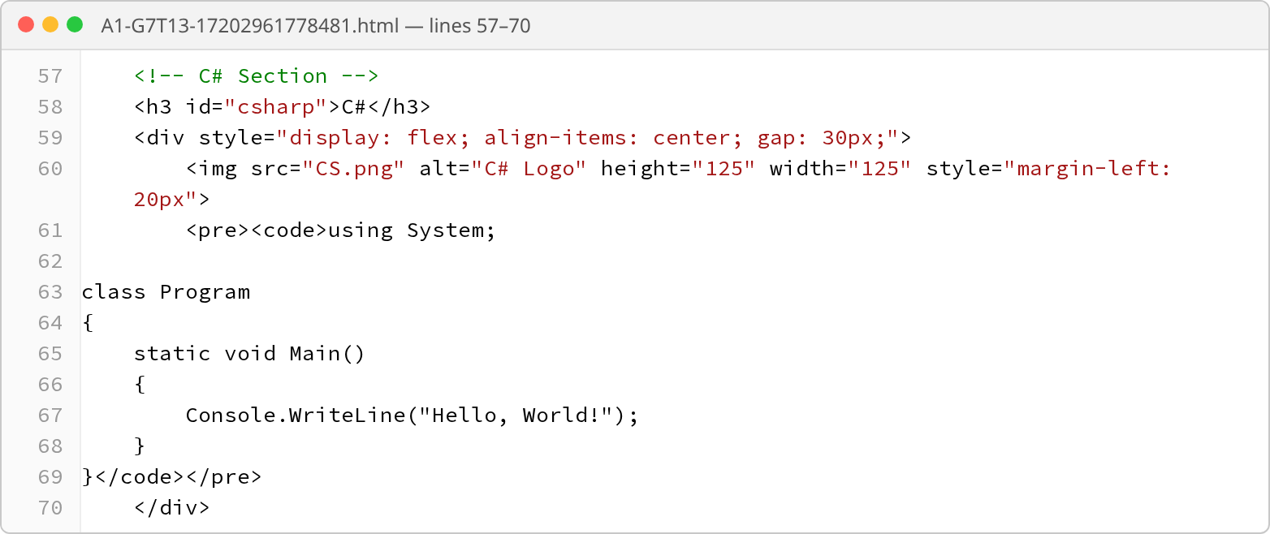
Figure 9: The C# section
This section is built exactly like the C++ one: a heading with id="csharp" (so the link at the top can find it), a flex box that puts the logo (CS.png) and the code side by side with a 30px gap, and the code inside <pre><code>. The C# code doesn't use any < or > symbols, so we didn't need the special &lt; and &gt; codes here.
Code | What it means
using System; | Lets the program use C#'s built-in tools, such as Console, which shows text on the screen.
class Program { … } | In C#, all code has to go inside a "class", which is like a folder for code. Program is the name we gave it.
static void Main() | The starting point. When the program runs, the code inside Main runs first.
Console.WriteLine("Hello, World!"); | Shows "Hello, World!" on the screen, then moves to a new line.
{ and } | Curly brackets mark where a block of code starts and ends, a bit like opening and closing tags in HTML.
Indentation | The spaces at the start of each line make the code easier to read. Because we used <pre>, these spaces are kept, so the code lines up neatly on the page too.

2.4 Python section (lines 74–87)
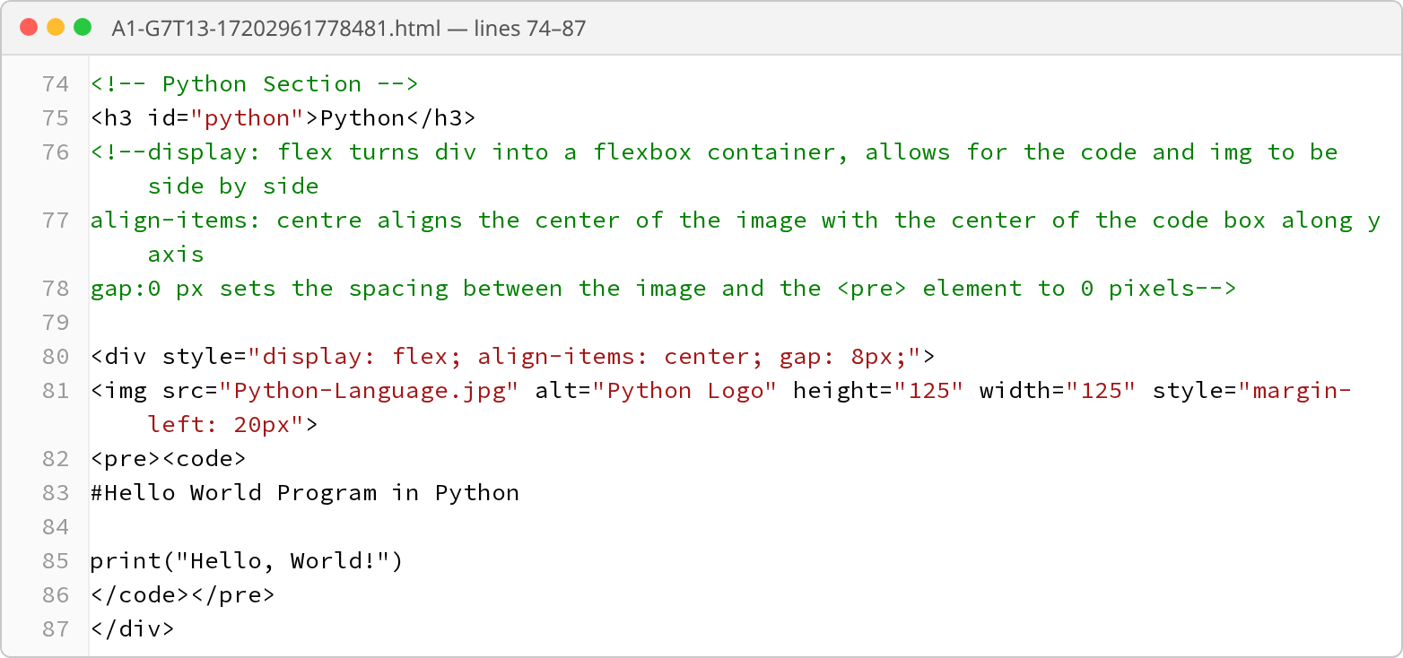
Figure 10: The Python section
Code | What it means
<!-- … --> (lines 76–78) | Comments where we wrote notes explaining how the flex box layout works. The browser ignores them.
gap: 8px | A smaller gap (8 pixels) than the other sections (30 pixels). The Python code lines already start with some spaces (lines 83–85), which adds extra room, so a big gap wasn't needed.
src="Python-Language.jpg" | This logo is a .jpg file, while the others are .png files. Both are common picture types, and <img> can show either one.
<pre><code> on its own line | Here the code starts on the line after <code>, and the closing tags are on their own line too. Because <pre> keeps every line break, this adds an empty line above and below the code.
#Hello World Program in Python | In Python, a line starting with # is a comment: a note for people reading the code. Python skips it when the program runs (just like <!-- --> in HTML).
print("Hello, World!") | print is Python's built-in command for showing text. This line shows "Hello, World!" on the screen. Python is famous for being short and simple, and this whole program is just one line.

2.5 HTML section (lines 91–104)
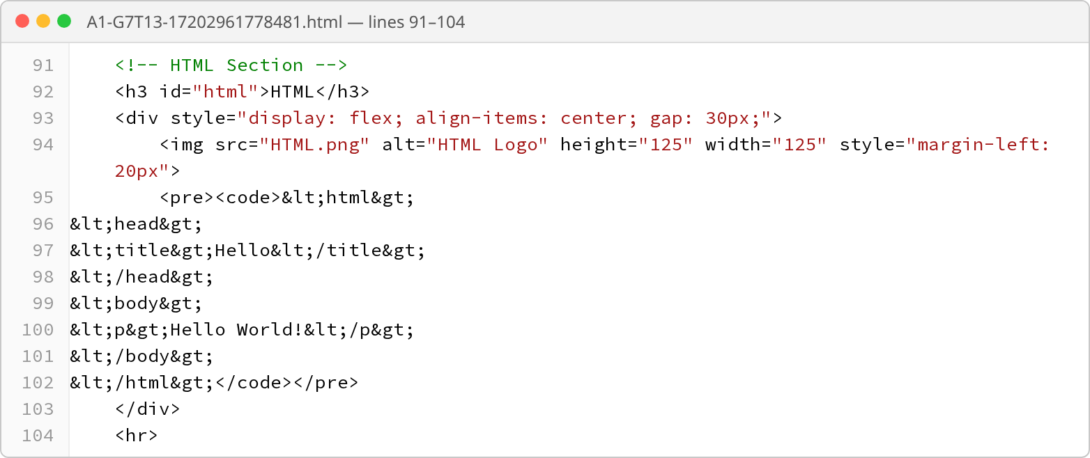
Figure 11: The HTML section
This section was the trickiest, because the code we want to show is HTML, the same language our page is written in. If we typed <p>Hello World!</p> directly, the browser would follow it as an instruction and make a real paragraph, instead of showing the code itself. To stop this, we replaced every < with &lt; and every > with &gt;. The browser then shows the symbols instead of following them:
Code | What it means
&lt;html&gt; | Shows on the page as <html>, the tag that wraps the whole example page.
&lt;head&gt; … &lt;/head&gt; | Shows as <head>…</head>, the "behind the scenes" section of the example page.
&lt;title&gt;Hello&lt;/title&gt; | Shows as <title>Hello</title>. On a real page, this would put the word "Hello" on the browser tab.
&lt;body&gt; … &lt;/body&gt; | Shows as <body>…</body>, the visible part of the example page.
&lt;p&gt;Hello World!&lt;/p&gt; | Shows as <p>Hello World!</p>. On a real page, this would display a paragraph saying "Hello World!".
</div> and <hr> | </div> closes the box holding the logo and code. <hr> draws a line to finish Part 2.

Part 3: University policies and services
Part 3 gives information about four university policies and services. Each one has a heading, a short paragraph that is pushed in slightly from the left, and a link to the UOW website that opens in a new tab. The Student Support Advisers section also has a small table with the advisers' contact details.
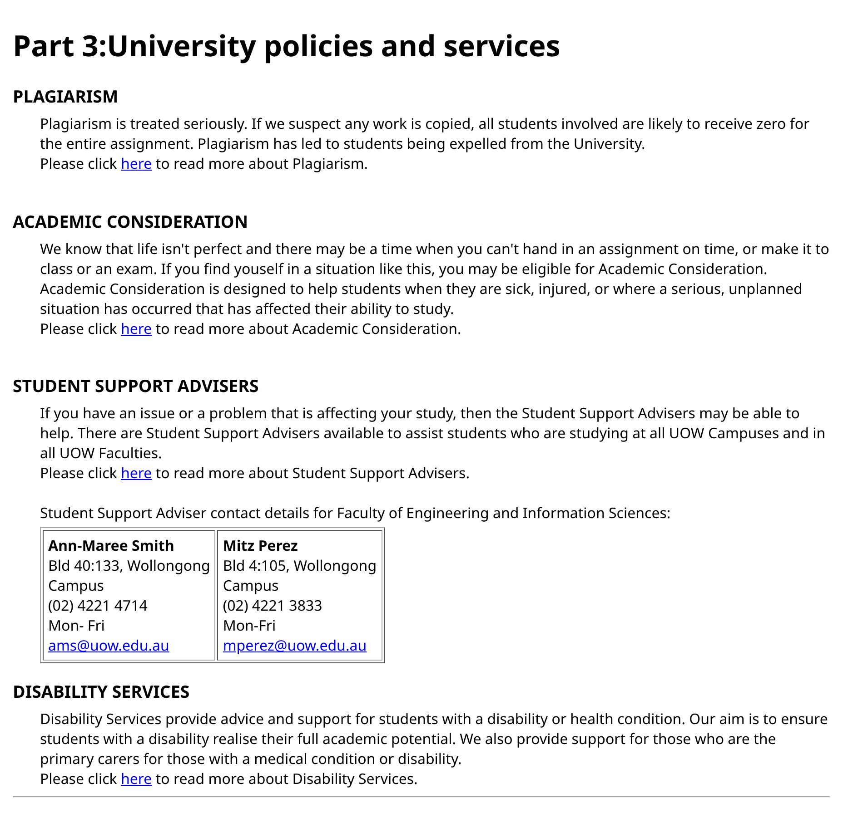
Figure 12: Part 3 as it appears in the browser

3.1 The Part 3 heading and Plagiarism (lines 105–117)
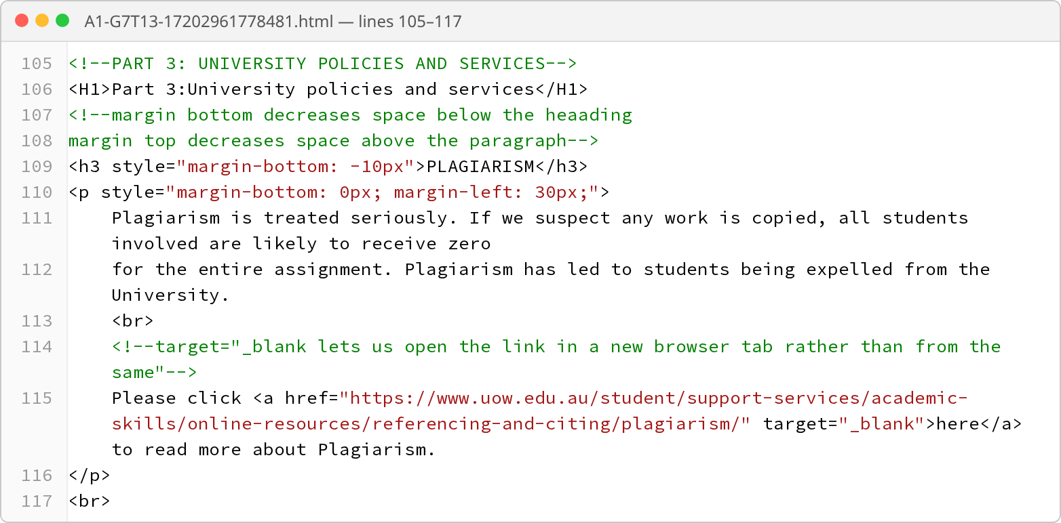
Figure 13: Part 3 heading and the Plagiarism section
Code | What it means
<H1> | The main heading for Part 3. We wrote it in capital letters, but HTML doesn't care about capitals in tag names, so <H1> works exactly the same as <h1>.
<!-- … --> (lines 107–108) | Our notes explaining the spacing settings used below.
<h3>PLAGIARISM</h3> | A smaller heading for this topic.
margin-bottom: -10px | Headings normally leave a gap of empty space underneath them. A minus number shrinks that gap: here it pulls the paragraph 10 pixels closer to the heading, so the heading and paragraph look like they belong together.
<p> | Starts a paragraph, which holds the main text.
margin-left: 30px | Pushes the paragraph 30 pixels in from the left, like an indent. It sits slightly to the right of its heading, which makes it clear the text belongs under that heading.
margin-bottom: 0px | Removes the gap the browser would normally leave below a paragraph.
Text split over lines 111–112 | In our code, the paragraph is split over two lines just to keep it easy to read. The browser ignores where we pressed Enter: it joins the text back together and fits it to the width of the window.
<br> | A line break (like pressing Enter). It makes "Please click here…" start on a new line.
<a href="…">here</a> | A link to the UOW plagiarism page. The web address goes inside href, and the word "here" is what the user sees and clicks (shown blue and underlined).
target="_blank" | Opens the link in a new browser tab instead of replacing our page. That way, the user can read the UOW page and still have our page open.
<br> after </p> | Adds an empty line of space before the next section.

3.2 Academic Consideration (lines 118–128)
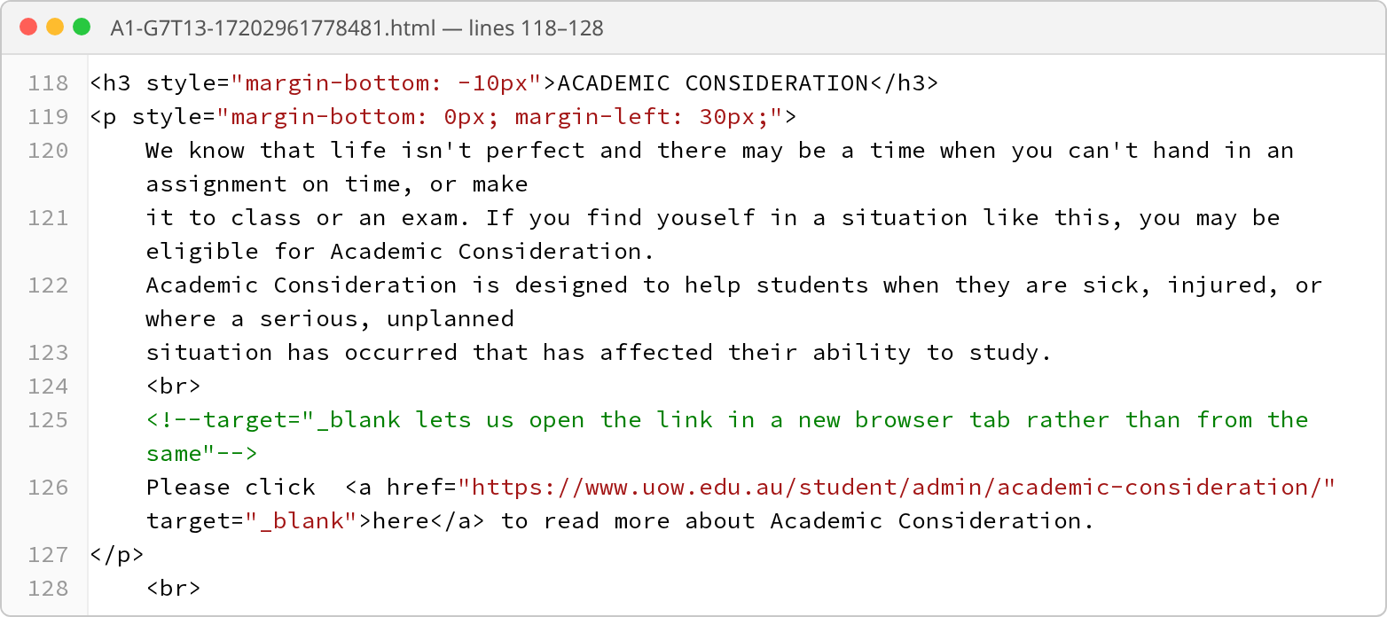
Figure 14: The Academic Consideration section
This section uses exactly the same pattern as Plagiarism: an <h3> heading pulled close to its paragraph with margin-bottom: -10px, a paragraph indented by 30 pixels, a <br> to start a new line, and a link that opens in a new tab with target="_blank". A couple of small things to point out:
- There are two spaces after "Please click" in our code. This doesn't show on the page, because the browser turns several spaces in a row into just one.
- The <br> on line 128 is indented further than the others. This doesn't change anything on the page either. Indenting in HTML only makes the code tidier (or messier) to read.

3.3 Student Support Advisers (lines 129–139)
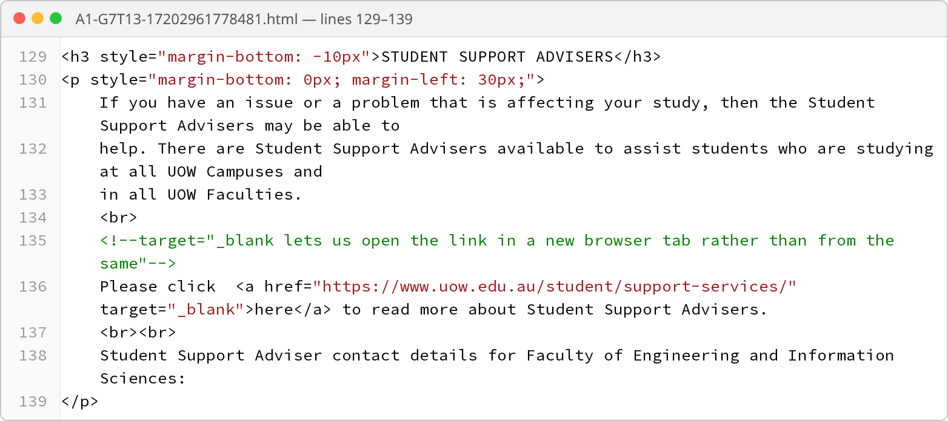
Figure 15: The Student Support Advisers section
This is the same heading, paragraph and link pattern again, with one new thing:
Code | What it means
<br><br> | Two line breaks in a row, like pressing Enter twice. The first one moves to a new line and the second one leaves a blank line. This creates a gap before the next sentence.
"Student Support Adviser contact details…" | This last sentence introduces the contact table, which comes straight after the paragraph.

3.4 The contact table (lines 140–165)
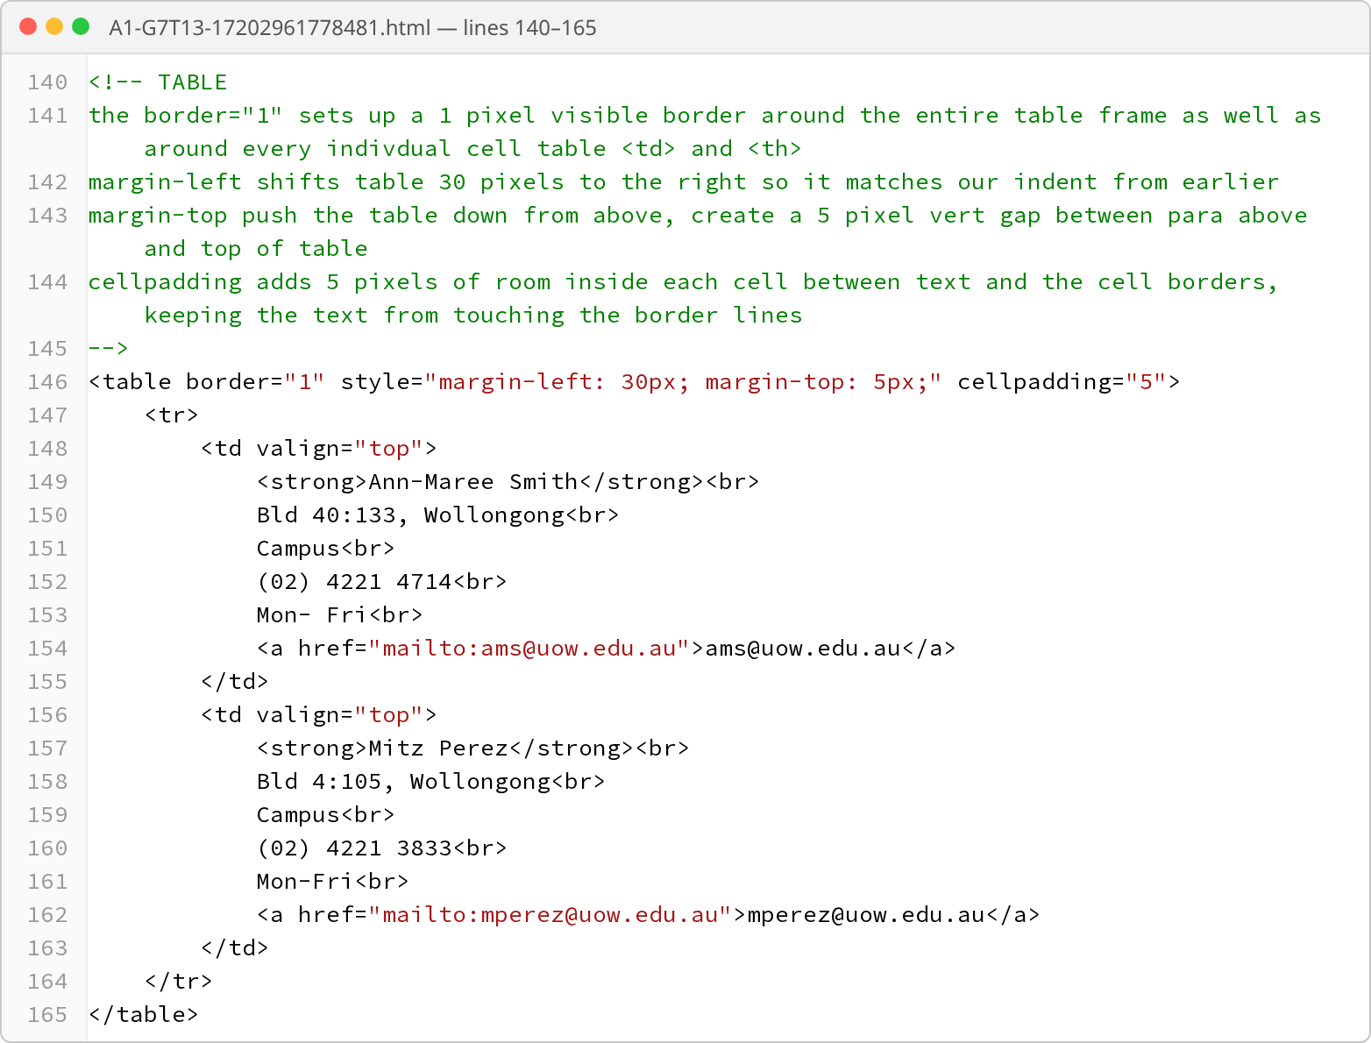
Figure 16: The Student Support Adviser contact table
Code | What it means
<!-- TABLE … --> | A comment that spans several lines, with our notes on what each table setting does.
border="1" | Draws 1-pixel lines around the table and each box, the same as in Part 1.
margin-left: 30px | Pushes the table 30 pixels in from the left, so it lines up with the indented paragraphs above it.
margin-top: 5px | Adds a small 5-pixel gap above the table, so it doesn't touch the sentence above.
cellpadding="5" | Adds 5 pixels of space inside each box, so the text doesn't touch the lines.
One <tr> with two <td> | The table has only one row with two boxes in it. This puts the two advisers next to each other, like two business cards side by side.
valign="top" | "Vertical align: top" makes the text start at the top of each box. Without it, if one box had less text, that text would sit in the middle of the box and the two cards wouldn't line up.
<strong> | Makes the text bold. We used it for each adviser's name so it stands out as the most important line.
<br> after each line | Puts the building, campus, phone number and working days on separate lines, like an address on an envelope.
<a href="mailto:…"> | A special kind of link for email addresses. Clicking it opens the user's email app with a new email already addressed to that adviser, so they don't have to copy the address.

3.5 Disability Services (lines 166–175)
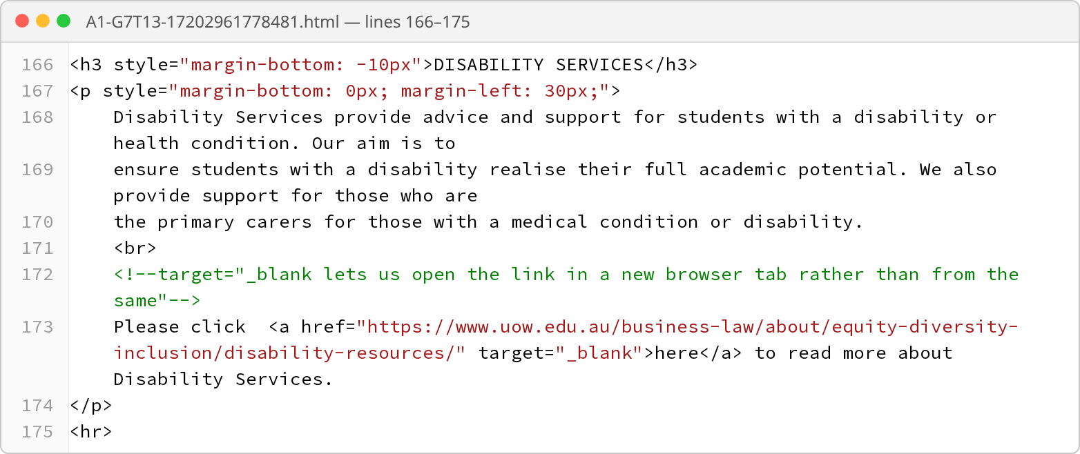
Figure 17: The Disability Services section
The last section follows the same pattern as the other three: an <h3> heading with margin-bottom: -10px to keep it close to its text, a paragraph indented by 30 pixels, a <br> to start a new line, and a link that opens in a new tab with target="_blank". The <hr> at the very end draws a line to finish Part 3.
Why we repeated the same pattern for every section: using the same heading, spacing and link style for all four sections makes the page look neat and consistent, and makes it easy for the reader to find information. It also made our code easier to write, because once one section worked, we could copy its structure for the others.

