**GROUP 15: CARPIO & DELA FUENTE**

**MACHINE PROBLEM 1**

**MATLAB**

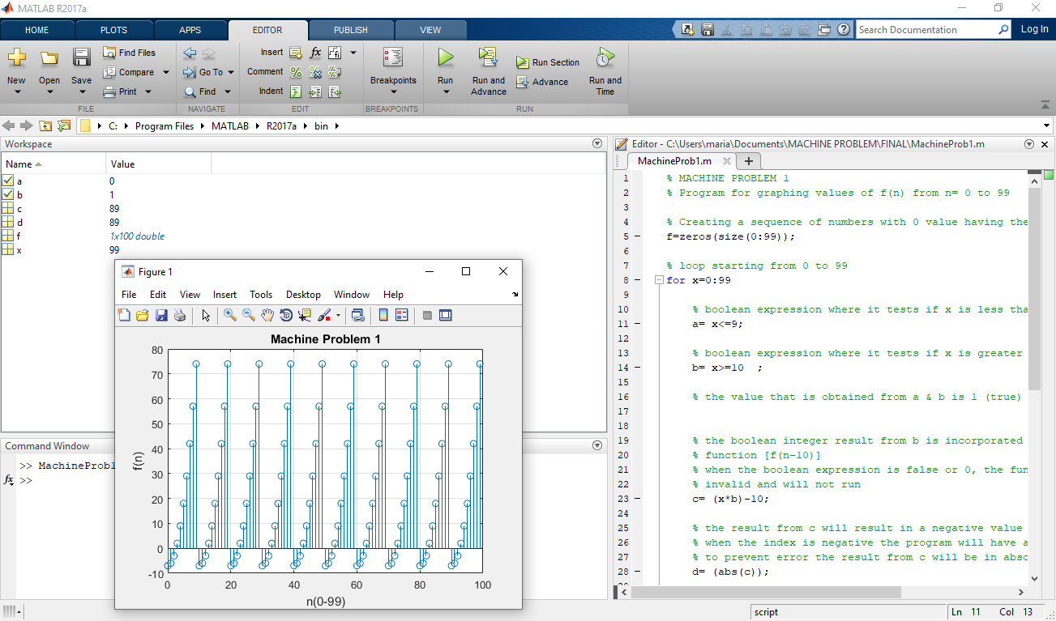

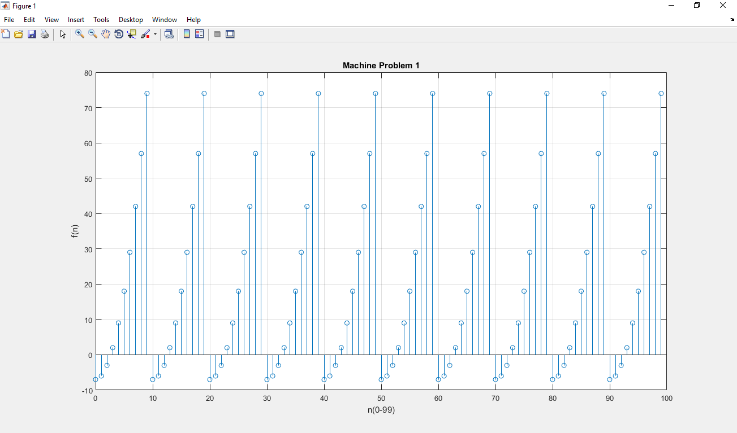

**DESCRIPTION AND COMMENTS ON THE GRAPH F(N):**

As you can see, the plot is a repeated cycle starting from -7, -6, -3, 2, 9, 18, 29, 42, 57, 74, it is because when x is equals to 0 until 9, f(n)= (n^2)-7. But when x is greater than or equal to 10, f(n) = f(n-10), which means that the corresponding y-component of a certain x-component (when x≥10) will be somewhere between the y values from when x is 0 to 9. When x is equal to 10, the first condition is not satisfied where x≤9, so the second condition will be used, f(n)= f(n-10), x is equal to n, and n-10= 0. f(0) is the y-component of the first x-component, the 0 in f(0), pertains to the index. So even though there are billions of numbers in the list for the x-values, with the conditions [(n^2)-7, x≤9; f (n-10), x≥10], the y-values will remain the same and repeated because the other x-values are just borrowing the y-values of the x-values 10 steps away from them.