**GROUP 15: CARPIO & DELA FUENTE**

**MACHINE PROBLEM 2**

**SAMPLE POINTS AND THE CORRESPONDING CENTER (X,Y), RADIUS AND DEF**

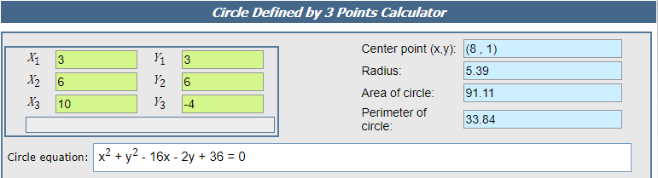

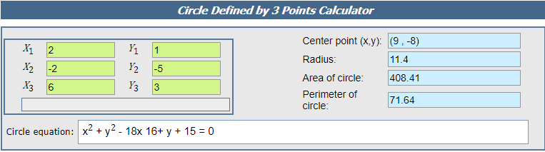

**MATLAB**

