**GROUP 15: CARPIO & DELA FUENTE**

**MACHINE PROBLEM 4**

**PYTHON**

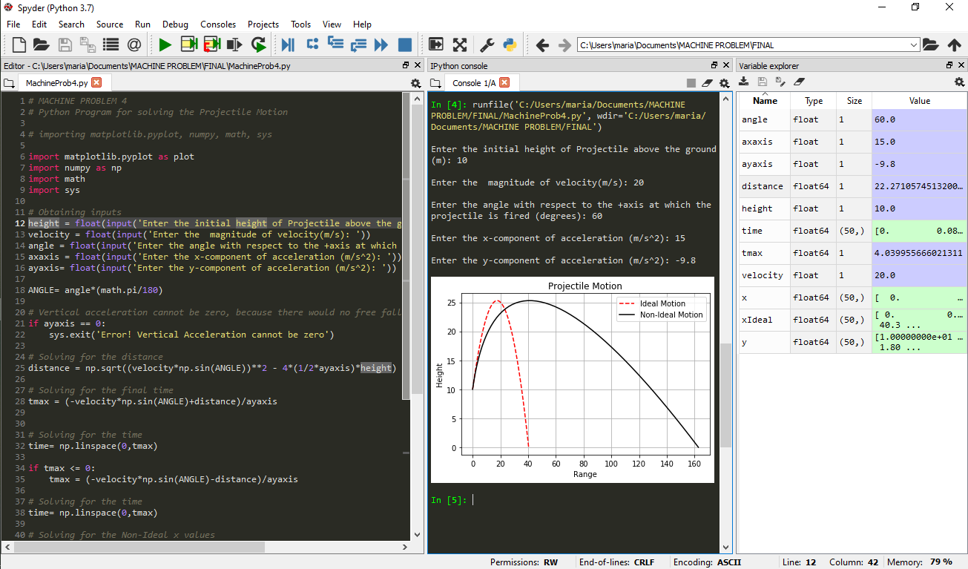



**PYTHON WITH ERROR**



