Git & GitHub Fundamentals

Student Information
Name | Muhammad Noman Shakir
Roll Number | SP26-BSAI-0007
Program / Semester | BSAI/1st Semester
Repository URL | https://github.com/mrnomanshakir0-afk/auhcollections
Submission Date | 26 June 2026

1. Screenshot of GitHub Account Profile

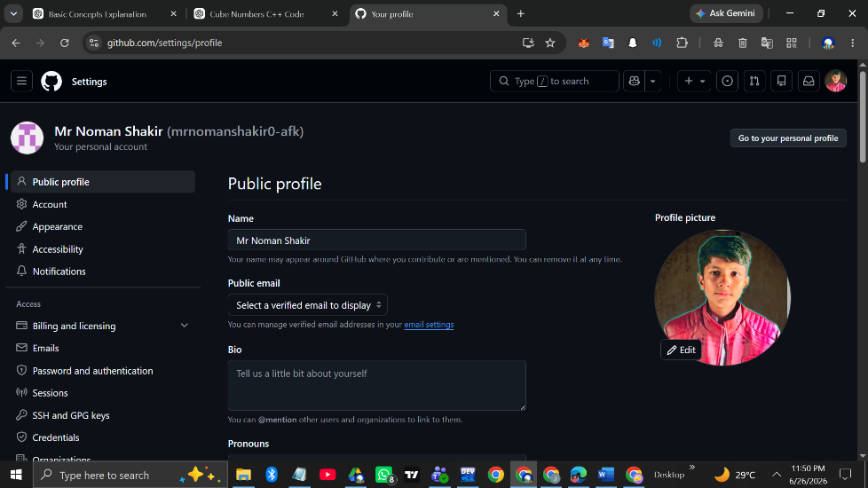

GitHub Username: mrnomanshakir0-afk
Profile URL: https://github.com/mrnomanshakir0-afk

2. Screenshot of Created Repository

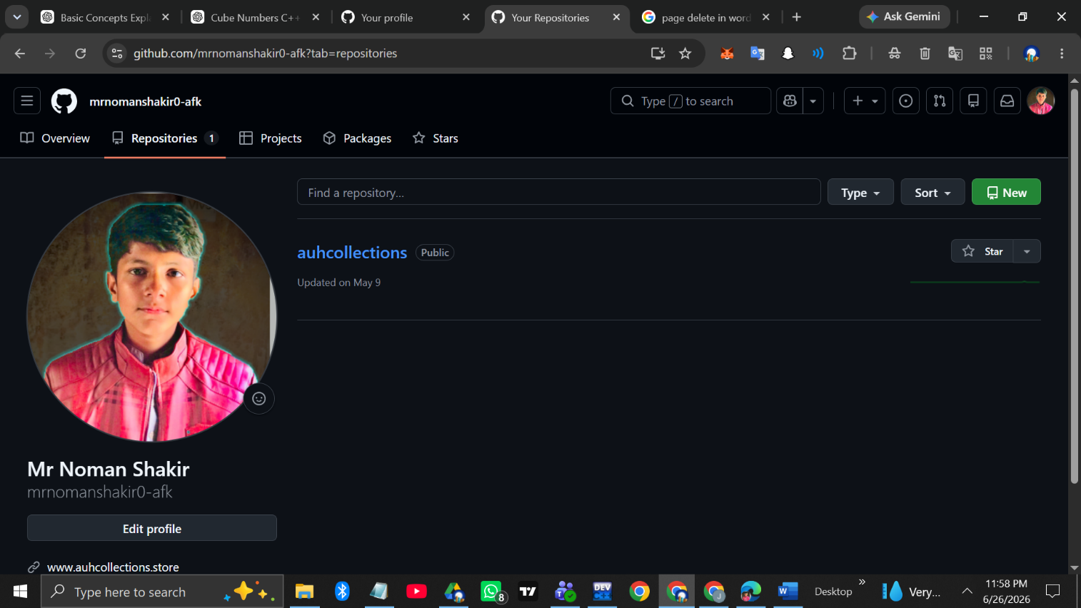

Repository Name: auhcollections
Visibility: Public
Repository URL: GitHub Repository

3. Screenshot of README.md Content

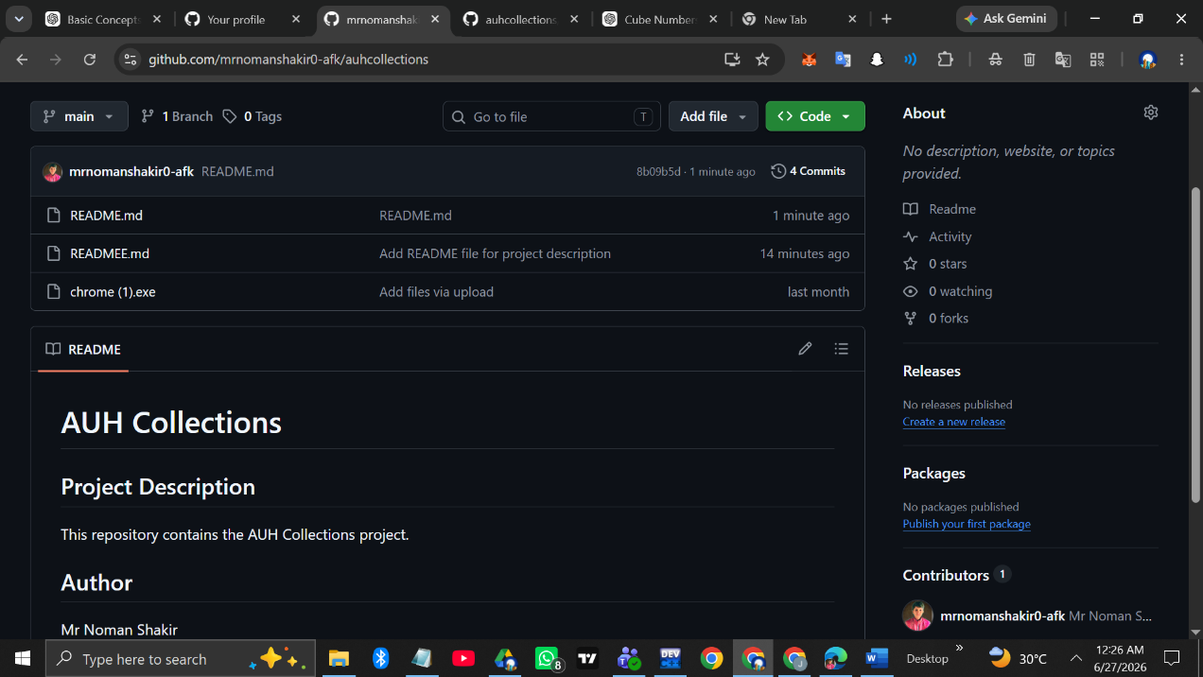

4. Screenshot Showing All Commits

Instructions: Paste a screenshot of the commits history page showing at least 3 meaningful commits.

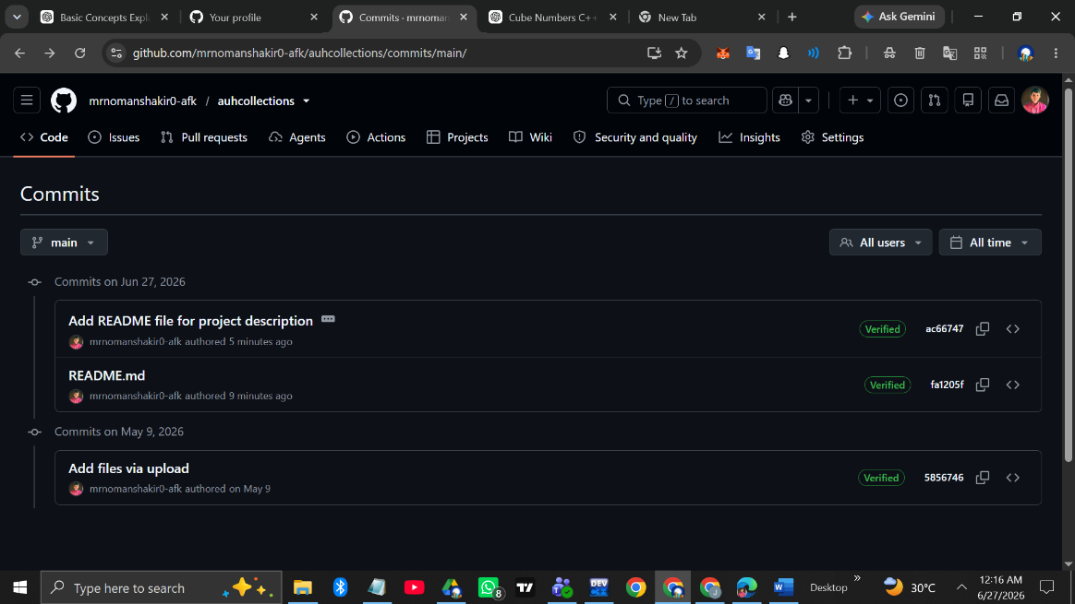

Commit Summary:
# | Commit Message | Date / Description
1 | Initial commit — Created README.md | 27 june 2026
2 | Updated README with personal info | 27 june 2026

5. Screenshot of Uploaded Additional File

Instructions: Paste a screenshot showing the uploaded Word document (.docx) visible in the repository file list.

File Name: [YourRollNo_YourName_GitHubAssignment.docx]
File Type: Microsoft Word Document (.docx)

6. Repository URL

Repository URL:
https://github.com/mrnomanshakir0-afk/auhcollections

7. Reflection

What did you learn from this assignment?

Through this assignment, I learned the fundamentals of version control using Git and GitHub. I understood how to:
- Create and manage a public GitHub repository.
- Write a structured README.md file using Markdown syntax.
- Make meaningful commits with descriptive messages to track changes.
- Upload files directly to a GitHub repository.
- Understand the importance of version control in software development.
[Add your own personal reflection here — what was easy, what was challenging, and how you plan to use GitHub in the future.]

8. Marks Distribution

Criterion | Max Marks | Obtained
GitHub Account & Repository Creation | 2 | ___
README.md Content | 2 | ___
Meaningful Commits (3+) | 2 | ___
Additional File Upload | 1 | ___
Screenshots & Documentation | 2 | ___
Reflection & Presentation | 1 | ___
TOTAL | 10 | / 10

Declaration: I confirm that all the work submitted in this assignment is my own and has been completed following the assignment guidelines.

