MPC-MAP Week 3 - Motion control

Author: Alikhan Nurkhat (242251)

Date: 05.04.2026

Task 1
By analyzing the provided examples in the maps folder, the following parameters were identified:
- Target coordinates (x, y)
- Rectangular bounding box of the simulation environment (x1, y1, x2, y2)
- Wall definitions (x_start, y_start, x_end, y_end)
- GNSS logic
  - Inf indicates a GNSS-denied (indoor/hangar) region
  - any non-zero numerical value represents a zone with active GNSS coverage
- GNSS-denied region borders
  - Defined as a polygonal area determined by a sequence of n vertex coordinates.

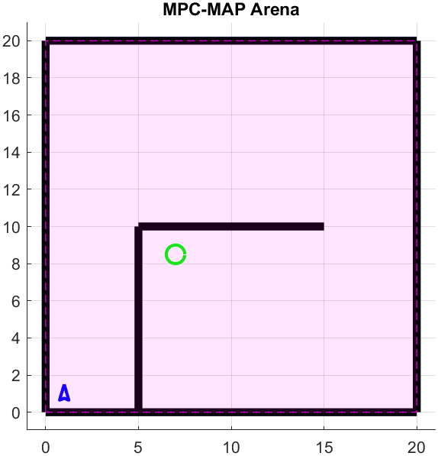
Fig. 1: Custom map

Task 2

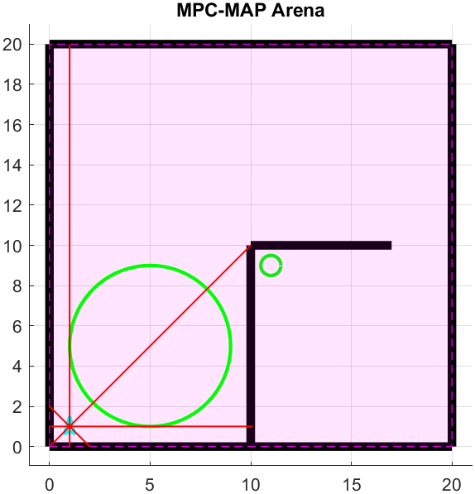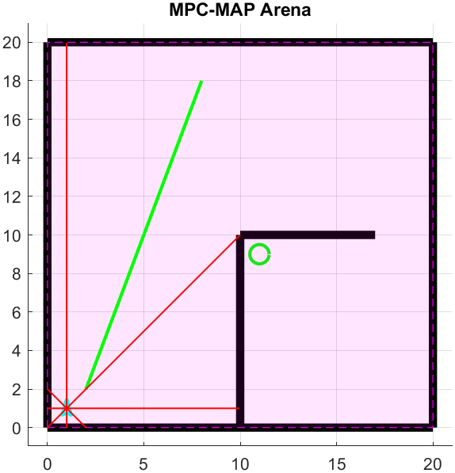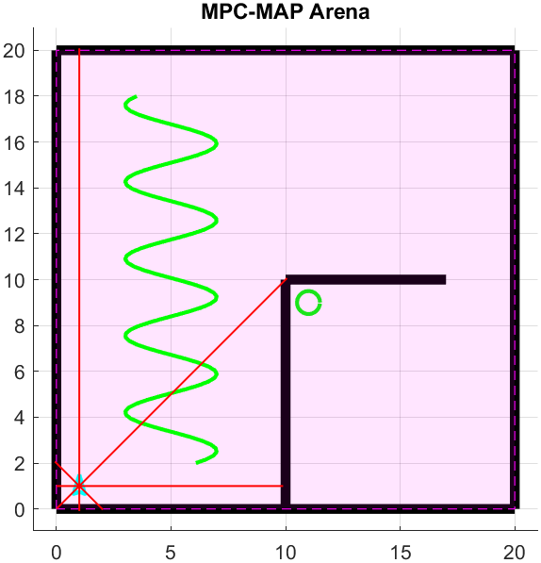
Fig. 2: a) Circular b) Straight c) Sine wave path

Task 3

The motion control is implemented using the Pure Pursuit algorithm within the plan_motion function to ensure reliable trajectory tracking for the differential drive robot. All critical control parameters, including the look-ahead distance and speed limits, are centralized and initialized in the student_workspace.m file starting at line 125. These values have been fine-tuned to provide an optimal balance between path-following precision and system stability across all test scenarios. Detailed comments are included within the source code to explain the physical meaning of each parameter and its specific impact on the robot's motion behavior.
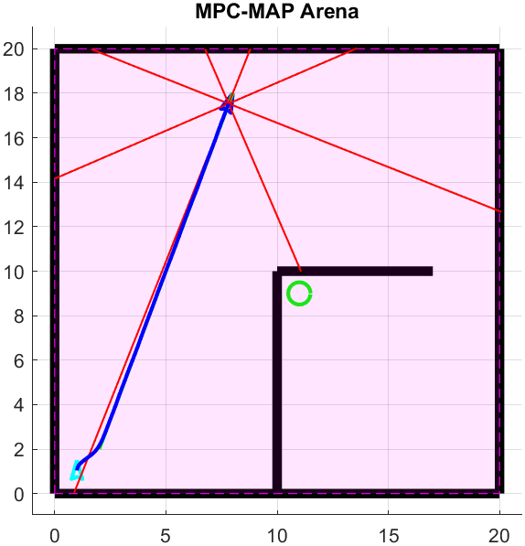
Fig 3: Pure Pursuit algorithm result

