MPC-MAP Assignment No. 2 - Uncertainty

Author: Alikhan Nurkhat (242251)

Date: 30.03.2026

Task 2
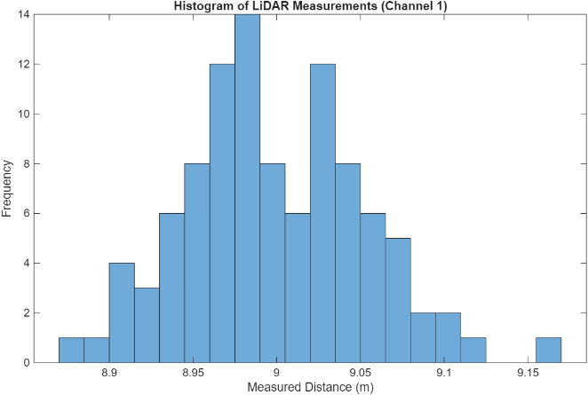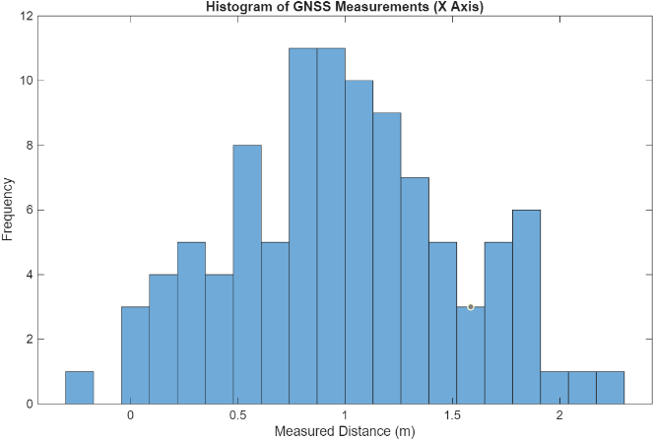

Сollected data shows that the standard deviations are stable and consistent, remaining nearly identical across all 8 LiDAR channels and both GNSS axes. The plotted histograms visually confirm that the measurement noise for both sensors follows a normal distribution.

Task 3
Сovariance matrices were computed, resulting in the expected 8x8 matrix for the LiDAR and a 2x2 matrix for the GNSS. The main diagonal values of both matrices equal the variance, matching the squared standard deviations for each channel.

Task 4
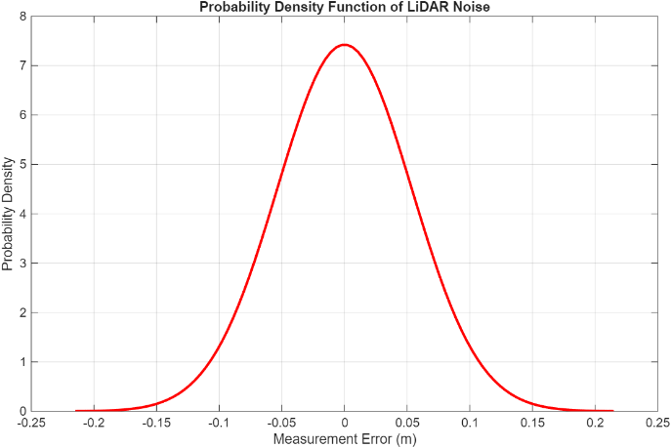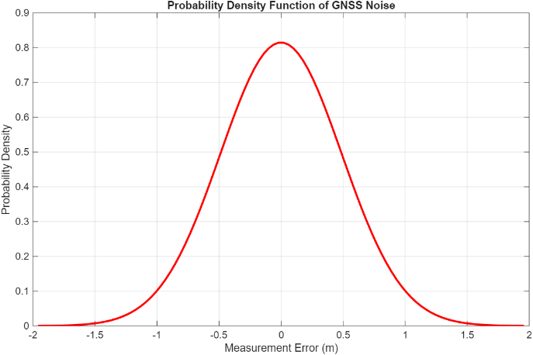
This visually confirms that LiDAR has a much lower standard deviation, making it a far more accurate sensor.

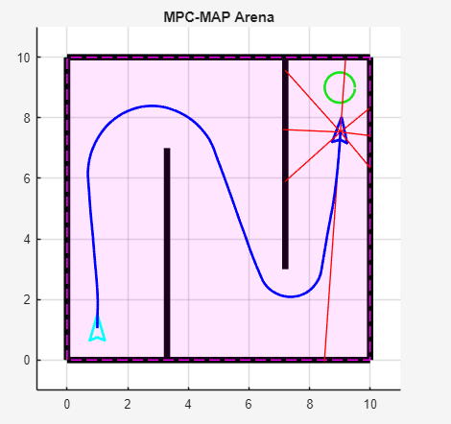
Task 5
Task demonstrates how motion uncertainties primarily caused by wheel slippage, mechanical imperfections, and actuator inaccuracies accumulate over time and cause the robot to drift.

