Technical Appendix
An AI-Enhanced Workflow for Verifiable Social Science

A1. Contents of this appendix and the research artifact
This appendix gives the status of each part of the workflow and offline commands that run the prototype. It explains how each part works, with the module contracts of the reproducible pipeline and the four verification procedures. It also covers the Stage 1 and Stage 2 development plan, the live judgment runs, privacy and security, and how AI was used to build the prototype and to draft this appendix.
The research artifact is one Git repository, [REPOSITORY NAME] at [REPOSITORY URL], tag [COMMIT OR TAG]. With it a reader can build a research product from plain text, run the four verification procedures on the test files that come with them, and run the tests and commands in A4.

A2. The system
This section describes the workflow as designed, how its parts interact, and which parts the prototype has built.
Each layer’s section ends with a table of the status of its parts, with the gaps and open questions that belong to that section and the Stage 2 item that covers each part, if any. Each part’s status uses four words from the proposal’s status section. “Built and tested” means code exists and a test exercises it. “Built” means code exists and no test exercises it. “Specified” means a design document describes it and no code exists, which is what the proposal calls designed but not yet built. “Planned” means it is named only as future work. The tables add four more. “Outside the artifact” marks software the research artifact does not include, “Open” marks a question the specification leaves undecided, “Not designed” marks a gap no document addresses yet, and “By hand” marks a step the scholar or an AI session does because no code does it yet.

A2.1 How the parts connect
Figure A1 presents the proposed AI enhanced system using layers to represent the multi-layer architecture.
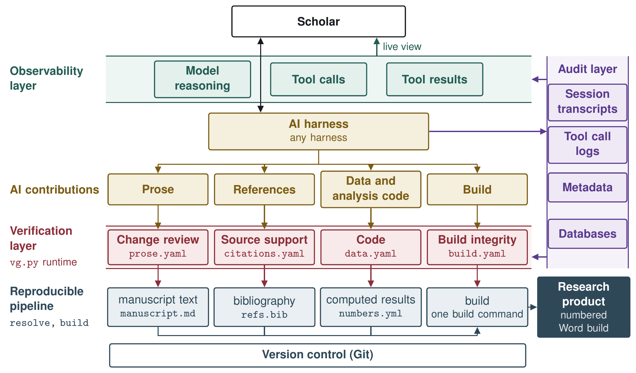
Figure A1. System Workflow Diagram
The workflow is designed as a multi-level architecture presented as layers.
- Scholar and External Software (A2.2). Every scholar has preferred software, including an AI harness, an AI model, statistical software, a reference manager, a text editor, and a tech stack. The scholar’s external software reaches the workflow through wrappers, Model Context Protocol (MCP) servers, and adapters.
- Reproducible pipeline (A2.3). A pipeline of documents and programs that build each research product from plain-text files.
- Audit layer (A2.4). The audit layer captures, records, stores, and tags every AI session transcript and tool call. In addition, the audit layer also contains the databases including the knowledge base where the procedural graphs are kept.
- Verification layer (A2.5). The verification layer is a series of programs and sequential steps that identify AI contributions in four streams, check them, and write reports for each stream. The scholar approves or holds each item, and the decisions go to the reproducible pipeline.
- Observability layer (A2.6). The observability layer lets the scholar watch AI work as it happens, including the work of subagents, AI programs outside the harness, and the knowledge base entries the AI reads.

A2.2 Scholar: External Software
The proposal’s Figure 2 draws the workflow as components, with the scholar, the AI model, and external software as inputs and the research product as output. The workflow does not replace the scholar’s tools. It reaches the AI harness, the AI model, and the scholar’s external software through three kinds of connectors: wrappers, MCP servers, and adapters.
Figure A2 shows the connections. Event adapters and wrappers turn what happens in the harness and in the scholar’s software into events in a schema that fits the databases in the audit layer (A2.4). File adapters turn a tool’s files into the fixed fields to be used in the verification layer (A2.5). MCP servers allow the harness and model to connect to tools, programs, and databases outside the system. The connectors sit outside any single project, so one setup serves every project a scholar runs.
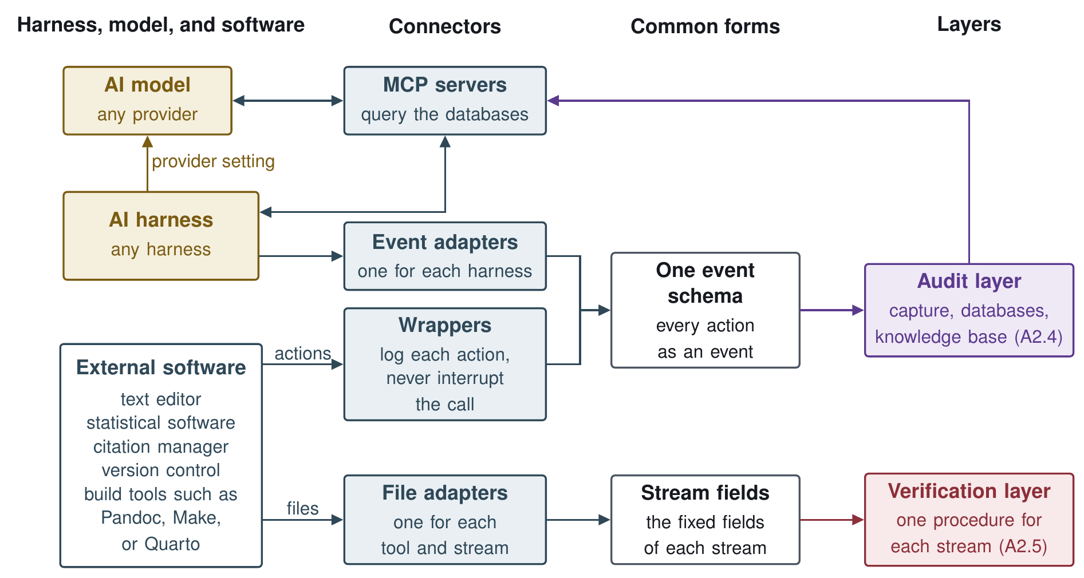
Figure A2. Workflow Connections
The workflow reaches the various external software programs through three kinds of connectors.
- External Components:
  - AI harness. The software that runs a model and connects it to tools and files, and so the scholar’s point of contact with AI. Any harness can fill this slot. Triggers that start a verification procedure are designed for one harness’s hooks, and AI work in another harness is caught at build time.
  - AI model. The model the harness runs and the judgment steps call. A provider setting, a base URL and a model name, makes the model swappable.
  - External Software. The scholar’s own editor, statistical software, citation manager, version control, and build tools such as Pandoc, Make, or Quarto.
- Connectors:
  - Wrappers. Small programs that log each action in the scholar’s external software for the audit layer.
  - MCP servers. Servers that expose the databases to the harness and the model through the Model Context Protocol, and MCP tools that bring events in from software outside the workflow.
  - Adapters. Small programs that translate a tool’s files or actions into the forms the workflow reads, such as a Word document with tracked changes into the fields the prose procedure checks.

Status
Table A1. Status of the scholar’s external software and the connectors
Part | Status | Note
Provider setting | Specified
Wrappers that log actions in external software | Specified
MCP servers for the databases | Specified | A knowledge base server runs outside the artifact

A2.3 The reproducible pipeline
The reproducible pipeline assembles research products through a build script (Healy 2020). It builds each research product from plain-text files. Figure A3 shows the pipeline. Two programs carry out the build, resolve fills in the computed results and build builds and numbers the research product. A separate command assembles the replication folder.
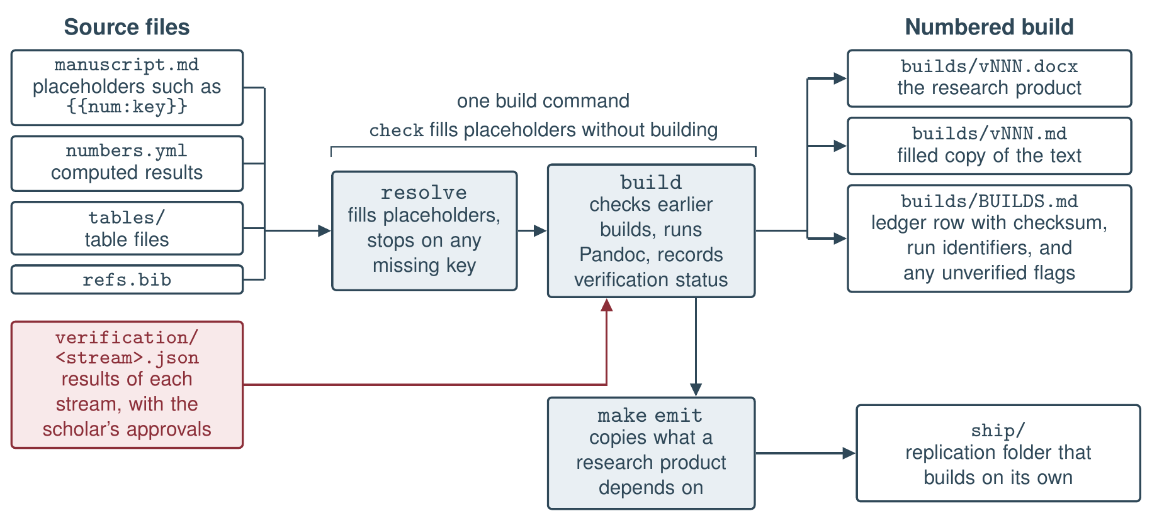
Figure A3. How the reproducible pipeline builds a research product and its replication folder.
The pipeline does five things to keep a research product reproducible.
- Computed results in the text. A computed result enters the text through a placeholder such as {{num:key}}, which the build fills from the manifest. Resolve fills the placeholders and stops any build with an unfilled one, listing every missing key. A manifest emitter writes the manifest from the analysis outputs.
- Numbered builds. Each build receives the next version number, a copy of its text with every placeholder filled, and a row in the ledger, a table that records each build’s checksum. A checksum is a short code computed from a file’s contents, which changes if even one character of the file changes. Before each new build, the build program recomputes the checksum of every earlier build and refuses to build while any of them differs from its ledger row or is missing.
- Verification status. The build reads the latest results file of each verification stream and runs no check itself (A2.5). A stream with out-of-date results, or with work the scholar has not approved, does not stop the build. Instead, the build flags the research product as unverified for that stream.
- Project layout. Each research product has one source file, and the project’s build file names it, so it is always clear which draft is current. An older draft that could be mistaken for the current one is marked as archived.
- Replication folder. A separate command copies the source text, data, code, and build settings a research product needs into one folder, so that another researcher can rebuild the product from that folder alone.
Each pipeline program has a module contract, a short file that states what it takes in, what it returns, and which of its promises are frozen. Its code can change, but a frozen promise must not change without a change to the contract.

Status
Table A2. Status of the parts of the reproducible pipeline
Part | Status | Note
The four pipeline modules and the command line | Built and tested | 46 tests
Slide builds (reveal.js) | Built and tested | 6 of the 46 tests above
Separating ospipe so that it holds only the pipeline’s modules | Planned | The five modules placed in other layers are built and tested, with 71 tests
Reading each stream’s results file and marking a build unverified | Specified | Needs a change to the ledger’s frozen columns
Manifest emitter | Planned | Built for one paper outside the artifact
Project map and archive lines | Specified | The build procedure checks a map and archive lines in its test project
Notes templates (templates/notes/) | Built | Template files, and nothing installs them yet
Replication folder with fixed-date builds (make emit) | Specified
Citation evidence file and the list of unverified claims | Planned

A2.4 The audit layer
The audit layer records, stores, and tags every AI session transcript and tool call, and holds the system’s databases. The proposal grounds the audit layer in a documented chain from each element of a research product to the inputs, sources, scripts, and sessions that produced it.
Figure A4 shows the layer. Capture sweeps each harness’s session files and the wrappers’ events (A2.2), keeps each transcript unchanged, and tags what it finds in two passes before writing it to the databases. The audit layer feeds the observability layer as records are written and the verification layer after the fact, the harness reaches the knowledge base through a knowledge base server, and a project’s records are written out as files for the pipeline and its replication folder. Privacy and retention of these records are discussed in A6.
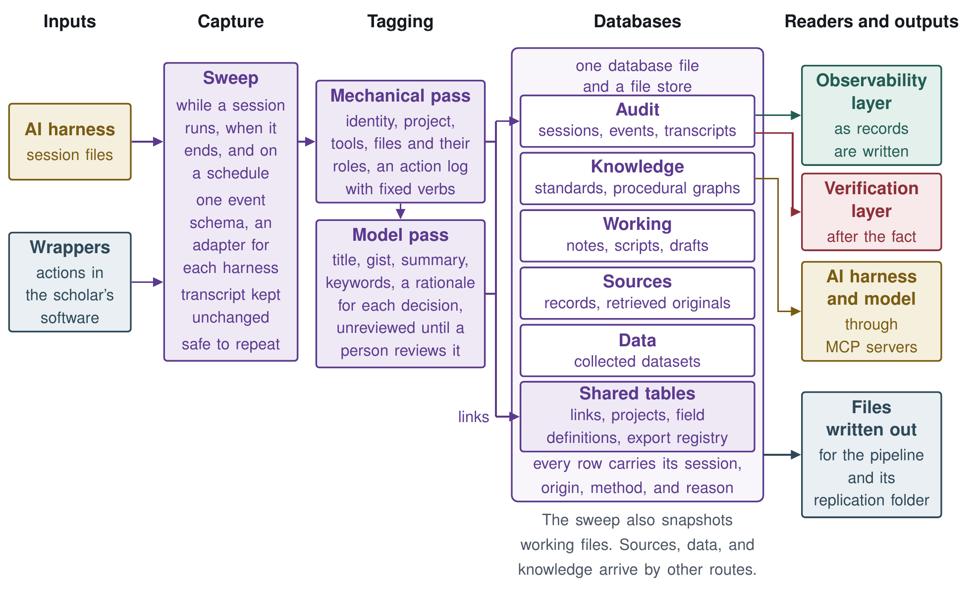
Figure A4. How the audit layer captures, tags, and stores each AI session, and what reads its databases.
The rest of this section covers the databases and schema, the knowledge base, capture, and metadata tagging.

Databases and schema
Table A3 summarizes the schema. One database holds five stores, and a file store beside it keeps each file once, however many times it is used.
Table A3. The stores of the database and the tables they share
Store | What it holds | Main fields
Audit | Each AI session, the work done in it, and its full transcript | Sessions with their identity, times, and a derived title, gist, summary, and keywords, each stamped with the pass that produced it. Events with an ordinal, a verb, a kind (action, decision, observation, or blocker), an object, and a rationale. Transcripts kept whole in the file store
Knowledge | Standards, guidelines, and procedural graphs | A sketch only, with an entry class, title, gist, keywords, content, and a checksum of the source material, and a history table that keeps every prior version
Sources | Each cited source and its retrieved original | Bibliographic metadata, an identifier block (DOI, OpenAlex, and Semantic Scholar), retrieval status, a content fingerprint, the retrieved original with its retrieval method and date, and extracted text by kind with its conversion method
Data | Collected data, held as data rather than as pointers to files | One typed table per dataset, written once, with a catalog row (name, version, row count, checksum, and collection date) and one codebook row per variable
Working | Snapshots of notes, scripts, and drafts | The workspace-relative path and kind of each snapshot
Shared tables | Relations, projects, field definitions, and file forms | A links table for every relation (membership, production, citation, and supersession), with a citation’s quote, location, and who settled it on its link. A row for each project. Each field’s definition, generation rule, and null behavior. An export registry giving each element type’s file form and path
Audit records and datasets are never overwritten, and a correction is added as a new record that supersedes the old one.

Knowledge base
The knowledge base holds standards as entry files and also holds the procedural graphs that encode methods and verification procedures. The harness and the model reach it through a knowledge base server, and the knowledge store of Table A3 stores its entries so they can be searched. The entries are created, managed, and served as follows:
- Creating entries. Each entry is one markdown file whose heading fixes its identifier, title, source, source version, date, and group, and whose body gives a short answer first, then the facts, then related entries.
- Managing entries. A history table keeps every prior version, and the checksum of an entry’s source shows when the source has changed since the entry was written.
- Serving entries. A read-only knowledge base server offers five tools, an overview of the corpus, search, a list of entries, a full entry, and an entry’s origin.

Procedural graphs
A procedural graph (Lu et al. 2026) is a record of how to carry out a task, kept in the system’s knowledge base so that a person can read and edit it. Like any graph, it is made of nodes joined by edges. Each node is one step, such as a tool call or a reasoning step, and each edge is an arrow from one step to a step allowed to follow it, so one step can lead to more than one next step. Each edge carries three notes, a condition that says when to take it, guidance on how to proceed, and pitfalls to avoid. In the references procedure, for example, the step that counts the AI model’s verdicts has two edges. One leads to a recheck by a second model, with the condition that at least one verdict finds the source does not fully support its sentence, the guidance to read the source before looking at the first verdict, and pitfalls such as simply agreeing with the first model. The other skips the recheck when every verdict finds full support.
The procedural graph system adds to these graphs a program, the runtime, that carries out each step and checks its output against a contract for that step. Running the graph this way is our extension of Lu et al. (2026). Each graph also gets a knowledge base entry naming its purpose, triggers, steps, and the command that runs it, so that a session finds a procedure through the server’s search like any other entry, while the runtime rather than the server runs it.
In the prototype, each graph is a file in a structured plain-text format (YAML) with two kinds of steps. Tool steps run Python scripts, all deterministic except the bibliographic lookup, and judgment steps put fixed questions about each item to an AI model. A step contract lists the files that a step reads and the shape of each file it must produce, with field types and allowed values. Figure A5 shows how the runtime uses them.
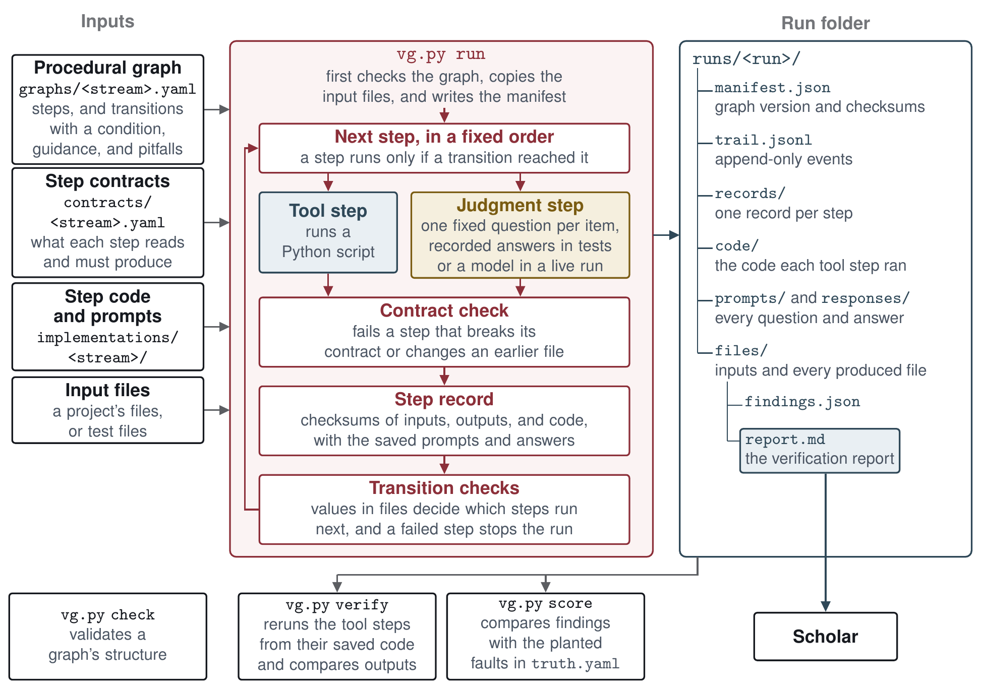
Figure A5. How the runtime runs a procedure.
The runtime executes the steps in a fixed order. It stops a run when a step breaks its contract.
Each run leaves a folder recording what ran, the versions of the graph and its inputs, the exact code of each tool step and the prompts, every model answer, and the report. A verify command reruns the tool steps, except the bibliographic lookup, and confirms they give the same results. Model answers are kept for review rather than rerun, since a model can answer differently each time.
The runtime has six commands, check, run, step, verify, score, and advise. A new procedure needs a procedural graph, a step contract and code or a prompt for each step, and clean and seeded test files with a truth file, while the runtime’s check command validates the graph’s structure.
Beyond verification, our procedural graph extension can be used to guide at least three other procedures. First, graphs for research methods, such as difference-in-differences, use the same representation but run, outside the research artifact, under a separate runtime with their own kinds of step. Second, graphs also hold reusable procedures for research tasks unique to a scholar’s institution and preferences, such as connecting to a university high-performance computing cluster or adding a project to GitHub. Third, wrappers and MCP servers can also be written as procedural graphs.

Capture
The capture step automatically collects every AI session and tool call. It sweeps each harness’s session files while a session runs, when it ends, and again on a schedule, through one event schema with an adapter for each harness.

Metadata tagging
The tagging step fills the fields with metadata in two passes, one mechanical and one using an AI model. Table A4 lists the fields each pass fills.
Table A4. The fields each tagging pass fills
Pass | Field | Description
Mechanical (a program, no model) | Session | Identifier, start, and end
 | Project | The project the session belongs to
 | Tools | The harness and tools the session used
 | Files | Each file touched, with its role (produced, edited, read, or cited)
 | Actions | Each action, with a verb from a fixed list (wrote, edited, ran, searched, verified, committed) and whether it was an action or an observation
Model (one AI model call per session) | Title | A short title for the session
 | Gist | One line on what the session did
 | Summary | A short paragraph
 | Keywords | Terms for search
 | Decisions | Each decision in the action log, with a one-sentence rationale
Model-pass fields stay marked unreviewed until a person reviews them.

Status
Table A5. Status of the parts of the audit layer
Part | Status | Note
Database file and file store, provenance on every row, and the two tests of written-out files | Specified
Stores for collected data, sources, and working files | Specified
Shared tables (links with citation evidence, projects, field definitions, export registry) | Specified
Choice of database software and how a scholar adds a table or field | Open | The stores section names one SQLite file, while the systems table leaves the choice open
Knowledge base entries as files (kb, 10 entries) | Built and tested | Four entries describe AI skills outside the artifact
Knowledge base server with five read-only tools, and its entry checker | Outside the artifact | Built
Knowledge store | Open | The specification leaves its design unsettled, including how its fields match the entry files
Cross-project loop, standards proven in one project registered for the next | Planned | A long-term goal in the specification
Procedural graphs kept in the knowledge base | Specified | An entry for each graph naming its purpose, triggers, steps, and run command is planned
Graph format, step contracts, and step code (graphs/, contracts/, implementations/) | Built and tested
Runtime with six commands, step records, and replay (vg.py) | Built and tested | Untested are the verify command reporting a failed replay, the score command reporting a missed fault, the refusal to run a step after its graph file changed, and the advise command
Self-test graph (graphs/selftest.yaml) | Built and tested
Methods graphs | Outside the artifact | Built
Operational-task graphs | Planned
Wrappers and MCP servers written as procedural graphs | Planned
Authoring guide for new procedures | Specified
Procedure for evaluating LLM runs | Planned
Capture through one event schema with an adapter for each harness | Specified | No adapter designed yet
Audit store of sessions, events, full transcripts, and metadata | Specified
Records the procedures read (file writes, citation log, AI rationales) | Built and tested | Readers only, and all three test records are synthetic
Checks for missed or interrupted captures | Planned | Built for one harness outside the artifact
Privacy controls for audit records and the databases (redaction, retention limits, access, review before sharing) | Not designed | See A6
Recording which model and version answered each AI call | Not designed | Run manifests name the judge and second-checker models but not their versions, and the audit store records only the model of the tagging pass
Mechanical tagging pass | Specified | The fixed list of verbs and the file roles are planned, and the pass runs for one harness outside the artifact
Model tagging pass, unreviewed until a person reviews it | Specified | Review marking is planned, and the pass runs for one harness outside the artifact

A2.5 The verification layer
The verification layer checks AI contributions with one verification procedure for each of the four streams. Figure A6 follows one AI-added citation from the citation log that names who introduced it to its entry in the references report. Tool steps then check what a program can check, and judgment steps put fixed questions to an AI model. Each result is saved with the record of the step that produced it, and the report is written from those results. The scholar then approves or holds each item.
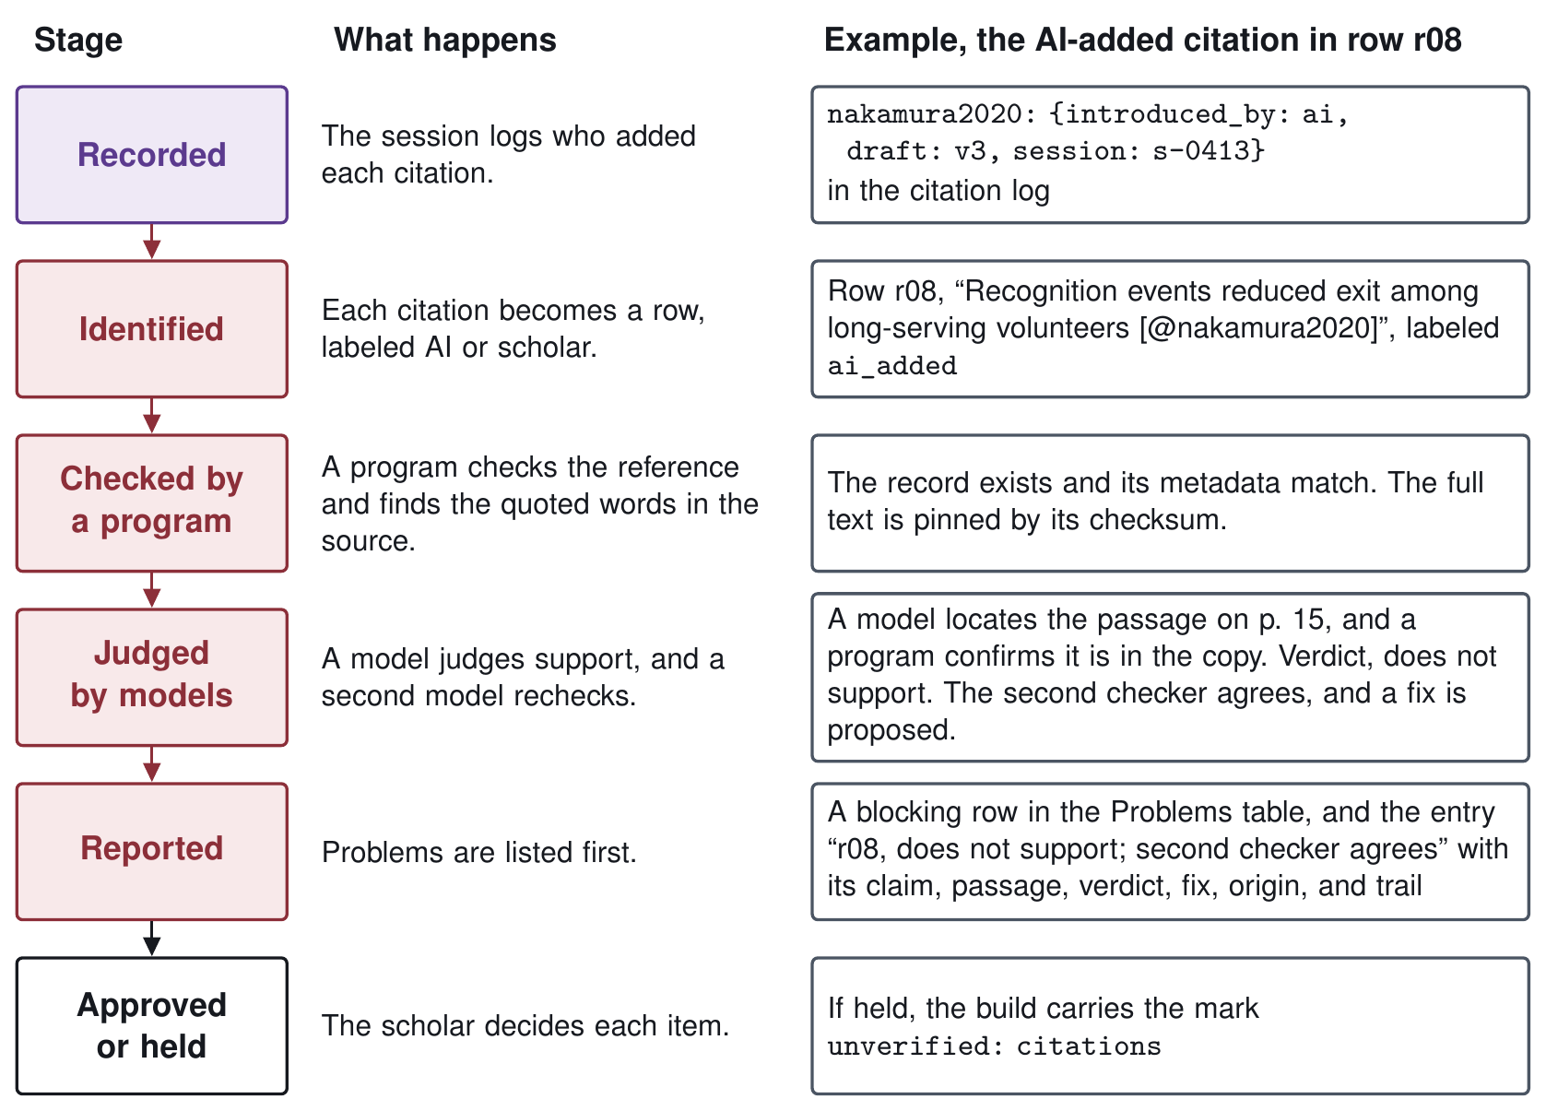
Figure A6. AI Contributions.

The four verification procedures
Each procedure has tool steps and, in three of the four, judgment steps. Figure A7 shows each procedure’s steps in the order the runtime runs them.
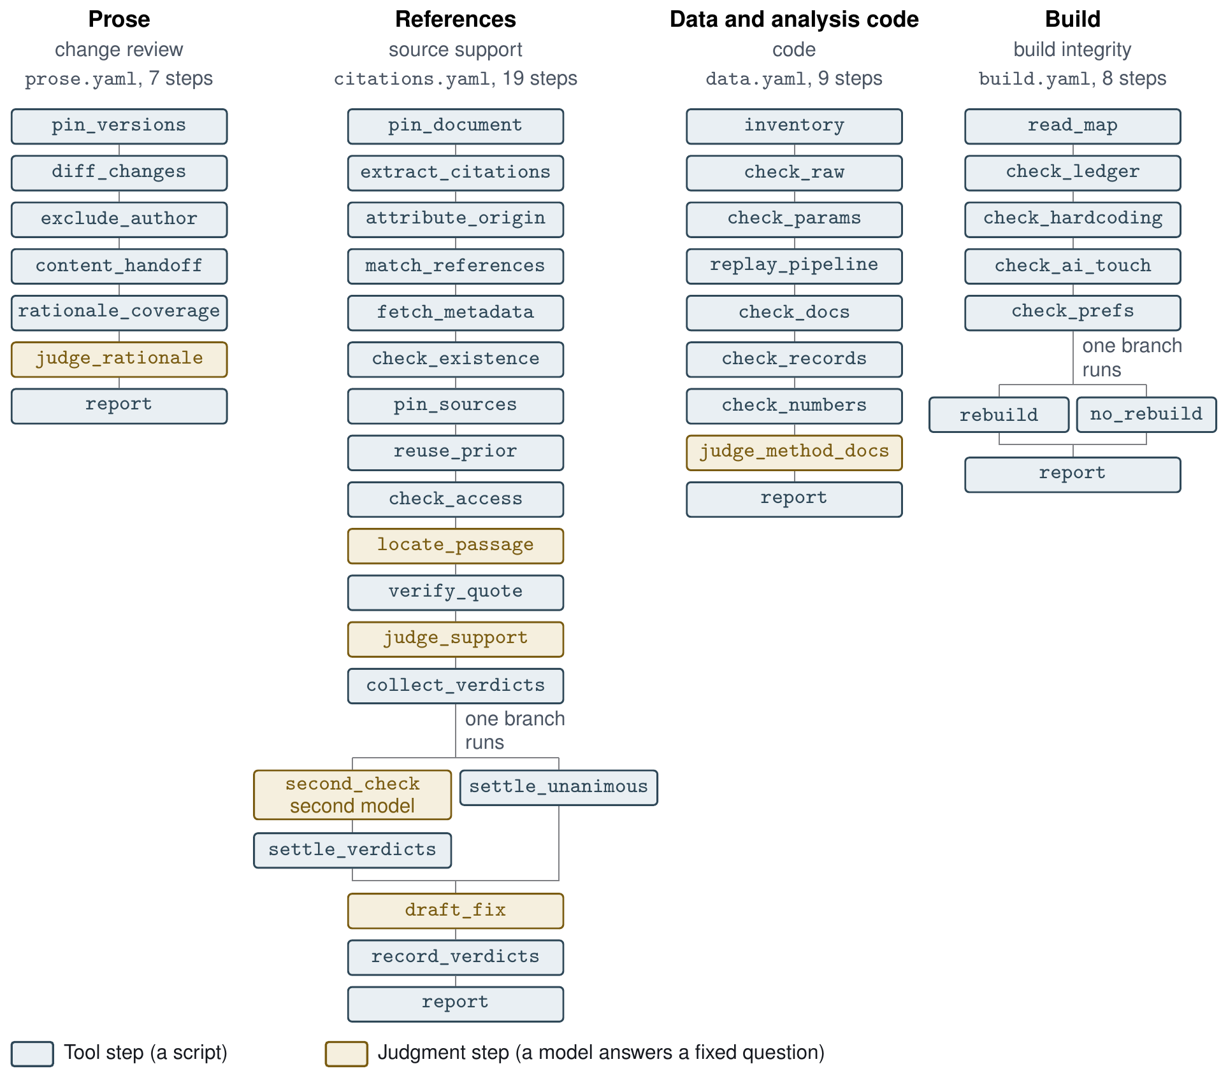
Figure A7. Verification Procedure Steps
Each procedure checks its stream as follows.
- Prose. Each AI edit has to come with a stated reason. A program lines up the changes between two drafts, and a model judges whether each reason honestly describes its change. For Word, programs use Word’s compare feature to show AI changes as tracked changes, then read back the scholar’s responses.
- References. A program checks that each cited work exists and that quoted words and numbers appear in the source. A model judges whether the source supports the sentence, and a second model rechecks any verdict other than “supports”.
- Data and analysis code. A program reruns the analysis from the raw data in an empty folder and checks that every value in the manifest of computed results (A2.3) matches the rerun. A model judges whether each method’s documentation describes what its code does.
- Build. A program checks that each research product comes only from its build and matches its ledger and a rebuild from the copy of its text kept with the build. No model is used.

Verification reports
Each run that completes writes one verification report for its stream, problems first, then every item with its evidence. At this stage the four reports are general purpose, and the intent is that they stay flexible as standards change.
One shared function writes the title, introduction, summary, problems table, and notes of every report. A program for each stream adds that stream’s own sections.
A model’s answers enter a report as findings, and the decision to approve each item for the reproducible pipeline is the scholar’s. The scholar can approve an item that has a finding, or hold one that has none. Each decision records who made it, when, and on which report run, and is kept in the stream’s results file beside its rows, so it reaches the pipeline with the results (A2.3). The report shows which items are approved. An item the scholar holds or has not yet decided does not stop a build, and the research product carries the mark unverified: <stream> until every item in that stream is approved and the stream’s results match the build’s inputs.
Example. The references report from the seeded run in A4 follows, abridged, with omissions noted in brackets and a long checksum shortened. Its entry for row r08 is the citation followed in Figure A6.
Citation verification report
Document: draft.md (sha256:397d3090b864…). Only AI-contributed citations are checked; a citation the author introduced, in a sentence the author wrote, is listed as the author’s warrant and not checked.
17 citation rows: 4 verified, 11 problems, 0 couldn’t check, 2 author’s warrant (not checked).
• Verified on the abstract only: 1. Verdicts carried over from an earlier check: 1.
• To confirm any verdict: open the retrieved copy named in its trail, search for the quoted passage, and read it beside the claim. Every ask and answer is saved under prompts/ and responses/ in the run folder.
Summary
• Blocking: 10
• Warnings: 9
• Notes: 6
Problems
Severity | Check | Item | Problem | Evidence
blocking | check_existence | ferrante2021 | citation may not exist: no record for DOI 10.5555/nmr.2021.0388 (not in the metadata cache, and live lookup was off) | 10.5555/nmr.2021.0388
blocking | judge_support | r05 | source does not support the claim: The source reports a 24% fall in twelve-month retention, not 42%. | Programs that reduced orientation to a single session saw twelve-month retention fall by 24% relative to programs that …
blocking | judge_support | r08 | source does not support the claim: The source says recognition events had no measurable effect on exit, and exit rose slightly afterwards, the opposite of the … | Recognition events had no measurable effect on exit among long-serving volunteers. If anything, exit rose slightly in t…
blocking | verify_quote | r04 | quoted words are not in the source (a paraphrase presented as a direct quote): “volunteers leave when the work stops feeling like their own” | source_brennan2016.txt
warning | check_access | r12 | abstract only: the verdict covers the abstract, not the full text | source_iversen2018.txt
[14 of the 19 problem rows omitted, from between and after the rows shown]
Rows
Problems (11)
[5 entries omitted]
r08: does not support; second checker agrees, @nakamura2020
• Claim: Recognition events reduced exit among long-serving volunteers [@nakamura2020].
• Reference: Nakamura, E. (2020). Recognition events and the long-serving volunteer. Voluntary Sector Studies. doi:10.5555/vss.2020.0063 Check: exists; metadata matches.
• Passage: “Recognition events had no measurable effect on exit among long-serving volunteers. If anything, exit rose slightly in the quarter after an event, a pattern we attribute to volunteers treating the event as a natural point to step down.” (p. 15)
• Verdict: does not support; second checker agrees. The source says recognition events had no measurable effect on exit, and exit rose slightly afterwards, the opposite of the claim.
• Access: full text
• Proposed fix: Reverse the claim to match the source: “Recognition events had no measurable effect on exit among long-serving volunteers.”
• Origin: ai_added (AI introduced the source)
• Trail: passage located by recorded:recorded_judge.json (record 10_locate_passage), checked mechanically (record 11_verify_quote), verdict by recorded:recorded_judge.json (record 12_judge_support); second check by recorded:recorded_second.json (record 14_second_check); reference checked (records 05_fetch_metadata, 06_check_existence); retrieved copy source_nakamura2020.txt sha256:b76d203442be…; fix proposed by recorded:recorded_judge.json (record 16_draft_fix); times: each record’s started_at
[5 entries omitted]
Couldn’t check (0)
None.
Verified (4)
[4 entries omitted]
Author’s warrant, not checked (2)
[2 entries omitted]
Notes
[6 notes omitted]

Status
Table A6. Status of the parts of the verification layer
Part | Status | Note
The four verification procedures | Built and tested | 33 of the 36 verification tests
Clean and seeded test files, truth files, and scoring | Built and tested
Second checker | Built and tested | The different-model rule is not enforced
Live judgment | Built | Ran October 8 on the test files (A5)
Live bibliographic lookup | Built | Never run
A report for each stream, written through one shared report function | Built and tested | Each stream’s own sections are written in code
Versioned schema for each stream, with not_run fields, and one report builder | Specified | Changing the version as standards change is not yet in a design document
Results file for each stream | Specified
Procedure registry and triggers | Specified
Adapters for Word, a citation manager’s export, R, and Quarto | Specified | The Word readers (returns, reconcile) are built, and the adapter that fills the prose stream’s fields is not
Acceptance tests for the four parts above | Specified
Word review modules (annotate, returns, reconcile) | Built and tested | 47 tests
Word compare script (ospipe/tools/word_compare.applescript) | Built
Carrying accepted edits into the source text | By hand | Done by the scholar or an AI session, since no code does this yet
Flagging numbers typed into prose (lint) | Built and tested | 14 tests
Standard records for each transition | Specified | Only the build ledger is code
The scholar’s approval of each item, kept in the results file and shown in the report | Planned | Named in Stage 2 item 2 (Table A9) and not yet in a design document
Two levels of verification, light working checks and formal build checks | Open | Not yet ruled on in the specification
Seeded-fault test on a full synthetic manuscript | Planned | Placed after Stage 2 in the specification

A2.6 The observability layer
The observability layer enables the scholar to observe an AI model’s reasoning where the model exposes it, the tool calls, and the tool results. The scholar can view these in the observability dashboard, the teal box in the proposal’s Figure 2. The layer’s events come from the audit layer’s record and, through the wrappers and MCP tools of A2.2, from software outside the workflow. Some harnesses already show elements of these in the chat interface. The layer adds observability of the work of subagents, AI programs that run outside the harness, and the knowledge base entries the AI reads, in one view that is the same for every harness and can be reopened after the session ends.
The observability layer uses the audit layer’s record as it is written, with events that follow OpenTelemetry’s conventions for AI calls so that the view does not depend on any one harness (Figure A4). A harness that already exports these events in OpenTelemetry’s form needs only a setting to send them to the record. The setting is turned on one project folder at a time, so sessions in folders the scholar excludes, such as those holding student records, are never recorded (A6).

Status
Table A7. Status of the parts of the observability layer
Part | Status | Note
Reading the audit record live, with events in OpenTelemetry’s conventions | Specified
Observability dashboard | Planned | Its design is still to be developed
MCP tools that bring events from outside software into the live view | Planned | The wrappers of A2.2 carry the same events

A2.7 Features
The proposal names two features that lower the cost of adopting the workflow and an interactive web portal that helps scholars learn and use it over the long term. Scholars can add features of their own, such as custom skills and programs, and each enters as a program with a declared contract and leaves the same records as any AI session. The three the proposal names come first below, then custom skills.
- Pipeline setup. An AI-assisted workflow that builds a reproducible pipeline for a project and connects it to the scholar’s software and harness.
- Project organizer. A tool that uses AI to organize files, builds, and past sessions, with every change observable and reversible, under the rule that AI never deletes and marks instead.
- Interactive web portal. A site that helps scholars learn, implement, and critique the workflow, built on a catalog site generator.
- Custom skills. Skills and programs unique to each scholar such as agentic systems developed to help with manuscript editing, literature searches, and source retrieval.

Status
Table A8. Status of the features
Part | Status | Note
Pipeline setup | Planned
Project organizer | Planned | Its rule that AI never deletes is specified
Interactive web portal | Planned

A3. Development plan
Stage 1 built the prototype and the research artifact this appendix describes. Stage 2, from January to May 2027, completes the verification layer and tests it through the proposal’s five items. Table A9 gives the plan by month with the special issue’s dates and names what each Stage 2 item starts from in the research artifact, and the Stage 2 item column of each status table shows which item covers each part.
Table A9. Development calendar for Stages 1 and 2
When | Stage | Development | Starts from (in the research artifact)
July 2026 | 1 | Reproducible pipeline built and tested, with its module contracts and the knowledge base files
August to September 2026 | 1 | Designs for the databases and the file protocol
October 2026 | 1 | Verification runtime and four procedures built and tested, and live judgment runs (October 8). Verification procedures design (October 9) and system specification draft 0.10 (October 22)
By November 1, 2026 | 1 | Research artifact released at [COMMIT OR TAG], and the proposal, this appendix, and the artifact submitted
November 2026 to January 10, 2027 | 1 | Selection by the special issue editors, with selected projects notified January 10
January 2027 | 2 | Item 1, “finalize the procedural graph system, so that verification procedures, wrappers, MCP servers, and operational tasks can all be written as procedural graphs” | The graph format, the runtime with its six commands, step contracts, and a self-test graph showing the runtime is not tied to the four streams
January to March 2027 | 2 | Item 2, “finish building and testing the verification layer”, with versioned schemas and one report builder, the results file and the scholar’s approval of each item, the registry and harness triggers, and adapters (A2.2, A2.5), and separating ospipe (A2.3) | Four procedures with their clean and seeded test files, 36 tests, and the live runs (A5)
February 27 to 28, 2027 | 2 | Special issue workshop (date tentative)
March to April 2027 | 2 | Item 3, “build the observability layer and the associated wrappers and MCP tools …, with the same events written to the logs”, with audit capture, storage, and tagging (A2.4, A2.6) | The step of the build procedure that already reads a session record of file writes (A2.4)
April to May 2027 | 2 | Item 4, “test the workflow across multiple open-source harnesses, models, external software integrations and scenarios” | Judges chosen per run, recorded answers, and the clean and seeded test files
May 2027 | 2 | Item 5, “develop an interactive web portal to help scholars learn, implement, and critique the workflow” | Nothing in the research artifact
Item 1 is described in the system specification’s definition of the procedural graph system and in the verification procedures design’s authoring guide and procedure registry, neither of which yet describes wrappers or MCP servers as procedural graphs. Item 2 is described in sections 1 to 6 of that design, apart from the scholar’s approval of each item, and its acceptance tests include three harness triggers and the Make trigger. Item 3 rests on the system specification’s description of the three layers and wrappers, item 4 on its provider setting for the AI model, and item 5 is named only in its Stage 2 list. The instruments that measure the verification work already run. They are the truth files of the seeded test files, the score and verify commands (A4, A5), and the 36 tests of the verification procedures, which report the planted faults caught, findings on clean files, and whether tool steps replay.

A4. Running the prototype offline
The commands below build a sample project’s research products, check its numbers, and run the procedures on their test files, answering judgment steps from recorded answers (A2.5). The research artifact is available [ACCESS ROUTE] under [LICENSE]. The commands need Python 3.9 or later with PyYAML, python-docx 1.2 or later, and pytest, plus Pandoc on the command path. The build procedure’s stored test builds were made with Pandoc 3.9.0.2. Under Pandoc 3.6.4, the one other version tried, one of the 36 verification tests fails, and the build runs give extra warnings, one replacing the blocking finding on the planted edit to a build. The reported results come from macOS with Python 3.9.5, PyYAML 6.0.3, python-docx 1.2.0, pytest 8.4.2, and Pandoc 3.9.0.2. Linux and Windows were not tried. The seeded and clean runs of the four procedures also gave the same results under Python 3.12.13.
Running the commands below needs a terminal with Python, and apart from fetching the repository and installing packages, none of them uses the network or calls an AI model. The repository’s files total about 1.1 megabytes, and nothing in it needs a GPU. The first block fetches the prototype, installs its packages, and runs both test suites.
git clone [REPOSITORY URL]
cd [REPOSITORY FOLDER]
git checkout [COMMIT OR TAG]
python3 -m venv ../vg-venv
. ../vg-venv/bin/activate
python3 -m pip install pyyaml "python-docx>=1.2" pytest
cd ospipe
python3 -m pytest -q
cd ../verification_procedures
python3 -m pytest -q
The first suite reports 117 passed in under 10 seconds and the second 36 passed in about a minute.
The second block builds the two research products of a small sample project in examples/sample_project/, a one-page test manuscript and a four-slide deck abbreviated from a talk on prompting. Its analysis script computes the results the two products cite from one data file, the build fills them in from the project’s numbers file, and the data procedure then checks each value in that file against a rerun of the analysis.
cd ../examples/sample_project
python3 s1_results.py
PYTHONPATH=../../ospipe python3 -m ospipe build --manuscript manuscript.md --manifest numbers.yml --tables-dir . --bib refs.bib --builds-dir builds/manuscript --purpose "sample manuscript"
PYTHONPATH=../../ospipe python3 -m ospipe build --manuscript slides.md --manifest numbers.yml --tables-dir . --to revealjs --builds-dir builds/slides --purpose "sample slides"
cd ../../verification_procedures
python3 vg.py run graphs/data.yaml --run runs/demo_sample --inputs ../examples/sample_project --judge recorded:../examples/sample_project/recorded_judge.json
Each build takes under a second and writes version v001, the manuscript as builds/manuscript/v001.docx and the slides as builds/slides/v001.html, each with a copy of its filled-in text and a row in its ledger. A placeholder with no value stops the build, which lists every missing key. Opening the slides in a browser loads the reveal.js library from the web. The data procedure’s run takes under 3 seconds and reports no blocking finding or warning, with all 10 cited numbers matching the rerun. In a trial with one number changed by hand in the numbers file, the run reported it as blocking.
The third block runs the references procedure (citations) on its seeded test files from verification_procedures/, then replays and scores the run.
VG_OFFLINE=1 python3 vg.py run graphs/citations.yaml --run runs/demo_citations --inputs fixtures/citations/seeded --judge recorded:fixtures/citations/seeded/recorded_judge.json --second recorded:fixtures/citations/seeded/recorded_second.json
python3 vg.py verify --run runs/demo_citations
python3 vg.py score --run runs/demo_citations --truth fixtures/citations/seeded/truth.yaml
The run takes about 3 seconds and completes 18 of the graph’s 19 steps, including the second check of verdicts. The verify command reports replay matches for each tool step it reruns (A2.4), and the score command prints {"faults": 13, "recall": 1.0, "missed": []} extras=5. All five extra findings fall on rows that carry a planted fault or cite a reference that does, and A2.5 shows part of the run’s verification report.
The fourth block runs the prose, data, and build procedures on their seeded test files and scores each run. The build procedure has no judgment step.
python3 vg.py run graphs/prose.yaml --run runs/demo_prose --inputs fixtures/prose/seeded --judge recorded:fixtures/prose/seeded/recorded_judge.json
python3 vg.py score --run runs/demo_prose --truth fixtures/prose/seeded/truth.yaml
python3 vg.py run graphs/data.yaml --run runs/demo_data --inputs fixtures/data/seeded --judge recorded:fixtures/data/seeded/recorded_judge.json
python3 vg.py score --run runs/demo_data --truth fixtures/data/seeded/truth.yaml
python3 vg.py run graphs/build.yaml --run runs/demo_build --inputs fixtures/build/seeded
python3 vg.py score --run runs/demo_build --truth fixtures/build/seeded/truth.yaml
The score command reports every planted fault caught, 10 of 10 for prose, 8 of 8 for data, and 7 of 7 for build, with 0, 4, and 0 extra findings. As in the references run, the four for data fall on items that planted faults touch. Each run takes under 3 seconds.
Offline runs take under 4 seconds per procedure on test sets of 6 to 25 files. A live run sends a model one request for each judged item, and the seeded references and data files have 40 and 30 judged items. Nothing has been measured on a full manuscript. Using the prototype today requires the command line, pipeline setup is planned, and the web portal is Stage 2 item 5.

A5. Live judgment and its variation
The tests use recorded answers so that they give the same result on every run, while a live run saves every prompt and answer per item with a checksum of the prompt. A reader can therefore review the verdicts a run used even if a model answers differently on another run.
On October 8, 2026, seven development runs had AI models answer every judgment step (A2.5) in the references, data, and prose procedures, on their clean and seeded test files. Table A10 gives the models and settings, and Table A11 the results. Both models are open-weight models reached through a university-hosted inference service, whose address is set in the runtime’s code. Recorded answers let any reader run every procedure without a model key (A4), while rerunning live judgment needs a key to that service.
Table A10. Models and settings in the live runs (settings and parsing as coded in the committed runtime, because the October 8 runtime file was not saved)
Item | Live runs of October 8, 2026 | Where to check
Judge model | qwen/qwen3.5-122b, for every judgment step except the references recheck | Run manifests and answer records
Second checker | openai/gpt-oss-120b, for the references recheck only | Same
Access | A university-hosted inference service through its chat completions interface, one message per item, with no state kept between items | vg.py, lines 51 and 266 to 284
Settings | Temperature 0 and a limit of 4,000 output tokens, with up to four attempts per request | vg.py, lines 270 to 283
Prompts | Rendered from templates in verification_procedures/implementations/<stream>/, filled with the procedure’s goal, the guidance and pitfalls on the step’s transitions, and the item, and saved per item | vg.py, lines 173 to 182, 296 to 302, and 446 to 472
Parsing | Reasoning blocks stripped and a structured answer extracted, with one retry that adds a fixed note to the prompt when an answer does not parse, after which an unanswered item becomes a “not judged” warning | vg.py, lines 244 to 253, 288 to 289, and 472 to 502
What was saved | 128 responses (127 items and one retry), answer text only, without reasoning output, token counts, finish reason, or seed | Run folders and vg.py, line 280
In the live runs, every planted fault was caught in all three procedures, and the six that depend on judgment were caught by the models’ own verdicts, read from the saved answers rather than from the score. The score command counts a fault as caught when any blocking finding or warning names the same check and item, so a “not judged” warning also counts. In a trial run with no model answers, the prose procedure still scored 10 of 10. The clean files gave no warning or blocking finding for references and data, and one warning for prose (Table A11).
In the seeded references run, four of the five extra findings follow from planted faults. The fifth is a partly verdict on row r06, a sentence with no planted support fault whose recorded answer is supports, and the second model agreed with the partly verdict. Row r06’s reference carries a planted wrong year, which is caught separately.
Table A11. Results of the live runs
Run (procedure, test file) | Planted faults caught | Other warning or blocking findings | What the saved answers show
References, seeded | 13 of 13, including both that need judgment | 5, described in the text | Verdicts differ from the recorded answers on 3 of 12 rows. The second model agreed with the first on all 5 rechecks.
References, clean | None planted | None | None
Data, seeded | 8 of 8, including the one that needs judgment | 4, each on an item a planted fault touches | One long answer was cut off, and the retry answered
Data, clean | None planted | None | None
Prose, seeded, graph version 0.1 | 10 of 10 | 2, a moved sentence whose rationale was judged dishonest and a disclosed change to a count judged to alter meaning beyond its rationale | Two pitfalls were added in version 0.2 from these errors
Prose, seeded, graph version 0.2 | 10 of 10, including all 3 that need judgment | None | None
Prose, clean, graph version 0.2 | None planted | 1 warning, on a disclosed deletion | The model judged that the deletion changed meaning beyond its stated rationale
Of note, the prose procedure’s pitfalls and prompt wording were revised after its first live run, which made two errors, and the same seeded test file was then run again. The clean prose warning came after that revision.
For all seven live runs, the saved code of every tool step is identical to the committed code, and for six of them every saved prompt is reproduced exactly from the committed templates. Four runs used contract files that differ from the committed ones, and one of them, the first prose run, also used an earlier graph and prompts. The runtime file is not recorded in run folders and changed on October 8. Every run folder from October 8 passed the verify command (A2.4) on October 23, 2026.
Each test file was run once per model configuration, except the seeded prose file, which was run again after the revision, so run-to-run variation has not been measured. Within these runs, live support verdicts differed from the recorded answers on 3 of 12 references rows, and one data answer was cut off and parsed only on retry, with its finish reason not saved. The second model agreed with the first on all five rechecks, and the recorded second answers also agree, so a disagreement between the two checkers has not yet occurred in either mode. The run records are [LIVE RECORDS LOCATION].

A6. Privacy and security
The test files are synthetic, written by hand or generated by scripts in the repository, and no file holds data about real people. The live runs reported in A5 sent only synthetic test content to the inference service they used, while a real project would send manuscript sentences, the AI’s rationales, analysis code, and cited texts, but no data files. The runtime reads the service’s key from the environment, and no key or credential is stored in the repository. The runtime works only on copies of its inputs, and the data procedure runs a project’s own Python scripts in a temporary folder, so running it on another project runs that project’s code. As specified, the audit layer keeps full session transcripts and tool calls, locally and under the scholar’s control, without expiry, so whatever a session reads enters the record. Capture skips sessions run in any folder the scholar excludes, though a session elsewhere that reads an excluded file still records it, and the specification has no redaction, retention-limit, or access rule yet. Sharing session records with journals needs a review step that is not yet designed. The same rules have to cover collected data in the databases, which MCP servers expose to the harness and the model, and the transcripts that the model pass of tagging sends to a model.

A7. Use of AI in building the prototype
AI tools were used to help draft and edit the proposal and technical appendix and to build the research artifact. The AI tools include author-developed agentic workflows for search, retrieval, storage, and summarization of scientific manuscripts, Anthropic’s Claude Code harness, and ForgeCode’s open-source harness. AI models used include both proprietary (GPT 6, Opus 4.6, 4.8, 5.5, and Fable 5) and university-hosted open-weight models (gpt-oss-120b and Qwen 3.5, 3.6, and 3.8). The prototype’s behavior is checked by its two test suites and by scoring each procedure’s findings against the planted faults listed in its truth files (A2.5). This appendix was drafted with AI assistance from evidence reports on the repository and the saved run records. Every number in it was checked against the code at [COMMIT OR TAG] or against those records, and every command was rerun on [DATE OF FINAL RUN].

References
Healy K (2020) The Plain Person’s Guide to Plain-Text Social Science. Version 2020-10-24. Accessed October 22, 2026, https://kieranhealy.org/files/papers/plain-person-text.pdf.
Lu Y, Chen Y, Wu S, Arık SÖ (2026) Procedural graphs: Self-evolving execution structures for LLM agents. Preprint, submitted September 8, https://doi.org/10.48550/arXiv.2609.09153.

